FARM POWER AND MACHINERY

This topic entails the following:
- Sources of farm power
- Systems of a tractor
- Tractor implements, uses and maintenance
- Animal drawn implements uses and maintenance
- Tractor servicing and maintenance practices

The following relevant questions and their answers in this topic will greatly motivate and
help the user to comprehend and understand the required concepts and practices:

1. Give four farm operations powered by engines

2. a) Describe the maintenance practices required on a tractor before it is put to daily use
b) Outline the factors that influence the power output by a draught animal

3. State two uses of gear box in a tractor
4. State two uses for which wind power is harnessed
5. Name three implements that are connected to the power take-off shaft
6. Below is a farm implement, study it keenly and answer the questions that follow:-
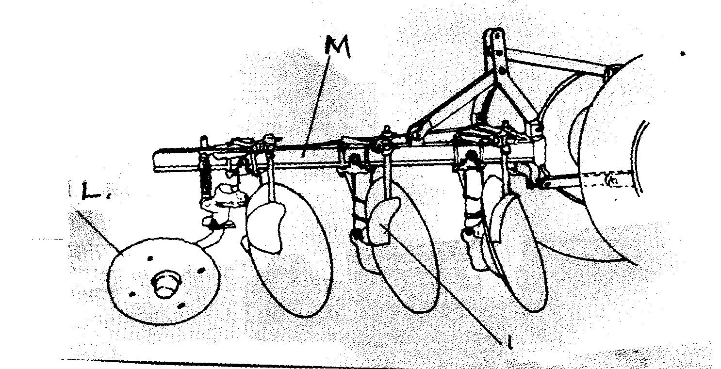

N

(a) Name the farm implement drawn above
(b) Identify the parts labelled L and M above
(c) Give the function of the part labeled M
(d) State the field condition under which the implement can work better than the others (½mk)

7. (a) Explain the factors that a farmer should consider in ensuring fast and efficient cultivation
by oxen
(b) Outline the importance of lubrication system in a tractor
(c) State the daily maintenance and servicing of a tractor

8. State the functions of the following parts of power transmission in a tractor:
(i) Hydraulic system
(ii) Draw bar
(iii) Propeller shaft
(ii) State three sources of tractor hire service

9. (i) What is a tractor hires services (1mk)
(ii) State three sources of tractor hire service (1½mks)

10. The diagram below represents an assembled differential of a tractor. Use it to answer the
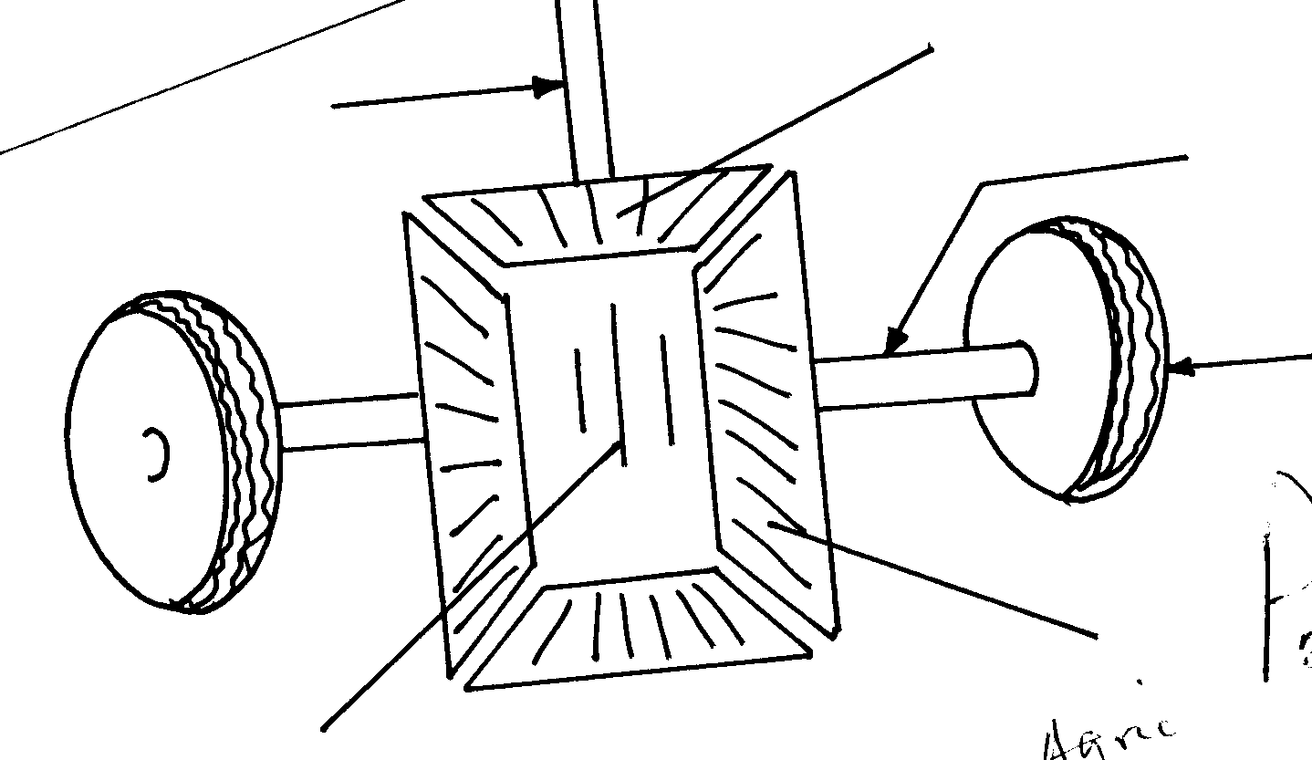
questions that follow:-
D
Wheel
B
A
Propeller shaft

C

(a) Name the parts labeled A, B, C and D
(b) State two functions of differential system of a tractor
(c) Give two reasons why wheel skidding of a tractor is not allowed

11. State four sources of power in the farm

12. Give the four strokes of a four stroke cycle tractor engine

13. State four factors which ensure efficient working by oxen in the farm

14. Mention two sources from which farmers can hire tractors
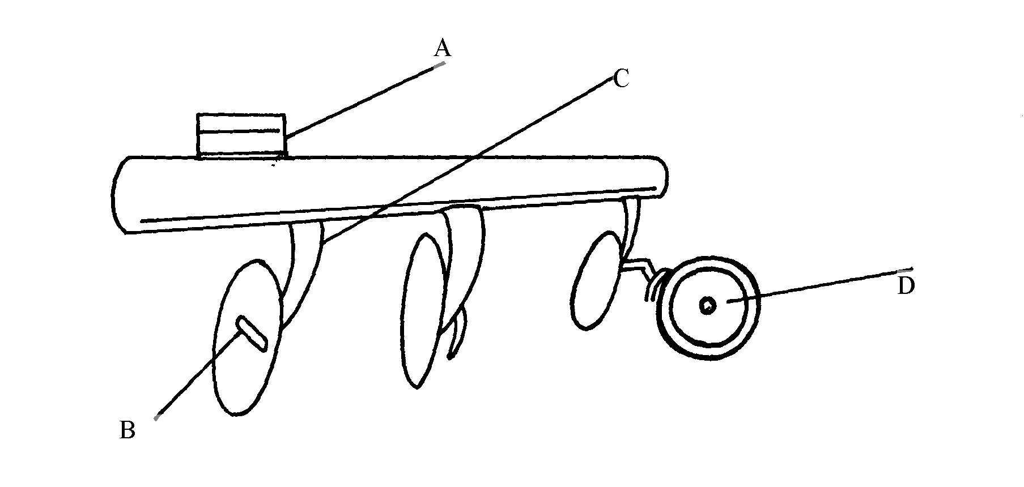
15. (a) Below is a diagram of a farm implement

(i) State the use of the implement shown above
(ii) Name the parts labeled A, B, C, and D
(iii) State two methods of increasing the depth of penetration of the implement

16. State four ways through which a farmer would ensure maximum power output from
ploughing animals

17. State three advantages of a disc plough over mould board plough

18. a) Explain the differences between petrol and chisel engine
b) Describe components of transmission system of a tractor

19. Name four systems of a tractor engine

20. Give one function of the clutch

21. State two adjustments that should be carried out on a tractor – mounted mould board plough
in preparation for ploughing
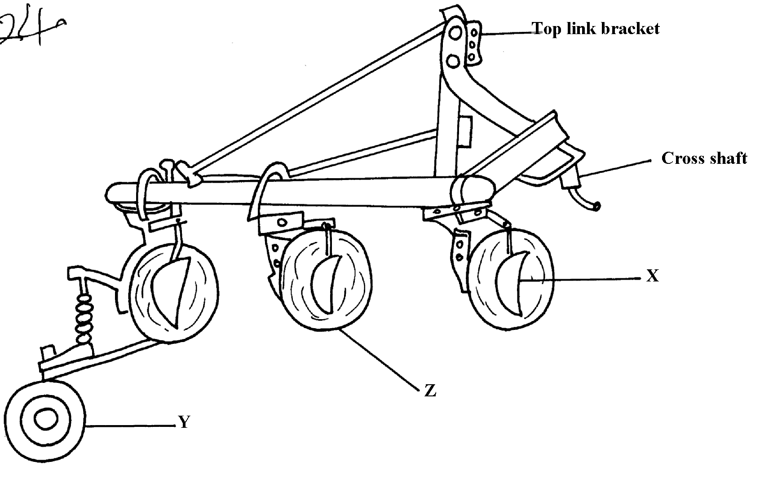
22. The diagram below illustrates a farm implement. Study it and answer the questions that follow

a) Identify the implement
b) Name the parts labeled X, Y and Z
c) State three maintenance practices that are carried out on a disc plough

23. a) Describe the operational differences of a disc plough and mould board plough
b) Explain six marketing problems affecting dairy farming in Kenya
c) State four reasons for culling a boar

24. Name the role of the following parts of a mould board plough
a) Share .
b) Mould board
c) Land side....

25. a) State five maintenance practices of a mould board plough
b) Explain five structural and functional differences between the petrol and diesel engines c) List five uses of farm fences

26. Give two uses of ox-drawn fine harrow

27. List four care and maintenance of a tractor battery

28. Study the diagram of a farm implement shown below and answer the questions that follow:
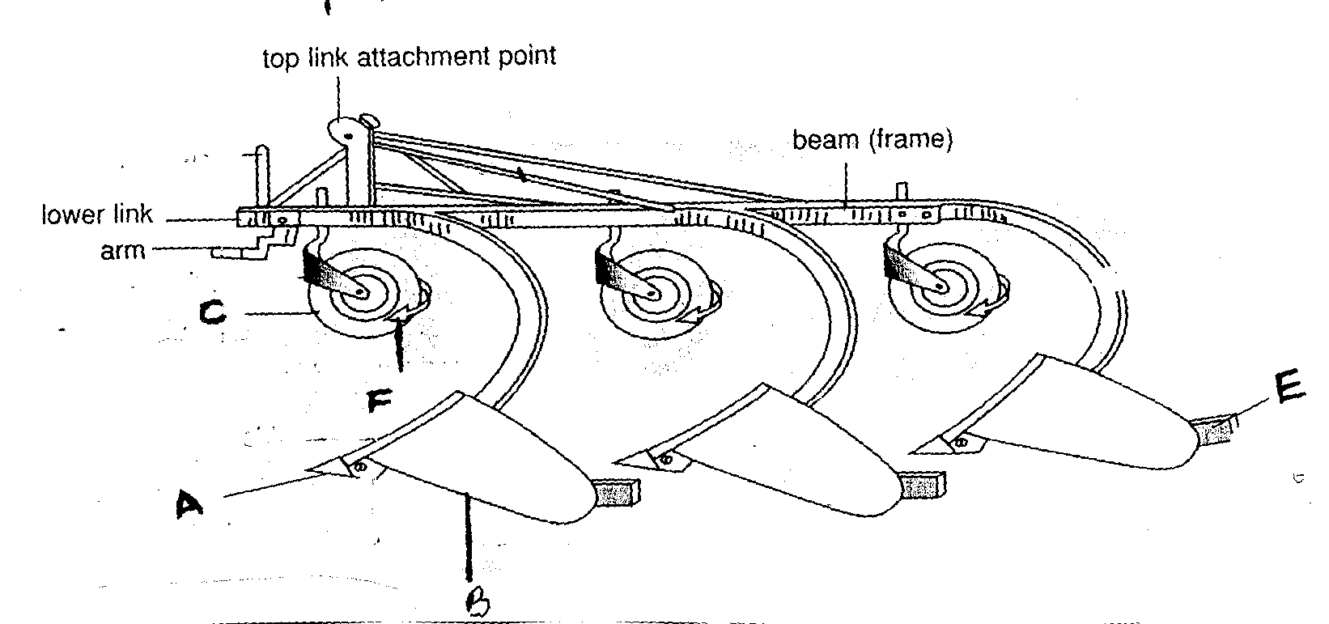

(a) Identify the farm implement illustrated above
(b) Label parts A, B and C
(c) Outline the functions of the parts labeled E and F
(d) Give two care and maintenance of the above implement

29. Outline six uses of live fences on the farm

30. List two possible causes of over heating in a tractor engine

31. List two events occur during induction stroke in a four stroke engine

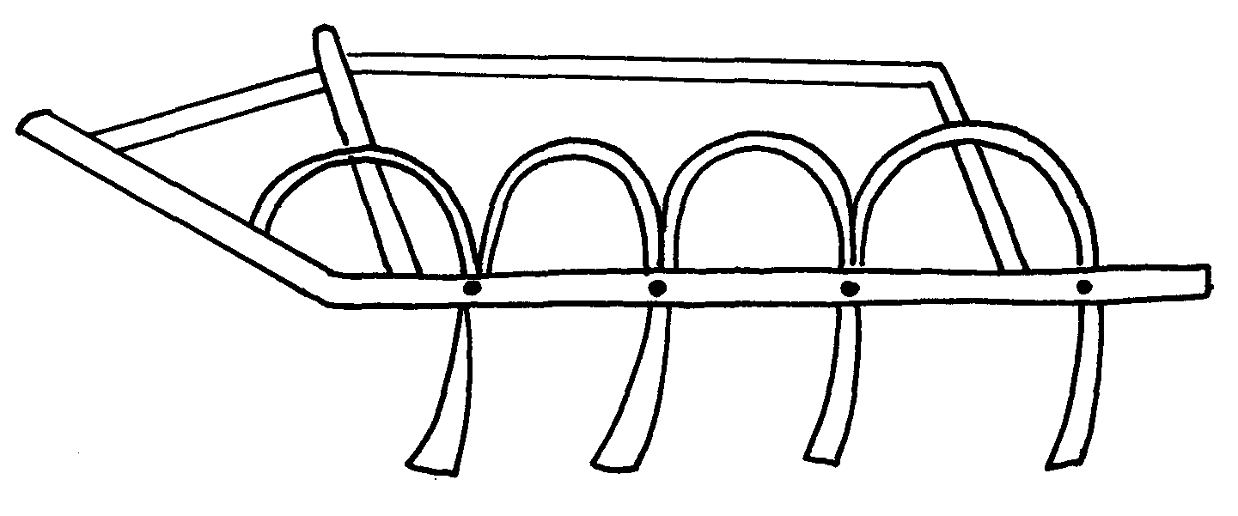
32. i) the diagram below shows a tractor drawn implement.

a) Name the implement
b) Give two uses of the implement above
c) State three maintenance practices carried out on the above implement. ii) Below is an illustration of a farm equipment. Study it and answer questions that follow
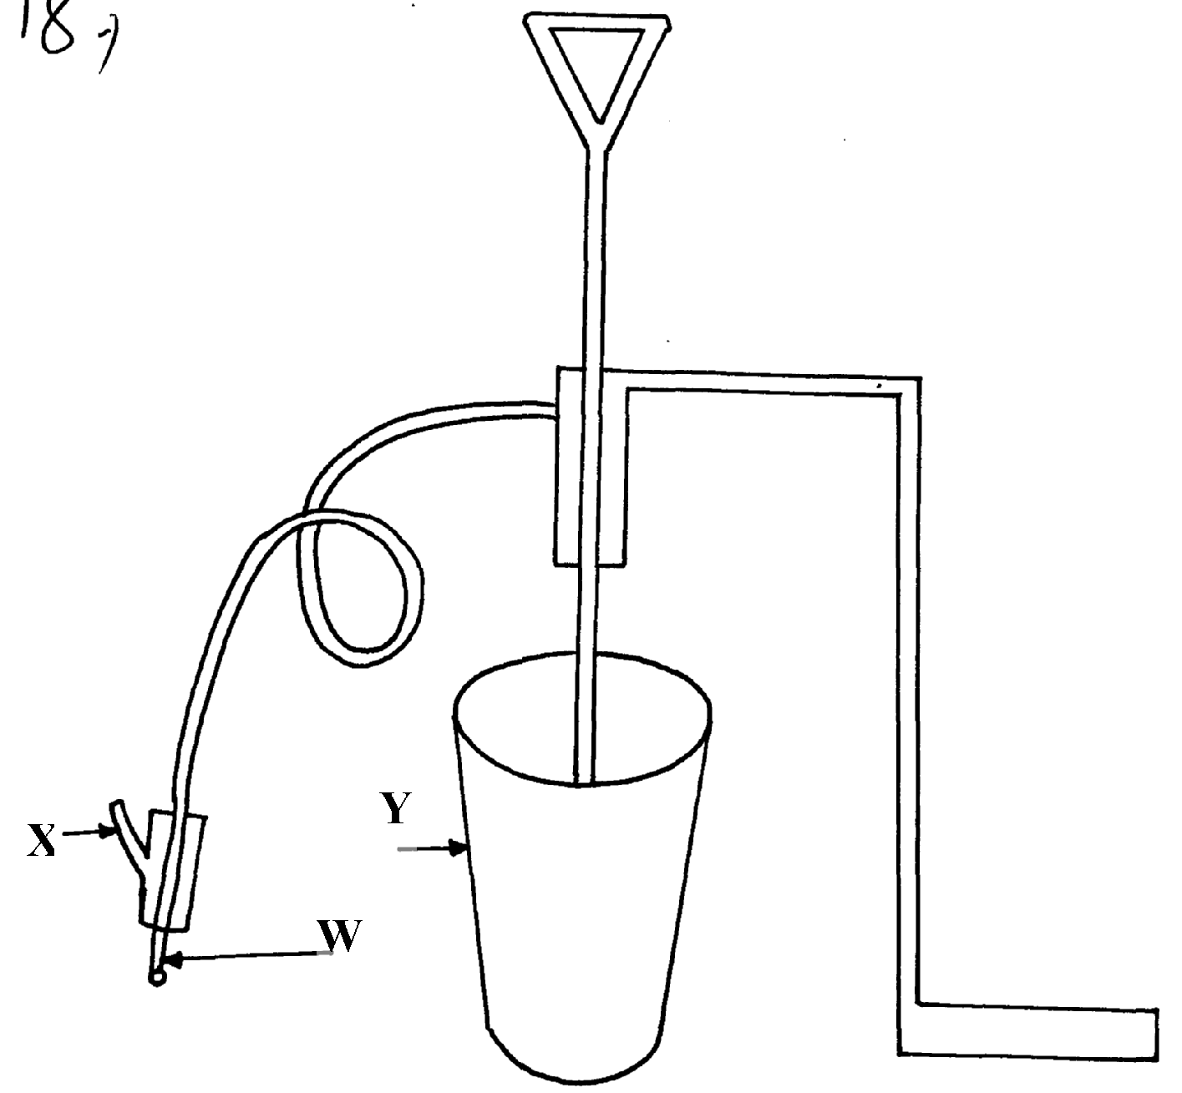

a) Identify the farm equipment illustrated above b) What is the use of the equipment c) Name the parts labelled W, X and Y d) What is the functions of Y on the equipment

33. a) Explain the factors that influence the power output of farm animals
b) State the importance of farm fences

34. Study the illustration of a biogas digester plant and answer the questions that follow.
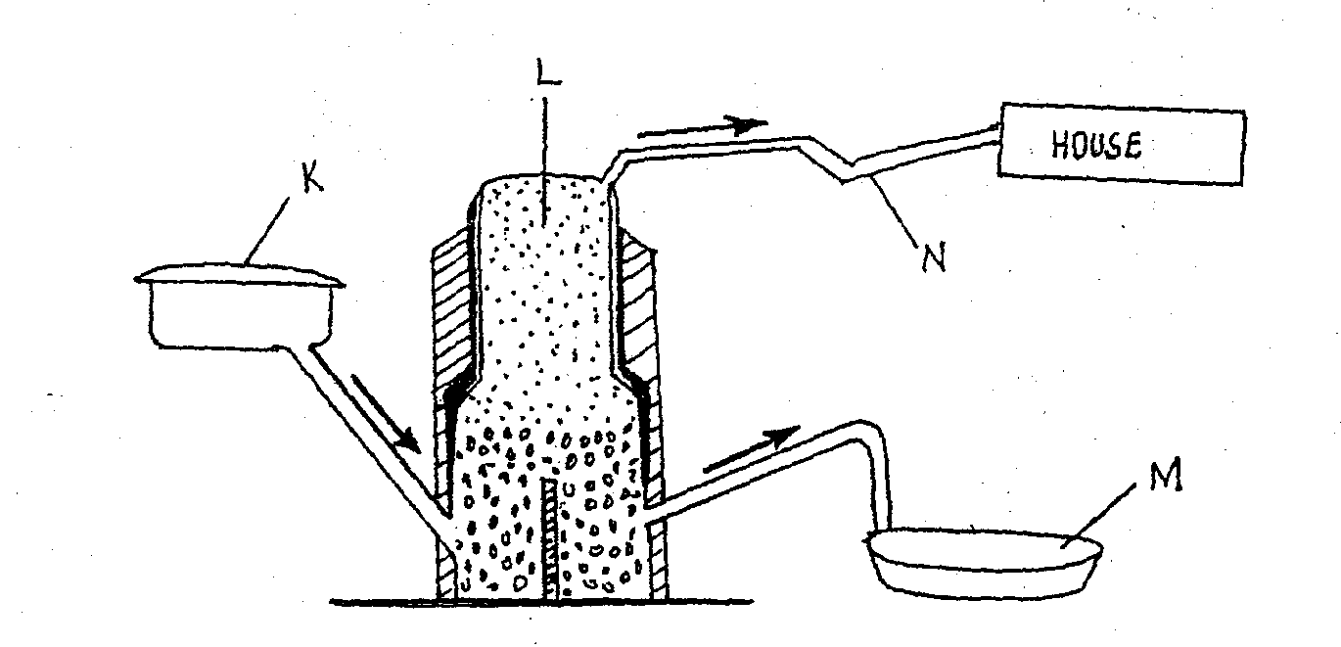
HOUSE
N
L
KL
M

a) Name the major component of biogas that is trapped in part L above
b) Give the name of the material deposited in part labeled M and its use
c) What is the component of K in the biogas production
d) Give three disadvantages of biogas as a source of farm power

35. Other than hydro-electricity mention two sources of electrical energy which can be available
for use in the farm

36. a) Describe the maintenance practices required on a tractor before it is put to daily use
b) Discuss the factors that influence the power output by a draught animal

FARM POWER AND MACHINERY
1. Farm operations powered by Engines.
- Ploughing and harrowing / land preparations;
- Transporting farm produce;
- Spraying of herbicides/ pesticides.
- Mowing the grass;
- Lighting of homes;
- Pumping water for irrigation.
- Harvesting farm produce;
- Machine milking.

2. (a) Maintenance practices required on a tractor before setting out to work.
- Check the engine oil daily using dip stick.
- Check fuel and add if necessary.
- Nuts and bolts are tightened whenever they loosen.
- Water level in the radiator be checked and added if necessary.
- Battery electrolyte be checked daily and if below level, top up be done using distilled water.
- Greasing be done on the bearings.
- Tyre pressure be checked and if low, should be added.
- Fan belt tension be checked.
- Break shaft bearing should be greased.
- Ensure break fluid and clutch fluid levels are maintained.
- Sediments from the sediment bowls should be removed.
- Check battery terminals and grease.
- Oil cleaner be cleaned.
(b) Factors that influence power output by a draught animal.
- Age – Mature animals produce more power output than young ones.
- Breed & Type – Indigenous animals are more hardy than exotic.
- Training Level – better trained animals have better work output.
- Body Weight – A draught animal can pull 10 – 20% of its body not for 6 – 8 hours.
(The bigger the animal, the more output).
- Harnessing of the animal – well harnesses animal is more efficient at work than poorly
harnessed work.
- Condition of working equipment on well maintained equipment have higher work output with the draught animal than poorly maintained ones.
- Environmental/ Ambient temperature – Cool temperatures lead to higher work output with a draught animal than high temperature.
- Health Status – A healthy draught animal has higher workout put than a sick animal.

3. Uses of a gearbox:-
- Stops the tractor without switching off engine
- Provides different forward speeds
- Enables reversing ( ½ x 2pts = 1mk)

4. Two uses for which wind power is harnessed
- To pump water
- To generate electricity
- For processing /winnowing of grains e.g. millet, rice e.t.c
5. Name three implements that are connected to the power take-off shaft
- Sprayers
- Rotarators
- Reciprocating (1mk each = 3mks)

6. (a) Impelement identity – Disc plough
(b) L – Furrow wheel M - Beam
(c) - Adds weight
- Forms attachment of all the other parts ( ½ x 1pt = ½ mk)
(d) Where there are hidden obstacles e.g. stumps , rocks e.t.c
- Heavy soils

7. (a) Factors that a farmer should consider in ensuring fast and efficient cultivation by oxen
- A well trained personnel
- Using well trained animals
- use of efficient implement
- Avoiding overworking the animals (allow them to rest
- Good working environment should be created for the animals
- Animals should be handled well
- Feeding the animals properly
- Using of males animals to do the work
- Using healthy animals only to do the work (1mk x 8pts = 8mks)

(b) The importance of lubrication system in a tractor
- Prevents rusting i.e when oiling is done
- It pacts as a cleaning agent as it washes off the dirt, dust
- Reduces the heat/cooling
- Increases efficiency of the machine and reduces the rate of wear and tear on moving parts

(c) The daily maintenance and servicing of a tractor
- Checking of maintenance and servicing of a tractor
- Checking of engine oil by use of dip stick and add if low
- The level of electrolyte in battery should be checked daily and add if low
- Inspect the H2O level in radiator and add if low
- Loose nuts and bolts should be tightened
- Tyre pressure should be checked and added if low
- Level of fuel should be checked and added if low
- Removal of large sediments from the sediment bowl
- Greasing should be done by use of grease on nipples of bearings
- Fan belt tension should be checked to ensure that it deflects between 1.9–2.5cm when pushed
- Break shaft should be greased
- Maintain break fluid level (1mk each for any 9pts= 9mks)

8. (i) Hydraulic system-raise and lower mounted implements like plough
(ii) Draw bar-attachment of trail implement
(iii) Propeller shaft-connect gearbox to differential which has axle to drive wheel
making tractors to move backwards or forward.(@ 1mkx3=3mks

9. (i)Hiring of tractors and implements by farmers who do not have them(correct definition=
(ii) three sources of tractor hire service (1½mks)
- Government tractors hire service
- Private contractors
- Individual farmers
- Cooperative societies (any 3x ½ =1 ½ mks)

10. (a) A-ring pinion gear
B-bevel side gear
C-wheel exle
D-drive pinion gear
(b) State two functions of differential system of a tractor (2mks)
- Change direction of drive to right angle for power to be transmitted to rear wheel
- Enable rear wheel to travel faster/slower than other when negotiation corner (1x2=2mks)
(c) Give two reasons why wheel skidding of a tractor is not allowed (1mk)
- To make tyres last longer
- To make it easy to control the tractor
11. Wind , water, human, animal, biogas, wood fuel, charcoal, kerosene, fossil fuel, petroleum,
ethane (natural gas), hydroelectric power, nuclear , Geothermal, storage battery
12. Induction, compression, power exhaust
13. - Keeping them healthy
- Proper feeding
- Proper handling e.g not over working /not beating them
- Proper training
- Not overloading them
14. Individual owners
- Government tractor hire service
- Co-operative societies
- Companies
15. (i) Primary cultivation
A- To link bracket
B _ scrapper
C- Standard/disc hanger
D – Rear finow wheel / thrust wheel 2mks
(ii) Adding weight on beam
- exerting more hydraulic force
- - Sharpen the disc blade
- - Increased space between the disc
- - Loosen the area of disc contact with the soil
- Increase the cutting angle
16. four ways through which a farmer would ensure maximum power output from
Ploughing animals
- Feeding and watering animals well before working
- Training animals on draft techniques
- Allowing animals to rest well after a day work/avoid overworking the animals
- Keeping the animals in good health while working
17. three advantages of a disc plough over mould board plough
- Tears and wear is less
- Needs less power to pull
- It can ride over obstacle
18. a) the differences between petrol and diesel engine
Diesel | Petrol
i)use diesel as fuel  ii)has injector pump  iii)has no spark plug  iv)fuel is ignites by compression  v)air and fuel first meet in cylinder before ignition  vi)specific fuel consumption is low  vii)higher air compression ratio  viii)air/fuel ratio is not constant  ix)has sediment bowls  x)operation cost is lower  xi)it is heavy in weight and suited to heavy machines  xii)produces a lot of smoke | Use petrol as fuel  Has carburetor  Has spark plug for ignition  Fuel ignites by spark plug  Air and fuel meet in carburetor before ignition  Specific fuel consumption is high  Lower air compression ratio  Air/fuel ratio is constant  No sediments bowls  Operation cost is high  Operation cost is high light in weight and suited to light machines  Produce minimal smoke
b) Describe components of transmission system of a tractor
i) Clutch- It disconnects the engine from the rest of the transmission system. It is mounted on the
flywheel and made up of pressure plates and clutch plate in the middle. The clutch
allows the driver to temporarily interrupt the power flow from the engine to the fear
box and shift from one gear to the other
ii) Gear- These are toothed wheels. They provide towards speed or reverse. The set of gears are
housed in the gear box.
iii) Differential- it is located between the wheel axial. it enables one wheel to move faster than the
other while negotiating a corner
iv) Driving axial- The final drive is brought about by driving axial which gets the power from the
differential.
When the axial rotates they rotate the wheels making the tractor to move either engorged gear
v. Wheels- Comprises of the tyres, tubes rims nuts and bolts. They must be inflated to the
movement of the tractor
19.
- Fuel system
- Electrical system
- Cooling
- Lubrication
- Transmission
- Ignition
- Hydraulic

20. Functions of clutch
- Connects or disconnects the drive shaft to or from the engine
- Facilitates smooth and gradual take off
- Provides power from the engine to the P.T.O (Power Take Off)
21. 2 adjustment on mould board plough
- Adjust the plough depth
- Front furrow depth
- Lowering/ raising ploughing pitch
- Front furrow width
22. a) Disc plough reject disc alone
b) X – Disc scrapper Y- Rear wheel/ furrow wheel
Z – Disc

c) - Replace broken discs
- Clean plough after use reject wash plough
- Lubricate hubs and furrow wheel bearing/ moving parts reject movable parts
- Lighten loose nuts and bolts
- Store in a cool dry place
- Apply old engine oil to prevent rusting during long storage/ paint implement
23. a) Differences operational
Disc plough | Mould board plough
Can be used in fields with obstacles | Cannot be used in fields with obstacles
Ploughs/ cuts at varying depths | Ploughs/ cuts at constant depths or confirm depth
Requires less skills to operate | Requires more skills to operate
Works well in sticky soils | Does not work well in sticky soils
Rotates and not easily broken since rolls over obstacles | Easily broken by obstacles
Requires more harrowing | Requires fewer harrowing
Poor furrow slice inversion | Proper furrow slice inversion
Does not require constant replacement of parts | More power to pull
b)
- Poor communication network/ poor infrastructures
- Lack of cooling/ handling facilities/ processing facilities
- Competition with non- dairy products/ cheap imported dairy products
- Prevalence of Zoonotic diseases
- Inefficient/ poor management of marketing society/ dairy boards
- Late/ non- payment by marketing agents/ exploitation by marketing agents/ middle men
- Lack of capital to finance marketing activities
- Price fluctuation due to changes in supply
- Lack of market information
c) Reasons for culling livestock
- Old age
- Poor health
- Low libido/ infertile
- Physical deformities
- Hereditary defects
- To avoid inbreeding
24. a) Share-makes a horizontal cutting on the furrow slice
b) Mould board-completes the turning of the furrow slice
c) Land side-stabilizes the plough by absorbing the side pressure ( ½ x3=1 ½ mks)
25. a) five maintenance practice of a mould board plough
- Lubricate the moving pests
- Sharpen blunt share
- Tighten bolts and nuts
- Clean the plough after use
- Coat the unpainted parts with old engine oil before any storage
- Replace worn out parts (1x5=5mks)
b) five structural and functional differences between the petrol and diesel engines
Petrol engine | Diesel engine
i)has a carburetor  ii)fuel and air mixed in the carburetor  iii)fuel ignited by an electric spark  iv)produces little smoke  v)is light in weight | i)Has an injector pump  ii)Fuel and air mixed within the cylinder  iii)fuel ignited by compression of air and fuel  mixture in the cylinder  iv)produces a lot of smoke  v)relatively heavy
c) List five uses of farm fences
- keep of wild life ,predation and intruders
- demarcates boundaries
- separate crop field from pasture land
- divide pasture land into paddock
- control movement of animals and people within the farm and prevent formation of unnecessary pests
- control disease and parasites helps in isolate sick animals
- helps in controlling breeding
- provide security
- act as wind break (1x5=5mks)
26. Uses of ox-dram tine harrows
- Leveling of seed bed
- Breaking large soils clod
- Mixing up soil with organic matter
- Destroy weeds
- Cover seeds
Collecting trash
27. Care and maintenance of tractor battery
- Maintain correct level of electrolyse by topping up with distilled water
- Scrap corroded terminals and smear with grease
- Fix battery tightly in box to avoid spillage and damage
- Charge regularly and periodically
- Under storage empty battery and keep it upside down
- Generator belt should always be functioned to charge
28. a) moulboard
b) A – Shaire B- Mouldboard C- Disc coulter
c) E- Stabilize the plough
- absorb side thrust by pressing against furrow wall
F- Scrapes of mind from disk coulter
d) Care and maintenance
- Lubrication of moving parts
- Loose nuts and bolts should be tightened
- Clean after use/ remove trash and wet soil
- For long shortage paint with old engine to prevent
- Replace/ repair worn out parts
29. Six uses of live fences
- Thorn species prevent wild animals and other invaders into the farm
- Tall varieties act as wind breakers
- Add aesthetic value to the homestead
- Roots holds soil firmly controlling soil erosion
- Species such as lantana canara can be used to feed livestock
- Provide shade to livestock and man
- Trimmed branches can be used as organic manure, wood fuel
- Some species have medicinal value
30. two possible causes of over heating in a tractor engine
- Slack fan belt
- Low oil level
Low water level in radiator
- Deformed / broken yolk.
31. two events occur during induction stroke in a four stroke engine. (1mk)
- Piston moves down from TDC
- Exhaust valve is closed
- Inlet valve is open
- Air / fuel mixture get into combustion chamber
- Piston reaches BDC. (4x ½ = 2mks)
32. i) a) Spike tooth harrow (1x1 =1 m k)
b) two uses of the implement above.(2mks)
- Level seed bed
- Break soil clods
- Stir soil
- Destroy weeds
- Incorporate fertilizer in the soil
- Removing trash from the field. (2x1 = 2)
c) three maintenance practices carried out on the above implement.(3mk)
- Replace worn out parts
- Clean after work
- Tighten loose bolts and nuts
- Oil unpainted parts for storage. (3x1 = 3mks)
ii) a) Bucket pump /stir - up pump (1x1 = 1mk)
b) Spraying acaricide on livestock (1x1 =1mk)
c) W – Nozzle X – Trigger Y - Pail /bucket
d) For holding acaricide solution during spraying. (1x1 = 1)
33. a) the factors that influence the power output of farm animals (8mks)
- Training
- Level of nutrition
- Harnessing animals properly
- Body weight
- Age-mature ones produce more power than young
- Handling of animals
b) State the importance of farm fences (12mks)
- demarcates farm land from that of neighbours
- keeps wild animals and other intruders from entering the farm
- separates crop field from pastures facilitating mixed cropping
- used to divide pastures into paddocks facilitating controlled grazing
- controls movement of animals and people preventing formation of unnecessary paths in the farm
- helps control spread of diseases and parasites in the farm by keeping wild animals away
- helps isolate sick animals from the rest of the herd preventing the spread of diseases
- enables farmer to control breeding rearing different animals in different paddocks
- provide security to the homestead
- they have aesthetic value
- live fences act as animal feeds
- live fences act as wind breakers (1x12=12mks)
34. (a) Methane
(b) slurry
(c) Fresh mixture of waste material
(d) Initial capital investment is high hence very expensive
Requires management skills that may not be available & it available expensive
Requires large number of farm animals to produce animal waste.
35 . – Solar panels
- Petrol and diesel generators
- wind mills
- steam production form boilers using organic or inorganic
36. (a) Check engine oil, fuel, water level, electronic in the battery
-Tighten nuts and bolts
-Apply grease
-Remove large sediments from sediment bowl
-Check the tyre pressure and inflated or deflated appropriately
-Fan belt tension should be checked to ensure it defients between 1.9cm to 2.5cm when punched
-Grease the brake shaft and maintain brake fluid level
(b) -Health of animal
-Level of feeding
-Animal slpeciesa
-Care and handling

