[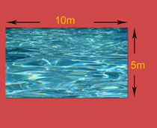](http://www.educationquizzes.com/library/KS3-Maths/Pythagoras-diagram-02-C.jpg)