[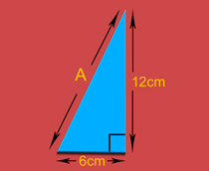](http://www.educationquizzes.com/library/KS3-Maths/Pythagoras-triangle-06-C.jpg)