121/2 MATHEMATICS ALT.A 2012 MARKING SCHEME

BUNGOMA JOINT INTER-SCHOOLS EVALUATION TEST.

|  |  |  |  |  |  |
| --- | --- | --- | --- | --- | --- |
| ***No.*** | ***SOLUTION*** | | |  | ***COMMENTS*** |
| 1. | New total marks 40x42.5=1700  Total marks 40x41=1640  60  Total ratio 10  Cheloti 6x3=18marks  Chobola6x2=12marks  6 marks | | | M1        M1    A1 | √ attempt to find the difference    Total marks added 60  Different ratio between  3 -2=1  10≡60  1⇒6*marks* M1A1 |
|  |  | | | 3 |  |
| 2. | *p* =−6  *s* = 1  2*x*2 +3*x* −2*x* −3 = *x*(2*x* +3)−(2*x* +3)    *x* −1  =  2*x* −3 | | | M1  M1  A1 | √fact of numeration  √fact of denomination |
|  |  |  |  | 3 |  |
| 3. | *No*.  2347  0.4666 2  0.0924 | *Log*  3.3705  −  2*x*1.6689  −  1.  2.  −  *x* 2.9657  −  3 +1.9657  >  3 ⇐ 3.  1,130 | 2.7083  −  1.6552 −  0531  .1 = 1.1301 *x*103 | M1  M1    M1      A1 | If calculators used follow thro  √All logs.  √x2 and √÷3    √ + 8-      1,130.1 |
|  |  |  | | 4 |  |
| 4. | a) Let Kamau be x  Ondiek be 2x  Simiyu be 6x | | | M1 |  |

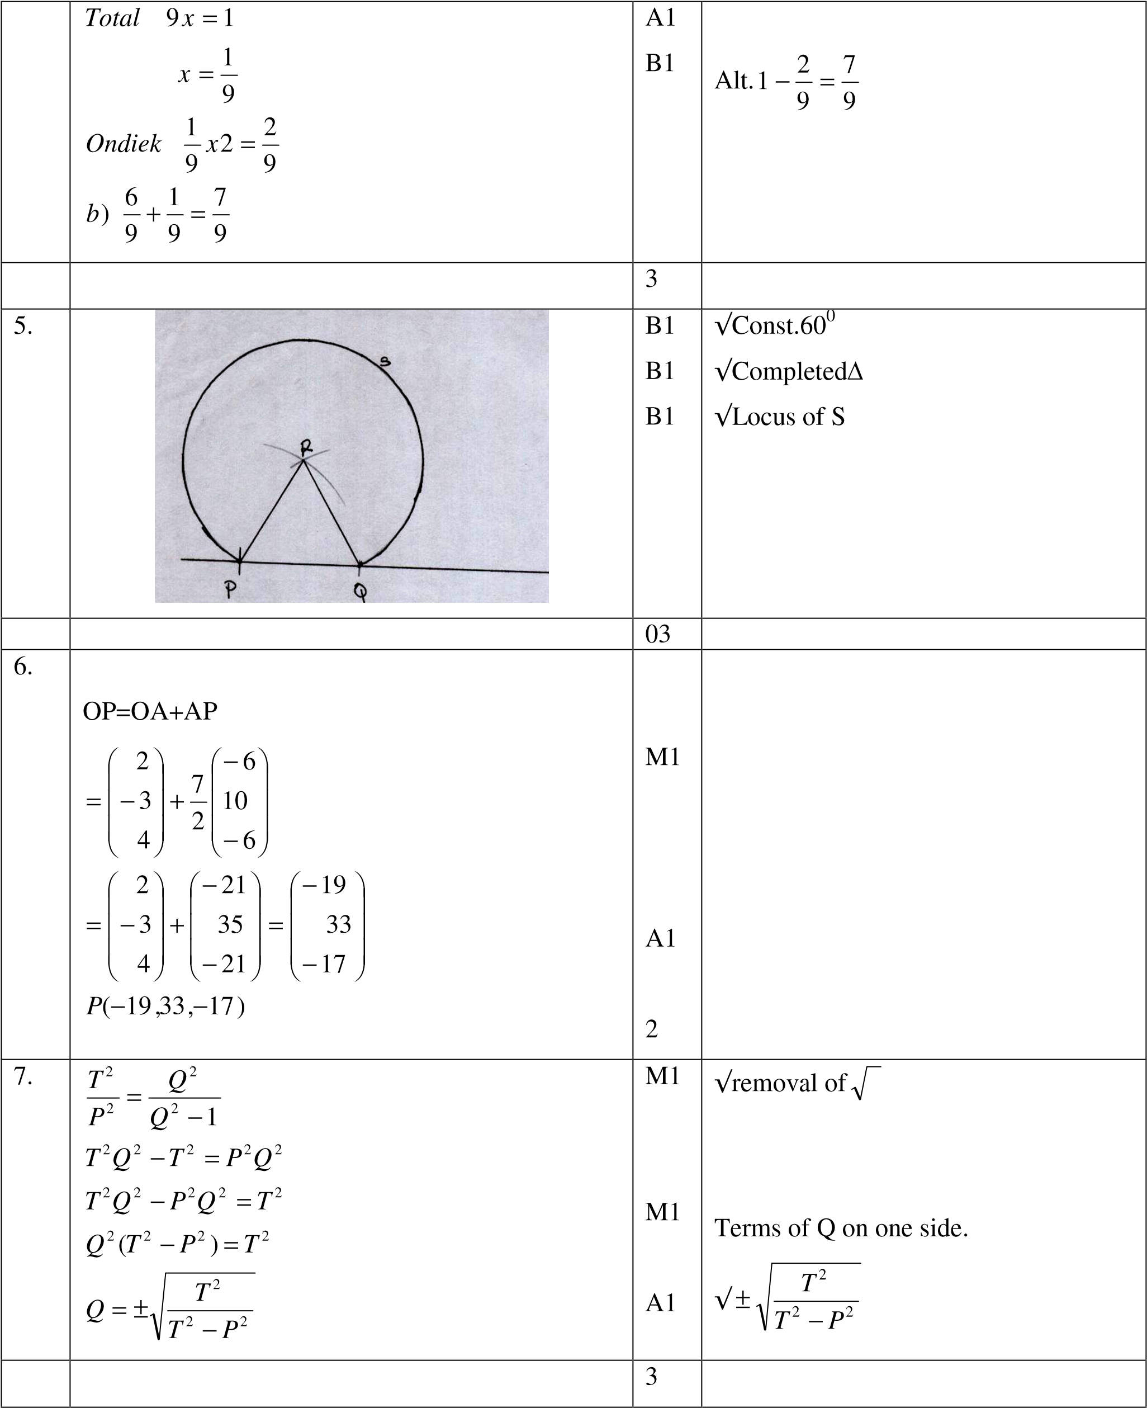

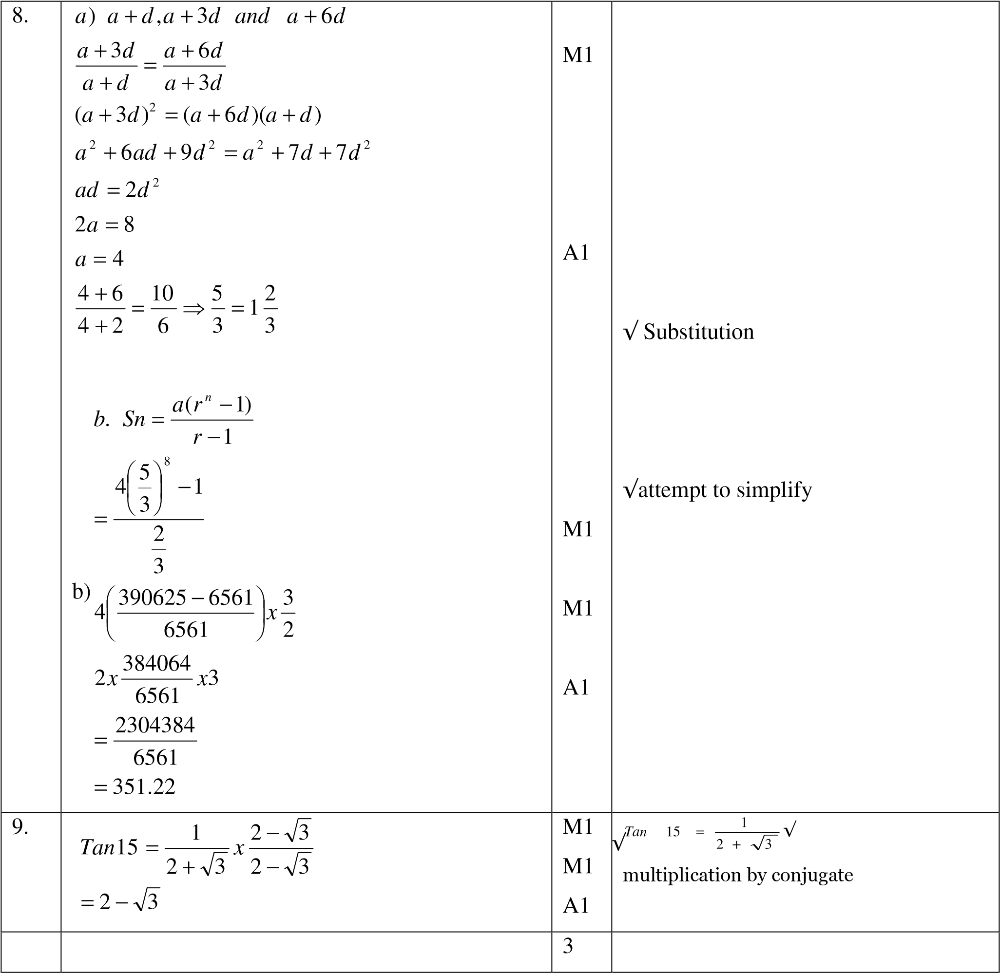

|  |  |  |  |  |  |
| --- | --- | --- | --- | --- | --- |
| 10. |  *x* 7 − *x* 0−   1. 1 −  = 3      3  7*x* 7*x*2  = 1 − +   * 1. 3   *x*   1. 1 − = 0.99   3  *x*  − =−0.01   * 1. *x* = 0.03   1 −+  = 1 −0.07 + 0.0021  = 1.0021 | *x* 1−  3   | *x* 2  3  | B1        M1        A1 |  |
|  |  |  |  | 3 |  |
| 11. | Length x+10  Width x  Area x(x+10)=7200  *x*2 +10*x*−7200 = 0 *x*2 + 90*x*−80*x*−7200 = 0  *x*(*x*+ 90)−80(*x*+ 90) = 0    (*x*−80)(*x*+ 90) = 0  ∴*x*−80 = 0 *x* = 80 | |  | M1  M1    M1    A1 | X=80 discriminated. |
|  |  | |  | 4 |  |
| 12. | x(x-1)-0 = 0 x (x-1) = 0 x= 0 or x = 1 | |  | M1  M1  A1 | √det =0  √ attempts to solve.  √ both values of x . |

|  |  |  |  |
| --- | --- | --- | --- |
| 13. | *x*3.5*x*3.5*x*500*cm*3 / sec  = 19250 *cm*3 / sec  19250 *cm*3 = 1sec .    ∴550 *x*300 *x*210*cm*3 =  = 1800 sec  = 30min *utes*  6.30*pm* | M1      M1    A1  B1 | √exp    √exp.    √ time deviation |
|  |  | 4 |  |
| 14. | 10(1 − *Sin*2*x*)+ *Sinx* +1 = 0  10 −10*Sin*2*x* + *Sinx* +1 = 0  −10*Sin*2*x* + *Sinx* +11 = 0 *p* =−110  *s* = 1  −10*Sin*2*x* +11*Sinx* −10*Sinx* +11  *Sinx*(−10*Sinx* +11)+1(−10*Sinx* +11)= 0  (*Sinx* +1)((−10 sin+11)= 0  *Sinx* +1 = 0 *Sinx* =−1 *x* = 270 0 | M1        M1    A1 |  |
|  |  | 3 |  |
| 15. | *A*α*ts*2*d*  *A*1α1.05*tx*(2*s*)2 *x*0.6*d*  α1.05*x*4*x*0.6*ts*2*d*    *A*1α4.20*x*0.6*A*  2.52*A*  2.52*x*100 = 2.52% | M1    M1  A1 | √exp. for % |
| 16. | *dy*  =2*x*−3  *dx*  2−3=−1 | M1  A1 | *dy*  √ *dx* |
| 17. | a) Total monthly taxable income  =45,000+20480  =Ksh 65,480  17,400 *x*=*Ksh* 1740    17,200 *x*=*ksh*2580 | M1        M1 |  |

|  |  |  |  |
| --- | --- | --- | --- |
|  | 17200 *x*= *Ksh*3440  *Ksh*3470  5  =    (65,480 −51,800)*x*  20 *Ksh*11,230   1. Ksh 11,230-1162   =10,068  Net income 65,480-10,068  =Ksh45,412   1. 65480 ×= *ksh*98,220     = *Ksh*20,826  *Net income tax* = 20,826 −1162 *Ksh* = 19,664  *Increase*  % | M1  A1    M1    A1  M1      M1    M1    A1 |  |
|  |  | 10 |  |
| 18 | 1. A(400N,300W) B(400N,300E   C(400S,300E) D(400S,300W   1. *x*2*x*3.142*x*6371*Cos*400*km* = 5111.48  *x*2*x*3.142*x*6371*km*   = 8896.75  *x*2*x*3.142*x*6371*Cos*40*km*  5111.48  *x*2*x*3.142*x*6371*km*  = 8896.75  *Total dis* tan*ce* = 28016.46*km* | B1  B1    M1    M1    M1    M1  A1  M1    M1    A1 | √any two √any two |

|  |  |  |  |  |
| --- | --- | --- | --- | --- |
|  | *c*) *hrs*  = 7*hrs*6min  = 4*hrs*  Local time at B 11hrs 6mins+8am  =7.06pm | |  |  |
|  |  | | 10 |  |
| 19. | x f c.f d t ft 15 2 2 -40 -4 -8  25 5 7 -30 -3 -15  35 9 16 -20 -2 -18  45 17 33 -10 -1 -17  55 22 55 0 0 0  65 15 70 10 1 15  75 8 78 20 2 16  85 2 80 30 3 06  −  *Mean* = 55 +  i)  *ii*)  b)  *c*) *i*) = 0.4  0.4*x*80 = 32  4 *th decile* = 50 *ii*) 15 *th*  85 *th*  *x*80 = 12 ⇒ 36  *x*50 = 68 *from* 36 *to* 68 | ∑ft=-21 | M1  M1  A1  M1  A1    S1  P1  C1    B1      B1 | If fx, fd  Follow through                √ft or equivalent  Accept 52.38 |

|  |  |  |  |
| --- | --- | --- | --- |
|  |  |  |  |
| 20. | a) x 0 15 30 45 60 75 90 105 120 135  150 105 180  3x-30 -30 15 60 75 150 195 240 285 330 375  420 465 510  Sinx 0 0.26 0.5 0.71 0.87 0.97 1 0.97 0.87  0.71 0.5 0.26 0  2sin(3x-30)-1 0.52 1.73 1.93 1 -0.52 -1.73 -1.93 -1 0.52 1.73 1.931  b)         1. Streach parallel to y-axis scale for 2 streach parallel to x-axis sf- 1/3   30  translationvactor   0    1. 750,124.50 | B2          S1 P1  P1  C1  C1    B2      B1 | B1 √Sin x  B1√2sin(3x-30)                  √ sin x  √2sin(3x-30)  √sin x  √2sin (3x-30) |

|  |  |  |  |
| --- | --- | --- | --- |
| 21. | *x* 2  *a*) =  4.5+ *x* 3 3*x* = 9 + 2*x x* = 9  62 + 62 = 72 = 6 2  *height of original pyramid*  2  = 13.52 −(3 2)  = 182.25 −18  = 164.25 =12.82  *Volume of frustrum* =108.3*cm*3  3 2 4.243  *b*) *i*)*Cos*θ= = = 0.3143  13.5 13.5 θ= 71.720  *ii*)*Tan*θ= == 4.273  3  .25  164  θ= 76.83 | M1    M1    M1    M1  M1  A1  M1        A1    M1    A1 | √    √ exp. For ½ diagonal follow thro |
|  |  | 10 |  |

|  |  |  |  |
| --- | --- | --- | --- |
| 22 | a)            )  +  *x*  *x*  *x*  *x*  *b*  3  2    B    1  /  10    1  /  5    R    L    R    L    10  /  3    4  /  10    /  6  10    10  7  /    6  /  10    C  1    3  1  G    9  /10  4  /5  /10  7  /10  3  /10  4  C  C  C  1    C  C  1    C  1    C    1 1 6 2 1 6  3 10 10 3 5 10  6 12 5  + =  300 150 50  =  1 9 3 1 1 4 2 4 3 2 1 4  *c*) *x x* + *x x* + *x x* + *x x*  3 10 10 3 10 10 3 5 10 3 5 10  27 4 24 8  + + +  =  =  1 9 7 2 4 7  *d*) *x x* + *x x*  3 10 10 3 5 10  27 56 112  = + =  = | B2        M1    A1    M1    M1    A1    M1  M1    A1 | B1 √  B2 √tree and values                  √exp. (all)    √ attempt to simplify |
| 23. | 1. <TCD=380 2. <ACS=<ADC < in alt. seg.   < subt.dia is 900  900-380 equal 520  c)<BCA=  =<ABC=180-52=1280  <*BCA*== 260   1. <BCS=260   *AC*   1. *Cos*380 =   20 | B1    M1    A1  M1  A1  B1  A1  M1 | 90-380 |
|  | AC=20 Cos380=15.76cm.  1  *AC*  *f* ) *Cos*26 = 2 = 7.88  *BC BC*  *BC* *cm* | A1    M1    A1 |  |
|  |  | 10 |  |
| 24. | *a*) *x* + *y* ≤10  52*x* + 28*y* ≥ 364  13*x* + 7*y* ≥ 91 *x* > 0  *y* > 0  *b*)  *c*)25000*x* + 20,000*y* =100000  5*x* + 4*y* = 20  *Max* 9 *type x*  1 *type y* max*imum income* = 9*x*25,000 + 20,000 = 245,000 | B1    B1      B1  B1  M1  A1    B1  B1  B1      B1 | *x*+ *y* ≤10    13*x*+7*y* ≥91    √ line drawn 5x+4y=20 or equivalent  9 type x and 1 type y √Subst.        √ *x*+ *y* ≤10  √13*x*+7*y* ≤91 **drawn**  **x>0 unshaded y>0**    **drawn or implied by inspection** |