THE KENYA NATIONAL EXAMINATIONS COUNCIL

KCPE 2000

ENGLISH

SECTION B: COMPOSITION

READ THESE INSTRUCTIONS CAREFULLY

1. In the spaces provided, above write your full Index Number, your Name and the Name of the School,
2 now open this paper, read the composition subject carefully and write your composition on the lines provided

You have 40 minutes, to write your Composition

The following is the beginning of a story, Write and complete the story. Make your’ story as interesting as you can

My best friend is a very finny person who really makes people laugh. One day…….

KCPE 2000
ENGLISH
SECTION A: LANGUAGE

Questions 1 to 15

Read the passage below. ti contains blank spaces numbered 1to 15. For each blank space, choose the best answer from the choices given.

The inter-class public speaking contest had started. I was representing my class and it was __1__ my turn to spealc I was a little__2__ but I knew that even experienced public speakers feel their hearts__3___ faster when about to face
their ___4___ My courage rose as I made my way __5__ the front of the classroom. I was __6____ for moment to make sure ___7__ my opening sentence. Then, looking into the faces of my__8___ pupils, I slowly ___9___my
speech. There was loud clapping as soon as I finished speaking. My teacher ___10____ my effort highly __11___it was really my father’s __12____ which had helped me to win the contest The __13__.my father __14__ me that careful preparation and courage were the __15___ important factors in public speaking.

1 .A. now | B. just | C. still D. really
2. A. shocked | B. excited | C. nervous D curious
3,A beat | B. beats | C.bit D. bits
4. A. fans | B. spectators | C. audience D opponents
5. A. across | B. towards | C at D for
6. A .quiet | B. calm | C. frightened D restless
7. A, over | B, on | C. with D of
8. A. follow | B. dear | C other D close
9. A. discussed | B. narrated | C. presented 0. explained
10 A. congratulated | B. praised | C. cheered D honoured
11. A, end | B. because | C. since D. but
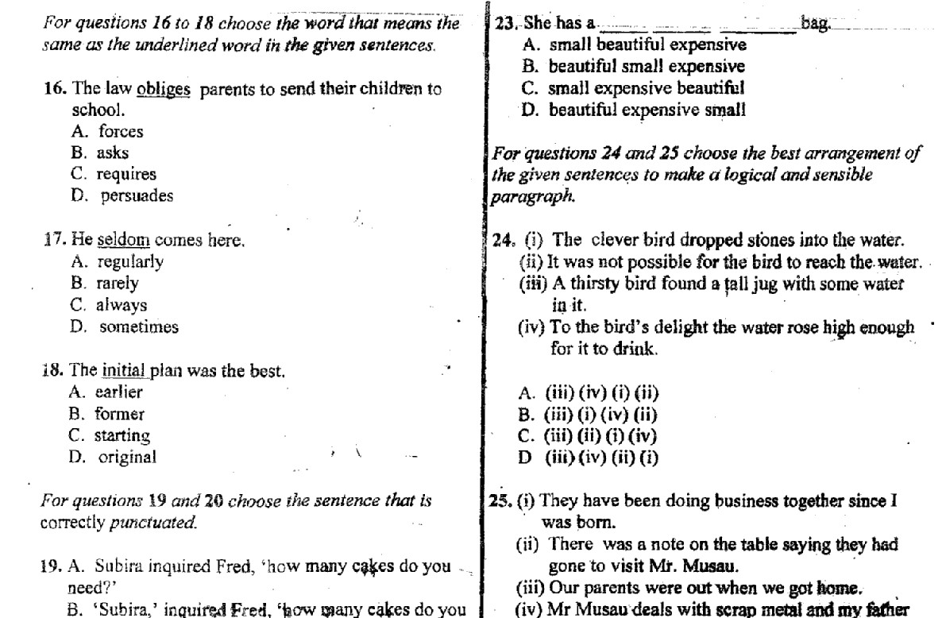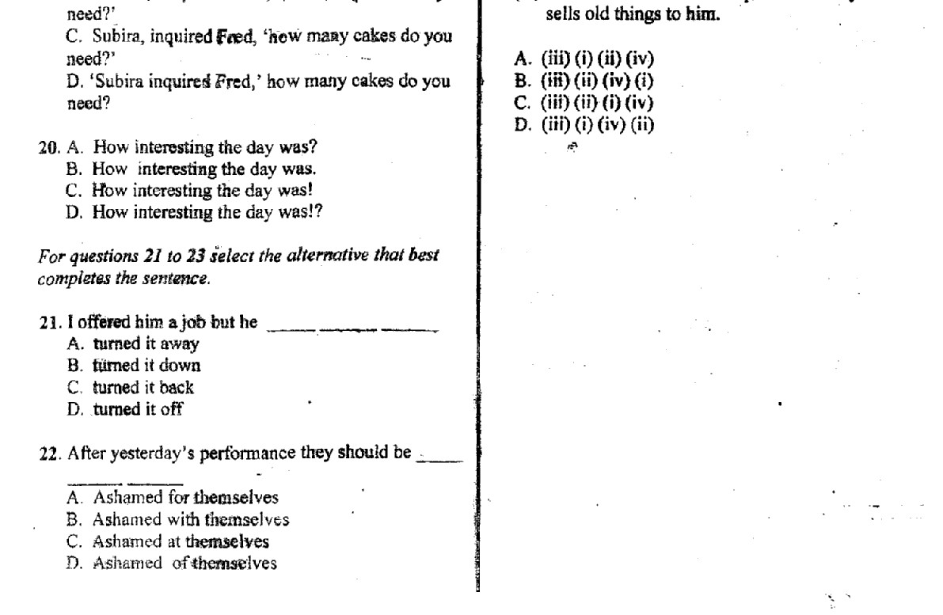
12
. A, thoughts
B. plan
C. opinion
D. advice

