INTRODUCTION TO AGRICULTURE
K.C.S.E PAST PAPER 1
Oct./Nov. 2010
SECTION A (30 marks)

Answer all the questions in this section in the spaces provided

1. Give two disadvantages of intensive system of farming. (1mk)

2. List four methods of farming. (2mks)

3. Give the meaning of the following terms:
a) nitrogen fixation into the soil; (1mk)
b) phosphorus fixation in loss of soil fertility. (1mk)

4. Give four reasons for keeping livestock health records on the farm. (2mks)

5. Explain the relationship between scarcity and choice as used in agricultural economics. (2mks)

6. Sate two reasons for land fragmentation in Kenya. (1mk)

7. Give four advantages of individual owner operator tenure system as practiced in Kenya. (2mks)

8. Sate four features that should be considered when choosing water pipes for use on the farm. (2mks)

9. Give four reasons for treating water for use on the farm. (2mks)

10. Name four statutory boards that are involved in the marketing of crop produce in Kenya. (2mks)

11. State four marketing functions of Kenya Co-operative Creameries 9K.C.C.). (2mks)

12. Give two reasons for carrying out each of the following operations in land preparation:
a) rolling; (1mk)
b) leveling. (1mk)

13. Name three recommended practices that should be carried out when clearing the bush during land preparation. (1^{1/2} mks)

14. State five advantages of zero grazing. (2^{1/2} marks)

15. Give four factors that would determine the stage at which a crop is harvested. (2mks)

16. Name two classes of weeds on the basis of each of the following:
a) growth cycle; (1mk)
b) plant morphology. (1mk)

SECTION B (20 marks)

Answer all the questions in this section in the spaces provided.

17. Below is a diagram of a weed. Study the diagram carefully and answer the questions that follow.
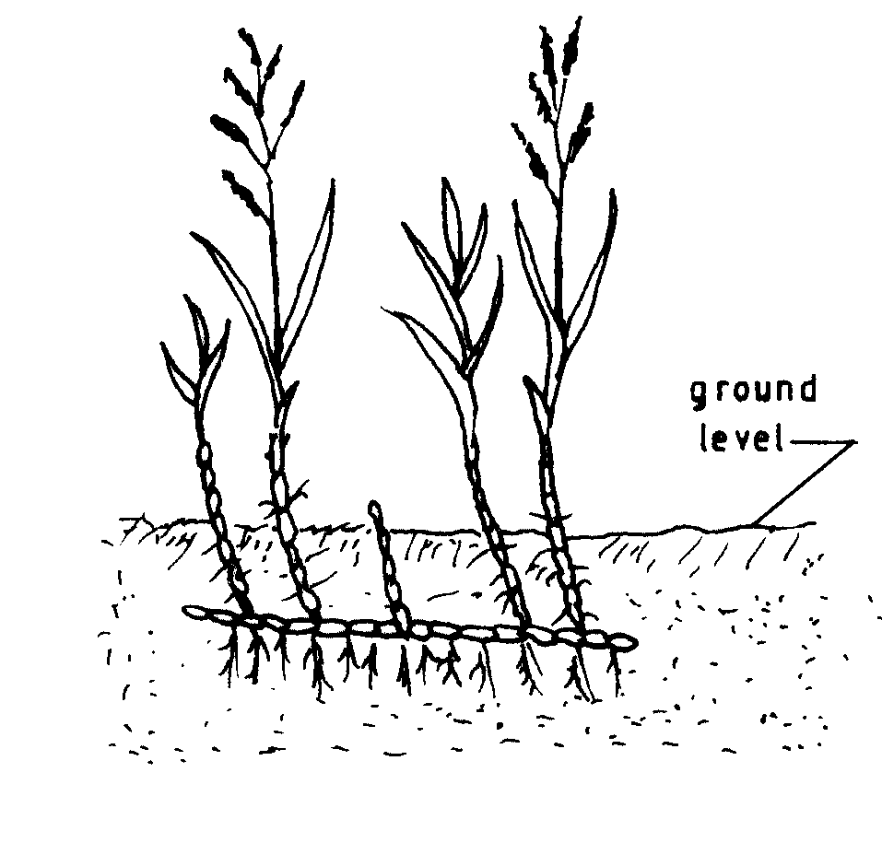
a) Identify the weed illustrated above. (1/2mk)
b) Why is the weed illustrated above difficult to control? (1mk)
c) State four ways in which the weed can be controlled in a field of maize.
(2mks)

18. The table below shows pH values of different soil samples. Study it and answer the questions that follow.

Soil sample  S₁  S₂  S₃  S₄  S₅  S₆  S₇  S₈ | pH value  3  4  5  6  7  8  9  10

a) Which soil sample has the highest acidity? (1/2mks)
b) State two ways in which the pH value of sample S₈ can be lowered.
(1mk)
c) Which of the above soil samples is suitable for growing tea? (1/2mk)

19. Explain how agroforestry tree seeds should be prepared after collection in readiness for planting. (4mks)

20. a) The diagrams below represent two ways in which a crop was pruned. Study them carefully and answer the questions that follow.

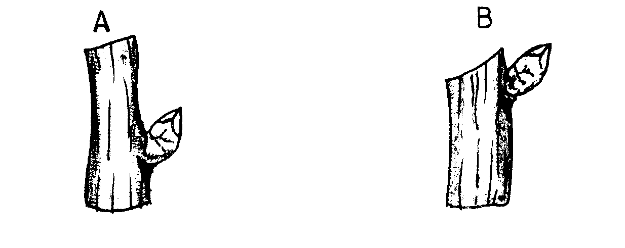

i) Which diagram represents the correct way of pruning? (1/2mks)
ii) Give a reason for your answer in (i) above. (1mk)

b) State two ways in which pruning assists in controlling crop diseases. (1mk)

21. On 1st January 2009, Kaburu Farm started farm operations with Ksh 30,000 cash. During the month, the farm made the following transactions. Study the transactions and prepare a cash analysis for Kaburu Farm for the month of January. (5^{1/2} mks)

Date Transaction Amount (Ksh)
05/0109 Livestock sales 80,000
08/01/09 Crop sales 50,000
15/01/09 Bought seed for planting 7,000
20/01/09 Paid K.F.A. for fertilizer 16,400
25/01/09 Bought livestock feeds 50,000
30/01/09 Paid wages for planting & weeding 56,000
31/01/09 Received cash from K.C.C for milk
delivery 120,000
31/01/09 Paid transport charges for milk
delivery 9,000

22. a) What do the figures 18:46:10 on a fertilizer bag represent? (1½ mks)

b) Calculate the quantity of filler materials in the fertilizer in (a) above.
(1mk)

SECTION C (40 marks)

Answer any two questions in this section in the spaces provided after question 25.

23. a) Explain eight factors that can encourage soil erosion. (8 mks)

b) Describe the seven management practices that should be carried out on a vegetable nursery after sowing seeds until the seedlings are ready for transplanting. (7 mks)

c) State five soil factors that should be considered when selecting a crop to grow in an area. (5mks)

24. a) Outline five ways in which high temperature affects agricultural production in Kenya. (5mks)

b) i) Explain four presentations that should be observed when harvesting cotton. (4mks)
ii) Describe the harvesting of sugar cane. (3mks)

c) Explain eight factors that should be considered when planning to set up a farm business. (8mks)

25. a) Explain six physical methods that can be used to control crop pests on the farm. (6mks)

b) Describe the production of bulb onions under the following sub-headings:
i) field management; (4mks)
ii) harvesting. (3mks)

c) Explain seven factors that influence seed rates in crop production.
(7mks)

AGRICULTURE 443/2
PAPER 2
Oct./Nov. 2010
SECTION A (30 marks)

Answer all the questions in this section in the spaces provided.

1. Name causal agent of anaplasmosis disease in cattle. (½ mks)

2. List four materials that can be used in constructing a Kenya Top Bar Hive. (2mks)

3. a) Name two breeds of dairy cattle that originated from the Channel Islands.
(1mk)
b) Give the distinguishing colour for each of the following breeds of livestock:
i) chinchilla rabbit; ( ½ marks)
ii) toggenburg goat. ( ½ mks)

4. State four reasons for castration in pig production. (2mks)

5. State four characteristics of roughage livestock feeds. (2mks)

6. State two functions of the crop in poultry digestive system. (1mk)

7. State four roles of worker bees in a colony. (2mks)

8. Give four reasons for controlling livestock diseases. (2mks)

9. State two control measures for fowl pox disease in poultry. (1mk)

10. State one function for each of the following:
a) shovel ( ½ mark)

b) strip cup ( ½ mk)

11. Give three reasons for carrying out maintenance practices on a mower. (1½ mks)

12. Give three limitations of using solar power on the farm. (1½ mks)

13. Why is it important to have a thermostat on a cooling system of a tractor engine?
(1mk)

14. Give two advantages of using a disc plough over a mouldboard plough in primary cultivation. (1mk)

15. Name four tools that are used when laying concrete blocks during construction of a wall. (2mks)

16. Why is it necessary to have guard rails in a farrowing pen? (1mk)

17. Give two reasons for having a footbath in a cattle dip. (1mk)

18. Distinguish between the following practices as used in livestock production:
a) crutching and ringing in sheep management (2mks)

b) cropping and harvesting in fish farming. (2mks)

19. Give three ways in which infectious diseases can spread from one livestock to another within a farm. (1½ mks)

SECTION B (20 marks)

Answer all the questions in this section in the spaces provided.

20. The following illustrations show the behavior of chicks in a brooder. Study them carefully and answer the questions that follow.
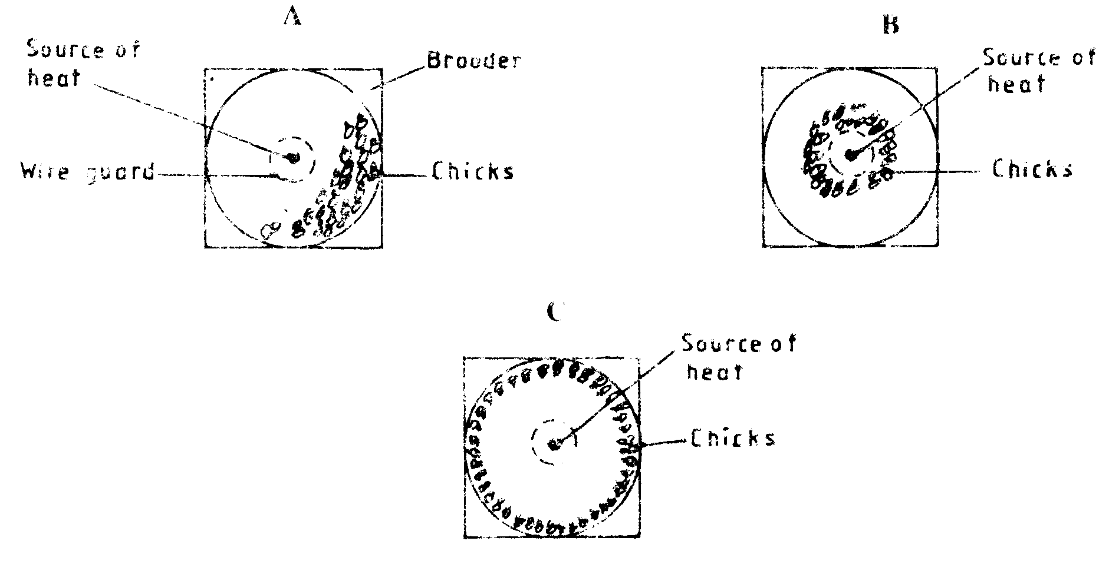insert diagram)

a) Explain the cause of behavior observed in chicks for each of the illustrations labeled A, B and C. (3mks)

b) Give a reason for making the brooder wall round in shape. (1mk)

21. The diagram below shows the reproductive system of a cow. Study it carefully and answer the questions that follow.

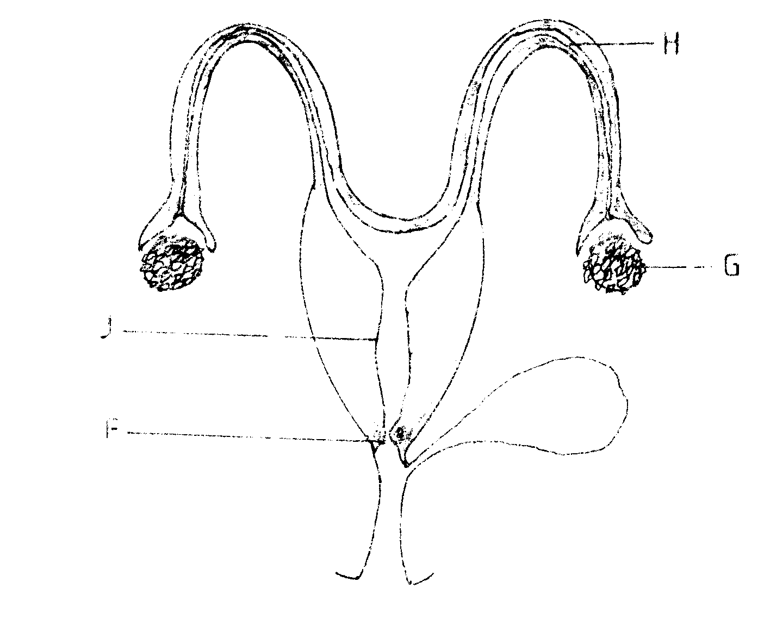
a) Name the parts labeled F and H. (1mk)

b) Give two functions of the part labeled G. (2mks)

c) Give the role of the part labeled J. (1mk)

22. Below are diagrams of internal parasites. Study them carefully and answer the questions that follow.
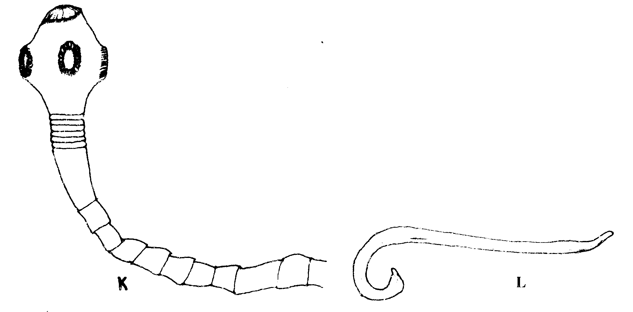
a) Identify the parasites labeled K and L. (1mk)

b) Name the developmental stage of the parasite labeled K in cattle muscles.
( ½ mark)

c) Outline the procedure of handling a heifer when administering a liquid deworming drug to control the parasites illustrated above. (2½ mks)

23. Below is a diagram of a farm structure for storing grains. Study it carefully and answer the questions that follow:

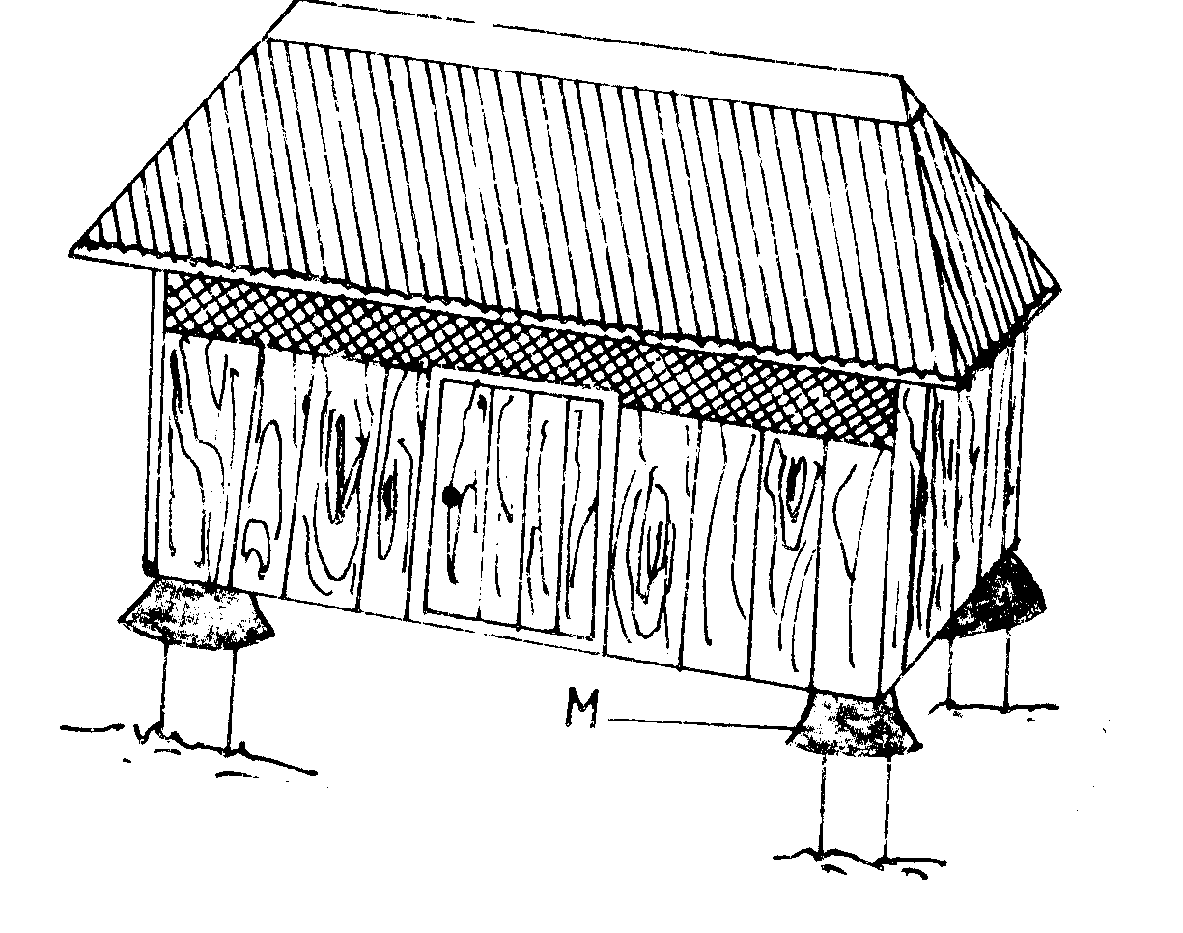
a) Identify the farm structure illustrated above. (½ mark)

b) State the function of the part labeled M. (½ mk)

c) State two maintenance practices that should be carried out on the farm structure illustrated above in readiness for grain storage. (1mk)

24. Below is a diagram of a knapsack sprayer. Study it carefully and answer the questions that follow:

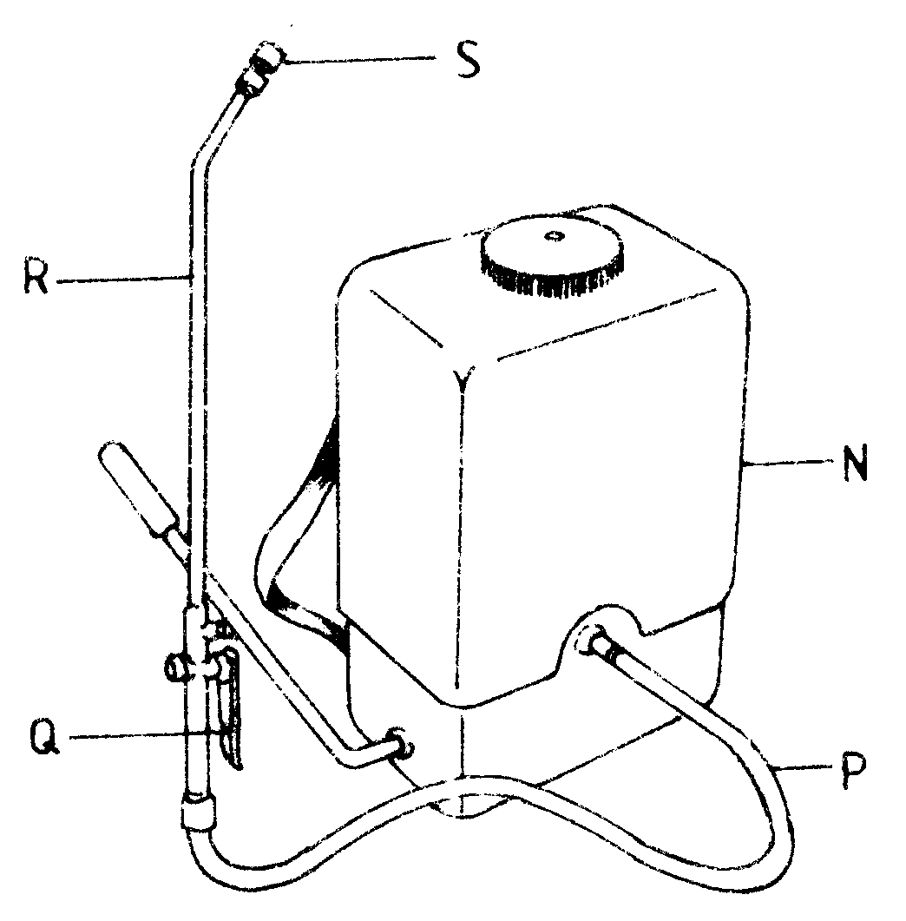
a) Name the parts labeled N, P, Q and R. (2mks)

b) State one function of the part labeled S. (1mk)

25. The diagram below illustrates the general shape of a cattle breed. Study it carefully and answer the questions that follow:

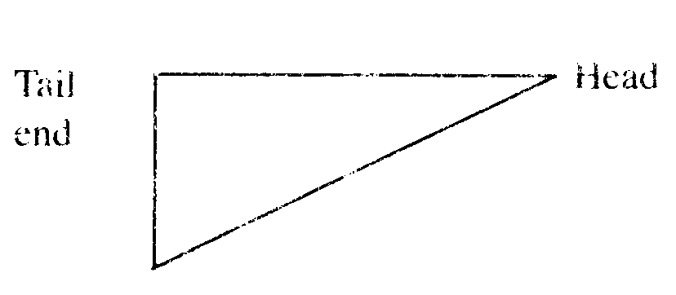

a) Identify the type of breed illustrated by the above shape. (½ mk)

b) Give an example of a breed in (a) above. (½ mk)

c) State four physical characteristics of the type of breed identified in (a) above. (2mks)

SECTION C (40 marks)

Answer any two questions from this section in the spaces provided after question 28.

26. a) Outline five advantages of artificial insemination in cattle management.
(5mks)

b) Describe ten signs of trypanosomiasis (Nagana) disease in livestock.
(10mks)

c) Explain five functions of water in nutrition. (5mks)

27. a) State the function of any six parts of a zero grazing unit in dairy farming.
(6mks)

b) Explain how the power transmitted from a tractor engine is made available for use on the farm under the following subheadings:
i) propeller shaft (2mks)
ii) power take off (P.T.O.) shaft (2mks)
iii) hydraulic system. (2mks)

c) Explain eight ways in which ticks can be controlled on a livestock farm.
(8mks)

28. a) Describe ten physical characteristics a poultry farmer would use to identify poor layers from a flock of hens. (10mks)

b) i) Outline three characteristics of clean milk. (3mks)
ii) Explain seven factors that affect milk composition in dairy farming. (7mks)

2011
THE KENYA NATIONAL EXAMINATIONS COUNCIL
Kenya Certificate of Secondary Education
AGRICULTURE Paper 1
2 hours
SECTION A (30 marks)
Answer all the questions in this section in the spaces provided.
1 (a) Name two field management practices that are carried out to obtain optimum plant
population in a crop field. (1 mark)
(b) Explain how each of the practices named in (a) above achieves optimum plant
population. (1 mark)
2. Give two examples for each of the following types of costs incurred in broiler production.
(a) variable costs; (1 mark)
(b) fixed costs. (1 mark)
State four disadvantages of mono cropping in crop production. (2 marks)

Give three reasons for early seedbed preparation. (1 ^{1/}₂ marks)
State two ways in which crop rotation controls weeds. (1 mark)
Outline four qualities of a mother plant from which vegetative propagation materials should be
obtained. (2 marks)
7 Give three factors that should be considered when choosing the type of labour to use on the
farm. (l¹/₂ marks)
8 State the use of each of the following in farm accounting:
(a) balance sheet; (¹/2 mark)

(b) inventory; (¹/2 mark)
(c) cash book. (16 mark)
9 State four functions of Agricultural Society of Kenya (A.S.K.). (2 marks)
10 How does leaching lead to loss of soil fertility? (¹/2 mark)
11 Give two reasons for imposing quarantine on imported planting materials. (1 mark)
12 State four ways of controlling bean anthracnose disease.

13 List four post-harvest practices that are carried out in maize production. (2 marks)
14 Name two types of non-competitive markets. (1 mark)
15 Name four settlement schemes that the Kenyan government started as a result of the success of
the Million Acre Scheme. (2 marks)
16 Give a weed for each case, which has the following effect on cattle:
(a) Poisoning; (¹/2 mark)
(b) Tainting milk when eaten before milking. (¹/2 mark)

17 Apart from training and extension services, state four other agricultural support services
the Kenyan government provides to a maize farmer. (2 marks)
18 State three methods of harvesting trees in agroforestry. (¹/₂ marks)

19 Give three maintenance practices for trees in agroforestry. (¹/₂ marks)

SECTION B (20 marks)
Answer all the questions in this section in the spaces provided,
20. The diagram below illustrates a seed potato prepared for planting. Study it carefully and answer the questions that follow:
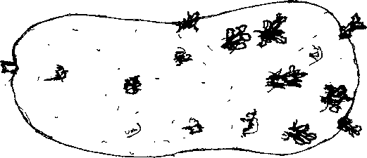
(a) Name the practice used in preparing the seed potato above for planting. (1 mark)
(b) Describe the procedure followed in preparing seed potatoes for planting. (3 marks)

21 The diagrams below show a set up of an experiment to study an aspect of soil. The set up was left undisturbed for five hours. Study it and answer the questions that follow.

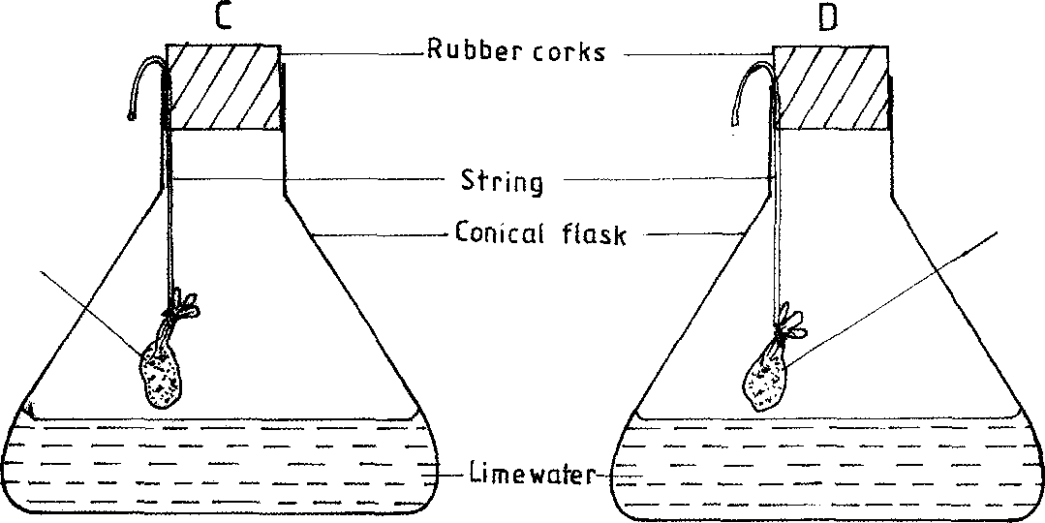
Strongly heated garden soil
inmuslin bag
Fresh garden soil in muslin bag

(1 mark)
(a) What was the aim of the experiment?
(b) State one observation that was made in each of the flasks labelled C and D.
C....................................................................................................................... 1/2 mark)
D....................................................................................................................... 1/2 mark)
(c) Give a reason for each of your answers in (b) above.
C....................................................................................................................... (1 mark)
D....................................................................................................................... (1mark)

22 Below is a graphical representation of a law in agricultural economics. Study the graph carefully and answer the questions that follow:

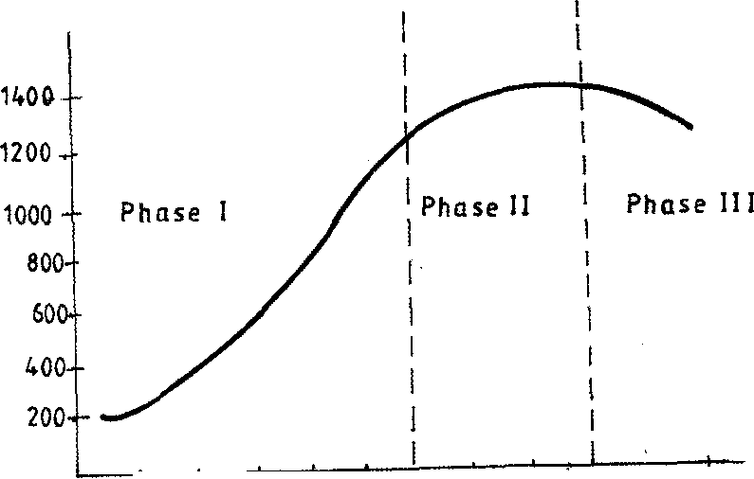
Total Output o f maize(90 kg bags I
20 20 40 60 ⁸⁰ ¹⁰°
Fertilizer Input [ 50kg bags)

(a) Identify the law illustrated by the graph.
(b) Explain how each additional unit of fertilizer input relates to the total output of maize in phases II and III.
Phase II................................................................................................................. (1 mark)
Phase III................................................................................................................ (1 mark)

(c) State the importance of the law identified in (i) above to the maize farmer. (1 mark)

23 The following information was extracted from Makueni Farm Records for the financial year ending on 30th June 2009. Study it and prepare a profit and loss account for the farm.
(3 marks)
• Rent received Sh. 10,000
• Egg sale Sh. 60,000
• Repair of tractor Sh. 30,000
• Opening valuation Sh. 80,000
• Interest on Bank loan Sh. 20,000
• Tax paid Sh. 40,000
• Closing valuation Sh. 90,000
• Purchase of farm inputs Sh. 90,000
• Debts receivable from fanners co-op society Sh. 100,000
• Maize sales Sh. 55,000

24 The diagram below illustrates a grazing system. Study it carefully and answer the questions that followfollow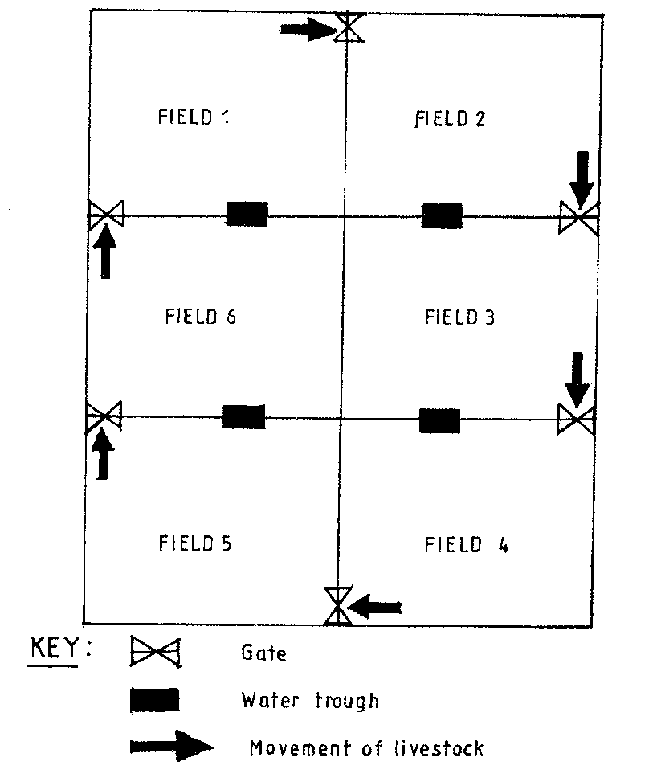
(a) Identify the grazing system illustrated above. (¹/₂ marks)
(b) State five advantages of the grazing system illustrated above. (3 marks)

25 The diagram below is an illustration of a weed. Study it and answer the questions that follow.

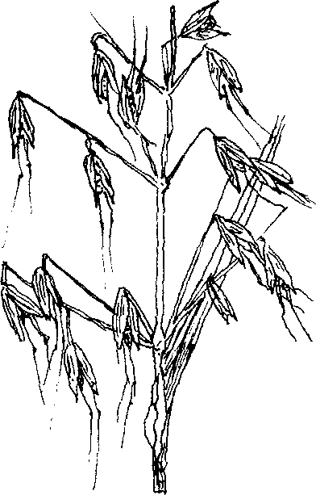

(a) Identify the weed. (¹/₂ marks)

(b) State two harmful effects of the weed illustrated above. (2 marks)
SECTION C (40 marks)
Answer any two questions from this section in the spaces provided after question 28.
26 (a) Describe how water is treated to remove solid impurities. (5 marks)
(b) Give a reason for each of the farm records kept on a dairy farm. (5 marks)
(c) Describe the production of cabbages under the following sub-headings:
(i) seedbed preparation; (3 marks)
(ii) transplanting of seedlings. (7 marks)
27 (a) Describe the effects of pests on maize in the field. (6 marks)
(b) (i) Describe the procedure of harvesting pyrethrum. (4 marks)
(ii) Explain the precautions that should be observed during the harvesting of pyrethrum. (3 marks)
(c) Describe the cultural methods of controlling soil erosion. (7 marks)
28 (a) Explain five ways in which biotic factors influence crop production in agriculture.
(5 marks)
(b) Describe how the stem cuttings for propagating tea are prepared. (9 marks)

(c) Describe the properties of nitrogenous fertilizers.

Agriculture paper 2 2011

SECTION A 30 marks)
Answer all the questions in this section in the spaces provided.

1. State four maintenance practices for a disc plough. (2 marks)

2 Name three methods that are used in selection of breeding stock in livestock production.
(1¹/₂ marks)

3 State four advantages of using animals instead of tractors as a source of power on the farm.
(2 marks)

4 Name one livestock disease that is transmitted by each of the following parasites:

(a) blue ticks; (¹/₂ marks)

(b) brown ear ticks; (¹/₂ marks)

(c) tsetse flies. (¹/₂ marks)

5 State four methods of controlling round worms (Ascaris sp) in livestock.
(2 marks)

6 Give the meaning of the following terms as used in livestock health:

(a) disease; (1 mark)

(b) vaccination. (1 mark)
7 State three maintenance practices for a tractor battery. (1¹/₂ marks)

8 Name the type of breed into which each of the following breeds of cattle are classified:

(a) Aberdeen Angus; (¹/₂ marks)

(b) Guernsey; (¹/₂ marks)

(c) Sahiwal; (¹/₂ marks)

(d) Redpoll. (¹/₂ marks)

9. Give two ways in which proper nutrition helps to control livestock diseases. (1 mark)

10 List four categories of livestock diseases. (2 marks)
11 Name two breeding systems that can increase the frequency of high milk production genes in
indigenous cattle. (1 mark)
12 Name two bloodless methods of castration in lambs. (1 mark)
13 Give the meaning of the following terms as used in livestock breeding:
(a) recessive gene; (1 mark)

(b) epistasis. (1 mark)

14 State four signs that indicate that a doe is about to kindle. (2 marks)

15 Name two developmental stages of a liverfluke (Fasciola sp.) which occur in the fresh water snail (Limnaea sp). (1 mark)

16 Name the strokes in a four stroke cycle engine. (2 marks)

17 State four signs of mite attack in poultry. (2 marks)

18 State three advantages of natural feeding in calf rearing. (1¹/₂ marks)

SECTION B (20 marks)
Answer all the questions in this section in the spaces provided.
19 A dairy farmer is required to prepare 100 kg of dairy meal containing 20% Digestible Crude
Protein (D.C.P.). Using the Pearson's Square Method, calculate the quantity of soya bean (40% D.C.P.) and rice (16% D.C.P.) the farmer requires for the dairy meal. (4 marks

20 Below is an illustration of a camel. Study it and answer the questions that follow.

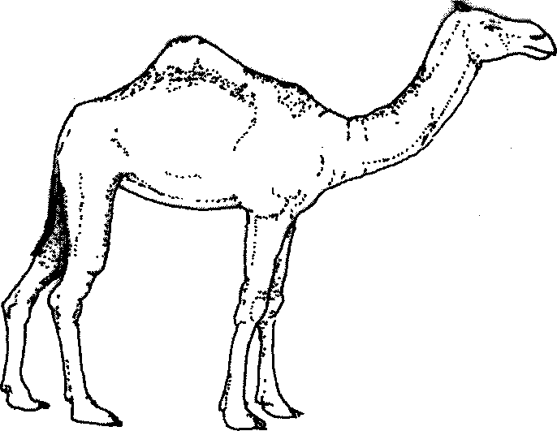

(a) Identify the camel species illustrated above. ( ¹/₂ marks)

(b) Name three products that farmers obtain from the camel species illustrated above.
(1¹/₂ marks)
(c) Give two reasons why the camel species illustrated above is able to survive in its
natural habitat. (2 marks)

21 The diagram below represents farm tools and equipment. Study them and answer the questions that follow.
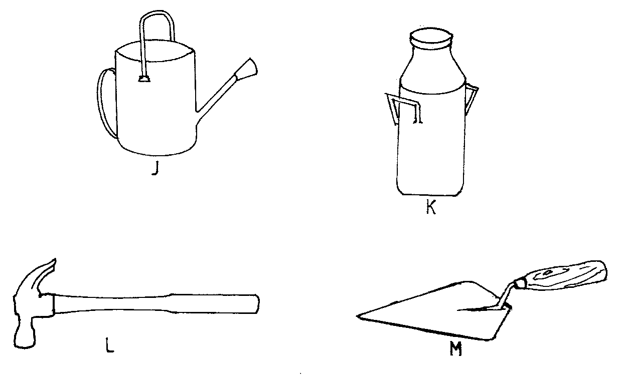

(a) Identify the tool / equipment labelled J, K and M. K.

J (¹/₂ marks)

K (¹/₂ marks)

M (¹/₂ marks)

(b) State one use for each of the tool / equipment labelled K and L.

K (1 mark)

L (1 mark)

(c) Give two maintenance practices for the equipment labelled K. (1 mark)

22 The illustration below shows a practice carried out to prevent mastitis infection in a dairy cow.

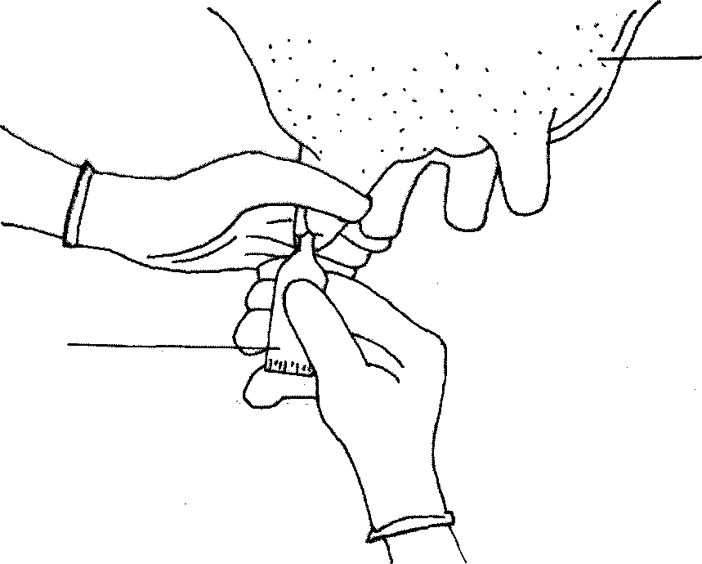
Udder
Syringe

(a) Identify the practice. (1¹/₂ marks)

(b) At what stage is the practice carried out? (1¹/₂ marks)

(c) State two other practices that are carried out on the udder to prevent mastitis infection. (2 marks)

23 The diagram below shows the digestive system of cattle. Study it and answer the questions that follow.
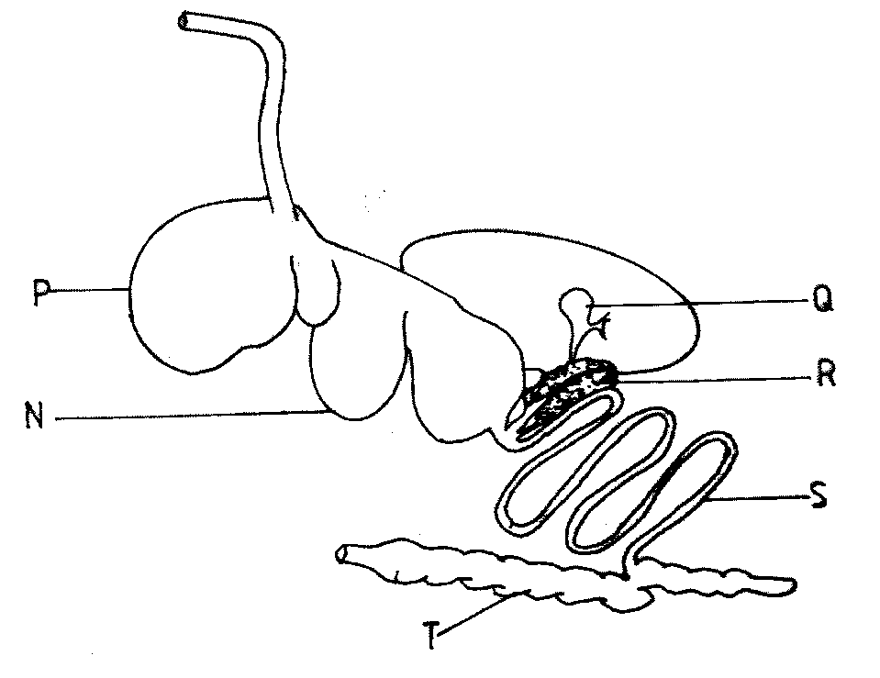

- Name the parts labelled N, P and Q.

N .......................................................................................................................... (¹/₂ marks)

P .......................................................................................................................... (¹/₂ marks)

- State one function for each of the parts labelled S and T.

S....................................................................................................................... (1 mark)
T ......................................................................................................................... (1 mark)

- Give one enzyme produced by each of the parts labelled R and S.

R .......................................................................................................................... (¹/₂ marks)

S ................................................................................................................ (¹/₂ marks)

SECTION C (40 marks)
Answer any two questions from this section in the spaces provided after question 26.

24 (a) Explain the factors considered when culling livestock. (5 marks)

(b) Describe poultry management under the following sub-headings:
(i) causes of stress; (8 marks)

(ii) control measures for cannibalism. (7 mark)

25 (a) Describe the feeding practices in artificial rearing of a dairy calf, (10 mark)

(b) Describe Newcastle disease under the following sub-headings

- causal organism; (1 mark)

(ii) signs of infection; (7 mark)

(iii) control measures. (2 marks)

26. (a) Describe the uses of fences on the farm. (10 marks)

(b) Give five harmful effects of liver flukes in sheep rearing. (5 mark)

(c) State the differences between a diesel engine and a petrol engine. (5 mark)

