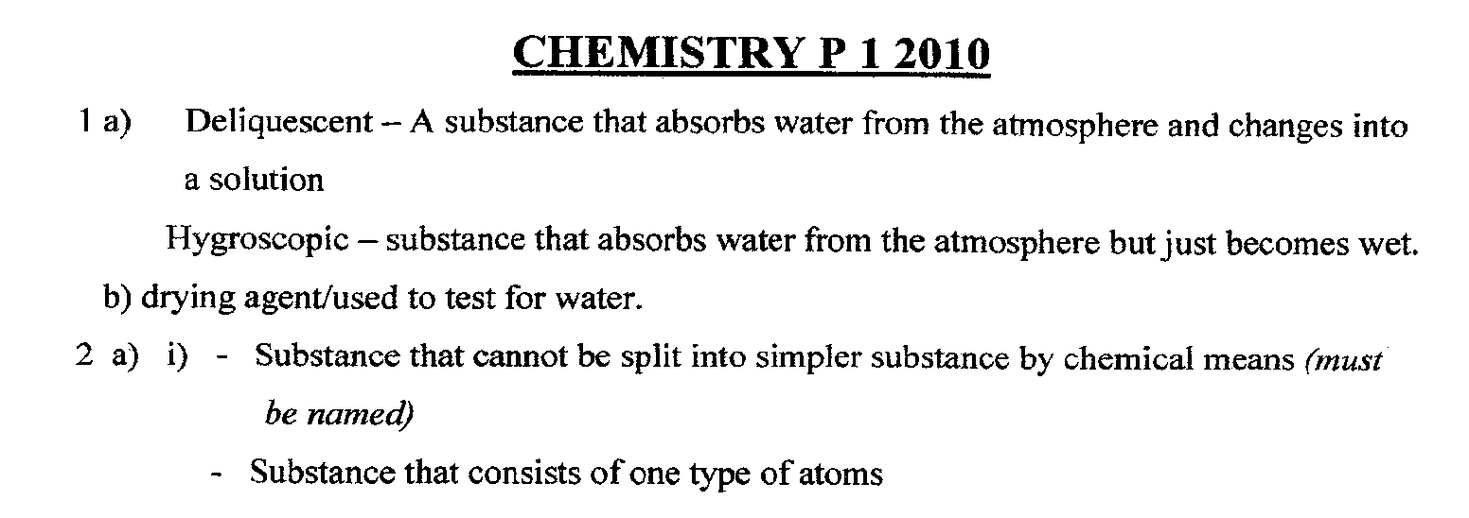
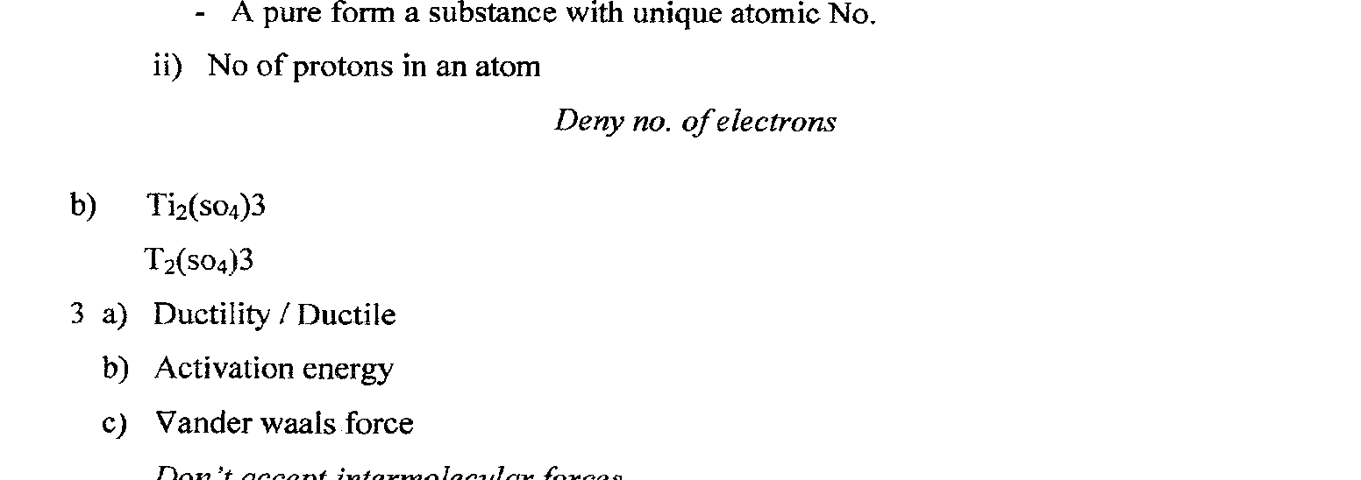
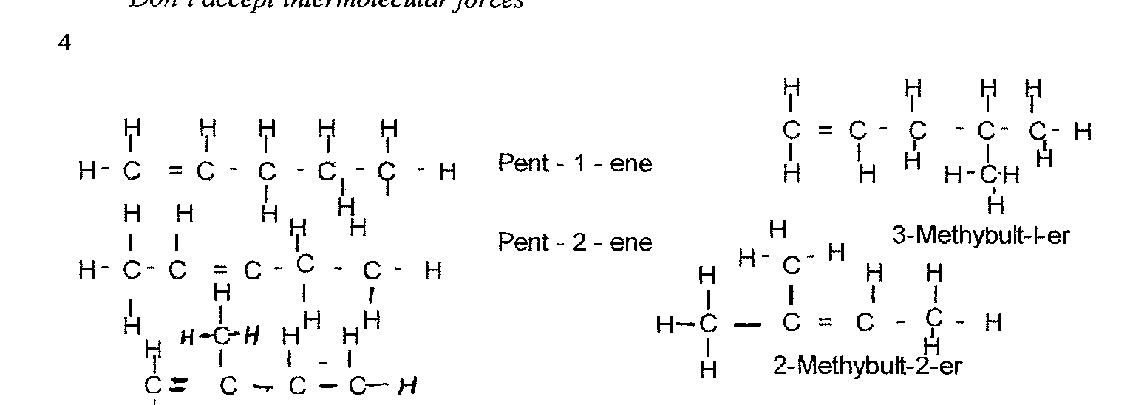
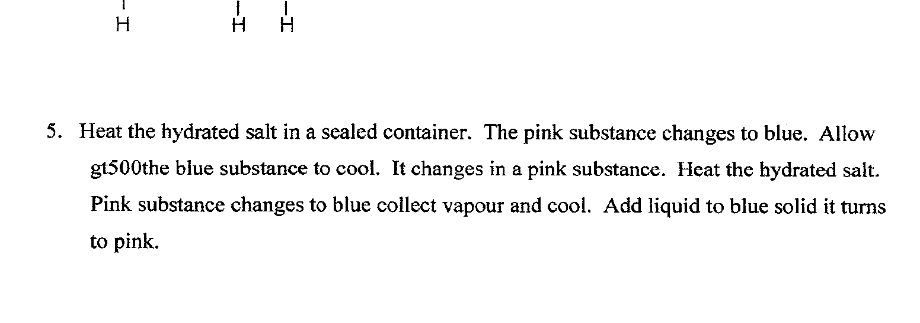

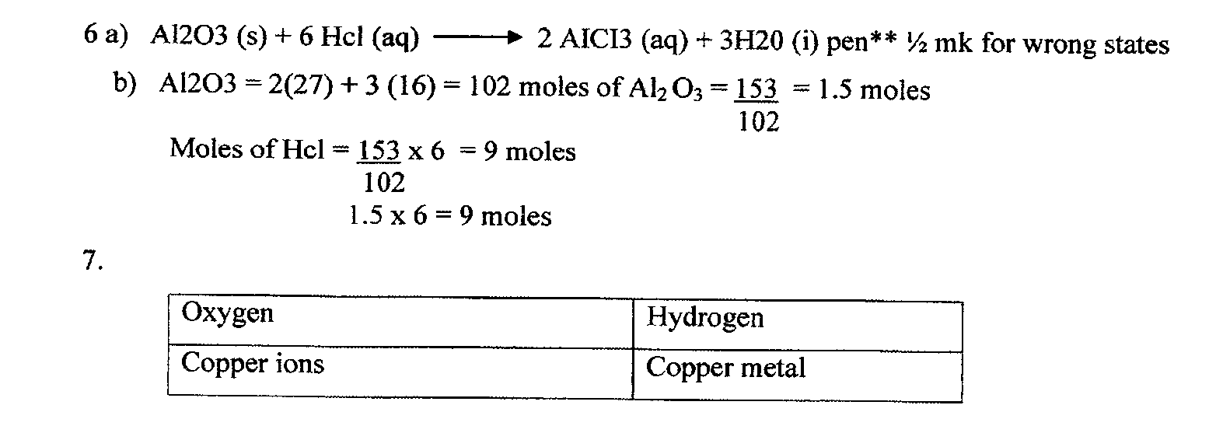
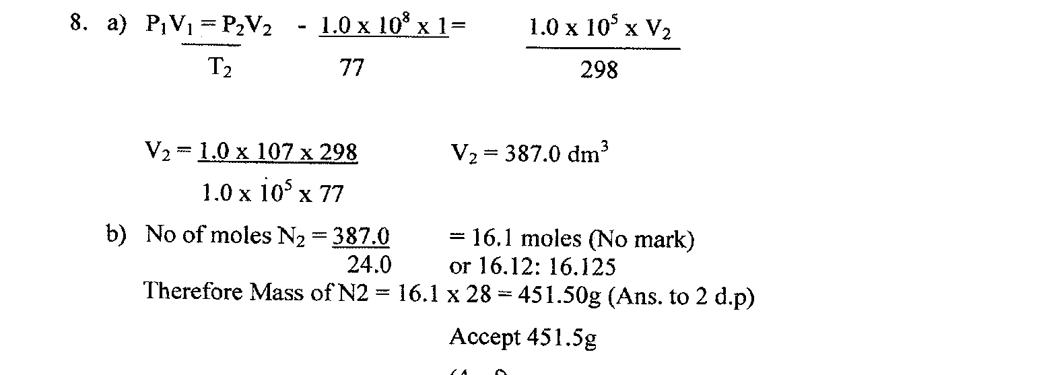
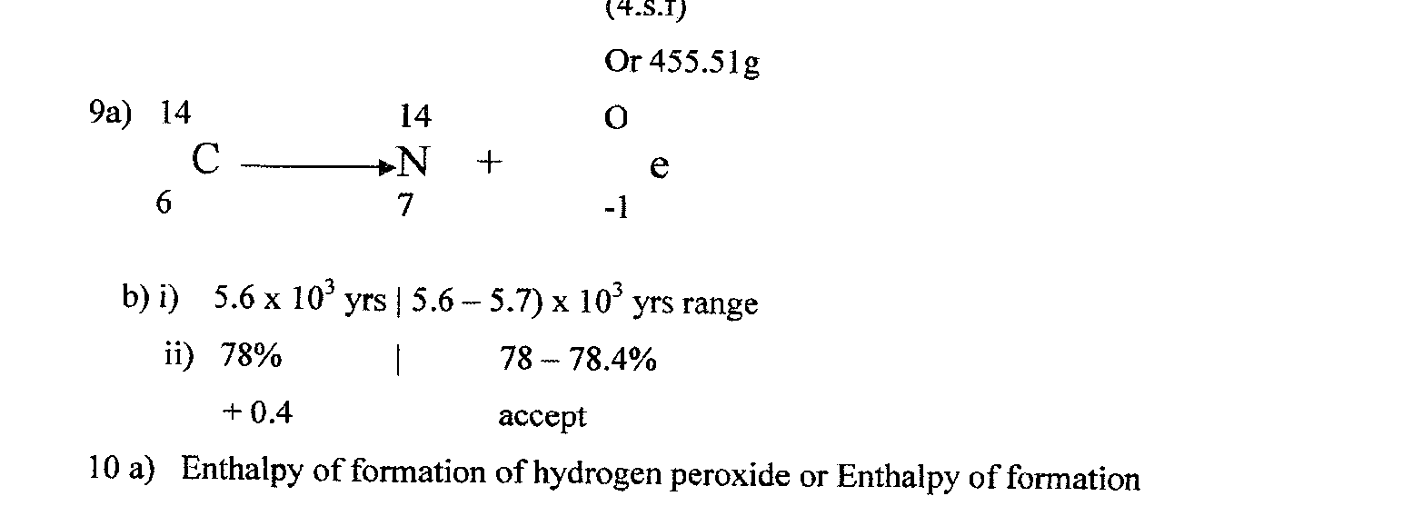
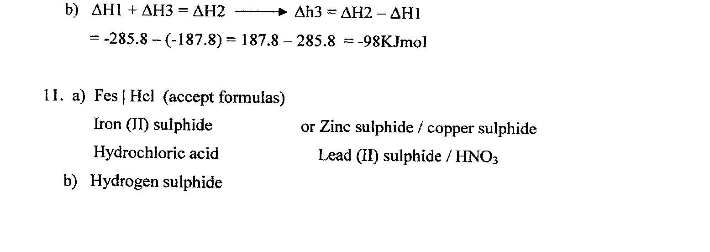

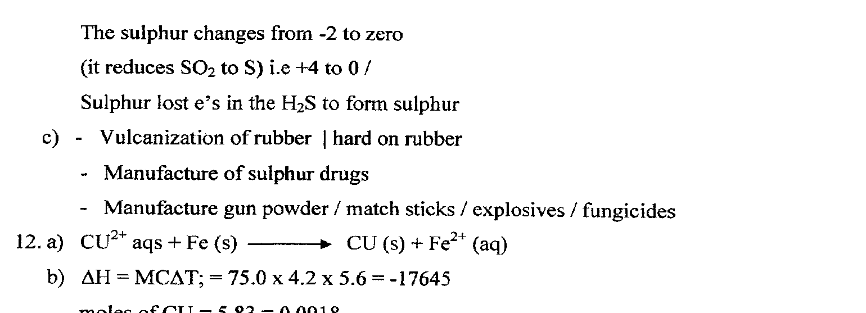
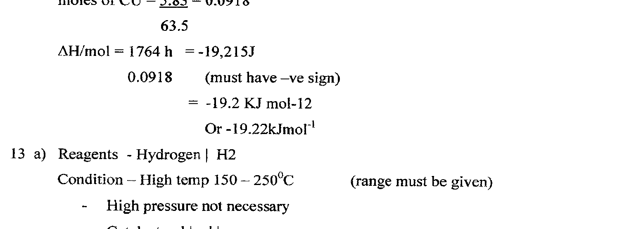
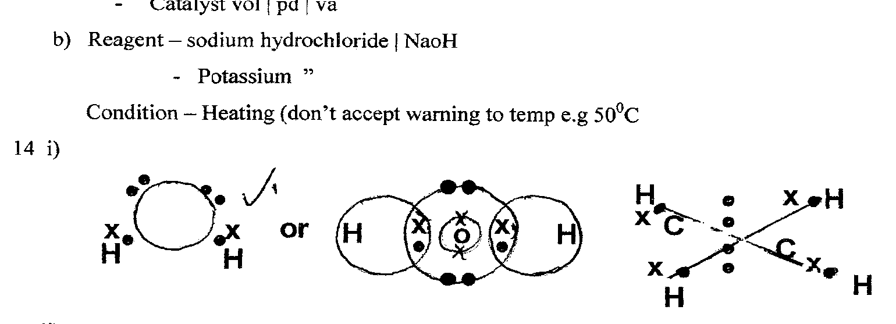
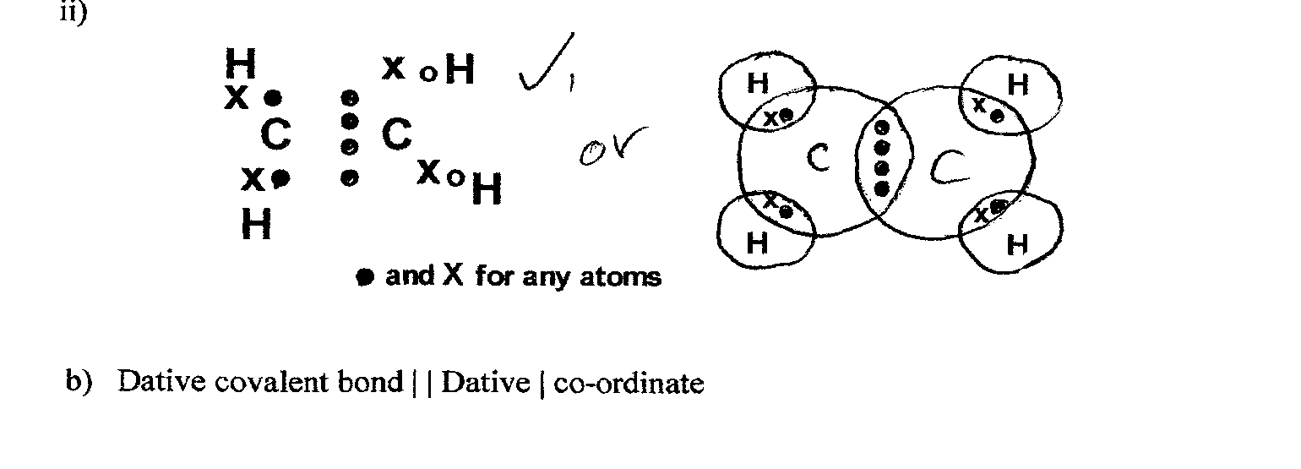

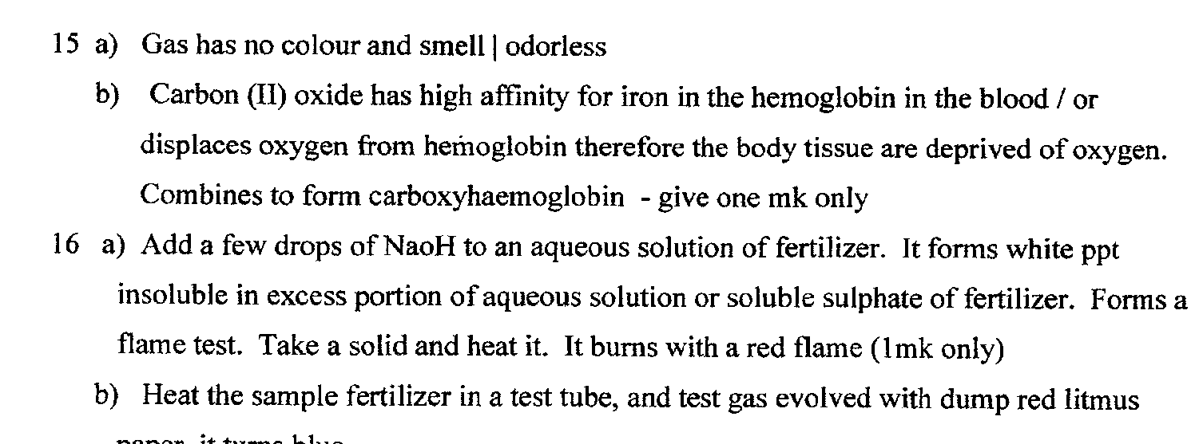
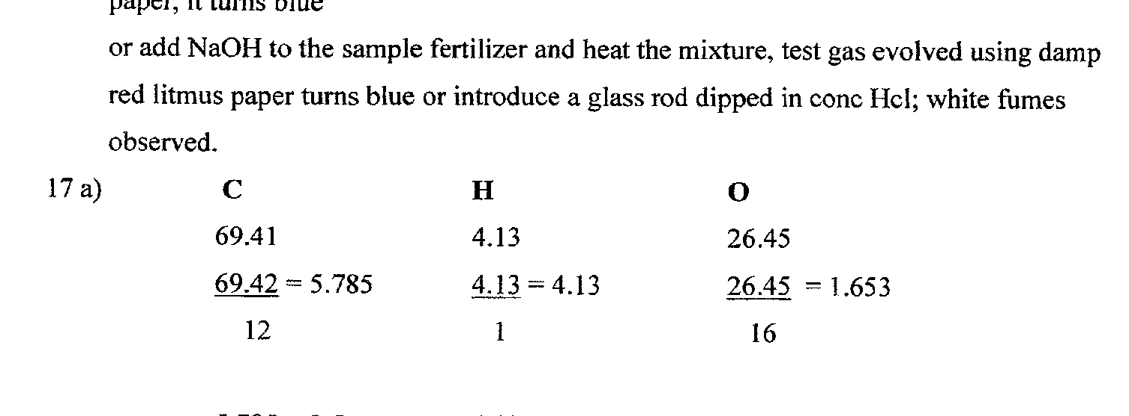
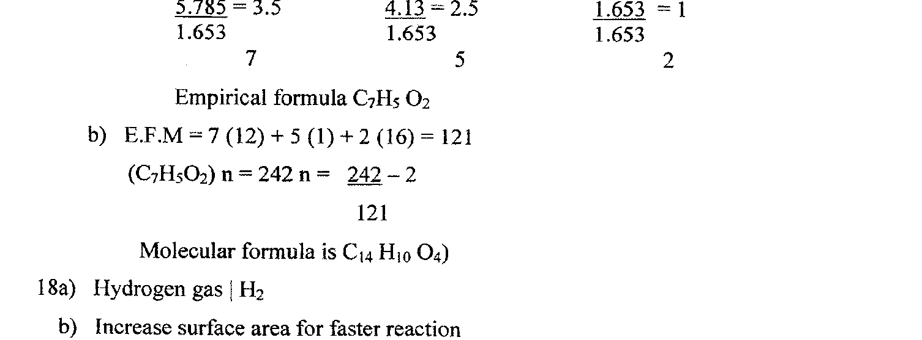
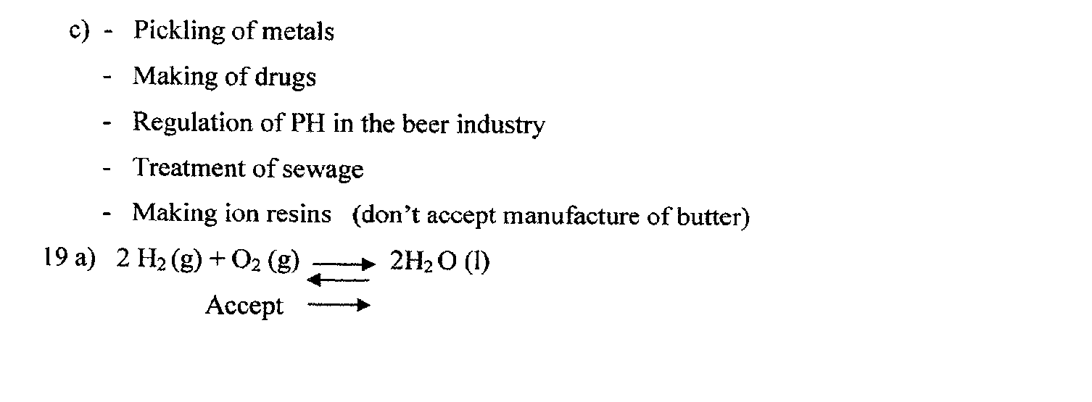

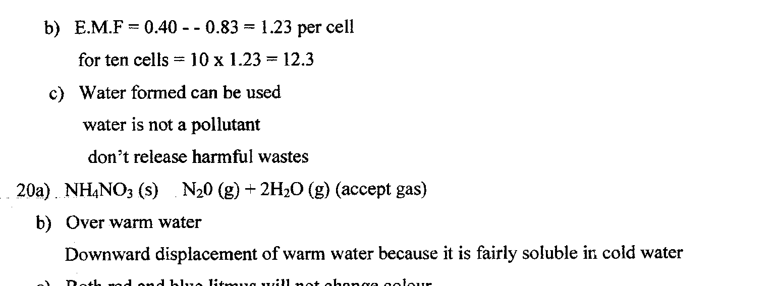
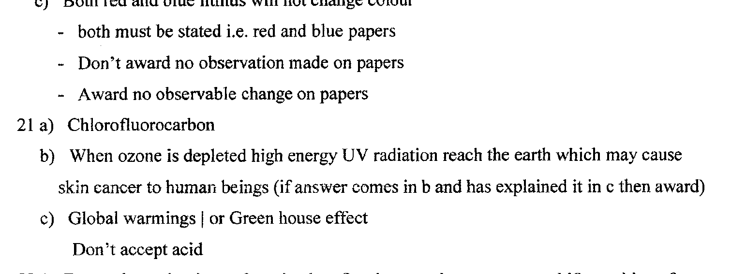
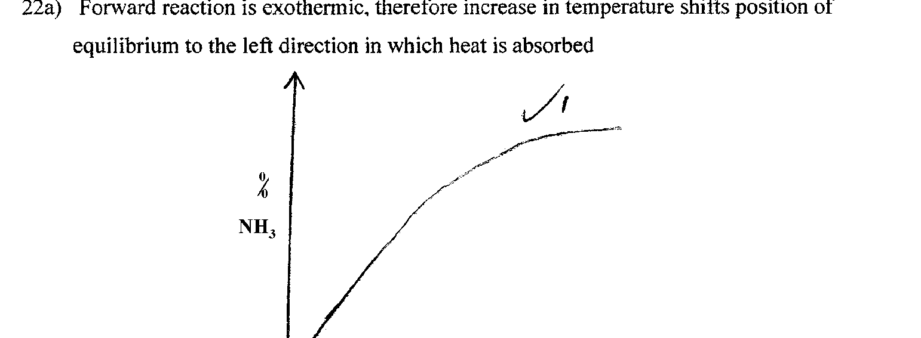
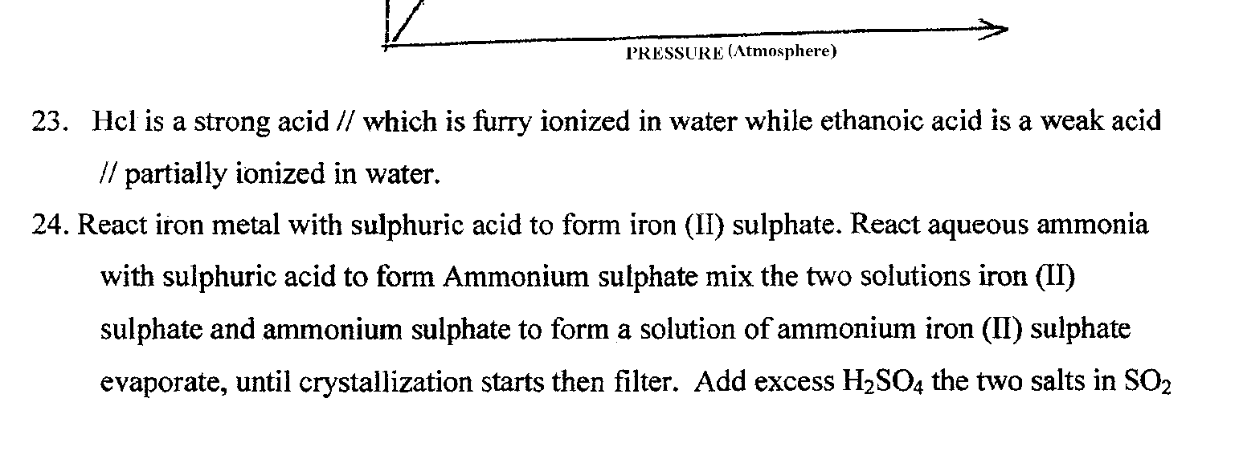

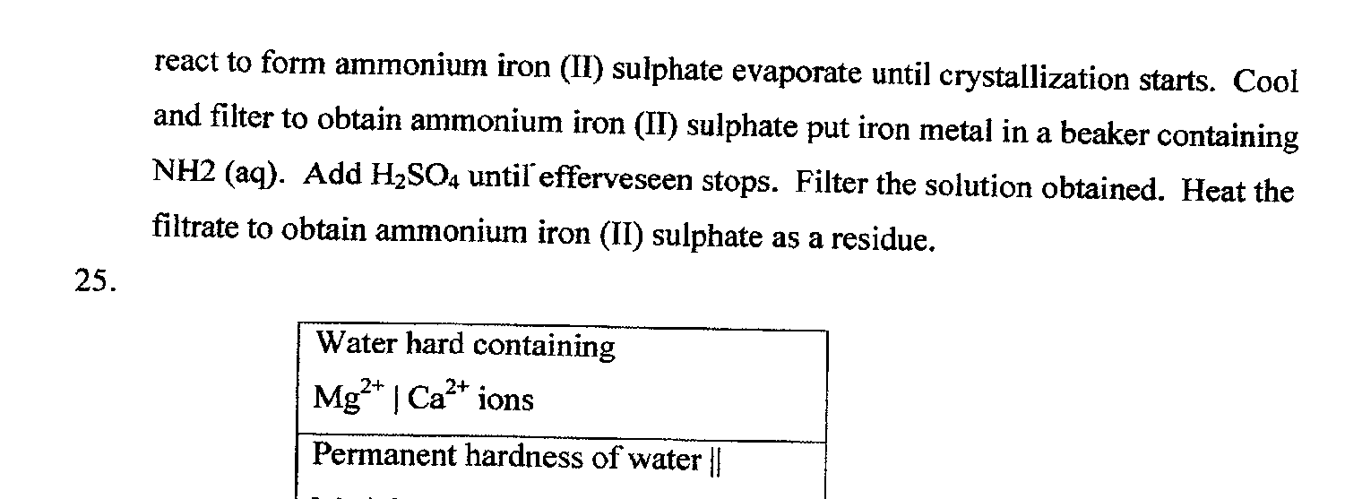
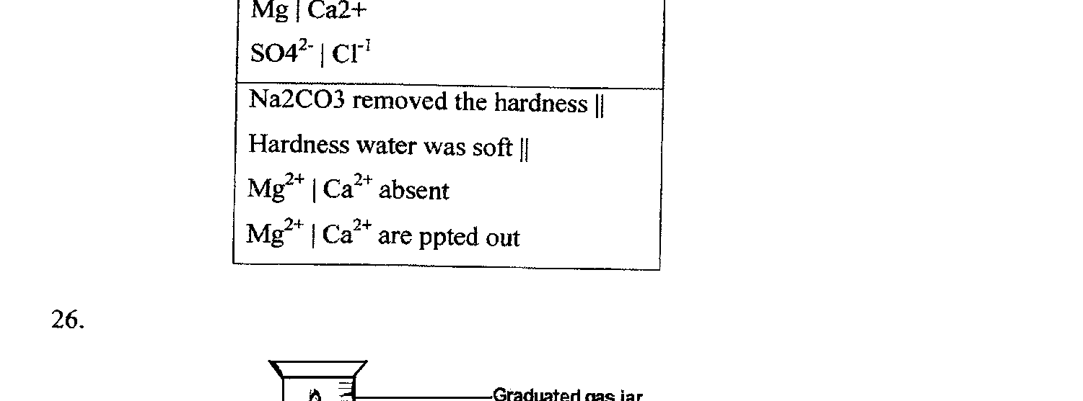
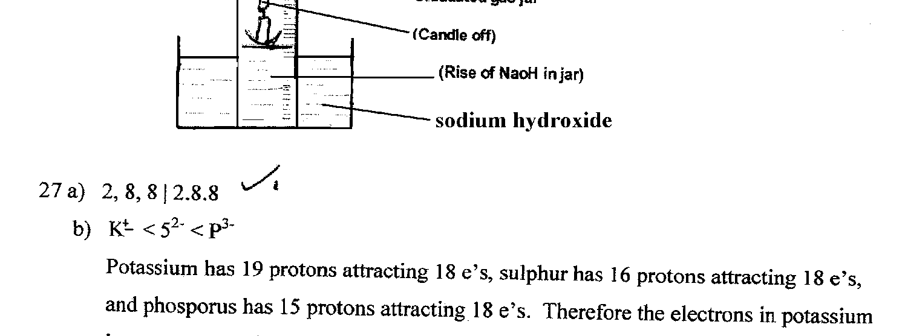
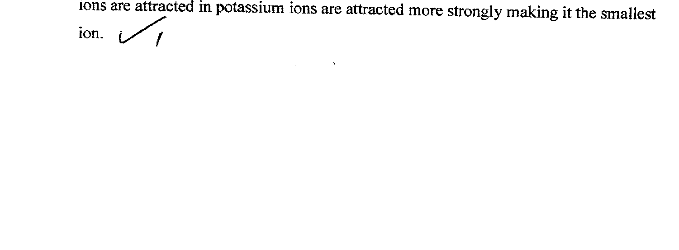

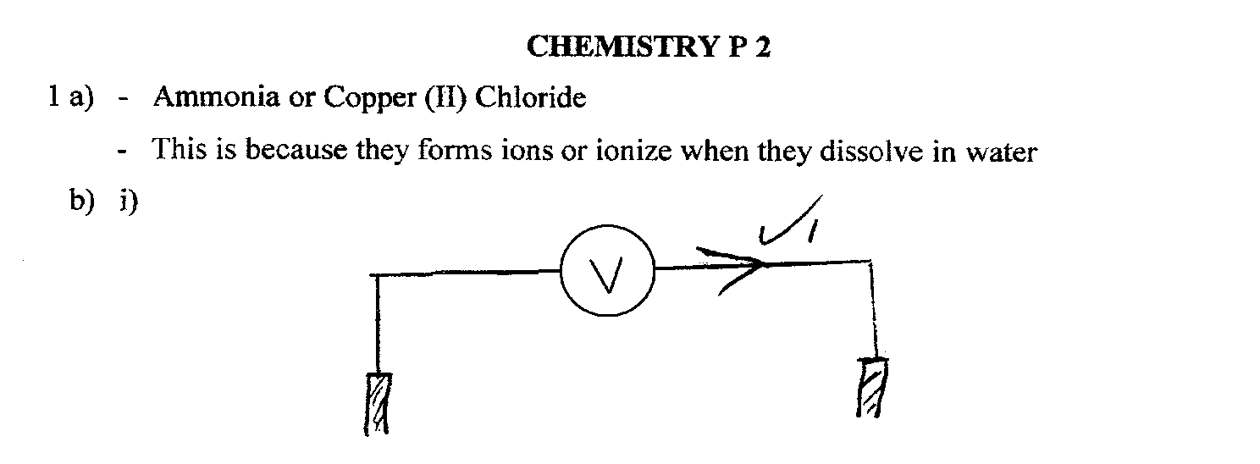
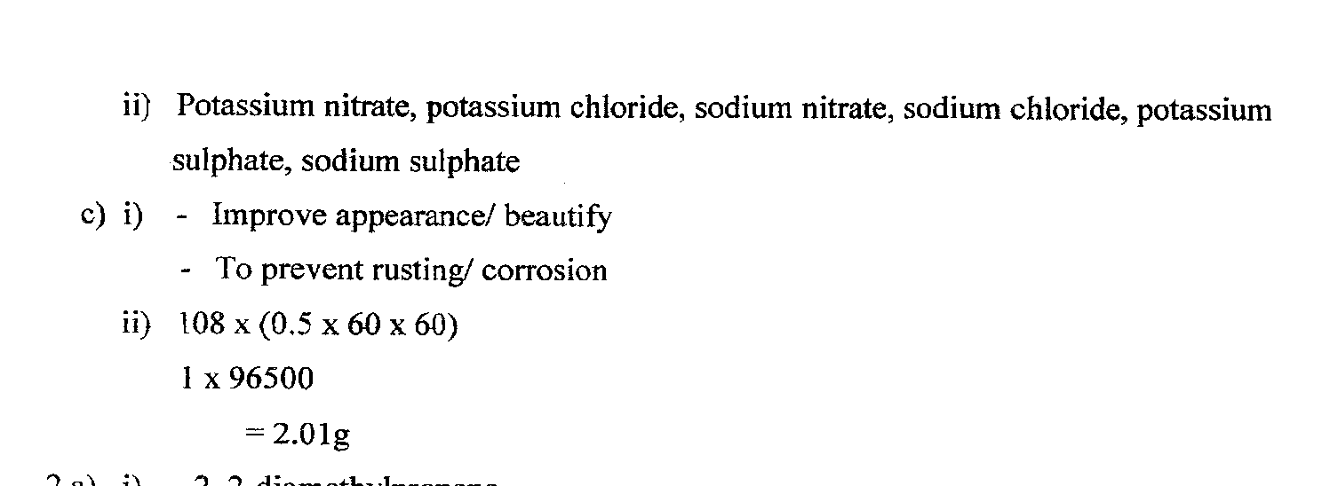
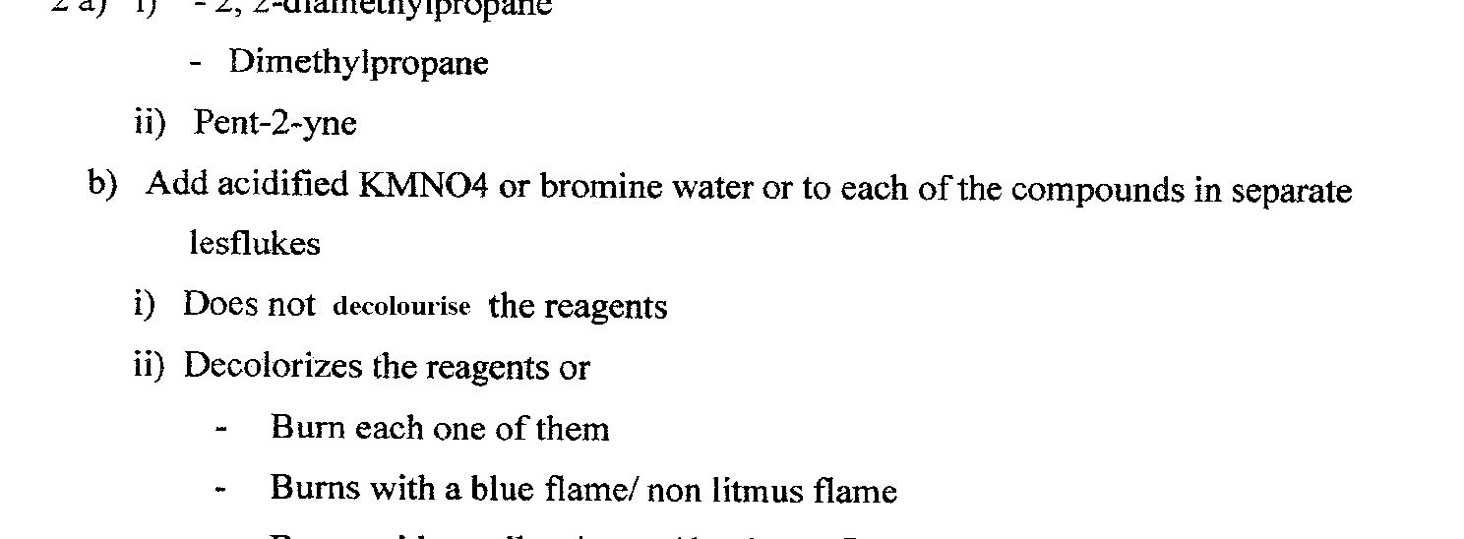
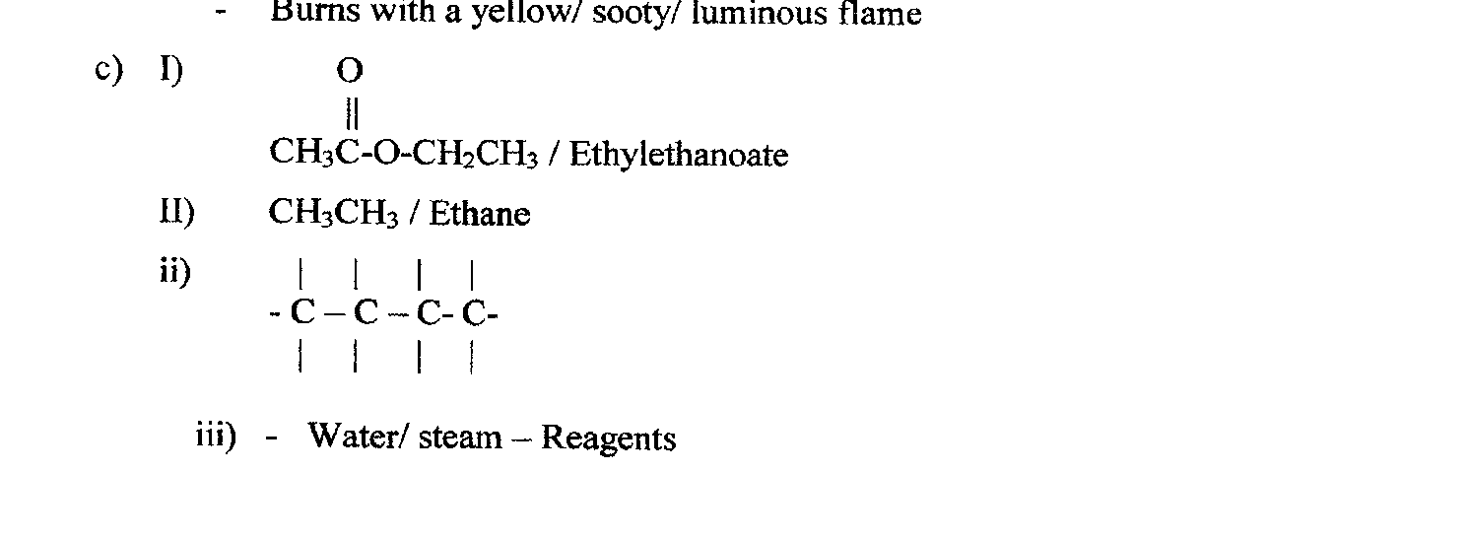

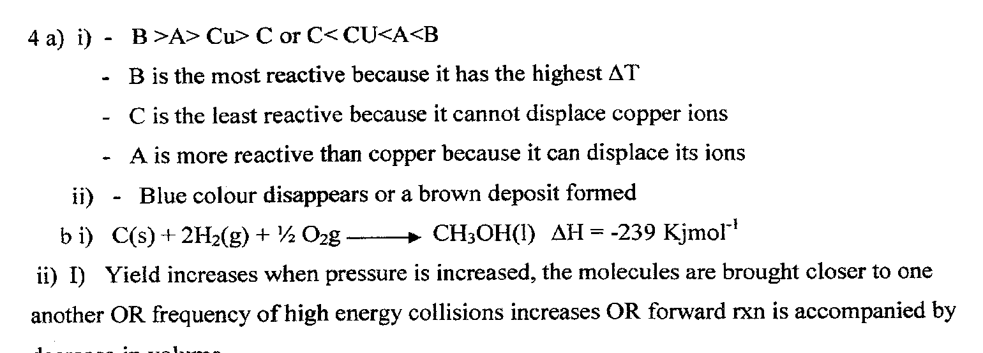
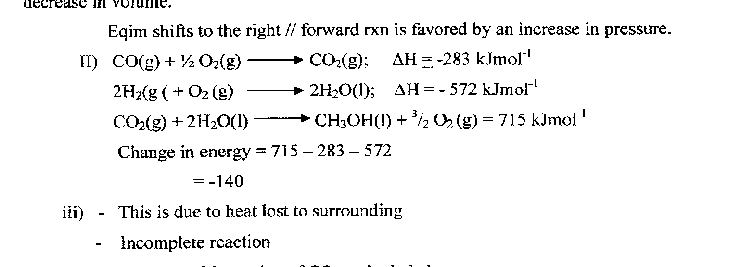
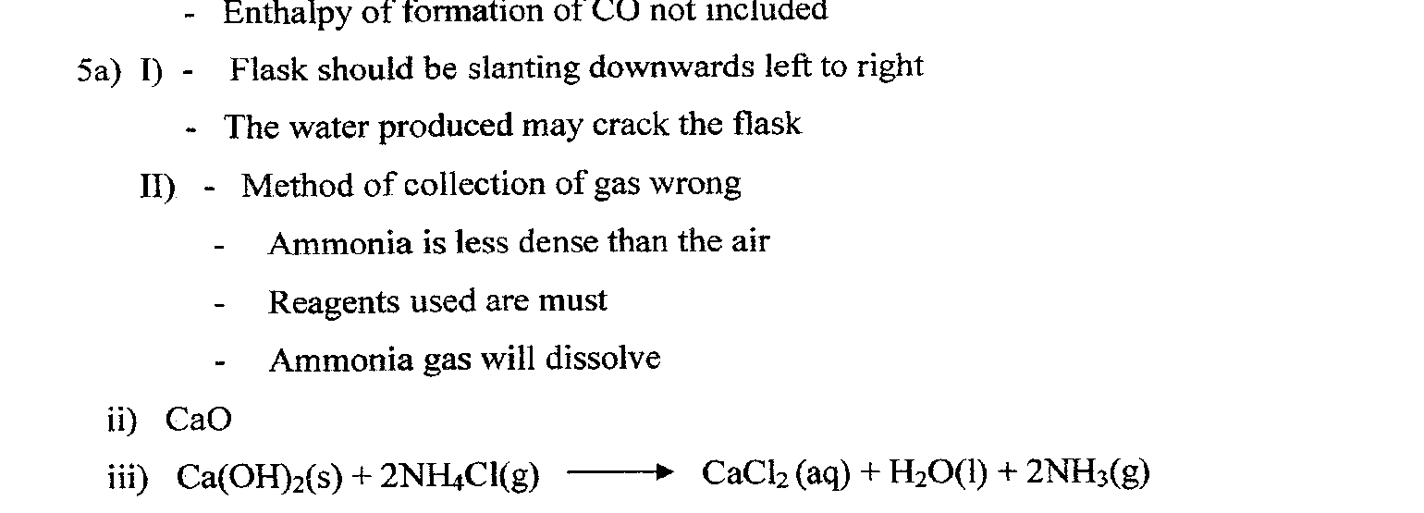
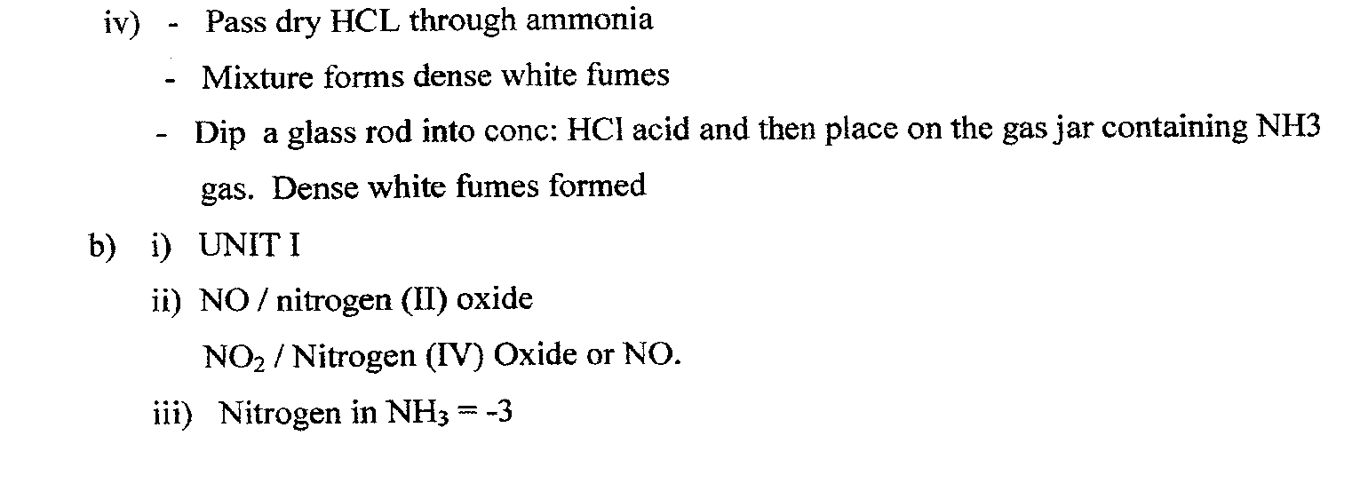

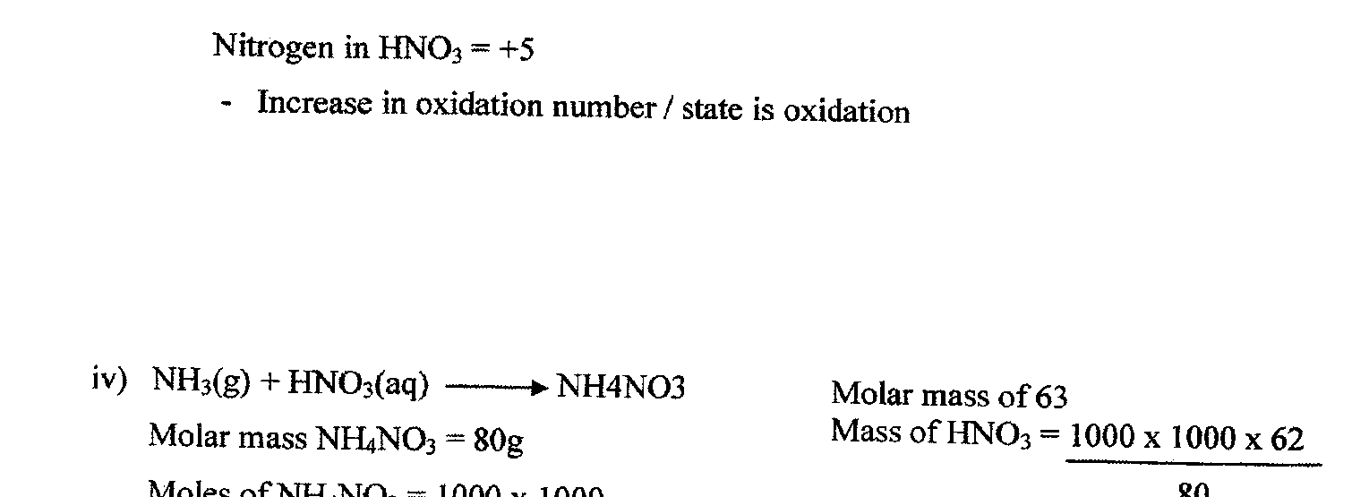
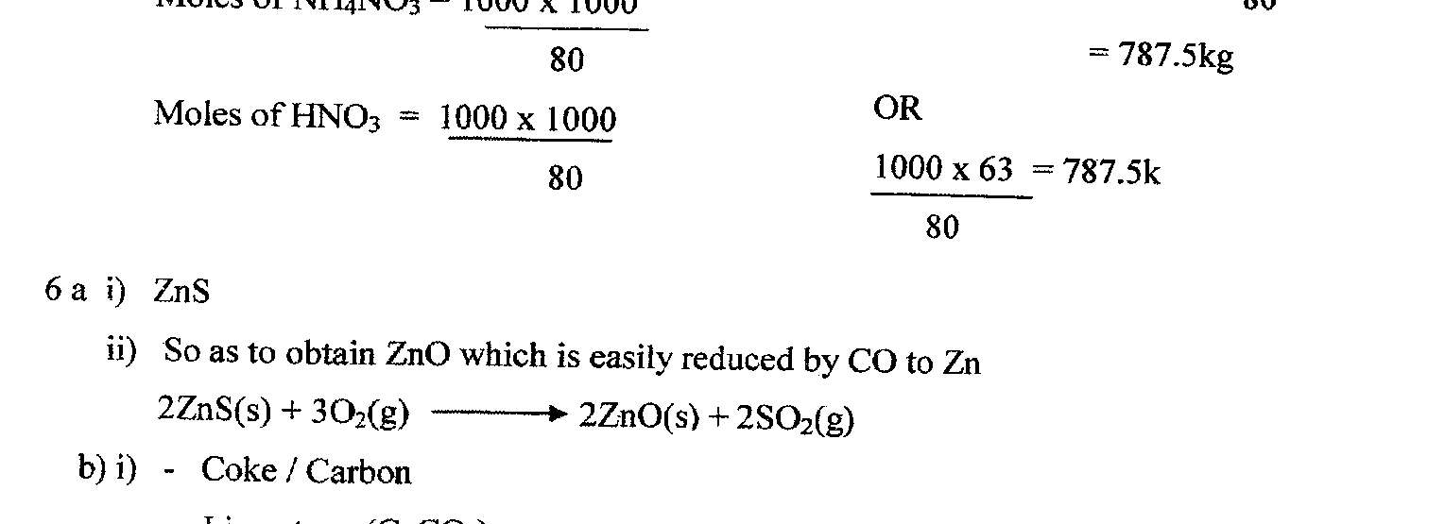
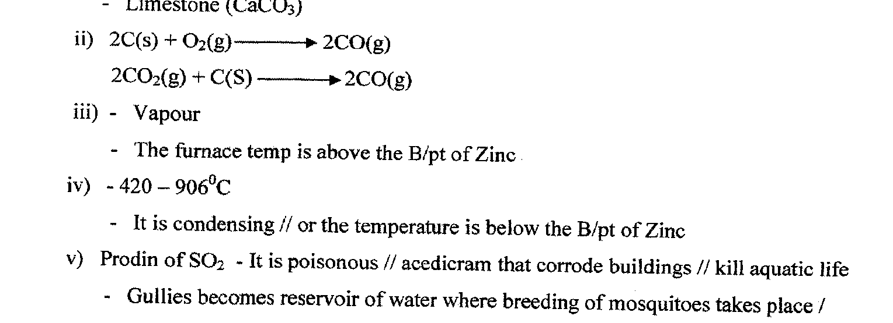
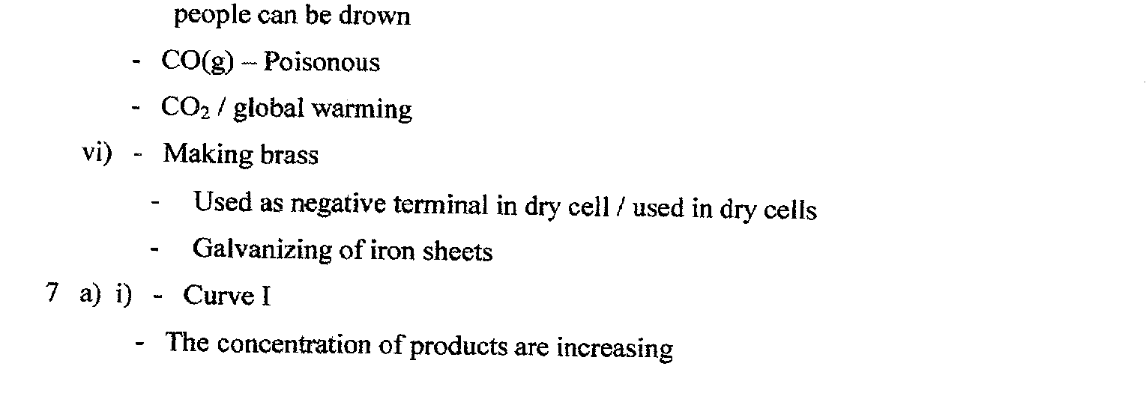

CHEMISTRY
PAPER 1 (MARKING SCHEME)
THEORY
2011

- (a) Fermentation

(b) Ethanol forms hydrogen bonds with water while Ethane does not / remains molecular / only weak Vanderwaals forces (intermolecular force. Ethane is non polar while Ethanol is polar.

- (a) oe
-1

t½ t½ t½ t½ t½
    - 50g 25g 12.5g 6.25g 3.125g 1.5625g

Or NW = 0.4(½ )^{n}
NW = 50 x (½ )⁵ = 1.5625g

    - Instant / cause death
Cause cancer
Cause gene mutation

- (i) Heat the mixture to sublime the NH₄Cl
Add water to dissolve the NaCl or copper (II) oxide does not dissolve. Filter and evaporate the filtrate to obtain sodium chloride.
    - Add water to the mixture to dissolve NH₄Cl and NaCl. Cuo does not dissolve. Filter and evaporate the filtrate to dryness. Heat to sublime NH₄Cl. NaCl remains behind.
    - Add water to dissolve. Filter to obtain NaCl & NH₄Cl . Cuo does not undergo traditional crystallization i.e. concentrate and cool. NaCl crystallizes first.

- (a) NaNo₂ reacts with NH₄Cl to form NH₄No₂. The NH₄No₂ decomposes to form N₂ gas. Or NaNo₂ (s) + NH₄Cl NaCl (s) + NH₄No₂(s)
NH₄No₂(s) N₂ (g) = 2H₂O (l)

(b) Provides inert atmosphere in certain industrial prcesses e.g. packaging / used in light bulbs.
Storage of semen (for artificial insemination)
Drilling of oil to provide inert atmosphere
Dilute effect of O2 gas
Fill aircraft tyres
Fill empty oil tankers
Provide inert atmosphere during welding

- (a) 2;8 / 2.8 / 2,8 / 2:8 / 2 8 deny 2-8

    - 3v (s) + Q₂ (g) V Q₂ (s)
3
Or 3Mg (s) + N₂ (g) Mg₃N₂(s) or N₂Mg₃

    - T has a lower ionization energy than M or M higher than T.
T has an extra energy level and hence e’s are less attracted by the positive nucleus M has higher e’s are more attracted.

- P₁V₁+ P₂V₂ = P₁V₁ x T₂ = 98,648.5 x 0.15 x 273

T₁ T₂ T₁ P₂ 293 x 101,3285

V₂ = 0.136dm³ (go to minimum of 2d.p)

- (a) 2 Pb (No₃)₂ (s) 2PbO (s) + 4 No₂ (g) + O₂ (g)

(b) Moles of No2 gas = 0.29 = 0.01208
24

Moles of Pb (No₃)₂ = ½ x 0.01208 = 0.006 or ½ x 0.29 = 0.006
24

Mass of Pb (No₃)₂ = 0.006 x 331 = 1.9998g / 1.986 g

Or 2 moles Pb (No₃)₂ 4 x 24 dm³ No₂ (g)

0.290 x 2 x 331 = 0.290 dm³
4 x 24 = 2g

- (a) An acid that ionizes fully / dissociates fully / completely gives all the H⁺ ions

(b) Curves start at the same point. Curve of Hcl above ethanoic. Curve ethanoic below. Joining at some point.

Volume of CO
2

cm
3

HCl

CH
3
COOH

- It is expensive
Time (min)

It is explosive
It is difficult to store

- (a) Greenish yellow / pale green colour of Cl₂ disappears
Brown solution / black solid is deposited

(b) Cl₂ (g) + 2 I⁻ (aq) 2 Cl⁻ (aq) + I ₂ (s)
Explanation; Iodine oxidation state changes from -1 to 0 hence oxidation while Cl₂ 0.5 changes from 0 to -1 hence reduction / increase is ON and decrease is ON or movement of electrons Cl₂ gains e’s where lose.
- (a) Carbon (II) oxide is formed when fuel burns under limited oxygen / incomplete combustion of fuel.

(b) Carbon (IV) oxide / Co₂ – Sulphur (VI) oxide / So₃
Nitrogen (IV) oxide / NO₂
Sulphur (IV) oxide / So₂

- (a) Small piece of sodium metal (pea size) with a lot of water Perform the experiment wearing goggles.

    - Electrolysis

    - Manufacture of paper (soften)
Manufacture of soaps and detergents
Fractional distillation of liquid air
Extraction of aluminium metal
Manufacture of bleaching agents eg NaOCl paper, textiles, oil refinery
Making herbicides on weed killers
It is boiled with
Textile industry to soften

- Deliquescent substance absorbs water from the atmosphere to form a solution / dissolve.
Efflorescent substance loses water of crystallization to the atmosphere.

- P is an alkanol / alcohol
The alkanol reacts with sodium metal to produce the colourless gas / H₂ gas
- (a) Ca(st)₂ or Mg(st)₂
Ca(st)₂ or Mgst₂
Ca(C₁₇H₃₅COO)₂ or Ca (c₁₇H₃₅COO)₂

(b) Ca²⁺ (aq) + CO₃²⁻ (aq) CaCo₃(s)
Or Mg²⁺ (aq) + Co₃²⁻ (aq) MgCo₃ (s)
- By adding conc H₂So₄ as a catalyst / adding H₂So₄

- (a) (i) Black solid is deposited. Lead (II) sulphide (Pbs) is formed
Bubbles are produced and seen. Gas is produced which is H₂S passes through the solution.

(ii) The indicator turns red/pink/orange. This is due to excess H₂S and/or SO₂ gas (formed are acidic)

(b) The experiment should be done in a fume chamber or in open air

- (a) At room temperature cold and dilute sodium hydroxide

(b) Used in sterilizing of water / treatment of water / killing germs
Used as a bleaching agent
Antiseptic for mouth wash
Fungicide

- Plot A (Urea)
% of N₂ in (NH₄)₂ SO₄ = 28 x 100 = 21.2%. Amount in 50kg = 21.2 x 50 = 10.6 kg
132 100
Plot B ((NH₄)₂SO₄
% of N₂ in urea = 28 x 100 = 46.7%. Amount in 30kg = 46.7 x 30 = 14.01kg
60 100
Plot B is more enriched with N₂ since it has a higher amount of N₂ than Plot A.

- Add universal indicator to match the colour of solution with pH chart and read the value using a pH meter.
Add water to dissolve the anti-acid powder. Dip electrodes directly into solution and read the pH from the screen.

- (a) Sulphur / Phosphorous / oxygen

(b) Carbon atoms in graphite are arranged in layers of hexagon which are held by weak van der waals forces. The layers slide over each other when force is applied.

- (a) Bromite
At room temp (25°c) Bromite is liquid since its M.P and B.P is between -7°c and 59°c /58.8°c. Room temp is between M.P and B.P

(b) Atomic mass / molecular mass / molecule of iodine is higher than that of Cl_{2.}
Van der waals forces are stronger in I₂ than Cl₂ hence iodines b.p is highest than that of Cl₂

23.

CS₂ (l)
Energy

DH = +117.0Kj/mol

C (s) + 2s (s)

Reaction co-ordinate

- (a) Y

(b) Y and Z. They have the same number of protons (8) but different atomic masses / mass numbers / no of neutrons.

- (a) When gases combine together at constant temp and pressure they do so in volumes which bear a simple ratio to each other, and to the volumes of the products if gaseous.

(b) C₂Hx (s) + 3O₂ (g) 2CO₂ (g) + 2H₂O (g)

 | Vol 10 | 30 |  | 20 | 20
 | Mol 1 | 3 |  | 2 | 2
Ratio

Therefore X = 4

- (a) (i) 10.352 – 10.240 = 0.112g

(ii) 10.400 – 10.352 = 0.048g or (10.400 – 10.240) – 0.112 = 0.048g

(b) Elements M O

Mole ratio 0.112 0.048
56 16

0.0020 0.0030

Simplest 2 3
Ratio

E.F M₂O₃

- (a) Zinc blende or/ calamite

    - 2 ZnO (s) + C (s) 2Zn (s) + CO₂ (g)

ZnO (s) + C (s) Zn (s) + CO (g)
3ZnO (s) + 2C (s) 3Zn (l) + CO₂ (g) + CO (g)
ZnO (s) + CO (s) Zn (s) + CO (g)

    - Dry cells
Galvanizing iron sheets
As electrodes
Making of alloys e.g. brass

- (a) Single covalent bonding / covalent
Dative / co-ordinate bonding

(b) 7 bonds x 2 = 14 electrons

- (a) Mg metal has free/mobile delocalized electrons which may carry the current.

(b) It has (Mg²⁺ and Cl⁻) ions which are free/mobile to move. Accept if ions only. Not necessarily free/mobile.

- Add aqueous ammonia until in excess.
A formation of white ppt which dissolves in excess shows presence of zinc ions.
Add aqueous acidified Ba(NO₃)₂/BaCl₂/Pb(NO₃)₂.
Formation of a white ppt shows presence of SO₄²⁻ ions

- Alkaline earth metals

2011
CHEMISTRY
PAPER II

1. The flow chart below shows some of the processes involved in large scale production of sulphuric (IV) acid. Use it to answer the question that follow.
- Describe how oxygen is obtained from air on a large scale (3 marks) Purity to remove impurities, bubble through NaoH/KoH to remove CO₂, reduce the temp, to remove water vapor compress to liquefy the residual air, then fractional distillation to obtain oxygen at -183⁰C
- (i) Name substance A. (1 mark0
Concentrated sulphuric
(vi) acid
(ii) Write an equation for the process that takes place in the absorption chamber (1 mark)
SO3(g)+ H2SO4(l) _H2S2O7(l)
(c ) Vanadium (V) oxide is a commonly used catalyst in the contact process.
  - Name another catalyst which can be used for this process. (1 mark)
Platinum/platinum asbestos
  - Give two reasons why vanadium (V) oxide is the commonly used catalyst
It is cheap/cheaper (2 marks)
Not easily poisoned/action stopped by impurities
- State and explain the observation made when concentrated sulphuric (VI) acid is added to crystals of copper (II) sulphate in a beaker.
(2 marks)
Turns blue & white. Forms white powder sulphuric (VI) acid dehydrates copper(II) sulphate crystals/ remove water of crystallization.
- The reaction of concentrated sulphuric (VI) acid with sodium Chloride produces hydrogen chloride gas. State the property of concentrated sulphuric (VI) acid illustrated in this reaction.
It is less volatile/volatility / involatile
- Name four uses of sulphuric (VI) acid. (2 marks)
Manufacture of sulphate fertilizer/superphosphate fertilizer/production of Ray on making dyes/used in car batteries/ As an electroly manufacture of sosaples detergents/cleaning of metals manufacture of pain HCL/HNO₃/Oleum.
As a drying agent, as adehydrating agent/manufacture of nylon
AL₂SO₄/ALCOH₃/sulphate drugs, pigments
- The set-up below was used by student to investigate the products formed when aqueous copper
- (II) chloride was electrolysed using carbon electrodes.
(a) (i) Write the equation for the reaction that takes place at the cathode.(1 mark)
CU2+ (G) + 2E – CU(S)
      - Name and describe a chemical test for the product initially formed at the anode when a highly concentrated solution of copper (II) chloride is electrolysed.(3 marks)
Chlorine gas

Moist blue litmus paper/fresh or moist coloured petals/ change from blue to white/
      - How would the mass of the anode change if the carbon anode was
replaced with copper metal? Explain. (2 marks)
Decrease the anode is not inert so l+ dissolves/reacts/iodine oxidized
(b) 0.6 g of metal B were deposited when a current of 0.45 A was passed through an electrolyte for 72 minutes. Determine the charge on the ion of metal B.
(Relative atomic mass of B=59, 1 Faraday = 96 500 coulombs) (3 marks) (c) The electrode potentials for cadmium and Zinc are given below:
Cd2+ (aq) + 2e ___ Cd (s) ; E^{ѳ} = - 0.4v
Zn2+ (aq) + 2e ___ Zn(s) ; E^{ѳ} = - 0.76v
Why is it not advisable to store a solution of cadmium nitrate in a container made of
Zinc. (2 marks)
Zinc reacts with cadmium ions/displaces/cadmium ions/Zinc container dissolve because Zinc is more reactive/Electropositive than calmium or calculate Zn is a stronger reducing /Zinc is oxidized
- (a) Ethanol can be manufactured from ethane and steam as shown in the equation below:
C₂H₄ _{(g)} + H₂O (g) _____ CH₃CH₂OH _{(g)}
Temperature and pressure will affect the position of equilibrium of the above reaction.
Name the other factor that will affect the position of equilibrium of the above reaction.
Concentration/volume
(b) The data table below was recorded when one mole of ethane was reacted with excess steam. The amount of ethanol in the equilibrium mixture was recorded under different conditions of temperature and pressure. Use the data to answer the questions that follow.
Temperature  (⁰C) | Pressure  (Atm) | Amount of ethanol at  Equilibrium (Moles)
300 | 50 | 0.40
300 | 60 | 0.46
300 | 70 | 0.55
250 | 50 | 0.42
350 | 50 | 0.38

      - State whether the reaction between ethane and steam is exothermine or
endothermic. Explain your answer. (3 marks)
Exothermic I increased in temp at constant pressure. The amount of ethabol formed at eqm decreases and vise versa decrease in temp at

      - State and explain one advantage and one disadvantage of using extremely high pressure in this reaction. (2 marks)
            - Advantage
Amount of ethanol increases, pressure favours the side with less molesle products/egm shifts to the right/forward rxn is favoured.
            - Disadvantage
It would be expensive/uneconomical. The cost would go up or maintaining / high pressure is costly. Explosion can occur hence costs will go up
It’s costly to maintain high pressure

(c ) In an experiment to determine the rate of reaction between calcium carbonate and hydrochloric acid,2g of calcium carbonate were reacted
With excess 2 M hydrochloric acid. The volume of carbon (IV) oxide evolved was recorded at regular intervals of one minute for six minutes.
The results are shown in the table below.

Time (minutes) | 1 | 2 | 3 | 4 | 5 | 6
Volume of carbon (IV) oxide (cm³) | 170 | 296 | 405 | 465 | 480 | 480

  - Plot a graph of time in minutes on the horizontal axis against volume of carbon (IV) oxide on the vertical axis. (3 marks)
  - Determine the rate of reaction at 4 minutes. (2 marks)
Drawing targent
Rate = Y₂-Y₁ = Ans CM³/Min
X₂-X₁

- (a) when excess calcium metal was added to 50 cm³of 2 M aqueous copper(II) nitrate in a beaker, a brown solid and bubbles of gas were observed.
    - Write two equation for the reactions which occurred in the beaker. (2 marks) Ca(s) + CU²⁺(aq) ____ Ca²⁺ (aq) + CU(s)
Ca(s) + Cu(NO₃)₂ (aq) ____ Ca(No₃)₂ (aq) + Cu(s)
Ca(s) + 2H₂O(l) _____ Ca(OH)₂ (aq) + H₂ (g)
    - Explain why it is not advisable to use sodium metal for this reaction. (2 marls) The reaction is highly explosive/highly exothermic because sodium is more reactive than calcium.
Na is more electro positive than calcium.
    - Calculate the mass of calcium metal which reacted with copper (II) nitrate solution.
(relative atomic mass of Ca=40) (2 marks)
No of moles of = 50/₁₀₀₀ x 2
Copper (ii) nitrate
= 0.1 moles
Ratio 1:1
Moles of Ca = 0.1
Mass of Ca = 0.1x40
=4g
    - The resulting mixture in (a) above was filtered and aqueous sodium hydroxide added to the filtrate dropwise until in excess. What observations were made? (1 mark) A white ppt is formed which is insoluble in excess
    - (i) Starting with calcium oxide, describe how a solid sample of calcium carbonate can be prepared. (3 marks)
Add Cao to dil HNo₃/Hcl/H₂O. Add Na₂CO₃/K₂CO₃/NH₄ CO₃/CO₂ a solution filter out CaCO3 as residue.
(iii) Name one use of calcium carbonate.
Preparation of CO₂ in the laboratory
Manufacture of Na₂Co₃ in s process
Manufacture of Cao
- (a) Other than their location in the atom, name two other differences between an electron and a proton. (2 marks)
Electron is negatively charged while proton is positively charged Electron has a mass of units while proton has a mass of unit Mass of proton is bigger that that of electron.
(b) The table below gives the number of electrons, protons and neutrons in particles A, B,C,D,E,F and G

Particular | Protons | Electrons | Neutrons
A | 6 | 6 | 6
B | 10 | 10 | 12
C | 12 | 10 | 12
D | 6 | 6 | 8
E | 13 | 10 | 14
F | 17 | 17 | 18
G | 8 | 10 | 8

  - Which particle is likely to be a halogen? (1 mark)
• F
  - What is the mass number of E? (1 mark)
• 27
  - Write the formula of the compound formed when E combines with G.
• E2 G3/AL2 O3
  - Name the type of bond formed in (iii) above. ( 1 mark)
• Ionic bend/electrovalent
  - How does the radii of C and E compare? Give a reason. (2 marks)
E has smaller atom in radius that C or Vice versa
E has more protons that C/nuclear attract stronger
  - Draw a dot (.) and cross (x) diagram for the compound formed between A and F.
  - Why would particle B not react with particle D?
B is inert/has stable configuration/has octet electron in the outermost/belong groups of periodic table /has noble gas configured
- (a) Study the flow chart below and answer the questions that follow.
  - I what observation will be made in Step 1? (1 mark)
Acidified KMno4 is decolorized/change from purple to colorless.
II Describe a chemical test that can be carried out to show the identity of
Compound C. (2 marks)
Add carbonate/HCO₃, effervescence is observed
Add a mixture of alkanol and conc H₂SO₄ and warm a pleasant /smell occurs
  - Give the names of the following: (2 marks)
      - E polyethene
      - substance D sodium ethoxide
  - Give the formula of substance B. (1 mark)
CH₂BrCH₂Br/H-C-C-H/C₂H₄Br₂
  - Name the type of reaction that occurs in: (1 marl)
      - step (II) dehydration
      - Step (IV) hydrogenation/Addition reaction
  - Give the reagent and conditions necessary for Step (VI). (2 marks)
Reagent; Methanoic Acid/H CooH
Conditions: concentrated surphuric (vi) acid and warm
(b) (i) Name the following structure.
• Hexan – I –OI
(iii) Draw the structure of an isomer of pentene. (1 mark)
• CH₃ – CH = C-CH₃- CH₃
- (a) What is meant by molar heat of combustion?
Amount of heat liberated/energy change when o ne mole of a substance is burnt in excess oxygen
    - State the Hess’s Law
Heat obsorbed/evolved in a chemical change is the same regardless of the route taken
    - Use the following standard enthalpies of combustion of graphite,hydrogen and enthalpy of formation of propane.
(i) Write the equation for the formation of propane.
• 3C(s) + 4H₂ (g) ____ C₃ H₈ (g)
      - Draw an energy cycle diagram that links the heat of formation of propane with its heat of combustion and the heats of combustion of graphite and
hydrogen. (3 marks)
      - Calculate the standard heat of combustion of propane. (2 marks)
• DHc (C₃H₈) = HO₄ + (3x-393) + (4x-286)
= -2219 KJ/MO1
(d) Other than the enthalpy of combustion, state one factor which should be considered when choosing a fuel.
        - Cost
        - Availability
        - Storage
        - Effect on environment
        - Ease of transportation
(e) The molar enthalpies of neutralization for dilute hydrochloric acid and dilute nitric (V) acid are -57.2KJ/mol while that of ethanoic acid is -55.2kJ/mol. Explain this observation. (2 marks)
        - Ethanoic acid is a weak acid some heat is used to ionize before neutralization occurs.
        - Ethanoic acid dissociates partially than another

