PHYSICS YEAR 2010 PAPER 1
SECTION A (25 MARKS)
Answer all the questions in this section in the spaces provided.
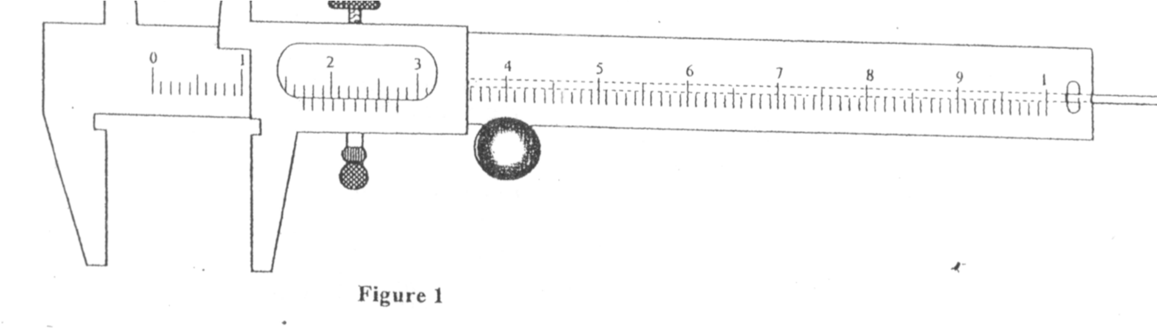
1
.
Figure 1 shows a vernier callipers being used to measure the internal diam
eter of a tube

Record the diameter of the tube. (1 mk)
1.62cm / 1.62
- A stopwatch started 0.50s after the start button was pressed. The time recorded using the stopwatch for a ball bearing falling through a liquid was 2.53s. Determine the time of fall. (1 mk)
  - 2.53 + 0.5 = (working must be shown)
- Some water in a tin can was boiled for some time. The tin was then sealed and cooled. After sometime it collapsed. Explain the observation. (2 mks)
  - Air (molecules) expelled by heating
  - Pressure inside is less that atmospheric pressure
- A paper windmill in a horizontal axis was paled above a candle as shown in figure 2.

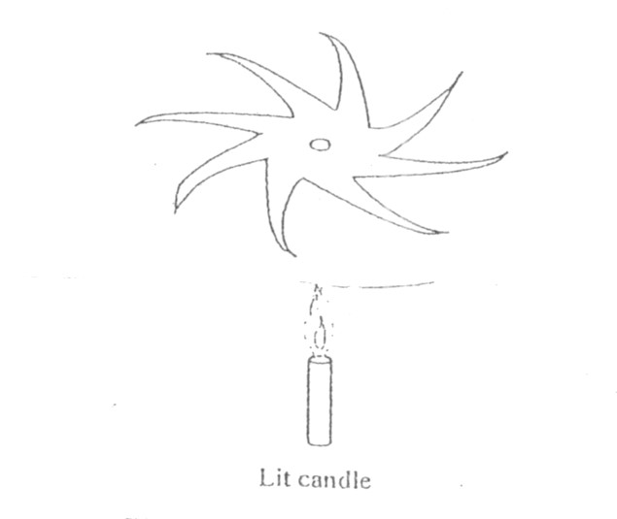

When the candle was lit the paper windmill begun to rotate. Explain this observation (2 mks)
  - Flame heats air which/becomes less dense (expands) /and move upwards expand - This will push the blade upwards/creates convection currents hence rotate.

- When liquid is heated in a glass flask, its level at first falls, then rises. Explain this observation.(2 mks)
  - Flask which is in intact with heat expands first - Liquid expands more than glass.

- Figure 3 shows a uniform metre rule pivoted at the 30cm mark. It is balanced by a weight of 20 suspended at the 5cm mark.
5cm 30cm

Figure 3

Determine the weight of the metre rule
Clockwise moments = anticlockwise moments either
OR W1d1 = w2d2 / f1d1 = F2d2
W x 0.2 = 2 x 0.25
W = 2.5N

7. Figure 4 shows a horizontal tube with two vertical tubes x and y. Water flows through the horizontal tube from right to left. The water travel in tube x is higher than water level in tube y.

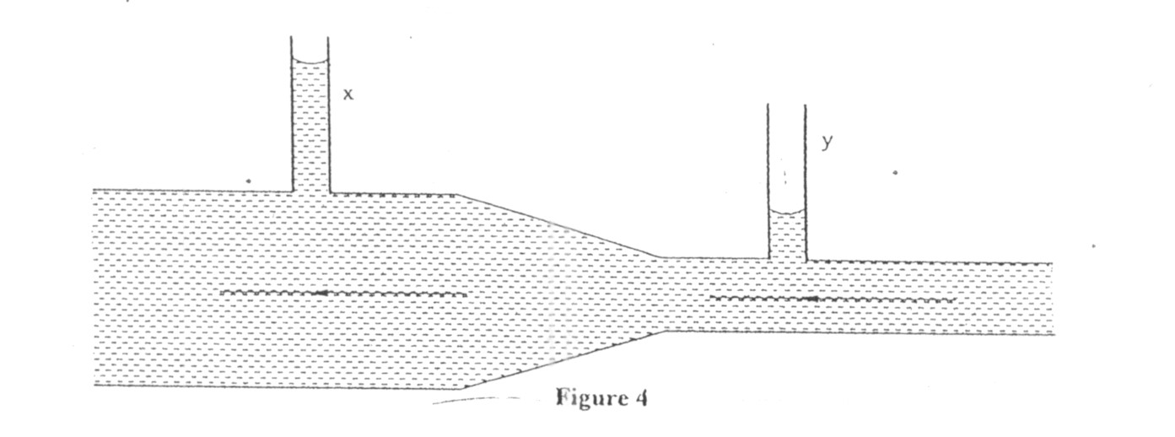

Explain this observation
- Water flows faster in Y than X hence pressure is lower at Y than X
(i.e 1st mark - compare velocity)
2nd - compare pressure

- A cart of mass 30kg is pushed along a horizontal path by a horizontal force of 8N and moves with constant velocity. The force is then increased to 14N. Determine
a) The resistance to the motion of the cart. (1 mark)
- 8N
b) The acceleration of the cart. (2 mks) 14 - 8 = 30n or F = ma a = ⁶/₃₀ = 0.2m/s²

- When a drop of aloeic acid of known volume is dropped on the surface of water in a large trough, it spreads out to form a large circular patch. State one assumption made when the size of the molecule of aloeic acid is estimated by determining the area of the patch. (1 mark)

- Patch is one molecule thick or monolayer

- The weight of a solid air is 50N. When it is fully immersed in a liquid of density 800Kg m³ its weight is 4.04N.
Determine:
i) The upthrust in the liquid (1mk)
u - 5.0 - 4.0 (working must be shown) u = 0.96N

b) The volume of the solid. (2 mks) Weight of liquid displaced = 0.96N
Mass of liquid displaced = 0.096kg
V = M/P = 0.096/800 = 1.2 x 10-1m3
1.2 x 10²cm³
120cm³

- When a bicycle pump was sealed at the nozzle and the handle slowly pushed towards the nozzle, the pressure of the air inside increased.
Explain this observation. (1 mk)
- Volume decreases so more collisions per second.

- Figure 5 shows a mass of 200g connected by a string through a hollow tube to a mass of 0.5kg. Teh 0.5kg mass is kept stationary in the air by whirling the 200g mass round in a horizontal circle of radius 1.0 metre.
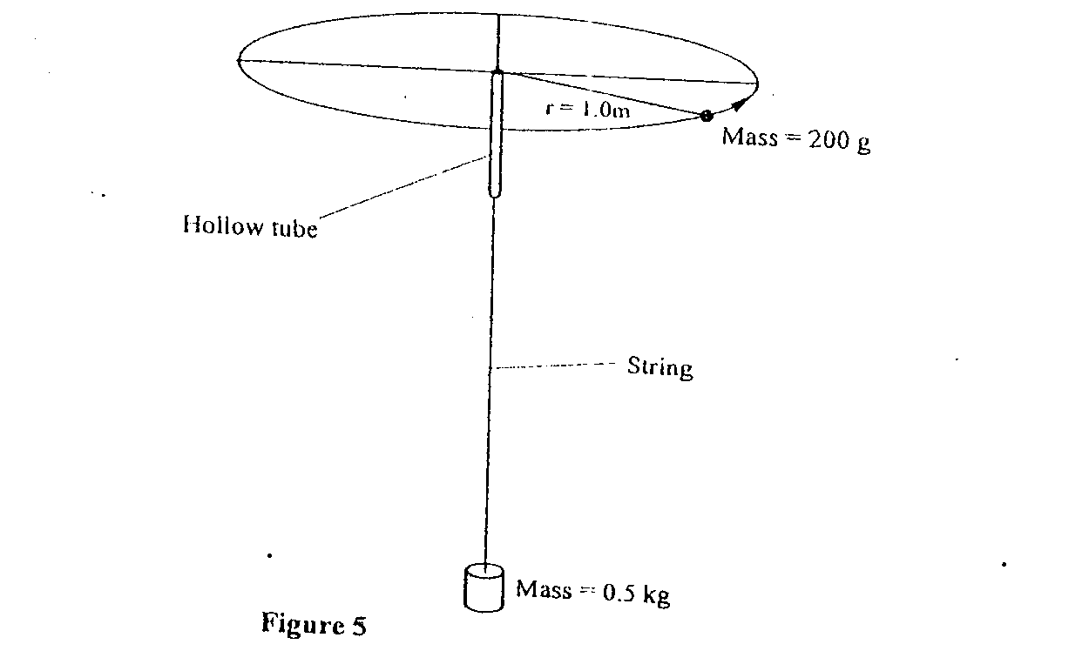
Determine the angular velocity of the 200g mass. (3 marks)
F = mw²r = mg Or F = ^{mv2}/_{v} but V = wr
0.2 x 1 x w2 = 0.5 x 10 w2 = f/mr = 0.5 x 10/0.2 x 1
w² = ⁵/_{0.2} w = 5 rad/s
w = √2.5 = 5 rad/s

- State the SI unit of a spring constant (NB in words) (1 mk)
- Newton per mete

- Figure 6 shows an athlete lifting weights while standing with the feet apart.

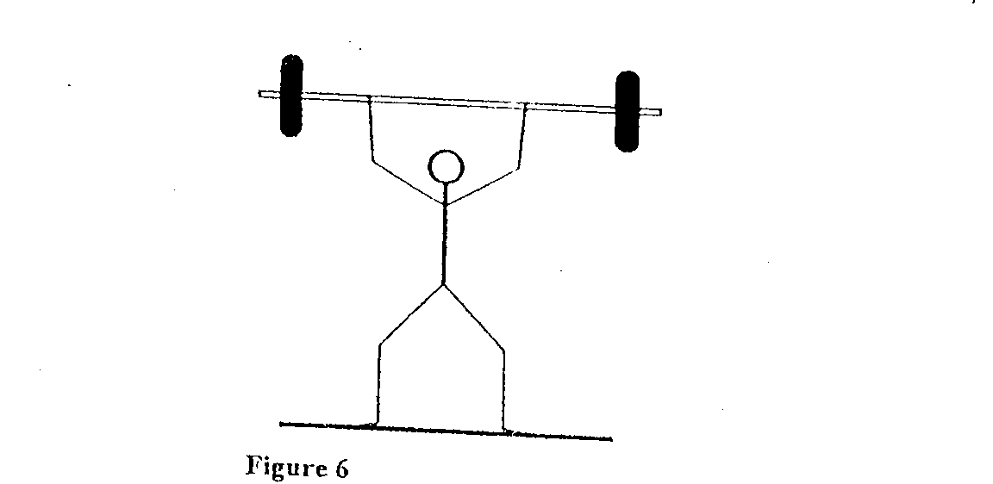

Explain why standing with the feet apart improves an athlete’s stability. (1 mk)

- Increases the base area or lowers the centre of gravity

SECTION B( Marks)
Answer all the questions in their section in the spaces provided
- a) A cyclist initially at rest moved down a hill without pedalling. He applied brakes and eventually stopped. State the energy changes as the cyclist moved down the hill. (1 mk)

Potential energy - Kinetic energy - heat + sound (sound not a must)

b) Figure 7 shows a mass of 30kg being pulled from point P to point Q with a force of 200N parallel to an inclined place. Teh distance between P and Q is 22.5m. In being moved from P to Q the mass is raised through a vertical height of 7.5m.
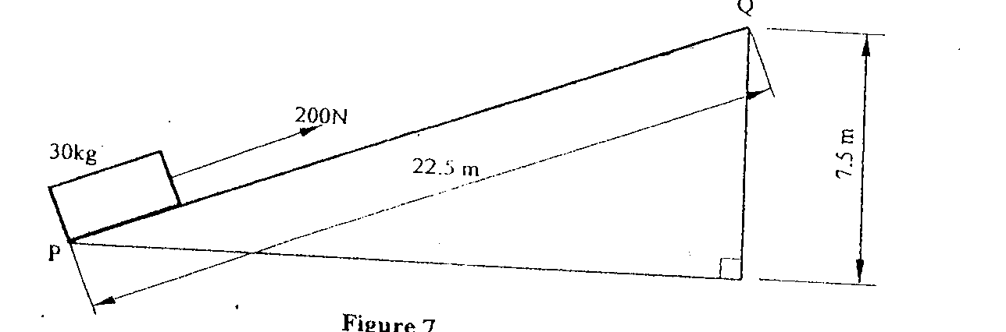

i) Determine the work done: I by the force (2mks)
work done by force = fd = 200 x 22.5
= 4500J

    - on the mass (2 mks)
= mgh = 30 x 10 x 7.5
= 2250J

    - to overcome friction (2 mks)
Work done by force - work done on mass = 4500 - 2250
= 2250J

ii) Determine the efficiency of the inclined plane. (2 mks) eff = work output x 100% OR eff = work output work input work input
2250/4500 x 100% = 50% 2250/4500 = 0.5
i.e eff - ^{MA/}_{VR} x 100% = ^{1.5/}_{22.5}/_{7.5} x 100% = 50

c) Suggest one method of improving the efficiency of an inclined plane. (1 mk) - Reduce friction by use of rollers/smoothening (polishing/oiling surface - Method of reducing friction must be stated.

- In an experiment to determine the density of sand using a density bottle, the following measurements were recorded:
Mass of empty density bottle - 43.2g
Mass of density bottle full of water = 66.4g
Mass of density bottle with some sand = 67.5g
Filled up with water = 82.3g

Use the above data to determine the:
    - Mass of the water that completely filled the bottle: (2 mks)
= 66.4 - 43.2
= 23.2g

    - Volume of water that completely filled the bottle: (1 mk)
23.2g/1gcm3 = 23.2cm3
(Nb: working must be shown)

    - Volume of the density bottle: (1 mk)
23.2cm³

    - Mass of sand
(67.5 - 43.2) g - 24.3g (working must be shown)

e) Mass of water that filled the space above the sand. (1mk)
82.3 - 67.5 = 14.8g (working a must)

    - Volume of teh sand:
Volume of the sand = volume of bottle - volume of added water
= 23.2 - 14.8
= 8.4cm3

    - Density of the sand (2 mks)
P = M/V = 24.3g = 2.893cm3
8.4cm3
(NB: at least 2 dec places)

- a) Explain why it is advisable to use the pressure cooker for cooking at high attitudes(2 mks)
- At high attitudes pressure is low so boiling point is low - So pressure cooker pressure inside it which raises boiling point - Pressure inside the cooker is higher raising the boiling point.

b) Water of mass 3.0kg initially at 20⁰C is heated in an electric kettle rated 3.0KW. The water is heated until it boils at 100⁰C. (Take specific heat capacity of water 4200jkg¹K⁻¹. Heat capacity of the kettle = 450JK-1, Specific latent heat of vaporization of water =
2.3mjkg-1)

Determine
i) The heat absorbed by the water. (1 mk)
Q = Mc∆θ or Mcθ or Mc∆T
= 3 x 4200 x 80 = 1008000J
ii) Heat absorbed by the electric kettle (2 mks)
Q = cθ / c∆θ / c∆T = 450 x 80
= 36000J
iiii) The time taken for teh water to boil (2 mks)
PL = Mc∆θ / c∆θ t = 34.8J
3000t = 1008000 + 36000
3000t = 1044000

iv) How much longer it will take to oil away all the water. (2 mks)
Mlv = Pt OR Mlv = Pt
3 x 2.3 x 10⁶ = 3000t 3 x 2.3 x 10-3 = 3000t t = 2300s t = 2.3 x 10⁻⁶s
(38.3 minutes)

- Figure 8 shows a stone of mass 4.0kg immersed in water and suspended from a spring balanced with a string. The beaker was placed on a compression balance whose reading was 85N. The density of the stone was 3000kg-3 while the density of the liquid was 800kg⁻³.

Determine the:
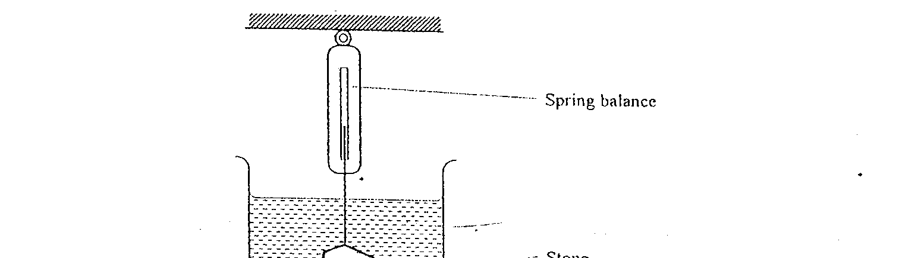
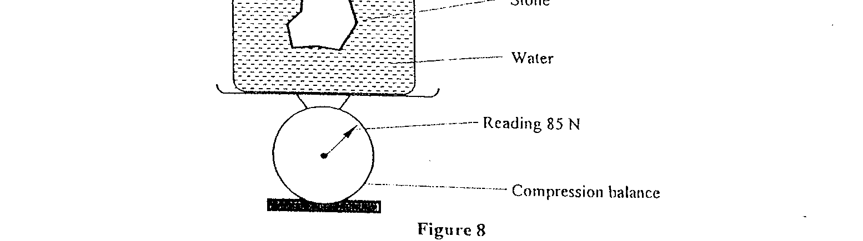
a) Volume of the liquid displaced. (2 mks)

V = m/p or V = 4/3000
V = 1.33 x 10⁻³m³
(at least 2 dec places)

    - Upthrust on the tone (4 mks)
Upthrust = weight of liquid disp = vpg upthrust = ^{weight of liquid displaced} ₌ vpg
= 800 x 1.33 x 10⁻³ x 10 = 1000 x 1.33 x 10⁻³ x 10
= 10.64N = 13.33N

    - Reading of the spring balance: (2 mks) Weight of stone air = 4 x 10 = 40N
Reading of spring balance = 40 - 10 64 = 29.36N
40 - 13.33 = 26.67N

d) Reading of the compression balance when the stone was removed from the water. (2mks)
85 - 10.64 = 74.36N or 85 - 13.33 = 71.76N

- a) Figure 9 shows a velocity-time graph for the motion of a certain body.

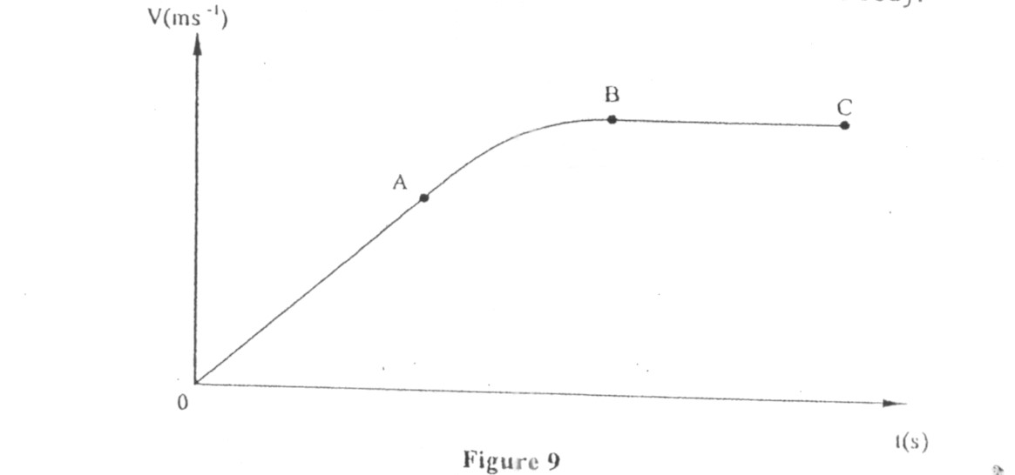

Describe the motion of the body in the region.
i) OA (1 mk)
Body moves with constant acceleration Increasing velocity or velocity increasing uniformly with time.
i) AB (1 mk)
Bodies moving with / decreasing or reducing /acceleration

iii) BC (1 mk)
Constant (uniform) velocity / zero acceleration

b) A car moving initially at 10ms⁻¹ decelerates at 2.5ms⁻²
i) Determine
I its velocity after 1.5s:
V = u + at either
V = 10- 2.5 x 1.5
V = 6.25m/s

II the distance travelled in 1.5s (2 mks)
S = ut + ¹/₂at²
S = 10(1.5) - ¹/₂(2.5) (1.5)² = 12.1875m
= 12.19m

III the time taken for the car to stop (2 mks)
V = u + at 0 = 10 - 2.5t t = 10/12 = 4s ii) Sketch the velocity-time graph for the motion of the car up to the time the car stopped. (1 mk)

iii) From the graph, determine the distance the car travelled before stopping. (2 mks)
Distance = Area of triangle
= ¹/₂ x 4 x 10 = 20M
or
S = ut + ¹/₂ at² a = gradient = -2.5m/s
S = 10 x 4 - ¹/₂ x 2.5 x 4²
S = 40 - 20
S = 20m

or
S = average velocity x time
= (10 + 0)4
2
= 20m

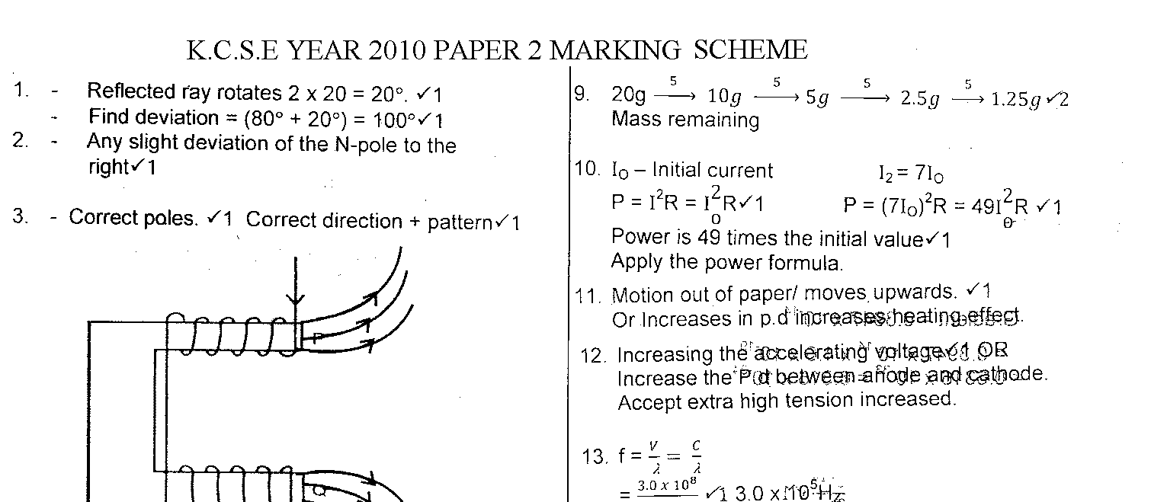
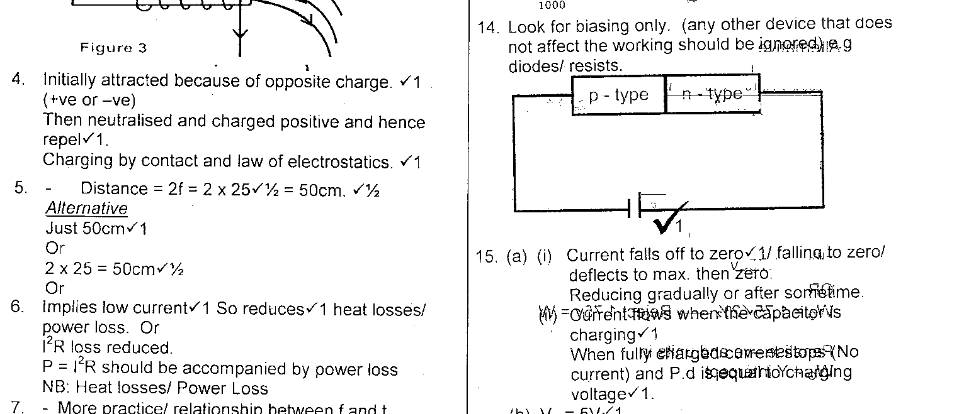
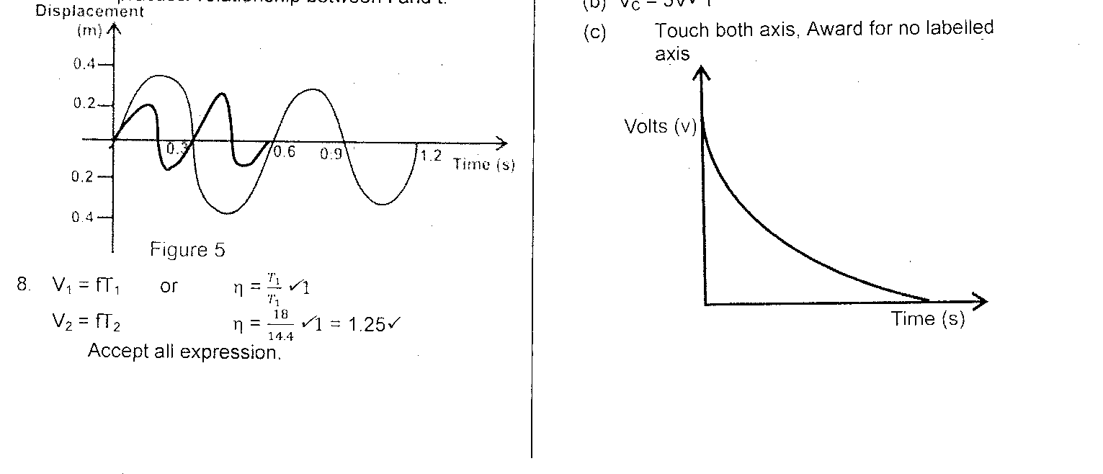
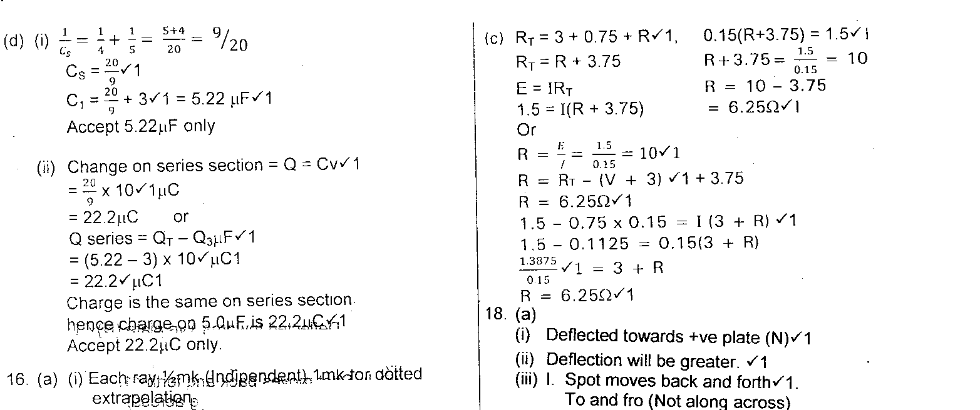
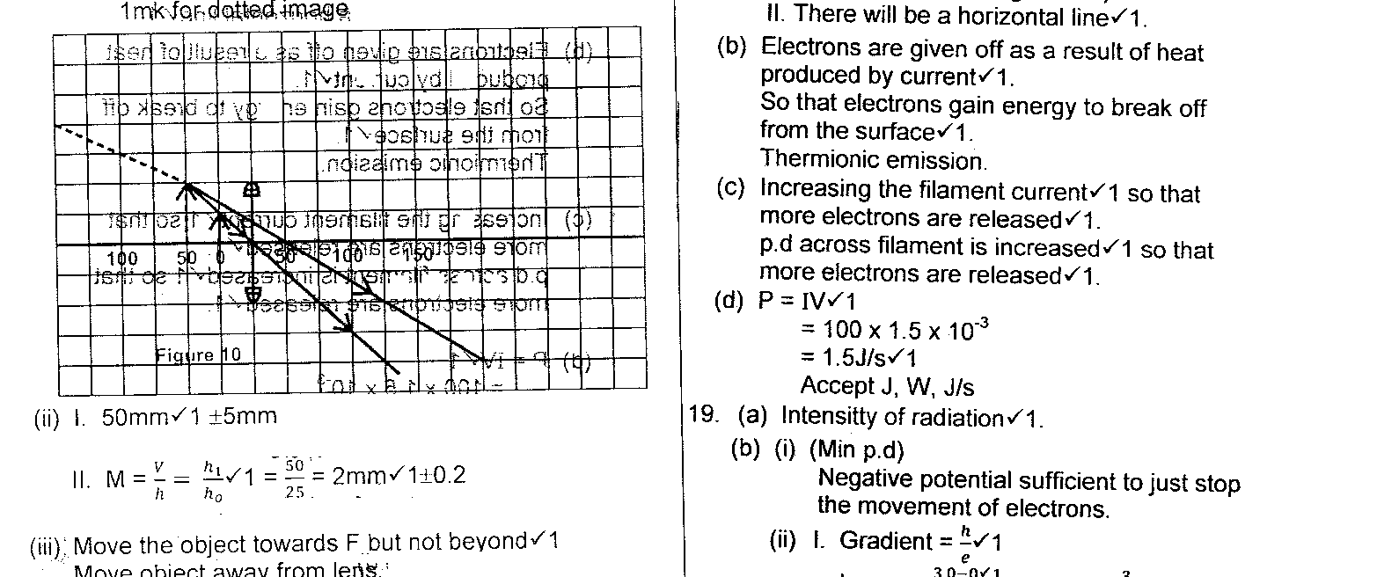
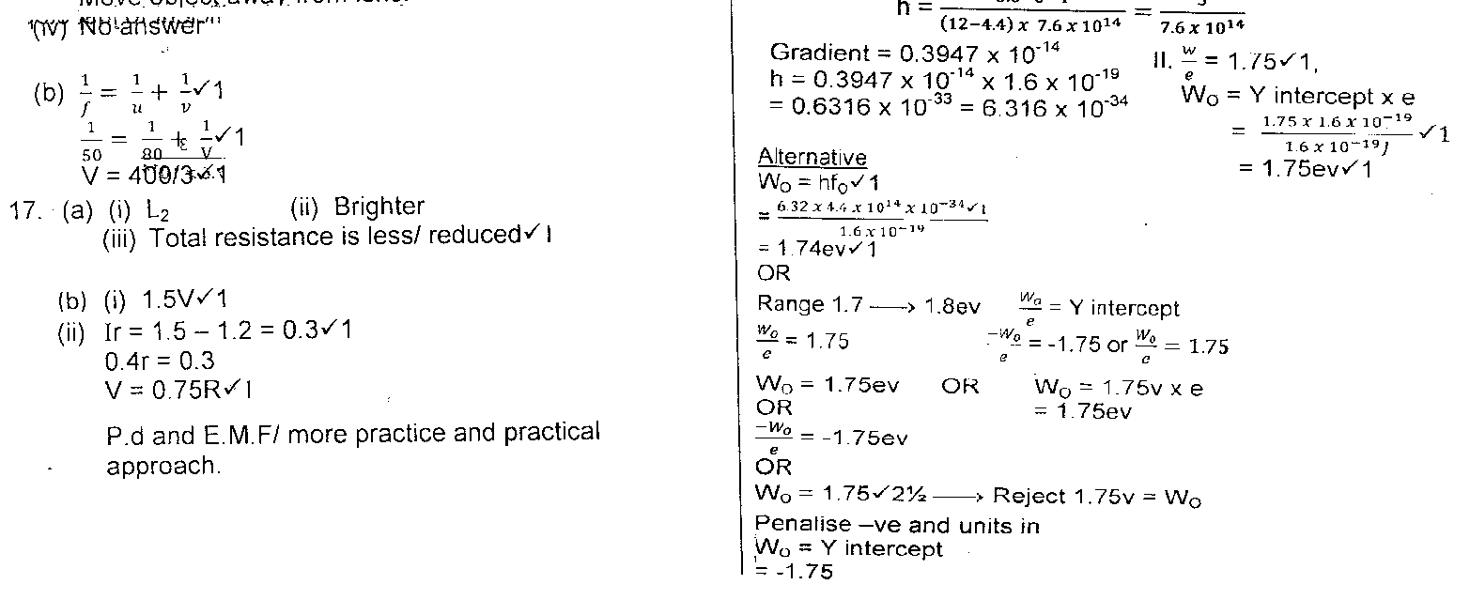
PHYSICS P 1 2011
SECTION A (25 marks)
Answer all the questions in this section in the spaces provided.
- Figure 1 shows a lorry moving on an inclined section of a straight road. At the back is a chain hanging from a point on a horizontal axis through the centre of gravity of the lorry.
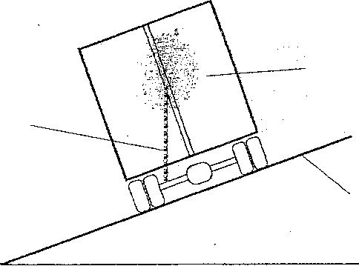

Lorry

Chain

Inclined .road

Figure 1

State with a reason whether the lorry is stable or not stable.

Stable -center of gravity is within base of lorry . or (1 mark)
Line of action of weight is within the base

- State the constant force that opposes the motion of a stone initially at rest, as it falls through air from a tall building . ( 1 mark)

upthrust

- Figure 2 shows a spring balance. It's spring constant is 125Nm⁻¹. The scale spreads over a distance of 20cm.

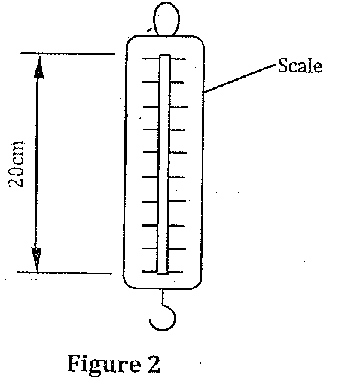

Determine the maximum weight that can be measured using this spring. (3 marks

F= Ke OR F=Ke
=125 X0.2 125 x 20
= 25 N 100
=25N
- Figure 3 shows an aluminum tube tightly stuck in a steel tube .

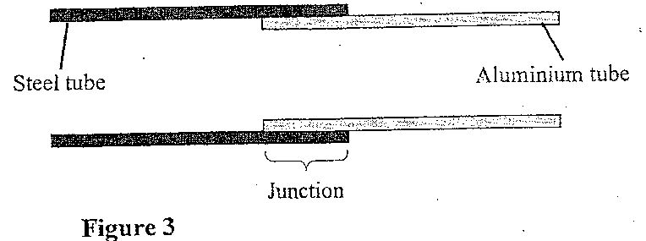
5 Explain how the two tubes can be separated by applying a temperature change at the junction given that aluminium expands more than steel for the same temperature rise.

Cooling / reduced temp
(2 marks) Aluminium contracts more /faster than steel

Figure 4 shows two identical beakers P and Q full of water at 90°C. Two similar cold wet clothes are wrapped, one around the top of P and the other around the bottom of Q.
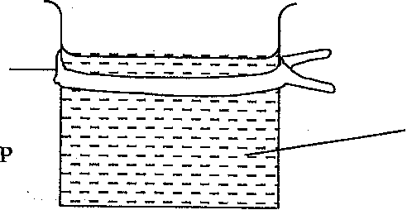
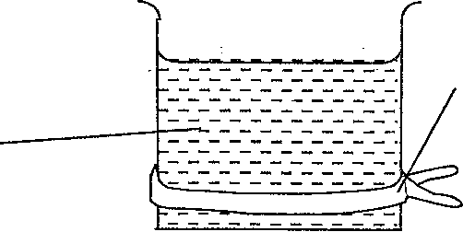
Cold Cold wet-wet
Water-

Figure 4

State with a reason, the,beaker in which the water cools faster. (2 marks)

P - cool layers from top descend and are replaced
By hot layers OR
There is complete convection currents in p

- Figure 5 is a graph of net force on a body against it's, velocity as it falls through a liquid.

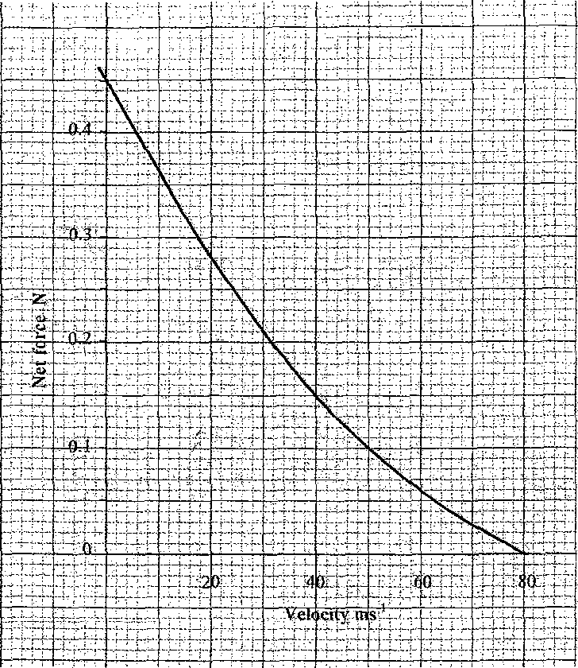
Figure 5

Determine the terminal velocity of the body. (1 mark)
80m/s

- Figure 6 shows a small toy boat floating on water in a basin. X and Y are-two points near the toy.

X

Water
Figure 6
When a hot metal rod is dipped into the water at point X, the toy is observed to move
towards Y. Explain this observation. (2 marks)
Surface tension at x is reduced / weakened / broken

Higher surface tension at y pulls the boat.

- When the temperature of a gas in a closed container is raised, the pressure of the gas increases. Explain how the molecules of the gas cause the increase in pressure.
(2 marks)

-speed of molecules increases / k.e increases / molecules move faster

-Molecules hit walls more frequently /with greater momentum /more collision per unit time

- Figure 7 shows part of a petrol engine, in which air flowing under atmospheric pressure passes into a constriction, where it mixes with petrol. The mixture then flows into a
combustion cylinder.
Atmospheric
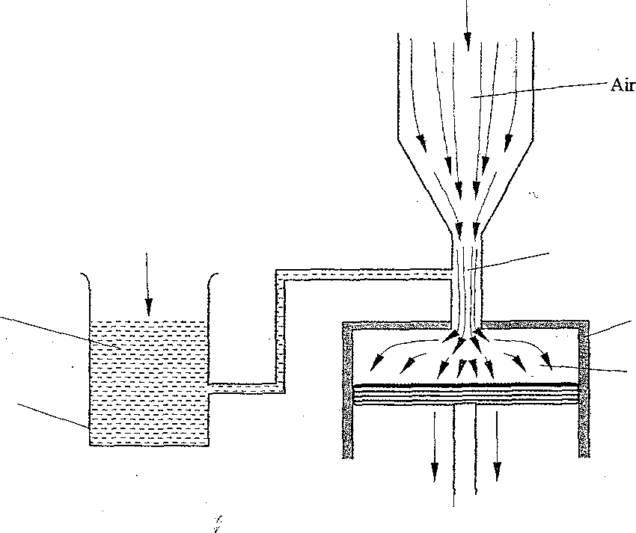
pressure

At
mosphe
ric
Constriction

Combusti
on
cylinder

Petrol/air
Petrol

Petrol
chamber

I
—
«Piston
moving

Figure 7

Explain what causes the petrol to move from the petrol chamber to the air stream in the
constriction when the piston is moved downwards. (2 marks
Air speed /verocity is higher at contraction
Pressure drops, higher pa pushes the petro either
Pressure drops or (atmospheric pressure ) pushes the petro

- State the reason why it is easier to separate water into drops than to separate a solid into smaller pieces. (1 mark
smaller /weaker intermolecular forces in liquids than solids or

smaller cohesive in liquids than in solids

Figure 8 shows a unifonn wooden block of mass 2kg and length 25cm lying on a bench. It hangs over the edge of the bench by 10cm. Use the figure to answer questions 11 and 12.

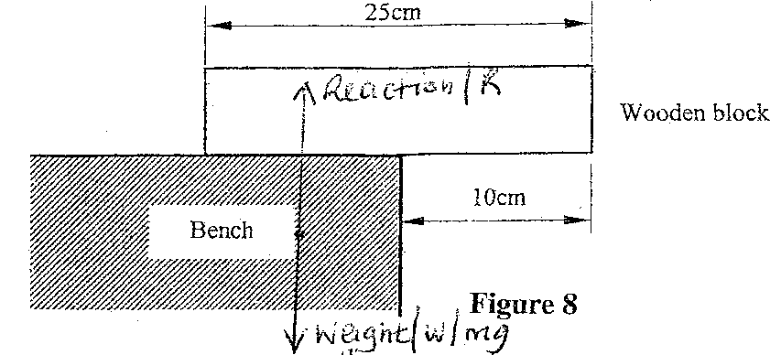NB; R&w must be
drawn a small distance from edge straight line with A
- Indicate on the figure two forces acting on the wooden block.
- Determine the minimum force that can be applied on the wooden block to make it turn
about the edge of the bench. (2 marks)
sum of clockwise moments = sum of antclockwise moments
OR F1d1 = F2d2

20 x2.5 = F x 10 or F x15 = 20 x 2.5
www.kcse-online.info

F= 5N F =3.33N (must be I three sig. fig
- A particle starts from rest and accelerates uniformly in a straight line. After 3 seconds it is 9m from the starting point. Determine the acceleration of the particle. (3 marks)
S=ut + ½ at³ OR v =u+ at OR v = u+at OR S = 1/2 (u+v)t
9 =0 + ½ x a 3² s = ½(u +v)t v = 3a 9= ½ x 3v
V= 6m/s v²= u² + 2as v =6 m/s A = 2m/s² a = v – u 9a²= 0+2a9 v =u +at t a² =2a 6= 0 +a x 3
= 6- 0 a = 0 or 2 a = 2 m/s²
3 a = 2m/s²
= 2 m/s²
- Figure 9 shows a syringe full of water. It has two identical holes A and B drilled along it's cylinder. The cylinder nozzle is closed.
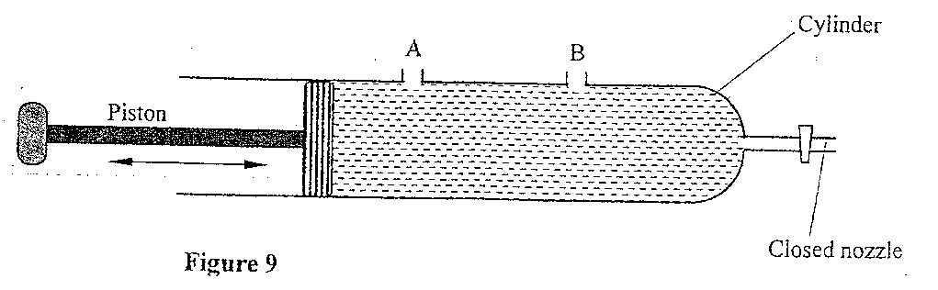
State with a reason how the speeds of the jets of water from A and B compare when the piston is pushed into the cylinder.

Identical jets / same speed

Pressure at sama level is equal / pressure is transmitted equally throughout the liquid

www.kcse-online.info

SECTION B: (55 marks)

Answer all questions in this section

- Figure 10 shows a simple pendulum of length 80cm. The pendulum bob whose mass is 50g oscillates between points A and B, through its rest position C. A and are both 10cm higher than C.
Figure 10 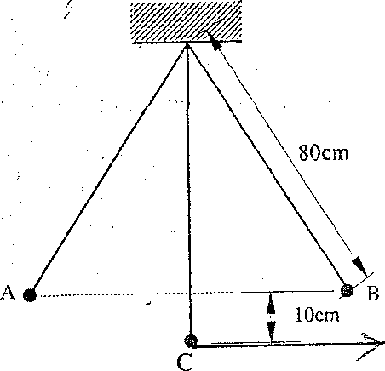
Arrow ,horizontal line and straight line
(a) (i) Indicate with an arrow, on the path ACB, the direction of the greatest velocity of the bob as it moves from A to B. (1 mark

(ii) State the form of energy possessed by the pendulum bob at point A.
1mark)
Potential energy / potential/ P. E
(3 marks)

(b)Determine:

  - the velocity of the bob at point C

www.kcse-online.info
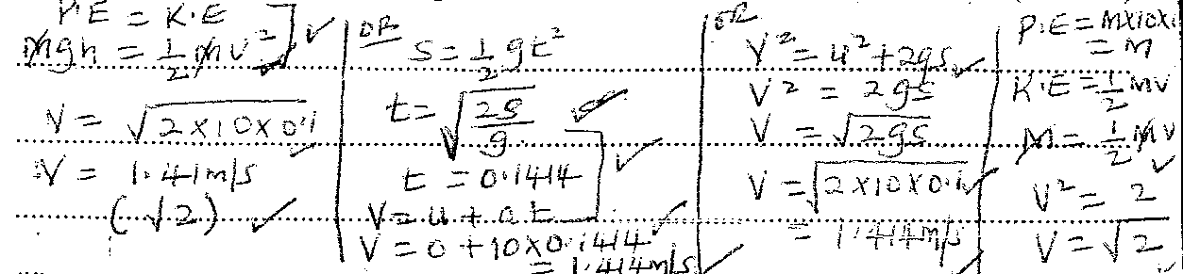

  - the tension in the string as the bob passes point C
(take acceleration due to gravity g - 10 m/s2)

T = mv² + mg
R
= 0.005 x 2 + 0.005 x 10
8
= 0.0625N

c) After some time, the pendulum comes to rest at point C. State what happens to the energy it initially possessed.
(1 mark)

used to do work against / air resistance /viscous drag / air friction or converted to heat energy

- Figure 11 shows a stone attached to the end of a string moving in a horizontal circle with a uniform speed of 2ms-¹. When the stone reaches point X on the circle, the string breaks.

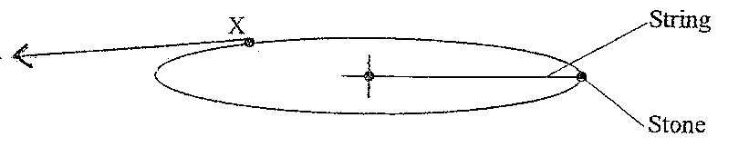

Figure 11
NB: tangent can be drawn facing the other side /must be straight (ruler used) and if extended should not cut the circle

- Indicate on the diagram with an arrow, the direction of the motion of the stone
when the string breaks. (1 mark)

(1 mark) www.kcse-online.info
- State the magnitude of the velocity after the string breaks.
2m/s
(iii)Give a reason for your answers in (i) and (ii) (1mark

Obeys Newtons first law of motion / due to its inertial /no external force act on it /centripetal force is zero (does not act on it

- Figure 12 shows a lorry towing a trailer using a rope.

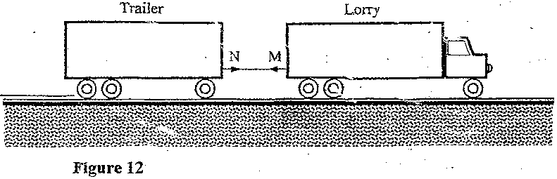

The lorry exerts a force N on the trailer and the trailer exerts an equal but opposite force M on the lorry. The frictional force between the trailer and the road is F.

Explain how the forces N, M and F enable the trailer to move. (2 marks

N > F

M does not act on the trailer

- Figure 13 shows a frictionless trolley of mass 2kg moving with uniform velocity towards a wall. At the front of the trolley is a spring whose spring constant is 25Nm⁻¹. The trolley comes to rest momentarily after compressing the spring by 3cm and then rebounds from the wall.

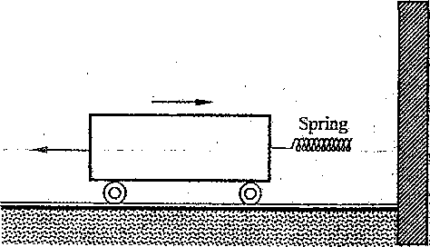
wall Trolley

Figure 13
www.kcse-online.info

(i) Determine

(I) the force exerted on the wall by the spring. (3 marks)

F = ke
= 25 x 30 = 0.75 N
100

(II) the maximum acceleration of the trolley as it rebounds from the wall.
(3 marks)
F = ma
0.75 = 2a
A = 0.375m/s²

(ii) State the reason why the trolley acquires a constant velocity after it rebounds.
(2 marks)
Force is the spring decreases as it recovers its original length
No force on the trolley after contact with wall b lost

17. (a) When the temperature of water reaches the boiling point, bubbles rise to the surface.

            - State what is contained in the bubbles. (1 mark)

Water vapour / steam

            - State the reason why bubbles rise to the surface only at the boiling point.
(1 mark)
Vapour pressure at boiling point exceeds prevailing / external pressure

(b) Figure 14 shows a graph of vapour pressure against the temperature of water vapour, in a laboratory where a mercury barometer indicates a height of 61.8 cm.
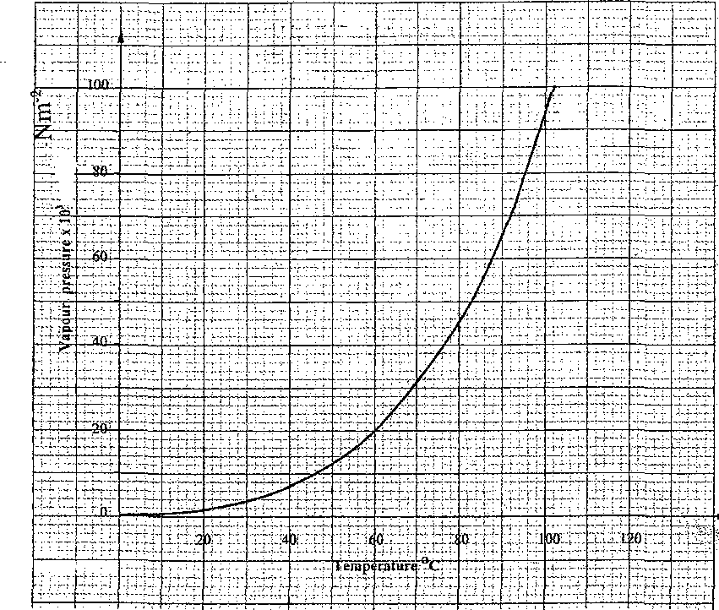
Figure 14
(b) (i) Determine the atmospheric pressure in the laboratory in Nm ⁻²
(Take g - 10m/S²and density of mercury - 13600 kg/m³). (3 marks)

P = pgh
= 13600 x 10 x 61.8
100
=840 x 10³ N/m³ or 84040N/m²

(ii) Use the graph to determine the boiling point of water in the laboratory. (1mark)

Reading of BP at p = 84 x 10³ is 96 + 1⁰c

(c) In an experiment to determine the specific heat capacity of a metal, a100g of the
metal was transferred from boiling water to a lagged copper calorimeter containing cold water. The water was stirred and a final steady temperature was realized. The following data was recorded.
Initial temperature of cold water and calorimeter = 20°C.
Temperature of boiling water = 99°C.
Final temperature of water, calorimeter and the metal = 27.7°C. Mass of cold water and calorimeter = 130g.
Mass of calorimeter = 50g.
(Take specific heat capacity of water as 4200Jkg-¹K⁻¹) (Specific heat capacity of copper as 400Jkg⁻¹K⁻¹).

Use the data to determine:
          - the heat gained by the water and the calorimeter; (3 marks)
M_{w}C_{w}D0 + Mcccdo =
0.08 x 4200 x( 27.7 -20 ) + 0.05 x 400 x (27.7 – 20) = 2741.2 j

          - the specific heat capacity of the metal. (3 marks)

Heat lost by metal = heat gained by water + calorimeter
0.1x 71.3 x c = 2741.2
c = 2741.2 =384.46J/kgk
7.13 (384J/kgk)

- State one possible source of error in the value of the specific heat capacity obtained in the experiment. (1 mark)

metal cooling is the process of transferring or metal carrying some hot water into the cold water
18. (a) Figure 15 shows a metal bolt which is threaded.

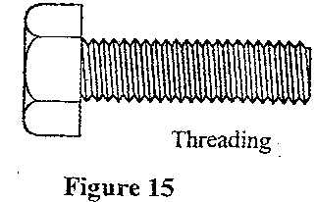
Explain how a metre rule can be used to measure The pitch (distance between
adjacent peaks) of the threading. (2 marks)

- Measure the length of threaded part
- Divide the length by number of threads /pitches divide by number of peaks – 1

- Figure 16 shows a screw jack whose screw has a pitch of .limn, and has a handle of 25 cm long.

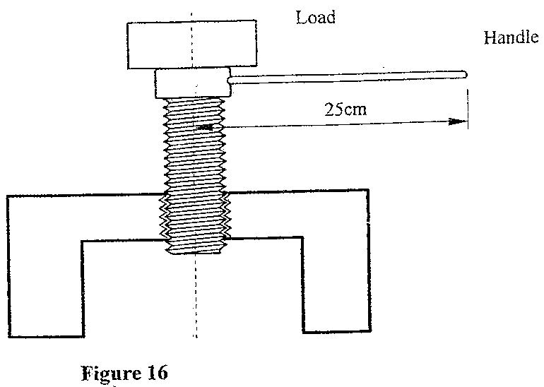
Determine the velocity ratio of the jack. (3marks)

VR = 2 Πr
Pitch
= 2 x 3.142 x0.25 = 1571.43
0.001

- A bullet of mass 60g travelling at 800ms⁻¹ hits a tree and penetrates a depth of 15 cm before coming.to rest

    - Explain how the energy of the bullet changes as it penetrates the tree. (1 mark) K.E =heat + sound OR K.E heat , sound OR K.E heat ,sound( light)
    - determine the average retarding force on the bullet.

K.E = work done against friction OR f = ma
½ mv² = fd v² =u² +2as
½ x0.006 x 800² =f x 0.15 o = 800² + 2 x0.15a
F= 12800N a =640000 =2.133333.3(2.13 x10⁶)
0.3
F = ma = 2.133x 10⁶⁴ x 60
1000

19. (a) State the condition necessary for a body to float in a fluid . (1 mark) Upthrust = weight or
Weight of fluid displaced = weight of the body or Its density is less than that of the fluid .

- A ship made of steel is observed to float on water yet the density of steel is approximately eight times that of water. Explain this observation. (2 marks)

ship has a large air space / hollow or
Average density of the ship is less than density of water
Upthrust of ship is equal to weight of the ship

- Figure 17 shows three stages of an experiment to determine relative density of cork which normally floats on water. To make it sink, a sinker is hung below the cork.
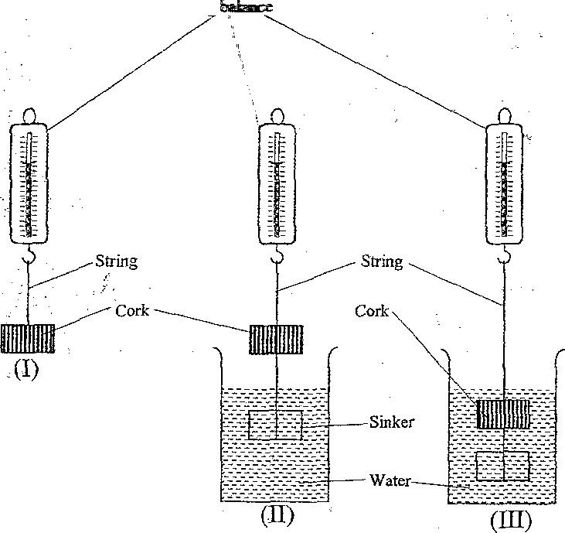

Spring balance

Figure 17

In (I) a spring balance is used to measure the weight W of the cork in air.
In (II) the spring balance is used to measure the apparent weight W₁, when only the sinker is submerged in water.
In (III) the spring balance is used to measure the apparent weight W₂ when both the cork and the sinker are submerged.
The following observations were made.
W = 0.08 N
W₁ = 0.060 N
W₂ = 0.28 N
Use this information to determine the:

- upthrust on cork. (3marks)

Upthrust = w1 - w2
= 0.60-0.28
= 0.32 N

- relative density of cork. (3 marks
RD = weight of substance = wt of cork Weight of equal volume upthrust

= 0.08
0.32
= 0.25

(d) Figure 18 shows parts of a simple submarine, a ship that can travel both on water and under water.
To do this water is pumped in or out of the ballast tanks.

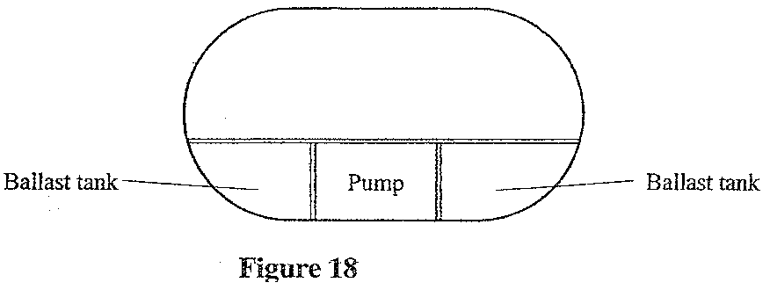

Explain how the tanks are used to change the depth of the submarine. 2 marks)

To sink , water is allowed into ballast tanks

To float , pumps are used to expel water from ballast tanks

PHYSICS 2011 PAPER 2
MARKIKNG SCHEMES
PHYSICS PAPER 2
MARKING SCHEMES
Section1 (25 marks)
Answer all the questions provided in this section in the space provides
1. Figure 1, shows an object placed in front of a plane mirror.
Objec

Figure 1,

Sketch the image of the object as seen in the mirror.

2. Figure 2, shows two identical pithballs A and B suspended with insulated threads. They are separated by an insulator X. A is positively charged while B is negatively charged, The quantity of charge on A is three the quantity of charge on B.
www.kcse-online.info

+++
+++
-
-
A
B
+++
+++
+++
+++
B
A

Figure 2.

Sketch on the space beside the figure.t he final position of the pithballs after the insulator is
removed. {1 mark)

- Figure 3, shows a voltmeter connected across two charged parallel plates.
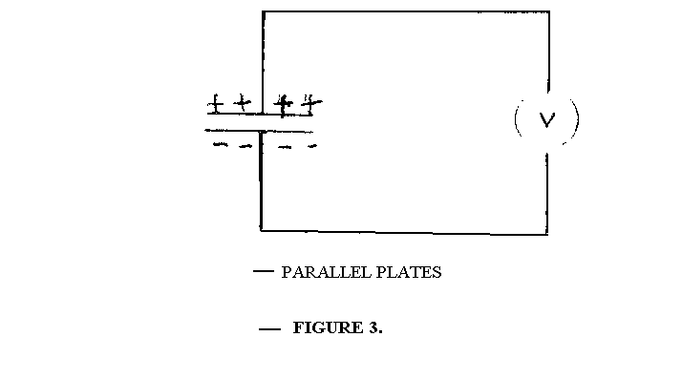

When a thin sheet of mica is inserted between the planes, the voltmeter reading is observed to
reduce. explain (his observation. (3 marks’)

Mica hashigh permitivivity /diletric constant/ raises capacitance hence lower potential difference since V = Q/C but Q is constant

Figure 4, shows the cross-section of a dry cell. Use the information on the figure to answer questions 4 and 5.
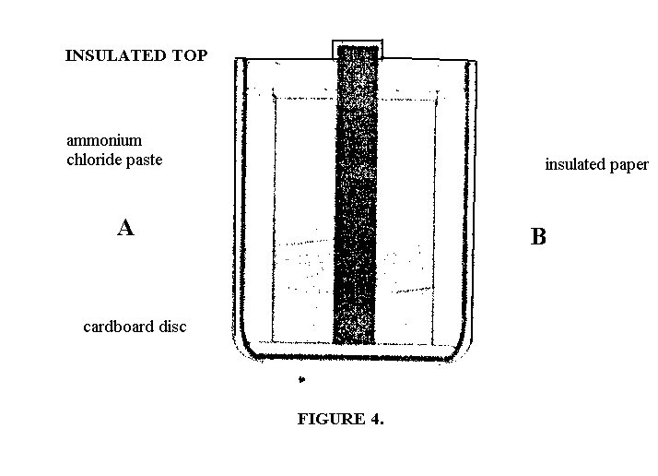

- Name the parts labeled A and B. (2 marks)
A-carbon rod /graphite
B- manganese (iv) oxide + powered carbon
- State the use of the manganese (IV) oxide in the cell. (1 mark)
Manganese (iv) oxide is a depolarizer / oxidizing agent / oxidizes hydrogen to water /reacts with hydrogen to form water .

- One method of producing a weak magnet is to hold a steel rod in the North South direction and then hammer it continuously for some time. Using the domain theory of magnetism explain how this method works.
(2 marks)
Hammering causes domains / dip lets to vibrate/ disturbs
As they settle , some face north –south due to earth ‘s magnetic field.

Figure 5, shows a motor connected to a magnetic switch called a relay operated by an ordinary switch S₁ . Use the information in the figure to answer questions 7 and 8.
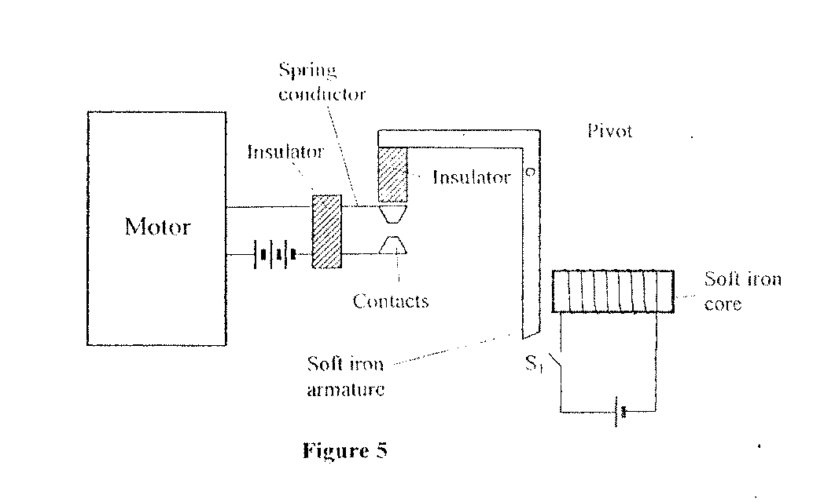
- Explain how the relay switches on the motor when S ₁ is closed. (3 marks)
When S is closed , current flows in solenoid magnetizing the iron , this attracts the iron armature closing the contacts this causes current to flow in the motor circuit / contact closes / switches on the motor / motor keep running continuously

- State with a reason the effect on the motor, if the iron core is replaced with a steel core and switch S ₁ is put on and then off. (2 marks)

Steel would remain permanently magnetized causing current in motor circuit to remain on when S is open.
Reason: 'Takes a Conger time to start; once switched on motor runs continoulsly
Not easily magnetisedanddemagnetised Hard magnetic material/permanent magnet.

- Figure 6, shows standing waves on a string, It is drawn !o a scale of 1:5
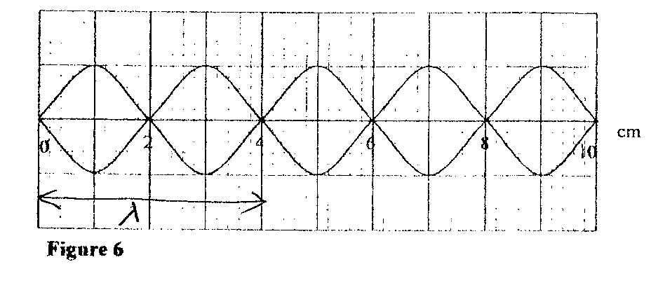
  - Indicate on the diagram the wavelength of the standing wave.
  - Determine the wavelength of the wave.

25A = 1O X 5
= 2OCm/ O.2m

- Figure 7, shows two rays of light incident normally on face PQ of a glass prism, whose critical angle is 42°.
2
nd
&3
rd
mark tied)

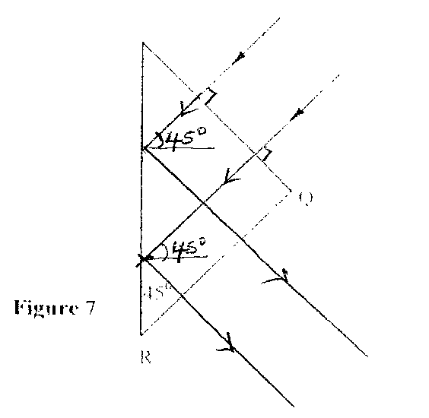
Complete the diagram to show the paths of the two rays as they pass through the prism.
(3 marks)

- A 4Ώ resistor is connected in series to a battery of e.m.f 6V and negligible internal resistance.
Determine the power dissipated by the resistor. (2 marks)

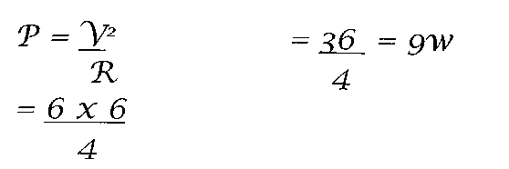

- Table 1 shows radiations and their respective frequencies.

Table I
Type of radiation | Yellow light | Gamma rays | Radio waves | Micro waves
Frequency (Hz) | 15  1 x 10 | 22 6 11  1 x 10 I x 10 I x 10

Arrange the radiations in the order of increasing energy. (l mark)

Radio waves microwaves yellow light gamma rays

- State the reason why electrical power is transmitted over long distances at very high voltages.
(1 mark)
High voltage leads to low current hence low power (RR)losses energy loss

- State the meaning of the term "threshold frequency" as used in photoelectric emission.
(1 mark)

The minimum frequency of an incident adiation to cause emission of photo electrons/photo emission/ to eject/ to dislodge/ remove electrons,

SECTION B ( 5 5 marks)
Answer all the questions in this section in the spaces provided.

15.
a) Figure 8, shows graph of potential difference V (volts) against a current (ampere) for a certain device.
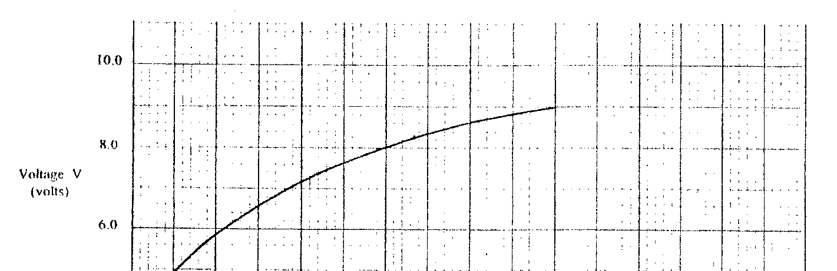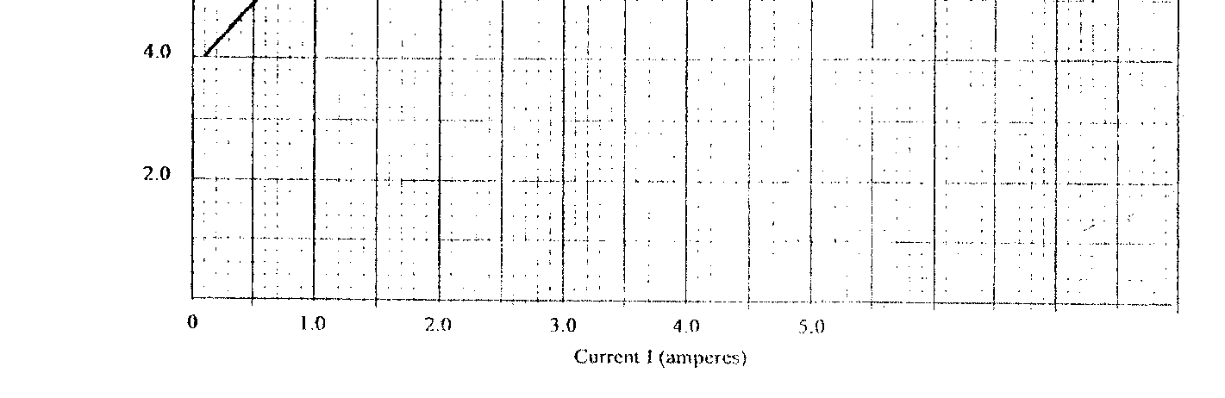

From the graph:
  - state with a reason whether or not the device obeys ohms law (2 marks)
Does not obey ohm Is law
The graph is not a straight line through the origin (non-linear not acceptable) current is not
directly proportional to p.d.

  - determine the resistance of the device at
    - 1 = 1.5A
R=gradient at I/ showing the tangent
= 9.2-4.8
36-c

    - I = 3.5A
R = gradient of tangent at I showing the tangent
9.4 - 7.2
5.4 - 1.5
=2.2 = 0.56 = 0.1(0.46 – 0.66)
3.9

  - From the results obtained in (ii) slate how the resistance of (the device varies as the current increases. (1 mark)
Resistance decreases as the current increases

  - State the cause of this variation in resistance. (1 mark) Change (increase) in temperature/ temperature is constant.

(b) Three identical dry cells each of e.m.f. 1.6V are connected in series to a resistor of 11.4Q. A current of 0.32A flows in the circuit. Determine:
- the total e.m.f. of the cells; (1 mark)
V _{total} =1.6 + 1.6 +1.6 = 4.8 v = E

- the internal resistance of each cell; . (3 mark)
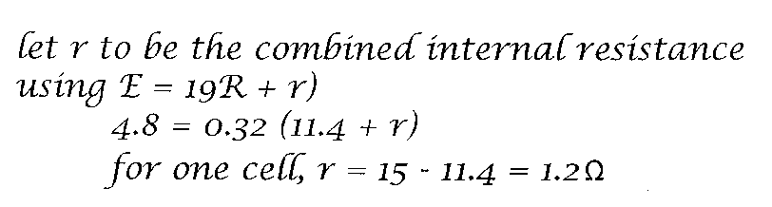

16. (a) State the meaning of the term "principal focus" as applied in lenses. (1 mark) - a biconvex lens and lens holder.
- a lit candle.
- a white screen.
- a metre rule

www.kcse-online.info

(i) Draw a diagram to show how you would arrange the above apparatus to determine the focal length of the lens

u

L

V

Screen
Candl
Len

- You are provided with the following apparatus to determine the focal length of a lens:
(1 mark)
  - Describe the procedure you would follow.
candle is placed at a certain distance from the lens. The distance Between tile screen/ and the lens is adjusted until a sharp image is focused on screen/ clear image.

  - State two measurements that you would take. (2 marks) The distance of candle from lens (u) is measured.
The distance of screen from lens (v) is also measured.

  - Explain how the measurements in (iii) would be used to determine (the focal length.

- An object is placed 30cm in front of a concave lens of local length 20cm. Determine the magnification of the image produced.(4 marks)

www.kcse-online.info

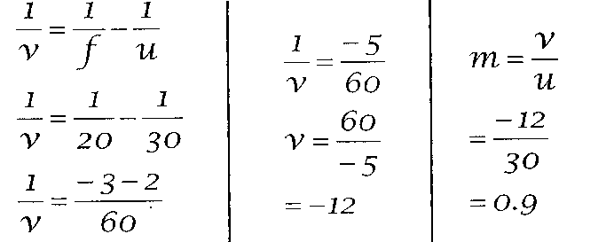

17.
- State what is meant by “electromagnetic induction” (1 mark)

The production of induced emf when the magnate flux linking a circuit is changed.

- Figure 9, shows a simple electric generator
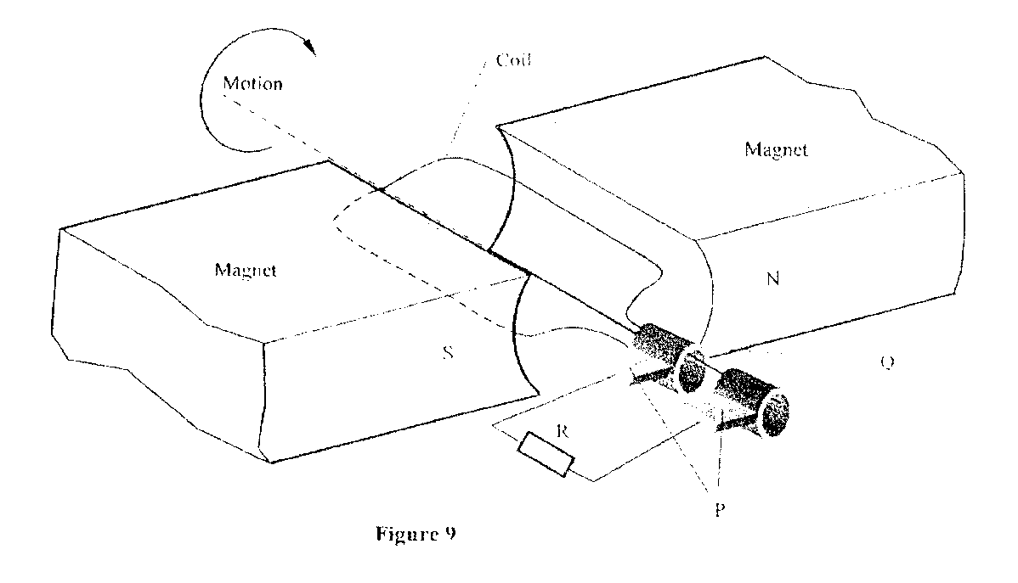
  - Name the parts labeled P and Q. (2 marks)
    - brushes /carbon /graphite
    - slip rings

  - Sketch on the axes provided, a graph lo show how the magnitude of the potential difference
across R, changes with the lime I (1 mark)

  - State two ways in which the potential difference produced by such a generator
can he increased. (2 marks)
Increasing number of turns/ coils
Increasing speed of rotation/ rate of rotation
Winding coil on soft iron cord
Increasing area/ size

(c) In a transformer, the ratio of primary turns to the secondary turns is 1:10. A current of 500mA flows through a 200Q resistor in the secondary circuit. Assuming that the transformer is 100% efficient, determine:
    - the secondary voltage; (1 mark)
Vs = 200 X 0.5
= 100v
    - the primary voltage: (2 marks)
NP = VP
NS VS
VP = 100 x 1 = 10v
10

    - the primary current. (2 marks)

VP = IS I P = 0.5 X 100
VS = IP 10
I = 5A

18. (a) State two differences between cathode rays and electromagnetic radiations. (2marks)

- cathode rays are deflected By magnetic or electric field EM can not be deflected.
- cathode rays are produced By thermometric emission while E.M originate from the changes in nucleus.
- Cathode rays have charge but e.m radiations don't have charge
- Cathode rays are particles and have a mass but cm radiations are waves
- Cathode rays trave lat a speed depending on the accelerating voltage e.m radiations travel at the speed of light vacution.

  - Figure 10, shows the main features of a cathode ray oscilloscope (CRO).

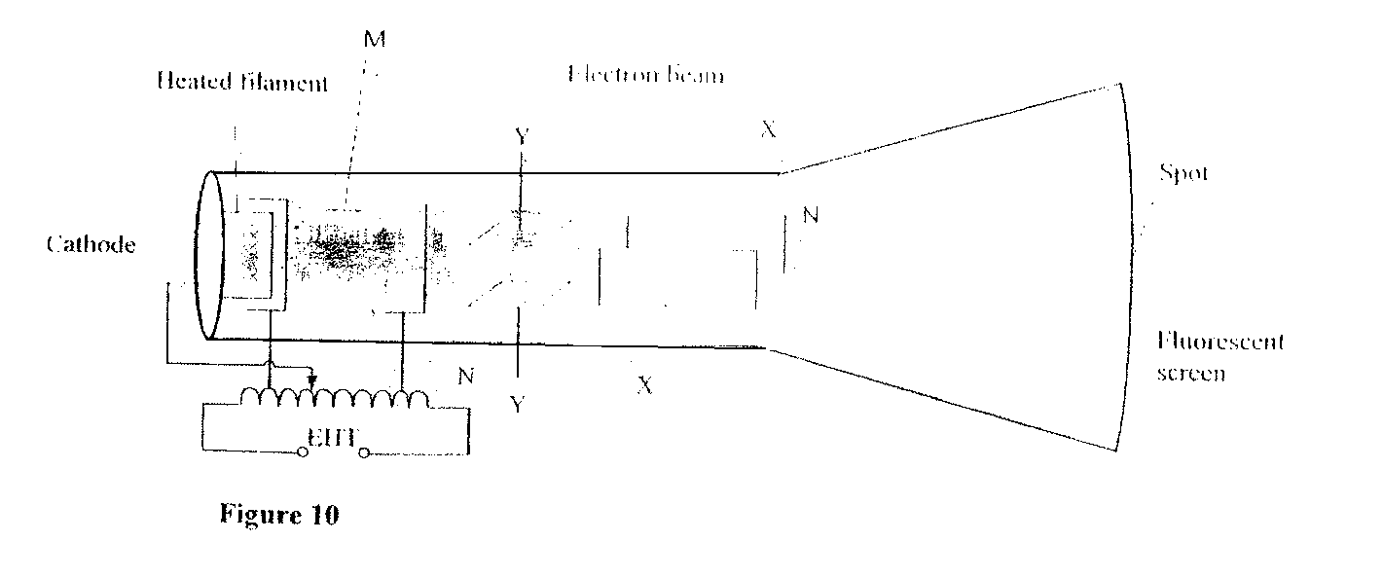
(i) Name the parts labelled M and N (2marks)

        - - grid
        - - accerelating anode / anode
N - vacuum space / evacuated space
    - Explain how electrons are produced in the tube. (2marks)
Cathode is heated by filament; electrons are released from cathode; by thermionic emission/ hot filament emits electrons

    - When using the CRO to display waveforms of voltages, stale where the following should be connected:
          - the voltage to be displayed on the screen; (1marks)
across y - plates / horizontal plates.

          - The time base voltage (1marks)
Across x plates / vertical plates
    - state why the tube is highly evacuated. (1marks) to reduce collisions, (hence ionization) with air molecules in the tube.

  - Figure 11, shows the waveform of a voltage displayed on the screen of a CRO. The Y-gain calibration was 5V per cm.

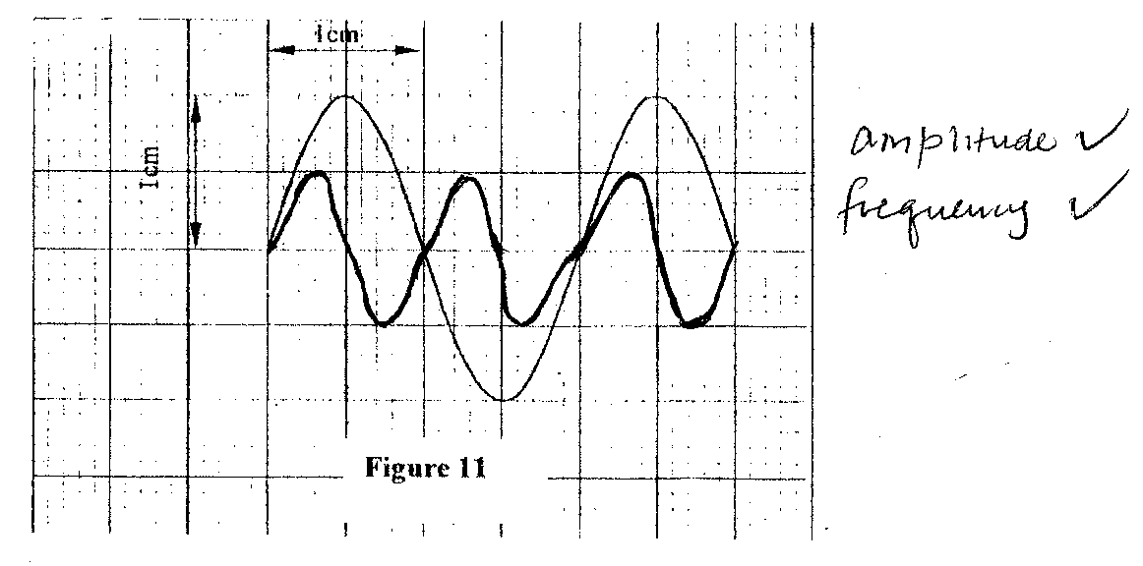
www.kcse-online.info

      - Determine the peak-to-peak voltage of the Y-input. (1mark)
Peak - to - peak voltage = 5 x 2
= 10v

      - Sketch on the same figure the appearance of the waveform after the voltage of the input signal is halved and it's frequency is doubled. (2 marks)
x - radiation / Alpha ⁴₂ He²⁺ short range with intense ionization hence tracks / massive /high ionization .

19. When a radiation was released into a diffusion cloud chamber, short thick tracks were observed. State with a reason, the type of radiation that was detected. (2 marks)

- The half-life of an element X is 3.83 days. A sample of this element is found to have an activity rate of
1.6 x 101 disintegrations per second at a particular time.
Determine its activity rate after 19.15 days. (2 marks)
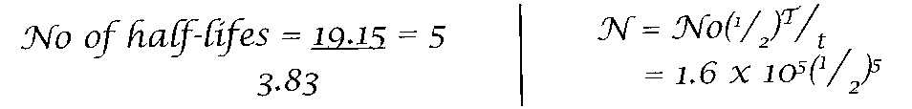

- State what is meant by an extrinsic semiconductor. ( 1 mark)
A semiconductor in which impurities have been added to change conductivity/ improve/ enhance conductivity.
pure semi-conductor which has been doped Impure semi-conductor

- Figure 12, shows n depletion layer in an unbiased p-n junction.

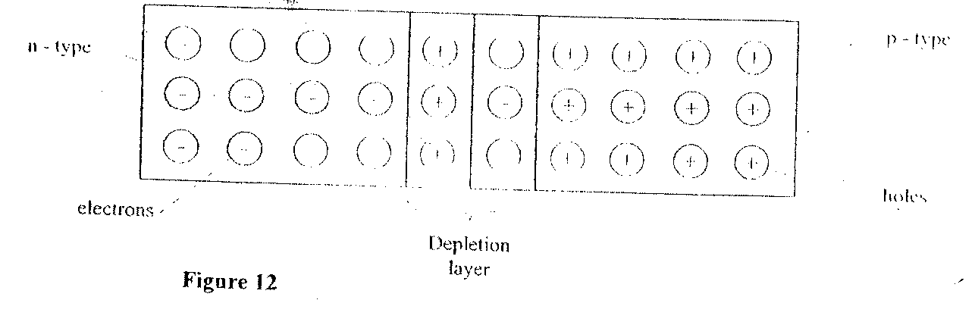

SKYDREAMERS PRODUCTION

State how a battery can be used to make the depletion layer narrower. ( 1 mark)

By connecting it in forward broad mode (ie p to + and n to -)

- Figure 13, shows an incomplete circuit of a full wave rectifier.

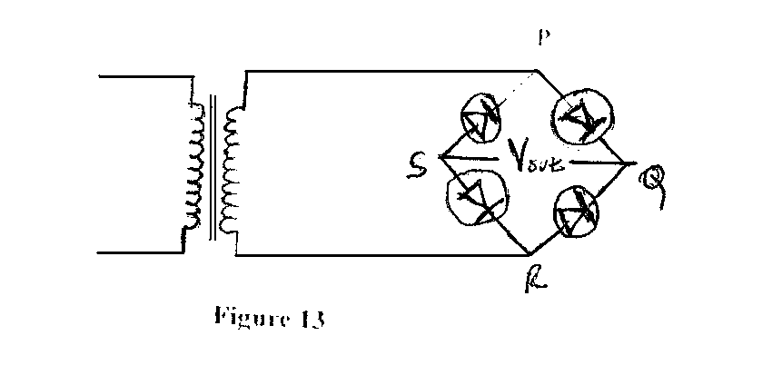
      - Draw in the figure two more diodes to complete the circuit. (2 marks)

      - Show on the figure the points across which the output of the rectifier should he obtained. (1 mark)

SKYDREAMERS PRODUCTION

