K.C.S.E YEAR 2010 PAPER 1
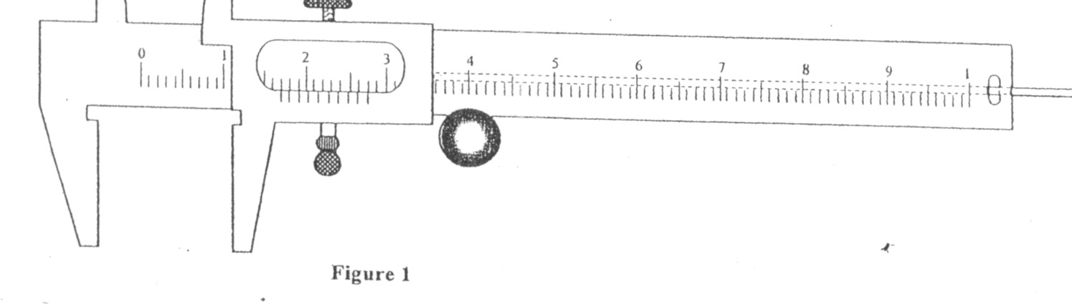
1.

Figure 1 shows a vernier caliper being used to measure the internakl di
ameter of a tube.

- A stop watch started 0.50s after the started the start button was pressed. The time recorded using the stopwacth for a ball bearing failing through a liquid was 2.53s. Determine the time of fail.
- Some water in a tin can was boiled for some time. The tin can then sealed and cooled. After some time it collapsed. Explained this observation.
- A paper windmill in a horizontal axis was placed above a candle as shown in figure 2.
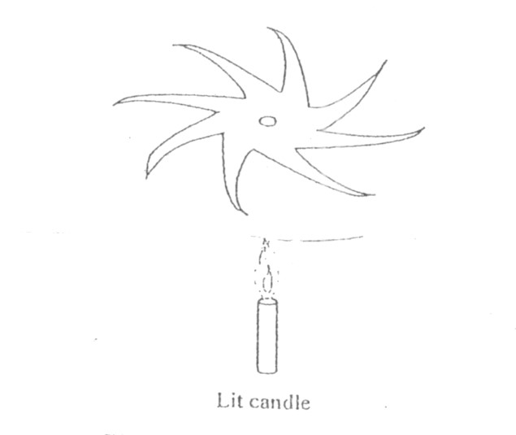
When the candle was lit the paper windmill begun to rotate. Explain this observation.
- When a liquid is heated in a glass flask, its level at first fails, mthen rises. Explain this observation.
- Figure 3 shows a uniform metre rule pivoted at 30cm mark. It is balanced by weight of 2N suspeded at the 5cm mark.
5cm 30cm

2N

Determine the weight of the metre rule.
- Figure 4 shows a horizontal tube with rwo vertical tubes x and y. water flows through the horizontal tube from right to left. The water level in tube x is higher than water in tube y.
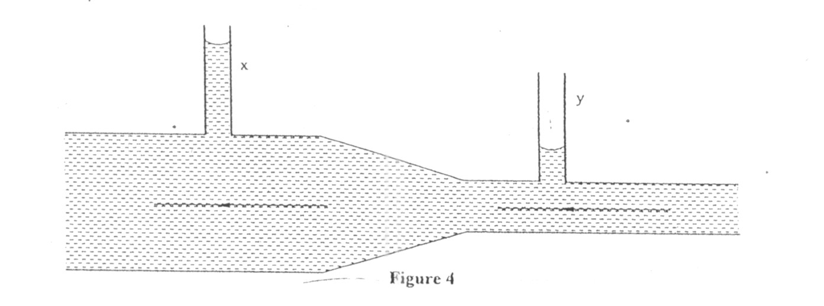

Explain this observation.
- A cart of mass 30kg is pushed along a horizontal path by a horizontal force of 8N and moves with a constant velocity. The force is then increased to 14N. determine:
  - The resistance to the motion of the cart.
  - The ecceleration of the cart.
- When a drop of oleic acid of known volume is dropped on the surface of water in a large trough, it spreads out to form a large circular patch. State one assumption made when the size of the molecule of oleic acid is estimated by determining the area of the pacth.
- The weight of a solid in air is 5.0N. when it is fully immersed in a liquid of density 800kgm⁻³ its weight is
4.04N. determine:
  - The upthrust in the liquid
  - The volume of the solid.
- When a bicycle pump was sealed at the nozzle and the handle slowly pushed towards the nozzle, the pressure of the air inside increased. Explain this observation. (1 mk)
- Figure 5 shows a mass of 200g connected by a string through a hollow tube to a mass of 0.5kg. Teh
0.5kg mass is kept stationary in the air by whirling the 200g mass round in a horizontal circle of radius 1.0 metre.
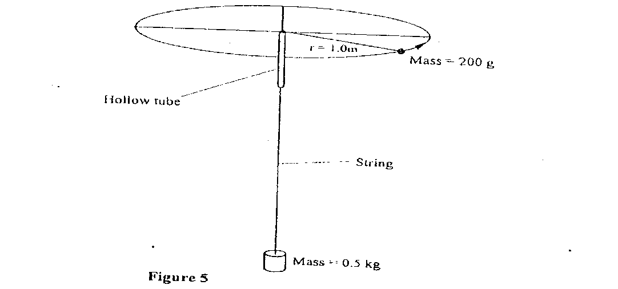
Determine the angular velocity of the 200g mass. (3 marks)
- State the SI unit of a spring constant (NB in words) (1 mk)
- Figure 6 shows an athlete lifting weights while standing with the feet apart.

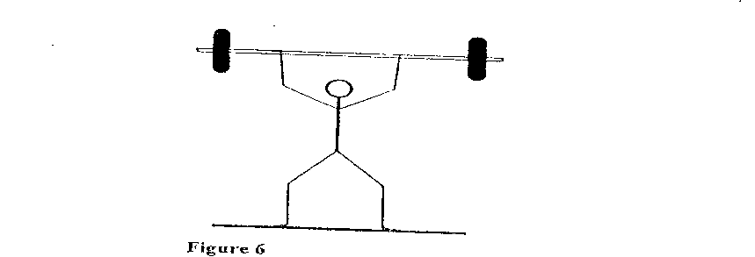

Explain why standing with the feet apart improves an athlete’s stability. (1 mk)

SECTION B( Marks)
Answer all the questions in their section in the spaces provided
- a) A cyclist initially at rest moved down a hill without pedalling. He applied brakes and eventually stopped. State the energy changes as the cyclist moved down the hill. (1 mk)
b) Figure 7 shows a mass of 30kg being pulled from point P to point Q with a force of 200N parallel to an inclined place. Teh distance between P and Q is 22.5m. In being moved from P to Q the mass is raised through a vertical height of 7.5m.
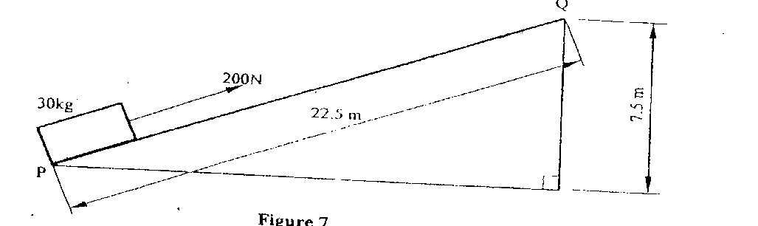

  - Determine the work done: I by the force (2mks)
II on the mass (2 mks)
  - Determine the efficiency of the inclined plane. (2 mks)
c) Suggest one method of improving the efficiency of an inclined plane. (1 mk)
- In an experiment to determine the density of sand using a density bottle, the following measurements were recorded:
Mass of empty density bottle - 43.2g
Mass of density bottle full of water = 66.4g
Mass of density bottle with some sand = 67.5g
Filled up with water = 82.3g

Use the above data to determine the:
  - Mass of the water that completely filled the bottle: (2 mks)
  - Volume of water that completely filled the bottle: (1 mk)
  - Volume of the density bottle: (1 mk)
  - Mass of sand
  - Mass of water that filled the space above the sand. (1mk)
  - Volume of teh sand:
  - Density of the sand (2 mks)
- a) Explain why it is advisable to use the pressure cooker for cooking at high attitudes(2 mks)
b) Water of mass 3.0kg initially at 20⁰C is heated in an electric kettle rated 3.0KW. The water is
heated until it boils at 100⁰C. (Take specific heat capacity of water 4200jkg¹K⁻¹. Heat capacity of the kettle = 450JK-1, Specific latent heat of vaporization of water = 2.3mjkg-1)

Determine
  - The heat absorbed by the water. (1 mk) ii) Heat absorbed by the electric kettle (2 mks) iiii) The time taken for teh water to boil (2 mks) iv) How much longer it will take to oil away all the water. (2 mks)
- Figure 8 shows a stone of mass 4.0kg immersed in water and suspended from a spring balanced with a string. The beaker was placed on a compression balance whose reading was 85N. The density of the stone was 3000kg-3 while the density of the liquid was 800kg⁻³.

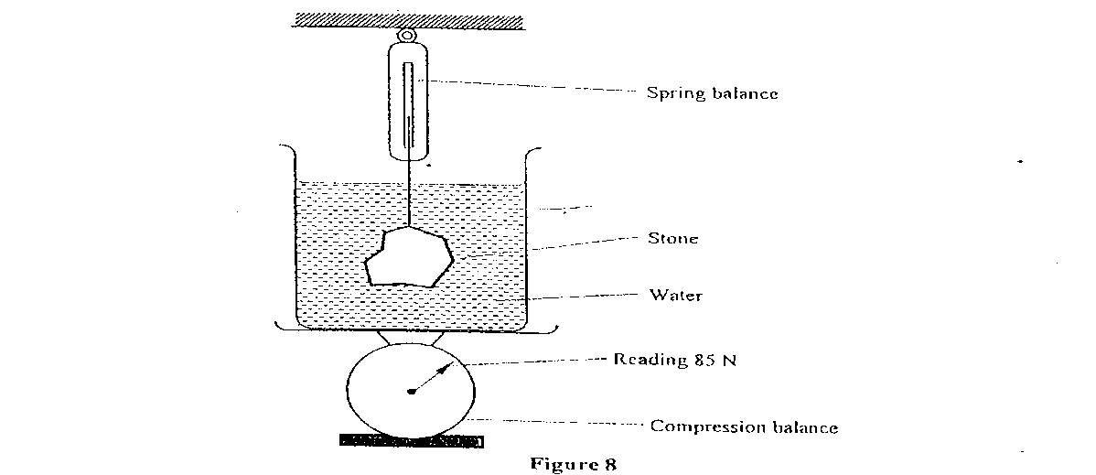
Determine the:
  - Volume of the liquid displaced. (2 mks)
  - Upthrust on the tone (4 mks)
  - Reading of the spring balance: (2 mks)
  - Reading of the compression balance when the stone was removed from the water. (2mks)
- a) Figure 9 shows a velocity-time graph for the motion of a certain body.

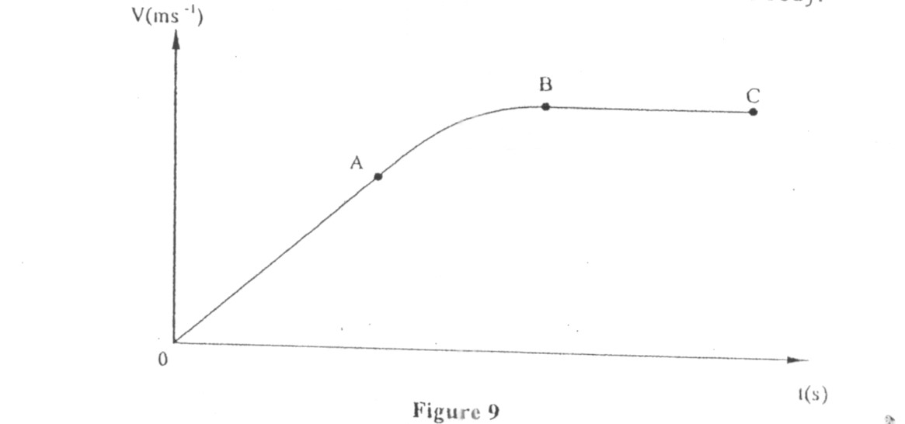

Describe the motion of the body in the region.
  - OA (1 mk)
i) AB (1 mk) iii) BC (1 mk)
b) A car moving initially at 10ms⁻¹ decelerates at 2.5ms⁻²
- Determine
- its velocity after 1.5s:
- the distance travelled in 1.5s (2 mks) III the time taken for the car to stop (2 mks)
- Sketch the velocity-time graph for the motion of the car up to the time the car stopped. (1 mk)

- From the graph, determine the distance the car travelled before stopping. (2 mks)

K.C.S.E YEAR 2010 PAPER 2
SECTION A (25 marks)
Answer ALL the questions in this section in the spaces provided.
- Figure 1, shows a ray of light incident on a plane mirror at O. The mirror is then rotated anticlockwise about O from position M to position M₂ through an angle of 10°. The final reflected rayisOC.
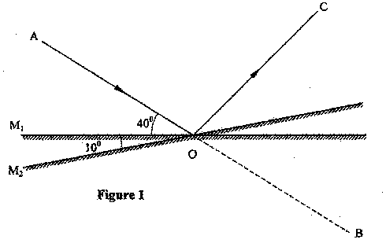
Determine the angle of deviation BOC.
- Figure 2(a), shows a magnetic compass placed under a horizontal wire XY
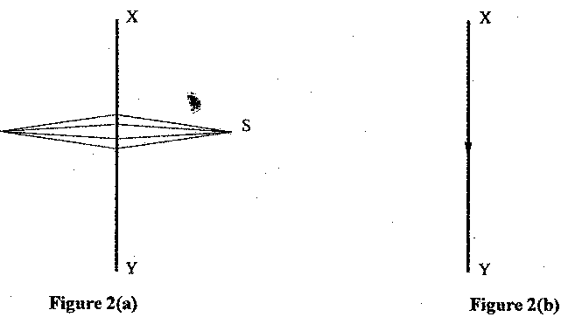
A large current is passed from X to Y. Draw the final position of the magnetic compass needle in figure 3. Figure 3, shows a diagram of a current-carrying wire wound on a U-shaped soft iron
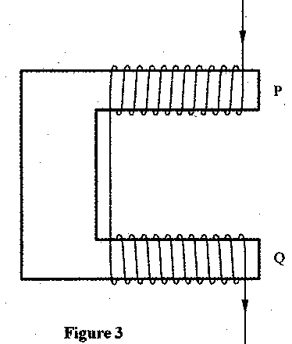
Draw the magnetic field pattern around P and Q.
- A positively charged sphere is suspended by an insulating thread. A negatively charged conductor is suspended near it. The conductor is first attracted, after touching the sphere it is repelled. Explain this observation.
- Figure 4, shows a bright electric lamp placed behind a screen which has a hole covered with a wire gauze. A concave mirror of focal length 25cm is placed in front of the screen. The position of the mirror is adjusted until a sharp image of the gauze is formed on the screen.

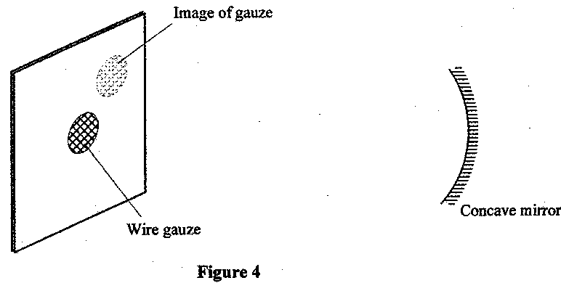
Determine the distance between the mirror and the screen.
6 Explain why electric power is transmitted over long distances at high voltages.
- Figure 5, shows how the displacement of a point varies with time as a wave passes it.
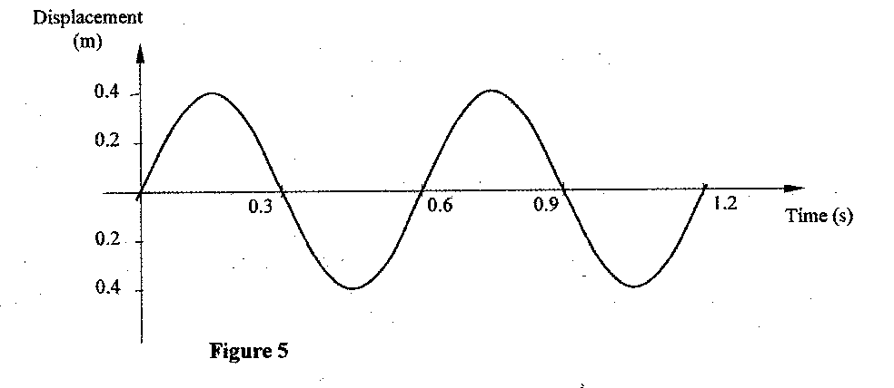
On the same diagram, draw a wave which passes the point with half the amplitude and twice the frequency of the one shown.
- A water wave of wavelength 18 mm is incident on a boundary of shallow water at right angles. If the wavelength in the shallow end is 14.4 mm, determine the refractive index of water for a wave moving from the deep to the shallow end.
- The initial mass of a radioactive substance is 20g. The substance has a half-life of 5 years. Determine the mass remaining after 20 years.
- A current I flowing through a wire of resistance R was increased seven times. Determine the factor by which the rate of heat production was increased.
11 Figure 6, shows a horizontal conductor in a magnetic field parallel to the plane of the paper.

conductor

State the direction in which the wire may be moved so that the induced current is in the direction shown by the arrow.
- An x-ray tube produces soft x-rays. State the adjustment that may be made so that the tube produces hard x-rays.

- The wavelength of a radio wave is 1km. Determine its frequency. (Take the speed of light as 3.0 x 10⁸ ms"¹)
- Figure 7, shows a block diagram of a p-n junction diode.

p-type
n - type
On the same diagram, show how a battery may be connected so that the diode is reverse biased.

www.kcse-online.info

SECTION B (55 marks)
Answer ALL the questions in this section in the spaces provided. 15 15. (a) Figure 8, shows a ckcuit that may be used to charge a capacitor.
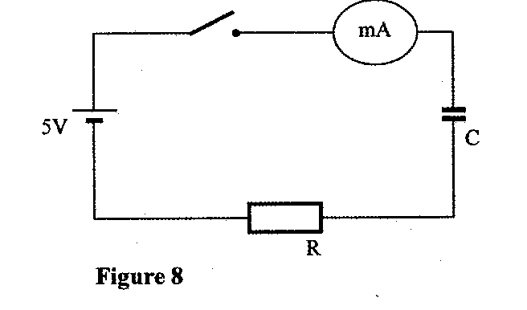
www.kcse-online.info

    - state the observation on the milliameter when the circuit is switched on:
    - explain the observation in (i) above.
(b) The circuit in figure 8 is left on for some time. State the value of p.d. across:
    - the resistor R;
    - the capacitor C;
(c) sketch the graph of potential difference (V) across R against time. (d) Figure 9 shows three capacitors connected to a 10V battery.
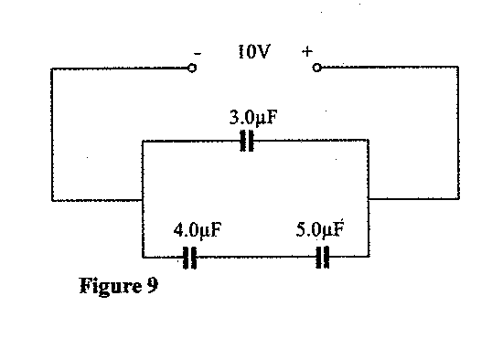
Calculate:
(i) the combined capacitance of the three capacitors; (ii) the charge on the 5.0 juF capacitor.
(b) Figure 11, shows a pin 60 mm long placed along the principal axis of the lens used in part (a). The near end of the pin is 80 mm from the lens
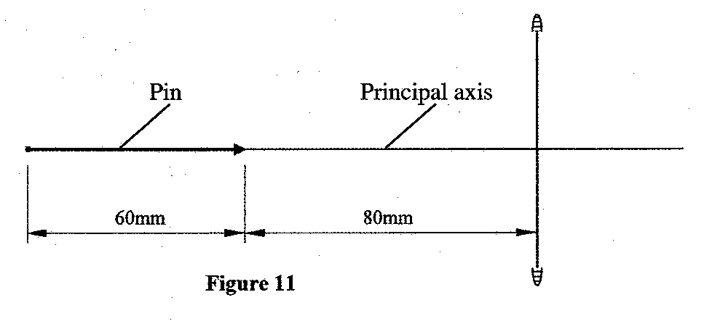
Determine the length of the image.
17 (a) Figure 12, shows an electrical circuit including three switches, Sj, S₂, S₃, and three identical lamps L,, L₂, L₃. A constant potential difference is applied across X and Y.
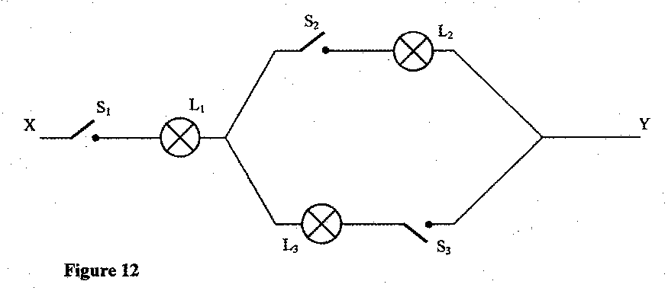
  - Other than Lj, state the lamp that will light when S: and S₂ are closed.
  - How does the brightness of L_{l} in (i) above compare with its brightness when all the switches are closed?
  - Explain the observation in part (ii) above.

(b) Figure 13, shows a cell in series with a 3Q resistor and a switch. A hig resistance voltmeter is connected across the cell.

3
Ω

Figure 13

V

The voltmeter reads 1.5V with the switch open and 1.2V with the switch closed.
- State the electromotive force of the cell.
- Determine the current through the 3Q resistor when the switch is closed. (iii) Determine the internal resistance of the cell.
(c)(i) Another resistor R is connected in series with the 3Q resistor so that a current of 0.15A flows when the switch is closed. Determine the resistance of R.
- Figure 14a, is a diagram of a cathode ray tube. M and N are parallel vertical plates.
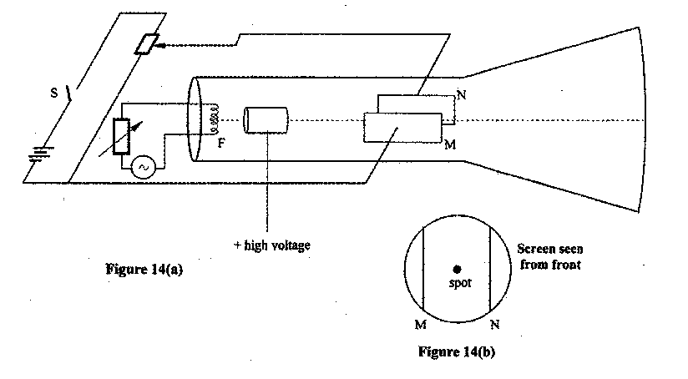
  - When switch S is open, a spot is seen at the centre of the screen as shown in figure 14(b).
    - State what happens to the spot when S is closed.
    - State what would happen to the spot if the potential difference across MN is increased.
    - State what would be seen on the screen if the battery is replaced with an alternating emf of:
        - a low frequency of about 1 Hz;
        - a high frequency of about 50Hz.
  - Explain the process by which electrons are produced at F.
  - State with a reason how the brightness of the spot can be increased.
  - The accelerating voltage of the tube is 1000V and the electron current in the beam is 1.5mA. Determine the energy conveyed to the screen per second.)
- (a) State the property of radiation that determines the number of electrons emitted when a radiation falls on a metal surface.

(b) Figure 15 is a graph of the stopping potential V_{s} against frequency in an experiment on photoelectric effect.

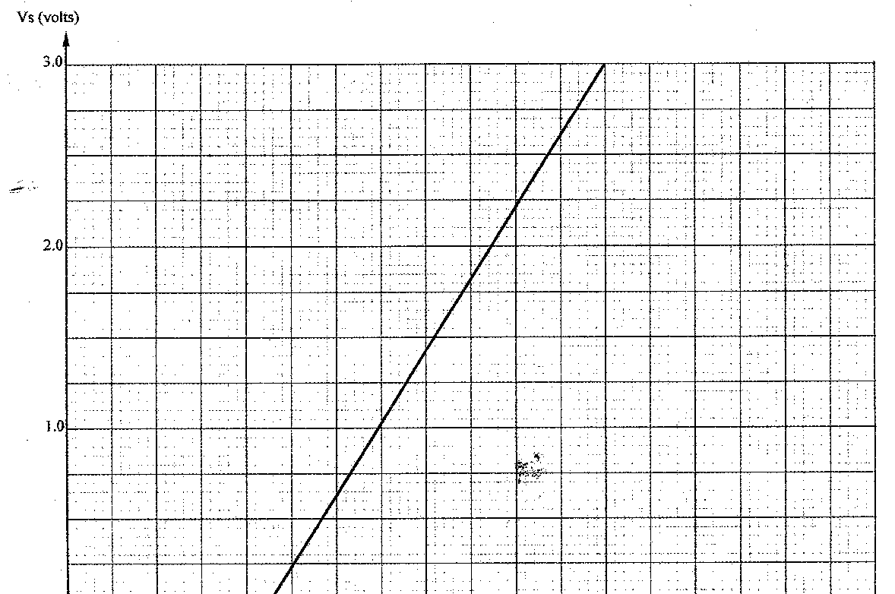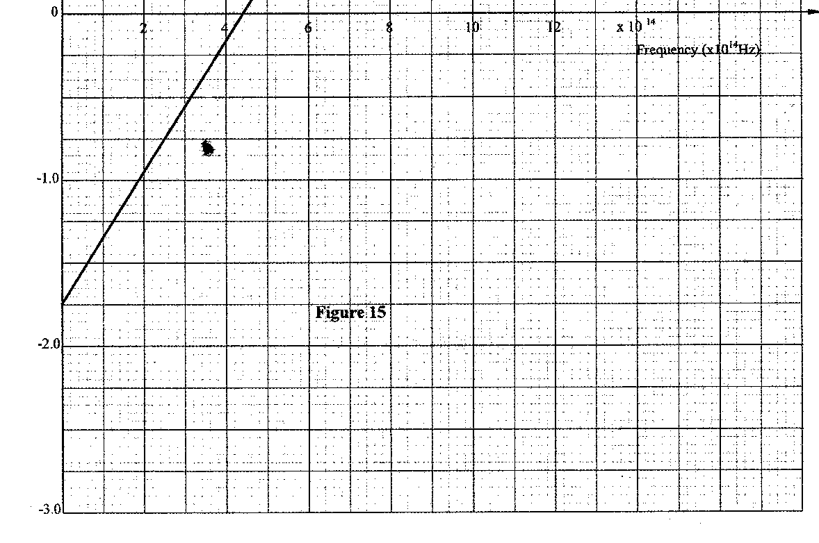

(
i) What is meant
by
stopping potential?

(ii) Given that the stopping potential V_{s} is related to the frequency by the equation.
V s = h f – w ₀ Where e is the charge of an electron, (e = 1 .6 x 10'¹⁹C) e e
Determine from the graph:
    - plank's constant, h;
    - the work function co₀ for the metal in electron volts (eV).

PHYSICS PRACTICALS 2011
PAPER 3
Question 1
Part A
You are provided with the following: .
- a voltmeter
- a resistance wire labelled P mounted on a metre rule.
- a resistance wire labella Q mounted on a piece of carton.
- 2 dry cells at dea cell holder
- 6 connecting wires each with a crocodile clip at one end.
Proceed as follows:
(a) Place the dry cells in series in the cell holder. Measure and. record the total emf E of the cell. E₀ = 3.0 +- 0.2 V (1 mark)
2.8 to 3.2V
(b) Connect the circuit as show in figure 1

O is a point on :P at the 50cm mark of the metre rule. A and B are points on P such (c) Adjust the positions of the crocodile clips A and B on. P such that.
AO = OB = X - 2.5cm; Close the switch. Read and record the potential difference
(V) across AO in table 1
      - Repeat. part (c) for other values of X shown in table 1 and complete the table.
      - On the grid provided, plot a graph of — (y - axis) against (5 marks)
      - Determine the slope S of the graph. (3 marks)
      - Use the slope to determine the constant h, given that h = 8 (9 marks)
E₀S

Part B
You are provided with the following:
- a soft drawing board.
- a semicircular glass block. -three drawing pins; - a white paper: - a liquid labelled L -a dropper.

Proceed as follows;
        - Place the white paper on the drawing board. Place the semicircular glass block on the paper and trace its outline using a pencil. ; .
        - At the centre of the straight edge of the outline mark a point 0. Also mark a point X approximately at the centre of the curved edge of the outline as shown in the figure 2.

        - Place the semicircular glass block on the outline. Push a drawing pin vertically through 0 into the drawing board. Ensure the pin is in .contact with the glass block. Using a dropper, place two or three drops of liquid L on the pin, so that the liquid flows down the pin forming a thin film between the pin and the vertical face" of the glass block.
        - View the image of the pin from point X through the glass block and move the eye round the curved surface to the right side of X until the image of the pin just disappears from view, (see figure 3)

Using a second pin locate and mark a point N on the curved outline at the point where the image just disappears.
        - Repeat part (k) with the eye moving to the left side of X. Locate and mark the point M on the curved outline where the image just disappears from view.
        - Draw the lines OM and ON on the outline.
          - Measure and record angle MON
          - If MON = 2A, determine q given that Sine A = 2 q
3

Question 2
Part A
You are provided with the following:
- a 100ml glass beaker.
- a weighing balance (to be shared).
- a liquid labelled L.
- a measuring cylinder.

Proceed as follows:
- Measure and record the mass M: of the empty beaker.
M₁
- Measure and pour 2ml of liquid L into the beaker. Measure and record the mass of the beaker + liquid L.
- Determine the density d: of the liquid L (2 marks) d =

Part B
You are provided with the following:
- a retort stand, boss and clamp.
- 2 boiling tubes - a thermometer.
- some distilled water in a beaker labelled W.
- some liquid in a beaker,labelled L
-a large beaker containing some water. - a measuring cylinder
www.kcse-online.info

-a stopwatch
- a tripod stand and wire gauze.
- a cardboard with a hole in the middle.
- a burner.

Proceed as follows:
- Clamp one boiling tube on the retort stand. Measure and pour 45ml of the distilled water (W) into the boiling tube. Setup the apparatus as shown in figure 4.

- Heat-the water in the large beaker until/the' temperature- of the distilled water reaches 85°C. Remove the boiling tube from the 'hot water by lifting up the retort stand and placing it a way from the burner.
- Stir the water in the boiling tube using the thermometer. Record in the table 2 the temperature of the distilled water at intervals of 30 seconds starting at 80°C until it drops to60°C. (Stir the distilled water before taking any reading).

- Using the second boiling tube; repeat the procedure in (d), (e) and (f) using 45ml of liquid L instead of distilled water. Record; your results in the same table.

- Using the same axes on the grid provided, plot a graph of temperature (y - axis) against time f or : (i) distilled water W (ii) liquid L.

(Lable the graphs of Land W).
- From the graphs determine (1 mark)
  - the time t taken for the distilled water to cool from 75°C to 65°G. t _{w} = minutes
  - The time t taken for liquid L to cool from 75⁰ to 65⁰C
t _{L} = minutes

both time to come from candidate work / graph within
www.kcse-online.info

- Determine the constant r given that r = 4.2 t _{L} where d is the density of the liquid L in part (A).
(2marks) dt_{w}
    - Correct substitution in right = 1mk
    - Correct evaluation to 1 d.p

GATEPASS REVISION KIT

