towiBg are somo onp'-acteristicr

;o

V Stigma

bii) isirtfttla pollen grains film, grains

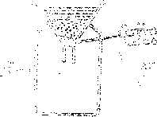

nLeisase no-cnems last

1. , Improve aeration of soil ' bb Binds ooi! particles together

D. Improves ability of sell to hold water Which, combination-:, below represents field pests only?

1. rats, moths, weevils, grain borers 3. grain borers, monkey, cutworms
2. . stalk borer, aphid, cutworms, monkey
3. aphids, white ants, weevils mice

'agram below shows a simple machine Lu

'Which of the foli ' ;

same class as the above machine?

1. i rod, tweezers
2. " ibarxow, slaw hammer
3. coal tongs, pliers
4. fishing rod, nutcracker

Improved jiko has a clay lining at its sides. This is highly recommended because

1. clay is an insulator
2. it is a good conductor of heat
3. it consumes a lot of charcoal
4. jikos cook very fast

In an experiment, equal amounts of water were added to three equal amounts of soil samples

1. F, G in funnels as shown in the diagram below

7.

:!/»4 '%hh:!hg/

st A#?;Hb?A"

' 1 \ s_i W j

„a i! i!

The tirrie'taken for the first drop of water to appear from e&cb funnel is Wown A she tab A below

i Soil sample

;l Time taken W

Which one of the following . ;

CORRECT conclusion iron - :

obtained?

1. E has larger air spaces between its particle;:; than G
2. G has larger air spaces between its particles than E and F
3. F has smaller air spaces between its- particles than G
4. F has larger air spaces between its particles than Eand G

A farmer intends to prepare a balanced diet for livestock. Which ons of the following should be included, in a di^ i: -~v'“c A - W A. Incem r B. rice husks

1. *maize germ A. nappier tpnss

Which one of the following practices polluter soil, air and water?

1. burning of tyre and plastic
2. use of artificial fertilisers'
3. use of all farm chsmiosA -
4. dumping of industrial wap;..-:

The diagram below represents a cn-oht chat cor: be used to make a temporary niaprst

gTixrtfh

The energy transformation that takes place a point marked H is

1. Electrical—>.magnetic
2. Chemical—>.electical
3. Magnetic—>. chemical
4. Chemical —>.magnetic

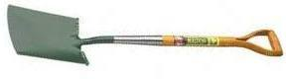

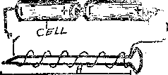

1. Which of the following practices should be I avoided as a precaution against being stuck by | lightning? jj
2. using an umbrella **when in an open** field f
3. wearing red clothing Jj
4. squating away from tail objects |
5. wearing shoes with rubber soles when jj walking in the rain
6. Which of the following is both a sign and an |

. effect of ill-health in livestock? 5

1. reduced yield ::
2. reduced quality of products i;
3. loss of wojgbt immediately > .D. traDsmkiran of disease to ,, 4 ^

j A Which one oAAe following drugs ar© ns-icbo :

salm. the nervoy.3 system? i

a. sedatives 3. analgesics? r

C, stimiilsxst!: D. hal’uciHogaap [

n. 'Aiq disease; Am Albets the liver aiics stmo’eAb

b marijujeee B. lung camm \

A ourkosi:? D, dehyfcedea. ;;

' : --y.v '?•£ eeerAtemeBis about all. arionr

1. . -xtvris? A ao -/alvas b - "aeries v.ereb blood eoiass e»ee A: ey

. seb'eiee e :e:y Mood from the besA b e.: . parts oi ee.:'.; ;/ody 0. A :cies 3 this elastic waits eAth a eb-A

*>:. '! i.;xi iilliMllO

/j' -' **ch e ?**

I effects:- **. circulation**

•A ehscamage U“; srill bri ill

; iv\ damage to nervous system Which disease is described by the above effects?

A. ?.yphi)lis B. gonorrhoea

**D. genital herpes**

> ' "1 Ae dyvtioprneni of the foetus, which of the

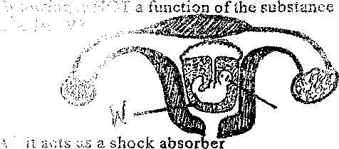

:-i it lubricates the foetus 1". it enables the foetus to move freely J). > ' ’ls the foetus with food nutrients ther

lYT ”>

1. The following are similarities between an air thermometer and a water thermometer. Which

one is NOT?

A. the scale ' B. coloured-water

C. inner tubes D. the bottles

1. In tobacco what makes the user to get Mag or iip cancer?

A. **carbon monoxide B. carbon** dioxide

1. **tar**
2. Which o:ae of the following statements about

birds feeding adaptation is INCORRECT?

A. a sliioiceri has a short, straight strong esd inpted to eating grains

3, a sinAiA has a long slender beak scAAea to , -jctar from flowers

C. a dre:A: b;-.3 a flat beak with . ~

;ring food from water A. a:c ea.:Ae has a long, strong pointed beeb: cutting and tearing flesh

1. * Bidii primary were sen.- to

'rnent as explained beAo-' Afferent materials like lastics, nails, corks, Afe.ae of A.eee':, pAss and stone

1 put water in r. siuuria ebi Aev eeb A, Ae water for a few ';nb?.uAs eee: ;cut Ae .-oeActedo ^ - '.vail':'

BEST conclusion from tbs

sAove expenneent?

~’Od conductors ofheai A. water is a poor conductor of heat

1. matter expands on heating
2. different materials conduct heat at different rares
3. Which of the following worms can easily ha passed to a healthy person through eating raw

meat?

1. liverfiukes B. tapeworms
2. roi’:ndworms D. threadworms
3. Which one of the following completes the list of the iyj: o of plants which have the type of root: shown below

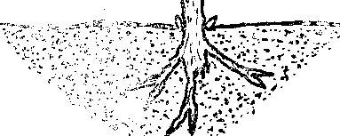

1. peas, rnaize, onion
2. sisal, maize, rice
3. bean, mango, acacia

lb on.'b;;:':i eveoiiuS, groundnuts

1. When investigating the rate at which water rises in different types of soil, which one of the following need NOT be the same?

A. amount of soil B. types of soil C. size of lubes D.ssze.ofci '00I

1. Uncooked dried beans afsc-i-'harv can be BEST preserved traditionally by

A. using honey • • B. salting

C. using low teiaperatiirss D. using ash Viuch oas of th following BEST describes cross Boiiiaetion?

a. traasdbr of tioiism. graiiis from the anther to fbe stlgcia al ike s£-m& A.vvta::

A. dae w'SiiSibr of poiiew w;ad:is. drew. 'die mats part of the. female -oarl cf different plants of dhe saiae Mad C. dse trkiisfiia of polled :.f.v.:-ns S'ew. ids ardher

• K _i « W 3

typo

dd tbs tradsfbr of dolled’ droids drcdi 'fee anther

to id.;; fciiignis of ascdisr : .plsai

iiiytdo 'dsidbsr iasid'dde: f sss'--er drs gaeatiod

odwv oo. tbo sanw

Wd

Cs.i.rerddv



.WWdd

29.

B.

Cd

dd

30,

A. joules B. metres

C. kilograms and grammes D. newtons The following are effects of drug abuse

1. rape
2. addiction
3. lack of concentration
4. truancy
5. impaired judgement

Which of these are ALL health effects?

A. i, iv, v B. ii, iii, v

C. ii, iii, iv . D. i, ii, iii

Which one of the following experiments win

Which of the following states.' n'ats about tbs  
making and the fenetiois of the bisfrarneni h  
INCORRECT?

A, on a very sunny day, the level of the  
coloured water on the tube will drop

as the degree of coldness locreasw, the ;  
empty space in the tube deco^as::d  
its scale reads from the top . a:' .•

it works with the principle of .;;xpar f :  
conti action of li quids

Most absorption of digested feed takes p'?.ce i  
ib the

1. upper part of the large intestine
2. lower part of the small intestine €. upper part of the small intestine D. lower part of the large intestine The weight of an object is the amount of force of gravity acting on on it. Force is measured id

35.

demostrate the fact that -pressure in 1

aqua! at the same depth? „

iqui

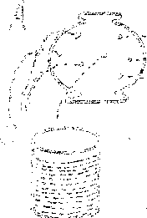

32.

Which one is tde aidhi dddcbon of wdved?'

A. they allow blood to hdw in two dirscdo-d.,

O, ! ~

1. iltey allow blood to ff.o w hi all dheetiooc
2. they allow blood to Sow ia one direction Which OBe of the following best describes why ssa water may be considered hard water?
3. discolouring boilers
4. depositing of scale
5. presence of large amounts of dissolved saits
6. presence of scum

What is the function of the fibre in the diet?

1. help in prevention of constipation
2. helps in absorption of nutrients
3. helps in digestion of food
4. helps in absorption of digested food Which group of materials contain only magnetic materials?

A. steel, nickel, aluminium, brass

8. steel, iron, nickel, cobait

1. alluminium, brass, tin, copper
2. copper, steel, nickel, cobalt

Which one of the following adaptations is not found in xerophytes?

1. long deep roots
2. increased number of stomata
3. shedding of leaves
4. thick waxy cuticle



36 Which one of the foil-owing groups of food  
contains only sources of proteins?

yaya vsa-is, groundnuts

44.

a.a

.-'a c SilJL J.

3, -JggS

:5sli, wheat griBs  
are forms of drag laia-aiss

EXCEPT

1. Along aa-v aia 3fi prescribed ror yorir aisver  
   'becau;:.;-: /-a-a are suffering fi'OBi a similar  
   disease
2. Addia aa aaAa-dose of medicine
3. Aai ag -1 dag pills in order ‘to relax £,.1  
   adviaea

7c-e of mediekis

ddld dr i a- ;.a ddlowieg is tdsa'aisa; aa aaaaa  
aAd-d. : .• aa dead plant aeaayi.ag aa.aa-v  
mr Aodv

1. :LHaaoya(y aa B. liydropdites  
   da Id xeropdyAs  
   A Aaaa d'A ,a'a allow soima ligif -to y-ss?  
   idroagd Aa ... ,r d-ANNOT see clearly iidaaayd  
   it is
2. B. transparent

d . ii'<: ica D, coloured

dar~da;y': a raara farmer divided Ms farm as  
showa its tde raagram

/ ’ -

a^asx:;;

lad dgrazing was ds asiag? r-a.rg,' B. strip grazing

"aaaaa

-arra radar; to

raaa

1. paddoeldng

A

is to work with soil .

' ‘ :...-ad ; .gars of soil

* d dA ar die soi! to hold water  
  . .:-s of roil particles
* a irlspdone wires sagging. Which  
  n.i 0-da)siter could she apply?  
  a jar Iter expands with increase of heat

a. . aa 'jghi (.ravels in a straight line

a.1. da. wdres sag in the morning

1. .1. aar ; matter contracts on heating

Gas e d the following is NOT necessary for a

plant a at has already germinated. Which one

is it?

A. Ada B. moisture

1. warmth D. oxygen

*6.

Standard 8 pupils were classifying tools. In  
ardicd group were they LIKELY to put an axe?

1. inclined rdaae
2. none of theabcvs  
   i;dAA of Ida ddlowiiig-aBisaals is CORJOCdAd  
   aarAded V'/ddi fae number-of legs it liasd

Number off legs  
6  
.6

dd Aayiaaraaaiis 8

:D. dak 8

ar drag oead'ains caffein. Which class is ia  
ddddEXA A- aaloag?

1. hallucinogen
2. narcotics  
   .- aA:Aaaa - dr: nlass was doing as experaaaa: a.

; W to

: • sor a short awhile, a Aaar  
a aa. The CORRECT aarae

a aaesAaara; W, X and Z are__

:aAent, solution  
rnlute, solution

. t. .on, solvent

id, sofcdaaA solute, solvent Aa aalddd aagr will opportunistic iafcciioias Sad adeir way aaady into the body of an auDS arrtiiA?

1. full bloam stage
2. wiadoar period
3. symptomatic stage Id r >> .-I dc stage

..a., scdAa

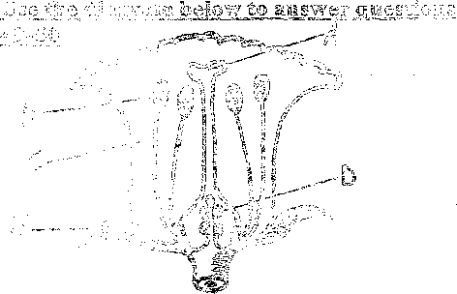

49.

50.

. After fertilization, the part marked D change:

arid becomes tii®

A. pollen tube

1. seeds.

In which part are  
manufactured?

A, B

1. D

B. fruit D. ovules

the pollen grains

B. A D. C

STD 8 SCIENCE