K.C.P.E SET I

STANDARD EIGHT 2013

KCSE ONLINE

SOCIAL STUDIES AND

RELIGIOUS

EDUCATION

Time: 2 hours 15 minutes

READ THESE INSTRUCTIONS CAREFULLY

1. You have been given this question booklet and a separate answer sheet. The question booklet contains 90 questions.
2. Do any necessary rough work in this booklet.
3. When you have chosen your answer, mark it on the ANSWER SHEET, not in the question booklet.

HOW TO USE THE ANSWER SHEET

1. Use an ordinary pencil.
2. Make sure that you have written on the answer sheet:

YOUR INDEX NUMBER YOUR NAME

NAME OF YOUR SCHOOL

1. By drawing a dark line inside the correct numbered boxes mark your full Index Number (i.e. School Code Number and the three-figure Candidate’s Number) in the grid near the top of the answer sheet.
2. Do not make any marks outside the boxes.
3. Keep your answer sheet as clean as possible and do not fold it.
4. For each of the questions 1 - 90, four answers are given. The answers are lettered A, B, C and D. In each case only ONE of the four answers is correct. Choose the correct answer.
5. On the answer sheet the correct answer is to be shown by drawing a dark line inside the box in which the letter you have chosen is written.

Example

In the question booklet:

1. Countries in North Africa experience winter season during the months of
2. March to May
3. December to February
4. June to August
5. September and November

On the answer sheet:

The correct answer is B

i A i i B i i C i i D i i A i i B i i C i i D I i A i i B i i C i i D i i A i i B i i C i i D i In the set of boxes numbered 33, the box with the letter B printed in it is marked.

1. Your dark line MUST be within the box.
2. For each question ONLY ONE box is to be marked in each set of four boxes.

This question paper consists of 12 printed pages

1

KEY

**PARTI: SOCIAL STUDIES**

**Mu pa Area**

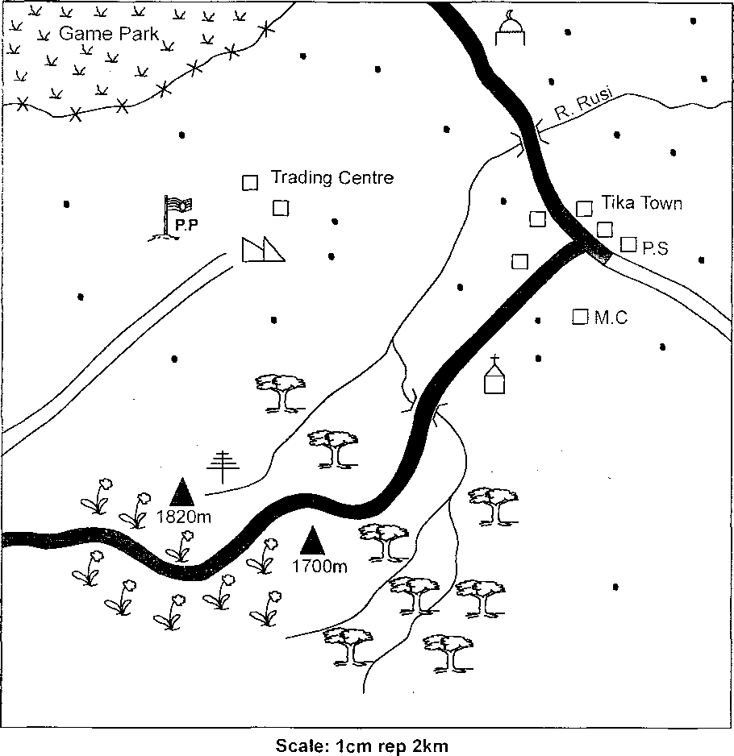

|  |  |  |  |  |  |  |
| --- | --- | --- | --- | --- | --- | --- |
| Tarmac road | |  |  | Telephone mast |  | Milk processing factory ' |
| Murram road | |  | V V  V  V | Gras*s | p.p | Police post |
| □ □ □ □ | Build up areas | p. |  | Mosque | P.S | Police station |
| • | Settled areas |  | | Pyrethrum |  | Church |
|  | Planieduf^S:; | **M.C.** | | Magistrate’s  court | A | Hi![tops?; |

3

STD 8 006 S/S 2013

1. The southern part of Mupa area has a iow population MAINLY because the area
2. is hilly and steep.
3. has forests.
4. has iow temperature.
5. has Sow rainfall.
6. Which one of the following is the LEAST function of Tika town? It is
7. an administrative centre.
8. a trading centre.
9. a tourist centre.
10. a transport centre.
11. Which one of the following economic activities is LIKELY to be carried out in Mupa area?
12. Limestone mining.
13. Dairy farming.
14. Fish farming.
15. Beef farming.
16. Trees have been planted in the southern part of Mupa area to
17. provide timber for building.
18. provide fruits for sale.
19. get raw materials for paper making.
20. protect rivers from drying up.
21. The telephone mast was erected because the area
22. has a large population.
23. has many people who use mobile phones.
24. has good tarmac roads.
25. is at a higher altitude.
26. Majority of the people of Mupa area are
27. Christians and Muslims
28. Muslims and pagans
29. Christians and buddhists
30. Hindus and Muslims
31. Mupa area is found in a
32. coastal lowland
33. dry area
34. highland region
35. a plain
36. Which one of the following statements about Young Kikuyu Association (YKA) during the colonial period in Kenya is TRUE?
37. It was formed by Mau Mau fighters
38. It had supporters from all over the country
39. Jomo Kenyatta became its secretary
40. Its founders were arrested by the British
41. The government encourages the establishment of Jua Kali industries MAINLY by
42. importing raw materials for the industries.
43. giving loans to the youth.
44. trainingyoung people in technical skills.
45. buying products of the Jua Kali industries.
46. Kariandusi in Kenya and Omo valley in Ethiopia are important as a source of
47. history about the evolution of man
48. diatomite used in filtering water
49. fluospar used in the steel industry
50. energy used in running industries
51. The movement of the Gal la people from the Horn of Africa led to
52. introduction of new crops
53. disruption of 11 ntu settlements
54. establishment of kingdoms
55. discovery of iron for tool making

*Use the diasram below to answer questions* 12 *and* 13

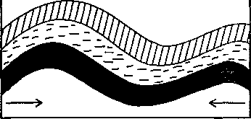

1. The illustration shown above shows the formation of
2. ox-bow lakes
3. the Rift v»5;ey
4. fold mountains
5. horst mountains
6. A physical feature in Africa formed through the process **shown** above is
7. Atlas mountains
8. Danakil Alps
9. Lake Chad

1

1. Mount Kilimanjaro
2. The MAIN source of fuel in most rural areas in Kenya is
3. electricity
4. natural gas
5. kerosene
6. firewood
7. The school promotes the customs of the communities around it by
8. making traditional items.
9. participating in music festivals.
10. teaching moral values to pupils.
11. making rules to be followed in the society.
12. There are less young people in Germany MAINLY because
13. the birth rate is low.
14. many children die before reaching five years.
15. majority of the people are not married.
16. most people in the country live in towns.
17. Which one of the following statements about the forests on Mount Kenya is NOT TRUE?
18. They are sources of rivers.
19. They are protected by the government.
20. They are homes for wild animals.
21. They provide raw materials for paper making.
22. Which one of the following factors has contributed MOST to the growth ofNakuru town?
23. Tourism activities around the town.
24. Mining activities around the town.
25. Farming activities around the town.
26. Presence of a railway line in the town.
27. The MAIN crop grown in the horticultural farms around Naivasha town is
28. pineapples
29. flowers
30. chillies
31. onions
32. The legislative council supported the struggle for independence in Kenya during the colonial period by
33. supporting laws demanding for Africans freedom.
34. writing newspapers demanding for independence.
35. supporting fighters fighting for independence
36. organising strikes and boycotts.
37. Which one of the following fishing methods is used in Japan?
38. Harpoon method
39. Hook and line
40. Trawling method
41. Use of herbs
42. Which one of the following events took place in Kenya in 1982?
43. Kenya was made a party state
44. The voting age was lowered to 18 years
45. Kenya African National Union was formed
46. Daniel Moi became the president.
47. Kenya promotes international tourism MAINLY by
48. employing more game rangers.
49. building more hotels in game parks
50. fencing all game parks
51. advertising tourism attraction sites.
52. Which one of the following irrigation schemes is CORRECTLY matched with the method of irrigation used?

**Irrigation scheme method nsed**

1. Mwea drip
2. Perkerra furrow
3. Ahero sprinkler
4. West Kano overhead ;
5. Below are facts about a certain type of marriage.
6. It is presided over by a religious leader.
7. Polygamy is allowed
8. Persons marrying must be 18 years or more.

The type of marriage described above is

1. Customary marriage
2. Christian marriage
3. Civil marriage
4. Islamic marriage
5. Which one of the following factors lead to rapid population growth?
6. Girls marrying at an early age.
7. Spread of HIV/AIDs infection.
8. People marrying at an old age.
9. Poor health services.
10. Which one of the following communities founded the kingdom of Old Ghana?
11. Mandinka
12. Ndebele
13. Soninke
14. Shona
15. The MAIN means of transport used in most rural areas in Kenya is
16. railway
17. road
18. air
19. water
20. The mining of soda ash in Lake Magadi has MAINLY led to
21. increase in tourism activities in the area.
22. improvement of living standards in the area.
23. improvement of livestock keeping in the area.
24. migration of people from the area.
25. Which one of the following horticultural crops is MAINLY grown in Netherlands?
26. Pyrethrum
27. Bananas
28. Kales
29. Flowers
30. Road accidents can be prevented in Kenya if the government
31. educates people on how to use the roads.
32. arrests all those who break traffic rules
33. employs more traffic police officers
34. erects bumps on all roads
35. The MAIN reason for the outbreak of the Mau Mau war in Kenya was that Africans
36. had acquired fighting skills in the 2nd world war.
37. could make their own guns
38. wanted to rule themselves
39. wanted Jomo Kenyatta to be released
40. Most industries in Kenya produce agricultural products MAINLY because
41. there is cheap labour from the large population.
42. agriculture is the main economic activity.
43. roads in agricultural areas are well developed.
44. the country lacks natural resources.
45. Which one of the following statements about the Kenya African National Union (KANU) is TRUE?
46. Its founders were arrested and jailed.
47. It was the official opposition party.
48. Its founder became the first president.
49. Members mainly consisted of big tribes
50. Which one of the following traditional methods of weather observation is still used today?
51. Observing the type of clouds.
52. Listening to the croaking of frogs
53. Use of traditional rainmakers
54. Looking at the behaviour of birds
55. The MAIN implement for tool making in the early stages of the evolution of human beings was
56. iron
57. wood
58. clay
59. stone

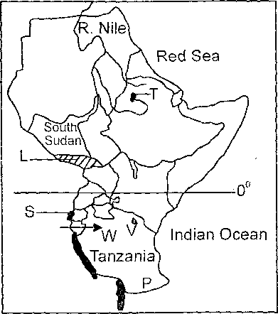

3 7. The river marked P on the border of the two countries is

1. Ruvuma
2. Rufiji
3. Wami
4. Pangani
5. Natural vegetation in the area marked L MAINLY consist of
6. dense tropical forests
7. scattered grass
8. low dry bushes
9. tall grass and acacia trees
10. The town marked V is the headquarters of
11. Inter-Government Authority on Development.
12. African Union (AU)
13. East African Community (EAC)
14. New Partnership in Development (NEPAD)
15. Three of the following statements are correct about the communities that used route W during migration. Which one is NOT?
16. Some of them settled in highland areas.
17. They were mainly long distance traders.
18. Some of them settled along the coast.
19. They intermarried with other < communities.
20. The Internal Security Department in Kenya is led by
21. Chief of “ fence forces
22. Com mis -T of prisons
23. The hea^i state
24. Inspects neral
25. Professor V ,iri Mathai is r lembered in Kenya beca- she was
26. recognis y the world for her efforts t<r nserve trees.
27. the first f-,rt:ale prolessor.
28. the first female to teach at a university.
29. the first female cabinet minister.
30. Expansion of roads in Kenya in the recent years had MAkNLY led to
31. increase in rural to urban migration.
32. decrease in road accidents.
33. increase in trading activities.
34. increase in transport expenses.
35. Records of discussions at a school management committee are kept by the
36. chairperson
37. treasurer
38. teachers on duty
39. headteacher
40. The northern parts of Kenya have low population densities MAINLY because they
41. experience high temperature.
42. lack major economic activities.
43. do not have natural resources.
44. have a low birth rate among the people.
45. Which one of the following is a characteristic of man-made forests in Kenya?
46. Most trees have straight trunks.
47. Trees form a canopy.
48. The trees grow in the salty water marshes along the coast.
49. All the forests are fenced by the government.

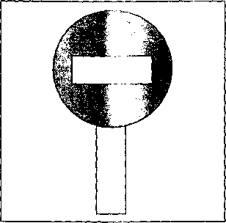

1. What should a motorist do when he comes across the road sign illustrated above?

*Use the diagram below to answer question* 47

1. Proceed with caution.
2. Reduce speed
3. Stop the vehicle
4. Increase the speed
5. The MAIN problem facing road transport in Kenya is
6. destruction by rains
7. lack of road signs
8. frequent increase in fuel prices
9. high costs of construction
10. The Bill of Rights pro motes human rights by
11. giving the freedom of citizens in the constitution.
12. giving the qualifications for a person to vote.
13. spelling out what should be done to law breakers.
14. carrying out laws that govern the country.
15. Which one of the following fanning methods was introduced by European settlers?
16. Irrigation farming
17. Plantation farming
18. Subsistence farming
19. Shifting cultivation
20. Fish farming is encouraged in Kenya in order to
21. produce more fish for export.
22. encourage more people to eat fish.
23. promote the production of fish in the country.
24. make use of land with poor soils.
25. Which one of the following statements about succession rights is CORRECT?
26. Girls do not inherit property of their parents.
27. A wife can inherit property if she has a marriage certificate.
28. All children have equal rights to parents’ property
29. Property of a married man can only be inherited by the children.
30. Copper in Zambia is obtained from under the ground by
31. drilling method
32. open-cast method
33. dredging method
34. scooping method
35. Major towns have set up areas to establish industries in order to
36. protect people living in the towns.
37. create employment in the country.
38. attract foreign investors to the country.
39. reduce number of people migrating to towns.
40. The heads of state in both Kenya and Swaziland
41. are elected by registered voters.
42. are members of parliament.
43. appoint members of the cabinet.
44. are leaders of political parties
45. Which one of the following is done by civic candidates on the election day in Kenya? They
46. are cleared by the body incharge of elections.
47. count tl'.e votes at’polling stations.
48. ask for votes at polling stations.
49. vote by markine the hallnt
50. Which one of the following means of communication is made up of electronic media ONLY?

|  |  |  |
| --- | --- | --- |
| Magazines |  | Radios |
| Letters | B. | Telephones |
| Radios |  | internet |
|  |  |  |
| Television |  | Mobile phones |
| Newspapers | D. | Letters |
| Courier services |  | Parcels |

1. Population in Kenya has increased rapidly MAINLY due to
2. improvement in health care services.
3. people marrying in their early ages.
4. increase in food production.
5. use of family planning methods.
6. It is important for citizens to participate in electing their leaders in order to
7. obey the laws of the country.
8. get leaders who support development.
9. avoid being arrested.
10. create good relations with neighbouring countries.
11. Petroleum is imported to Kenya by
12. air
13. pipeline
14. railway
15. sea