NAME ___________________________ INDEX NO_________________
CLASS _________________CANDIDATE’S SIGN ____________________
DATE__________________________
FORM 4 END OF TERM II PHYSICS
EVALUATION EXAM
PAPER 1
TIME 2HRS

FORM 4 END OF TERM 2 EVALUATION EXAM
PHYSICS PAPER I

Answer all the question in section A and all the questions in section B

SECTION A (25 MKS)
- A ball bearing of mass of 1.5 x 103-3 is held between the anvil and spindle of micrometer screw as shown below.
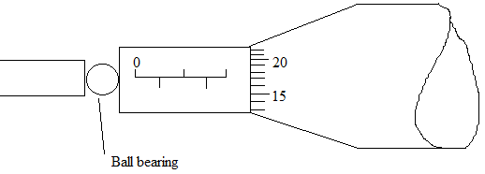
The reading between completely closed jaws without any object them is 0.10mm. What is the diameter of the ball bearing?
(2mks)

- Find the density of the ball bearing in question 1 above correct to 3 significant figures (3mks)

- Figure 2 below shows the appearance of water when poured on plane and on a waxed glass.

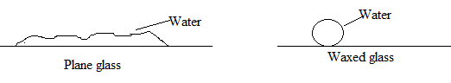

Explain the appearance (2mks)

- Explain why it is easier to walk on muddy ground wearing a flat healed shoe than while wearing sharp pointed shoe. (1mk)

- Smoke particles observed through a microscope to move random. Explain this observation (2mks)

- Figure 3 below shows the levels attained by two liquids L1 and L2 after the temperature was lowered. The liquids were initially at the same level as indicated by the dotted line.
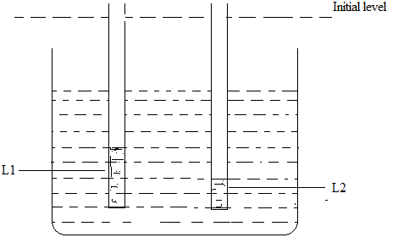

- Mark on the diagram the levels of the liquid when the temperature is raised above the initial temperature. (1mk)

- Give a reason for your answer in (a) above. (1mk)

- Give a reason why heat transfer by radiation is faster than heat transfer by conduction (1mk)

- Figure 4 below shows a uniform metre rule
Balanced by a mass of 60g suspended at 0 cm mark. If the pivot is at 30 cm mark, Calculate the weight of the metre rule (3mks)
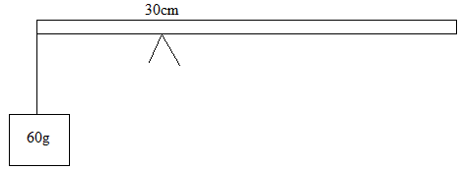

- A certain spring balances produces an extension of 2cm when a mass of 500g was suspended from it. Find the extension when a mass of 750g is used. (3mks)

- Figure 5 below shows a Bunsen burner
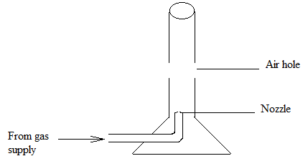

Explain how it works (2mks)

- State one similarity between speed and velocity (1mk)

- Figure 6 below shows a smooth card placed on the open end of a cup. A coin is placed on the card. When the card is suddenly pulled away horizontally, the coin drops into the cup.

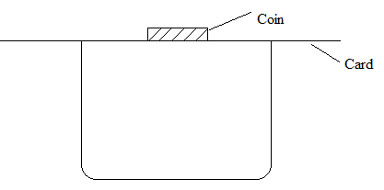

Explain this observation (1mk)

- State a factor that will affect the stability of an object other than position of C.o.G and line of action (1mk)

- A vehicle was being towed by another using a rope. Explain why the rope cut as they were moving over a bump. (1mk)

PHYSICS PAPER 1 SECTION B (55MKS)

- Define specific heat capacity (1mk)

- Explain why a burn from steam at 100⁰c is more severe than a burn from water at 100⁰c (1mk)

- In an experiment to determine specific latent heat of evaporation of steam, Steam of mass 6g at 100⁰c was passed into 400g of water at 15 degree Celsius. The final temperature of the mixture was 24.4 degre Celsius. Neglecting heat absorbed by the container, Find:
- An expression for heat,Q, lost by the steam as it condenses to water at24.4 degree Celsius (3mks)

- The heat gained by water (2mks)

- The specific latent heat of vapourasation of steam
(3mks)

- a)
- Define angular velocity of a body (1mk)

- Explain why a body moving in a circular path is said to be accelerating (1mk)

b)Figure 7 below shows a trolley moving on a circular rail with a vertical plane, given that the mass of the trolley is 250g and the radius of the rail is 1.6m.
x
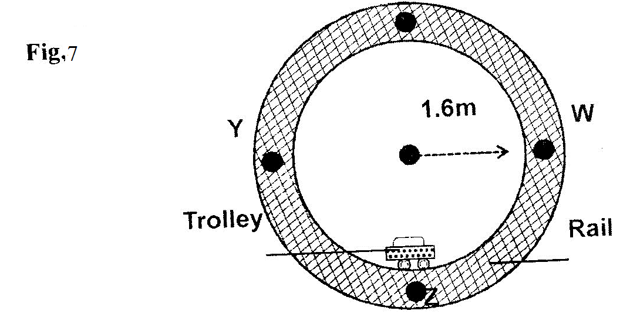

i) Determine the minimum velocity at which trolley passes point X. (3mks)

ii) Find the angular velocity at point Z (3mks)

- The force exerted on the rail at this point, Z

- The graphs below show velocity- time graphs for the motion of the body in two separate occasions. Explain the shape of each graph.
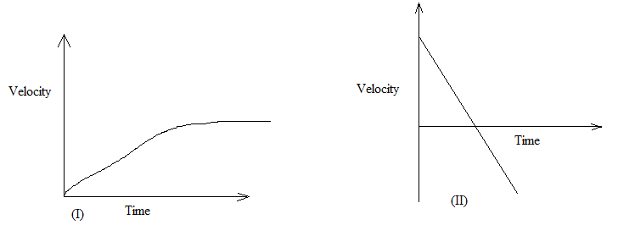
- Explain why a hammer of mass 3kg strikes a nail when moving at 40km/s making the nail sink into wood yet when the same hammer is placed on the nail head, it cannot sink in the wood (1mk)

- Atrolley of mass 20kg moving at 0.6m/s on a frictionless horizontal surface was acted upon by a force of 2.5 N. The resultant velocity of the body was 4.8 m/s. Determine
- The change in momentum of the trolley (2mks)

- The time interval and the force acted on the body (2mks)

- The acceleration of the trolley (3mks)

- A gun of mass 3kg fires a bullet of mass 20g at 600m/s. Calculate the recoil velocity of the gun (3mks)

- Figure 8 below shows an inclined plane, a trolley of mass 30kg is pulled up a slope by force of 100N parallel to the slope. The trolley moves so that the centre of mass C travels from points A to B.
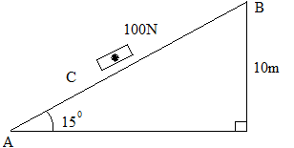
- What is the work done on the trolley against the gravitational force in moving from A to B? (2mks)

- Determine the work done by the force in moving the trolley from A to B (2mks)

- Determine the efficiency of the system (3mks)

- Determine the work done in overcoming the frictional force (2mks)

- Determine the mechanical advantage of the system (2mks)

- State the law of floatation (1mks)

- Explain why a person can swim more easily in sea- water than in fresh water. (1mk)

- Why does a person swimming in fresh water taking a deep breath float without exhaling? (1mk)

- The diagram below shows a wooden block of mass 50 g with 20% of its volume above the water surface and kept in place by a string tied to the bottom . Given that the tension of the string is 0.06 N Determine;

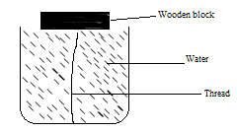

- The upthrust on the object (2mks)

- The density of the object (3mks)

