GEOGRAPHY

INSTRUCTIONS TO STUDENTS

- Answer ALL the questions in section A and section B

SECTION A
Answer all the questions in this section.
1. The diagram below shows the structure of the earth.
L

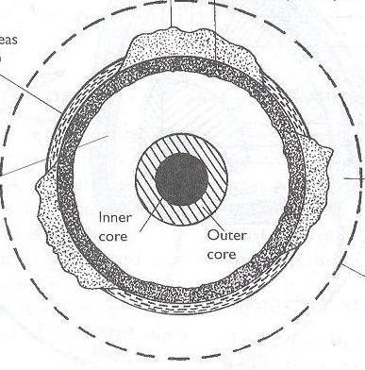
K
Atmosphere
(a) Name the parts marked K and L. (2 marks)
(b) Describe the composition of the mantle. (3 marks)
2. (a) State two factors influencing atmospheric pressure on the earth’s surface. (2 marks)

(b) Describe how a rain gauge is used to measure the amount of rainfall. (3 marks)

3. The map below shows climate regions in Kenya. Use it to answer question (a) and (b).
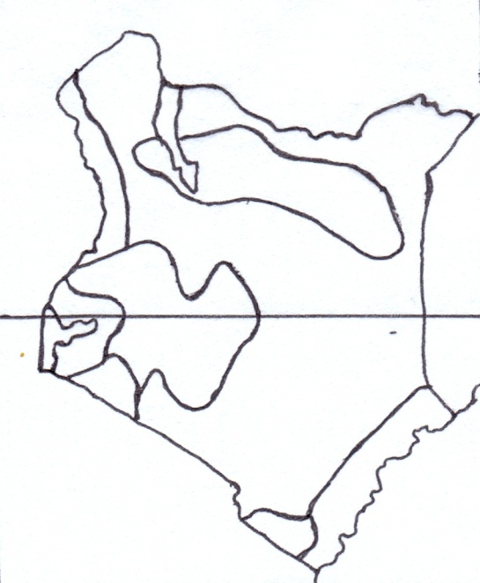
Q
R
(a) Name the climatic regions Q and R. (2 marks)
(b) Give three characteristics of the climate in the region marked R. (3 marks)
4. (a) Distinguish between block disintegration and exfoliation. (2 marks)
(b) State three economic benefits of weathering process. (3 marks)
5. (a) The diagram below shows a waterfall. Name the parts marked X, Y and Z. (3 marks)
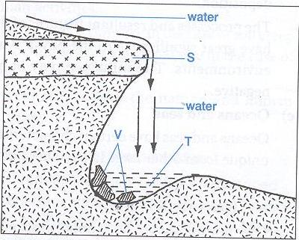
Z
Y
X
(b) Give two ways in which a gorge may be formed. (2 marks)

SECTION B

Answer question 6 and any other TWO questions from this section.
6. Study the map of Kitale 1:50,000 (sheet 75/3) provided and answer the following questions.
(a) (i) What is the six figure grid reference of the trigonometrical station in
Kitale DC. (2 marks)
(ii) Give two districts found in the area covered by the map. (2 marks)
(iii) Measure the distance of Suwerwa river in the South Western part of
the area covered by the map. (Give your answer in kilometers)
(2 marks)
(iv) Calculate the area of land covered by Kitale Municipality. (Give your
answer in square kilometers). (2 marks)

(b) Using a vertical scale of 1cm represent 100metres draw a cross section
along northing 28 from Easting 35 to Easting 41. (2 marks)

- On the cross section mark and name.
      - Footpath (1 mark)
      - River Saiwa (1 mark)
      - Steep slope (1 mark)

- Calculate the vertical exaggeration (V.E) of the section. (2 marks)

(c) Describe the relief of the area covered by the map. (4 marks)
(d) Citing evidence from the map, give three reasons why cattle rearing is carried out in Kitale area. (6 marks)
7. (a) (i) Differentiate between Orogenic and Epierogenic forces. (2 marks)
(ii) Describe how isostatic adjustment causes earth movements. (4 marks)

(b) The world map below shows major volcanoes. Use it to answer question (i)

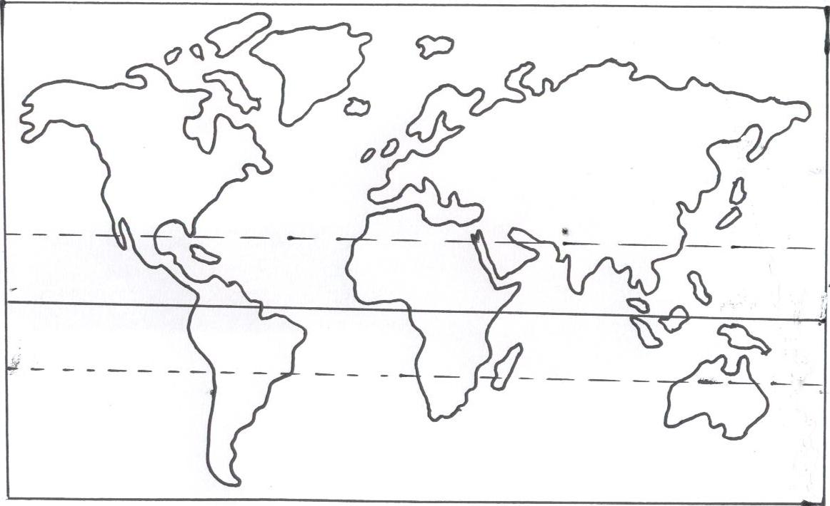
V
W
U
(i) Name the volcanoes marked U, V and W. (3 marks)
(ii) Give an example of a Lava plateau in Kenya. (1 mark)

(c) Using a well labeled diagram, describe how a batholith is formed. (7 marks)

(d) Explain four significance of volcanicity to human activities. (8 marks)
8. (a) What is a glacier? (2 marks)

(b) Describe how the following glacial erosional processes occur.
(i) Plucking (3 marks)
(ii) Abrasion (3 marks)

(c) The diagram below shows features on a glaciated lowland.

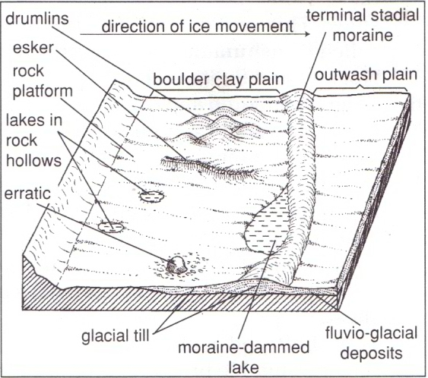
W
X
Y
Z

(i) Name the features marked W, X, Y and Z. (4 marks)

(ii) Describe how a drumlin is formed. (5 marks)

(d) Explain four negative effects of glaciations in low-land areas. (8 marks)

9. (a) (i) State two characteristics of ocean water. (2 marks)
(ii) State four factors which influence horizontal movement of ocean waters. (4 marks)

(b) (i) Describe two ways through which continental Islands are formed.
(4 marks)
(ii) Name three features that form as a result of emergence of coasts.
(3 marks)

(c) Explain three factors that influence wave deposition. (6 marks)

(d) Using a labeled diagram describe how a tombolo is formed. (6 marks)

10. (a) (i) Apart from rain and ice, name two other sources of underground water.
(2 marks)

(ii) Explain how the following factors influence the existence of groundwater.

- Nature of the rocks (2 marks)
- Vegetation cover (2 marks)

(iii) Distinguish between phreatic and vadose zone. (2 marks)

(b) The diagram below represents features in a limestone area.

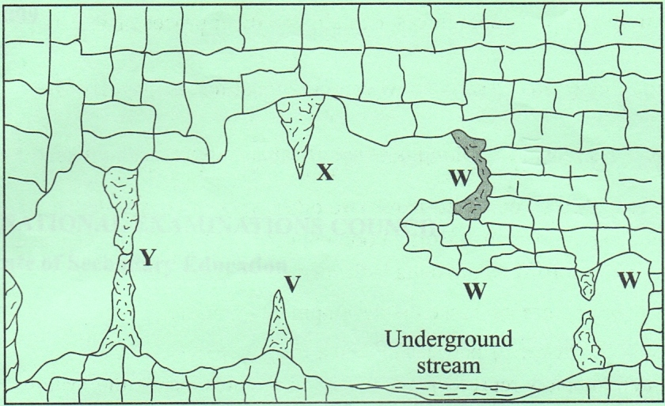
Y
Y
Z

(i) Name the features marked X, Y and Z. (3 marks)

(ii) Describe how limestone pillar was formed. (5 marks)

(c) You are supposed to carry out a field study of an area eroded by underground water.

(i) Name two surface features you are likely to identify during the field study. (2 marks)

(ii) State four reasons why you would prepare a work schedule. (4 marks)

(iii) Give three follow-up activities you would engage in. (3 marks)

