HOLIDAY ASSIGNMENT, PHYSICS
FORM ONE WORK
INTRODUCTION TO PHYSICS
- State two factors that should be controlled in manufacturing a cylindrical container of uniform thickness, which should normally be in a standing position.
- The figure shows a measuring cylinder which contains water initially at level A. A solid mass 11g is immersed in the water, the level rises to B.
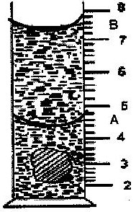

Determine the density of the solid. (Give your answer to 1 decimal point)A butcher has a beam balance and masses 0.5 kg and 2 kg. How would he measure 1.5 kg of meat on the balance at once?
- The number of molecules in 18cm³ of a liquid is 6 x 10²³. Assuming that the diameter of the molecules is equivalent to the side of a cube having the same length as the molecule. Determine the diameter of the molecule.
- Determine the density in kg/m³ of a solid whose mass is 40g and whose dimensions in cm are 30 x 4 x 3
- Record as accurately as possible the masses indicated by the pointer in figures A.
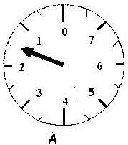

- Figure 1 shows the reading on a burette after 55 drops of a liquid have been used.
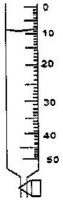

If the initial reading was at 0cm mark, determine the volume of one drop.
(2 marks)
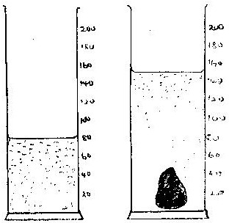
- Fig. 1 shows the change in volume of water in a measuring cylinder when an irregular solid is immersed in it.

Given that the mass of the solid is 567g, determine the density of the solid in gcm⁻³. (Give your answer correct to 2 decimal places.

- A thin wire was wound 30 times closely over a boiling tube. The total length of the windings was found to be 9.3 mm. Calculate the radius of the wire.
- (a) Given that a kilogram of copper contains about 10²⁵ atoms and that density
of copper is about 9000kg/m³/ estimate the diameter of the copper atom?
(b) State the assumption made in (9a) above.
- A drop of oil of volume 1.0 x 10⁻³ spreads out on clean water surface to a film of area 10cm². Calculate the thickness of the film.
- A small drop of oil has a volume of 5 x 10⁻⁸m³. When it is put on the surface of some clean water, it forms a circular film of 0.lm² in area;
(i) What is the size of a molecule of oil?
(ii) State two assumptions you make in your calculations?
- The density of concentrated Sulphuric acid is 1.8gcm⁻³. Calculate the volume of 3.6kg of the acid.
- 1600 cm³ of fresh water of density l g/cm³ are mixed with 1400cm³ of seawater of density 1.25g/cm³. Determine the density of the mixture.

TOPIC 2
FORCES
- A student was heard saying “the mass of a ball on the moon is one sixth its mass on earth”. Give a reason why this statement is wrong.
- In the study of a free fall, it is assumed that the force f acting on a given body of mass m is gravitational, given by F= mg. State two other forces that act on the same body.
- State how a lubricant reduces friction in the bearings of moving part of a machine.
- Distinguish between mass and weight of a body stating the units for each.
- State with reason the purpose of the oil that circulates in a motorcar engine.
- Name two types of forces which can act between objects without contact.
- A house in which a cylinder containing cooking gas is kept unfortunately catches fire. The cylinder explodes. Give a reason for the explosion.
- Give a reason why the weight of a body varies from place to place

