FORM 2 APRIL HOLIDAY PHYSICS ASSIGNMENT
- describe one method of determining the diameter of the oil drop? (3 mks)
2. Explain the cause of random motion of smoke particles as observed in
Brownian motion experiment using smoke cell.
3. Fig. 3 shows part of an experimental set up of estimating the diameter of
an oil molecule.
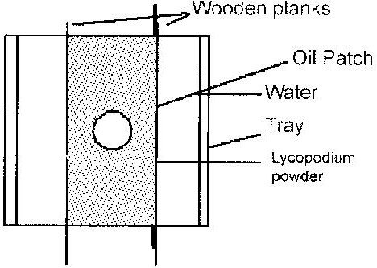

(i) Describe how the oil patch is formed. (2 marks)
(ii) In an experiment, the diameter, a, of the patch was measured to be 200mm for an oil drop of radius 0.25mm. Determine the diameter of the molecule of the oil. (4 marks)
(iii) State why this is an estimate (1 mark)
4. An oil drop of average diameter 0.7mm spreading out into a roughly circular patch of diameter 75mm on the surface of water in a trough.
(i) Calculate the average diameter of a molecule of oil.
(ii) State two assumptions to be made in (i) above when calculating the diameter.
5. The Screw of micrometer screw gauge has a pitch of 0.5mm. The thimble is divided into 50 equal divisions. What is the smallest unit it can measure?

Figure 1 shows a metal cube of mass 1.75g placed between the jaws of a micrometer screw gauge. The magnified portion of the scale is also shown. The reading on the gauge when the jaws were fully closed without the cube was 0.012cm. Use this information and the figure to answer questions 6 and 7.

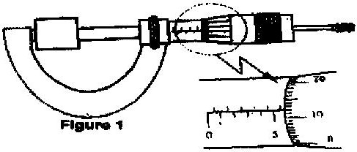

6. What is the length of the cube?
7. Determine the density of the metal cube giving your answer correct to three significant figures.
- In an oil drop experiment the diameter of the oil was found to be 0.4mm and the drop was placed on a clean water surface. It spread into a circular parch of diameter 180mm. Estimate the size of the oil molecule.

