FORM THREE WORK, PHYSICS
TOPIC 1
LINEAR MOTION
PAST K.C.S.E QUESTIONS ON THE TOPIC
1. a) The diagram below shows part of the motion of a tennis ball, which is projected vertically upwards from the ground and allowed to bounce on the ground. Use this information to answer questions that follow.
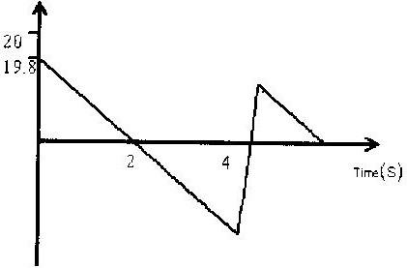

i) Describe the motion of the ball relating it to different positions of the ball along the following AB, BC, CDE.
ii) From the graph, calculate the acceleration due to gravity.
iii) How high does the ball rise initially?
iv) Explain why E is not at the same level as A.
2. Sketch a velocity- time graph showing the motion of a ball vertically upwards with an initial velocity of u.
3. Calculate the acceleration shown by the tickers-tape that was made using a ticker timer vibrating at 50HZ.

A B C D E

4. What is the difference between speed and velocity?
5.An object is projected vertically upwards at a speed of 15m/s. How long will it take to return to the same level of projection?
6.A block slides off a horizontal table 4 meters high with a velocity of 12-m/s. Find:
a) The horizontal distance from the table at which the block hits the floor.
b) The horizontal and vertical components of the velocity when it reaches the floor.
TOPIC 2
REFRACTION OF LIGHT
PAST KCSE QUESTIONS ON THE TOPIC
1. The diagram below shows a transparent water tank containing water. An
electric light is fixed at corner A of the tank. A light ray from the slit shines on the water surface BC at an angle of 48⁰ as shown
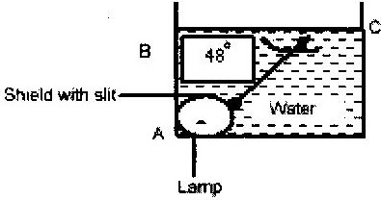

a) i) Determine the angle of refraction for the ray shown in the diagram.
ii) Complete the diagram to show the refracted ray.
b) Determine the angle of incidence for which the angle of refraction is 90⁰
c) Calculate the speed of light in water (nw = ⁴/₃, C= 3 x 10⁸ms)
2. The figure shows the path of a yellow light through a glass prism. The
speed of yellow light in the prism is 1.88 x 10⁸ m/s.
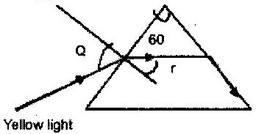

a) Determine the refractive index of the prism material for the light. (Speed of light in vacuum = 3.0 x 10⁸ ms⁻¹)
b) Show on the figure the critical angle C and determine the value.
c) Given that r= 21.2⁰, determine angle Q.
d) On the same figure, sketch the path of the light after striking the prism if the prism was replaced by another of similar shape but lower refractive index. (Use dotted line for your answer).
3. 2002: The figure below shows two rays A and B entering a semi circular glass
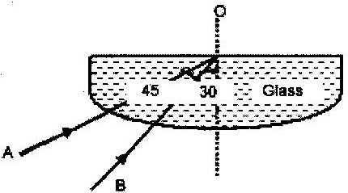
block which has critical angle of 42⁰. The rays are incident at an air glass boundary at point O

Complete the path of the two rays from point O. Label A¹ and B¹ the corresponding rays.
4. A ray of light is directed at an angle of 50⁰ on to a liquid-air boundary.
The refractive index of the liquid is 1.4.
Show on a diagram the patch taken by the ray on striking the liquid-air boundary. Show how you arrive at your answer.
- Figure 13 shows a coin placed in a large empty container. An observer
looking into the container from the position shown is unable to see the coin.
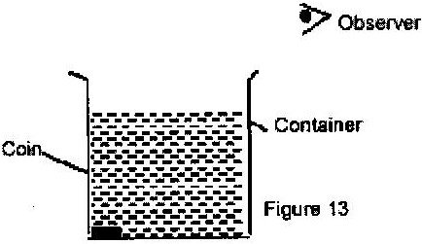

Sketch two rays from a point on the coin to show how the observer is able to see the image of the coin after the container is filled with water.
TOPIC 3
NEWTON’S LAW OF MOTION
PAST K.C.S.E QUESTIONS ON THE TOPIC
1. Two masses of 3kg and 7kg are connected by a light string. The 3 kg mass rests on a smooth incline plane 30⁰ to the horizontal. The 7 kg mass hangs freely from the frictionless pulley attached to the top of plane.
i) Draw a diagram showing the bodies and identify the forces acting on the 3 kg mass.
ii) Calculate the acceleration of the masses.
2. A rocket propelled upward with a constant thrust. Assuming friction due
to air is negligible and the burning of the fuel is steady. Explain its motion.
3. A 2 kg body slides down a smooth slope from a height of 5m. As it
reaches the horizontal, it strikes another body of mass 3 kg which is at rest. Both bodies stick together. Calculate the velocity of the bodies after collision.

