FORM FOUR APRIL HOLIDAY ASSIGNMENT
TOPIC 1
THIN LENSES
PAST K.C.S.E QUESTIONS ON THE TOPIC
1. The figure below shows how a distant object is focused in a defective eye.
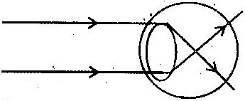

i) State the nature of the defect.
ii) Suggest suitable lens to correct the defect.
2. a) You are provided with a rectangular glass block, two pins and a
piece of white paper. Describe how you would use them to determine the refractive index of the glass using real and apparent image method.
b) An object O is placed 15cm from a converging lens of focal length 10cm.
i) At what distance should a screen be placed so that a focused image is formed on it?
ii) A diverging lens of focal length 37.5 cm is placed half way between the converging lens and the screen. How far should the screen be from the diverging leans in order to receive a focused image?
c) Two lenses L₁ and L₂ placed 12cm from each other. The focal length of L₂ is 4cm. An object 5mm high is placed 4cm from L₁.
i) Construct a scaled ray diagram on a graph paper to obtain the position of the final image as would be observed by a person on the right hand side of L₂
ii) Determine the magnification obtained by the arrangement.
3. The figure below represents and object O placed 10cm in front of a
diverging lens. F is the focal point of the lens.

Draw rays to locate the position of the image. Determine the image distance.

4. A vertical object is placed at the focal point F of a diverging lens as shown
in figure 16.

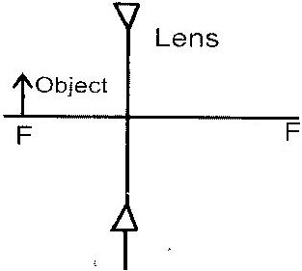

Sketch a ray diagram to show the image of the object. (3mks)
5. a) Describe with the aid of labeled diagram an experiment to
determine the focal length of the lens when provided with the following; an illuminated object, a convex lens, a lens holder, a plane mirror and a metre rule. (5mk)
b) A small vertical object is placed 28cm in front of a convex lens of focal length 12cm. On the grid provided, draw a ray diagram to locate the image. The lens position is shown. (Use a scale: 1 cm represents 4 cm).
c) Fig. 1 shows a human eye with a certain defect.
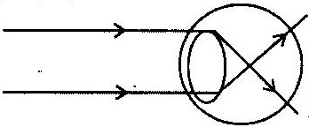

i) Name the defect. (1mk)
ii) On the same diagram, sketch the appropriate lens to correct the defect and sketch rays to show the effect of the lens. (2mks)

CIRCULAR MOTION
1. A light inextensible string of length L is fixed at its upper end and support
a mass m at the other end. m is rotated at horizontal plane or radius r as shown. The maximum tension the string can withstand without breaking is 2N. Assuming the string breaks when the radius is maximum, calculate the velocity of the mass when the string breaks, given that L 1.25m, and m= 0.1kg.
2. The diagram below shows a mass m, which is rotated in a vertical circle.
The speed of the mass is gradually increased until the string breaks. The string breaks when the mass is at its lowest position A and at a speed of 30ms⁻¹. Point a is 5m above the ground.

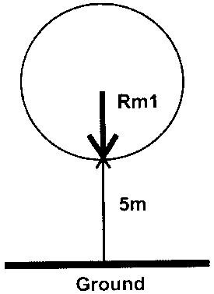

a) Show on the diagram.
i) The initial direction of the mass at the point the string breaks.
ii) The path of the mass from A until it strikes the ground at a point b.
b) Calculate;
i) The time the mass takes to reach the ground after breaking off.
ii) The horizontal distance the mass travels before it strikes the ground.
iii) The vertical velocity with which the mass strikes the ground.
3. State the principle by which a speed governor limits the speed of a vehicle.
4. The rear wheel of a certain car has a diameter of 40cm. At a certain speed
of the car, the wheel makes 7 revolutions per second. A small stone embedded in the tyre tread flies off initially at an angle of 45⁰ to the ground. Determine the initial velocity of the pebble (take π = ²²/₇)
5. a) Explain why a pail of water can be swung in a vertical circle
without the water pouring out.
b) A car of mass 1,200kg is moving with a velocity of 25m/s around a flat bend of radius 150m. Determine the minimum frictional force between the tyres and the road that will prevent the car from sliding off.

FLOATING AND SINKING
1. State how a hydrometer may be used to test whether a car battery is fully
charged.
2. Determine the density of glass that weighs 0.5N in air and 0.3N in water.
3. A mass of 120g half immersed in water displaced a volume of 20cm³.
Calculate the density of the object.
4. A solid displaced 5.5 cm³ of paraffin when floating and 20cm³. Calculate
the density of the object.
5 The figure below shows a cube of a certain wood whose density is the
same as that of water. The cube is held on the surface of the water in a long cylinder. Explain what happens to the cube after it is released.
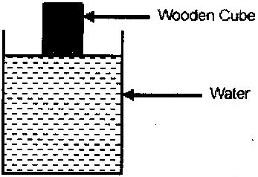

6. A right angled solid of dimensions 0.02m by 0.02m by 0.2m and density
2,700kg/m³ is supported inside kerosene of density 800kg/m³ by a thread which is attached to a spring balance. The long side is vertical and the upper surface is 0.1m below the surface of the kerosene.
i) Calculate the force due to the liquid on the lower upper surface of the solid.
ii) Calculate the up thrust and determine the reading on the spring balance.

TOPIC 4
ELECTROMAGNETIC (EMS) SPECTRUM
PAST KCSE QUESTIONS ON THE TOPIC
1. State one-way of detecting ultra violet radiation.
2. Arrange the following radiations in order of increasing wavelengths.
Ultraviolet Gamma Rays
Radio Waves Infra Red
3 Name two types of electromagnetic radiations whose frequencies are
greater than that of visible light.
4. Calculate the wavelength of the KBC FM radio waves transmitted at a
frequency of 95.6 mega hertz.
5. The chart below shows an arrangement of different parts of the
electromagnetic spectrum. Complete the table.
Type of Radiation | Detector | Uses
Ultraviolet | Photographic paper, fluorescent  material, phototransistor
Radio waves | Balanced thermometer | Warmth sensation, making toast.
Radio waves |  | Communication

6. Arrange the following in order of increasing frequency. Visible light,
infrared radiation, x-rays, u.v. radiation, radio waves.
7. State the difference between X-rays and gamma rays in the way in which
they are produced (1mk)

TOPIC 5
ELECTROMAGNETIC INDUCTION (EM I)
1. The diagram in figure 1 shows an arrangement that may be used to
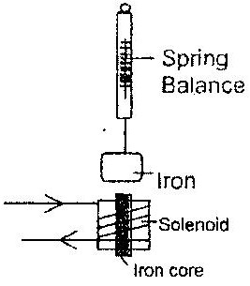
investigate how electromagnetic force varies with current. Explain how the arrangement may be used for this investigation.

2 a) The free ends of a coil are connected to a galvanometer. When the
north pole of a magnet is moved towards the coil, the pointer deflects towards the coil, the pointer deflects towards the right as shown. State with reason the behaviour of the pointer in the following cases.
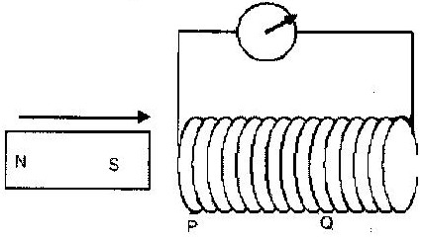

i) The north pole of the magnet is held stationary near p.
ii) The south pole of the magnet is made to approach the coil from Q.
c) Two coils T and S are wound on a soft iron core as shown. T has 1000 turns while S has 600 turns and resistance of 100Ω
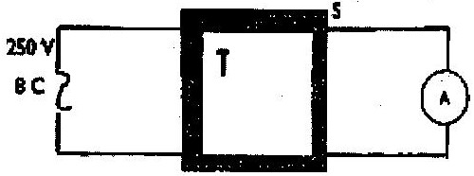

Calculate the maximum current measured by the ammeter.
3. Calculate the peak value of an alternating current which has a root mean
square value of 3.0A.
4. A large sub station transformer is used to step down voltage from
11,000V to 450V.
i) Determine the ratio of the turns in the primary to secondary coils.
ii) How is the efficiency of this transformer ensured?
iii) State one function of the core in a transformer.
5. A generator produces a peak voltage of 220v. What is the root mean
square value of this voltage?.
6. Name any two ways by which a transformer loses energy.
7. The Fig; Represents a transformer connected to an ac source and a resistor
R. Compare the magnitudes of the:
i) Voltages V_{p} and V_{s}
ii) Currents I_{p} and I_{s}
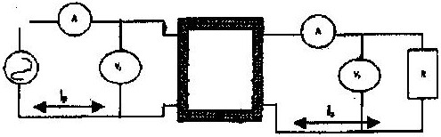

8. (a)
i) A researcher studying the behaviour of step up transformer made the following observation. ‘More joules per coulomb and fewer coulombs per second at the output than at the input terminals’. Explain why the observation does not imply a violation of the principle of conservation of energy.
ii) A transformer of 480 turns in the primary coil used to connect a 9-volt a.c. electric device to a 240V a.c. mains power supply. Calculate the number of turns in the secondary coil
9. What causes electromagnetic damping in a moving coil galvanometer?
10. State how Eddy Currents are reduced in a transformer.

