NAME INDEX NUMBER
SCHOOL DATE

STRUCTURE AND BONDING
- 1989 Q 6
The table below gives the distance between atoms (bond lengths) in halogen molecules and the energies required to break the bonds (bond energies) between the atoms.

Molecule | Bond length (nm) | Bond Energy (KJ Mol⁻¹)
Cl – Cl  Br – Br  I – I  At – At | 0.20  0.23  0.26  0.29 | 240  195  150

- Predict the energy required to break the At – At bond
................................................................................................................................................................................................................................................................................................................................................................................................................................................................................................................................................................................................................................................................................................................................................
- What is the relationship between bond length and bond energy for the halogen molecules?
................................................................................................................................................................................................................................................................................................................................................................................................................................................
2. 1989 P1 A Q 8
A solid compound has a giant Ionic Structure. State and explain whether the compound has electricity in the solid state.
................................................................................................................................................................................................................................................................................................................................................................................................................................................................................................................................................................................................

3. 1989 Q 33c
(c) Using dots (.) and crosses (X) to represent outermost elections, draw a
diagram to show the bonding CCl.

4. 1991 P1A Q 21
Using dot (.) and crosses (X) to represent electrons, draw a diagram which shows the bonding in phosphate molecule, PH₃ (Atomic numbers: p = 15, H = 1) (1 mark)

5. 1993 Q 13
In terms of structure and bonding, explain why graphic conducts electricity while diamond does not (2 marks)

................................................................................................................................................................................................................................................................................................................................................................................................................................................
6. 1993 Q 23c
- Study the information given in the table below and answer the questions that follow: -
Formula of compound | NaCl | MgCl₂ | AlCl₃ | SiCl₄ | PCl₃ | SCl₂
B.P. (⁰C) | 1470 | 1420 | Sublimes at 180⁰C | 60 | 75 | 60
M.P. (⁰C) | 800 | 710 |  | -70 | -90 | -80

- Give two chlorides that are liquids at room temperature. Give a reason for the answer (2 marks)
................................................................................................................................................................................................................................................................................................

(ii) Give a possible reason why AlCl₃ has a much lower melting point that MgCl₂ although both Al and Mg are metals (1 mark)

................................................................................................................................................................................................................................................................................................
(iii) Which one of the chlorides would remain in liquid state for the highest temperatures range? Show you arrive at your answer (2 marks)
................................................................................................................................................................................................................................................................................................................................................................................................................................................
- 1994 P1A Q 14
When an electric current was passed through two molten substances M and N in
different containers, the observations in the table below were made.
Molten M | Conducts an electric current and is not decomposed
Molten N | Conducts an electric current and a gas is formed at one of the electrodes

Suggest the type of bonding present in substance M and N

................................................................................................................................................
- 1994 Q 1 P2
The table below gives elements represented by letters T, U, V, W, X, Y and their atomic numbers

Element T | U | V | W | X | Y
Atomic number 12 | 13 | 14 | 15 | 16 | 17
Electron arrangement

Use the information in the table to answer the questions below: -
- Complete the above table giving the electron arrangement of each of the elements

.....................................................................................................................................................................................................................................................................................................................................................................................................................
- In which period of the periodic table do these elements belong? Give a reason

............................................................................................................................................................................................................................................................................................................................................................................................................................................................................................................................................................
- How does the atomic radius v compare with that of X? Explain

................................................................................................................................................................................................................................................................................................................................................................................................................................................................................................................................................
- Give the formula of the compound that could be formed between U and W

...........................................................................................................................................................................................................................................................................
- What type of bonding will be present in a compound formed between T and Y? Explain

............................................................................................................................................................................................................................................................................................................................................................................................................
- Arrange the species T,T,T, in increasing order of size

................................................................................................................................................................................................................................................................................................................................................................................................................................................................................................................................................
- Which of the ions X²⁺ and X²⁻ is the most stable? Explain

.............................................................................................................................................................................................................................................................................................................................................................................................................................................................................................................................................................................................................................................................................................................................................................................................................................
(h) Give the formula of:
- An acidic oxide formed when one of the elements in the table is heated in air

............................................................................................................................................................................................................................................................................................................................................................................................................
(ii) A basic oxide formed when one of the elements in the table is heated in air
............................................................................................................................................................................................................................................................................................................................................................................................................
- 1996 Q 5
a) Using dots (.) and crosses (x) to represent electrons draw diagram to represent `
the bonding in:
(i) NH₃ (ii) NH₄⁺ (1 mark)

b) State why an ammonia molecule (NH₃) can combine with H+ to form NH₄⁺
(Atomic numbers: N=7 and H=1) (1 mark)
............................................................................................................................................................................................................................................................................................................................................................................................................
- 1996 Q 11
Complete the table below.

Species | Number of neutrons | Electrons
H
- 1996 Q 4 P2
Study the table below and answer the questions that follow:

Element | Atomic number | Relative atomic mass | Melting point (ºC)
Aluminium  Calcium  Carbon  Hydrogen  Magnesium  Neon  Phosphorous  Sodium | 13  20  12  10  15 | 27.0  40.0  12.0  1.0  24.3  31.0  23 | 850  3730  -259  650  -249  44.2 (white)  590 (red)

a) Complete the table by filling in this missing atomic numbers and atomic mass.
(2 marks)
b) Write the electron arrangement for the following ions (2 marks)
Ca⁺
P³⁺
................................................................................................................................................................................................................................................................................................................................................................................................................................................

c) What is the melting point of hydrogen in degrees Kelvin? (1 mark)
................................................................................................................................................................................................................................................................................................
d) Which of the allotropes of phosphorous has a higher density? Explain (2 marks)

................................................................................................................................................................................................................................................................................................
e) The mass numbers of three isotopes of magnesium are 24, 25 and 26.
What is the mass number of the most abundant isotope of magnesium? Explain
(2 marks)

............................................................................................................................................................................................................................................................................................
f) Give the formula of the compound formed between aluminium and carbon. (1 marks)
................................................................................................................................................................................................................................................................................................

g) Explain the difference in the melting points of magnesium and sodium. (2 marks)

...................................................................................................................................................
.....................................................................................................................................................................................................................................................................................................

12. 1998 Q 5
The table below shows some properties of substances C, D and E. Study it and answer the questions that follow.

Substance | M.P (0C) | Solubility in water | Electrical solid state | Conductivity  molten state.
E | -39 | Insoluble | Good | good
D | 1610 | Insoluble | Poor | poor
E | 801 | Soluble | Poor | good

Select substance
      - With a giant molecular structure
..............................................................................................................................................................................................................................................................................................
      - That is not likely to be an element

................................................................................................................................................................................................................................................................................................
- 1998 Q 10
An ion of phosphorous can be represented as 31 P³⁻
15
Draw a diagram to show the distribution of the electrons and the composition of the nucleus of the ion of phosphorous.

14. 1998 Q 11
Diamond and graphite are allotropes of carbon. In terms of structure and bonding
Explain the following.
(a) Diamond is used in drilling through hard rocks

................................................................................................................................................................................................................................................................................................................................................................................................................................................................................................................................................
(b) Graphite is used as a lubricant

................................................................................................................................................................................................................................................................................................................................................................................................................................................................................................................................................

15. 1998 Q 7d
Study the information given in the table below and answer the questions that follow.
The letters do not represent the actual symbols of the elements

Element | Atomic number | Boiling point
S  T  U  V  W | 3  13  16  18  19 | 1603  2743  718  87  1047

(d) What type of bond would exists in the compound formed when U and T react?
Give a reason for your answer

................................................................................................................................................ ................................................................................................................................................
16. 1999 Q 6
What type of bond is formed when lithium and fluorine react? Explain
(Atomic numbers: Li = 3 and F = 9)
................................................................................................................................................................................................................................................................................................
17. 1999 Q 25
When solid magnesium carbonate was added to a solution of hydrogen chloride
in methylbenzene, there was no apparent reaction. On addition of water to the
resulting mixture, there was vigorous effervescence. Explain these observations

................................................................................................................................................................................................................................................................................................
................................................................................................................................................................................................................................................................................................

18. 1999 Q 3e P2
Study the information in the table below and answer the questions that follow.
The letters do not represent the symbols of the elements.
Element(C) | Atomic number | Melting point
L  M  N  Q  R | 11  13  14  17  19 | 97.8  660  1440  401  63.7

e) Using dots(.) and crosses (x) to represent outermost electrons show bonding in the
compound formed elements N and Q.

19. 2000 Q 16
Compound Q is a solid with a giant ionic structure. In what form would the
compound conduct an electric current

................................................................................................................................................................................................................................................................................................
20. 2000 Q 6a P2
(a)The following diagrams show the structures of two allotropes of carbon.
Study them and answer the questions that follow
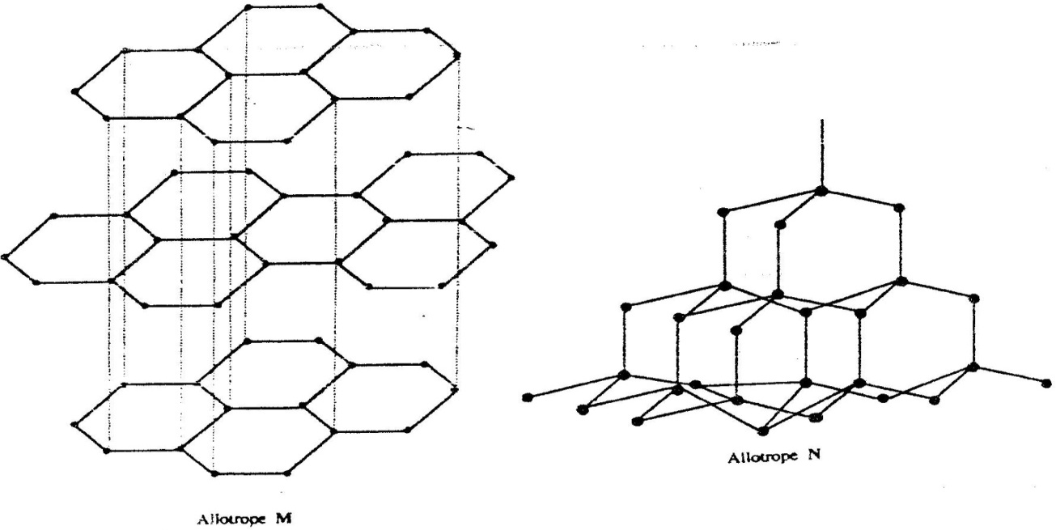

(i) Name allotrope
M ................................................................................................
N.................................................................................................
(ii) Give one use of N
......................................................................................................................................................................................................................................................................................................
(iii) Which allotrope conducts electricity? Explain

......................................................................................................................................................................................................................................................................................................
......................................................................................................................................................................................................................................................................................................
21. 2001 Q 23
The table below shows the properties of substances K, L, M and N the substances which are
likely to be:

Substances | Reaction with oxygen at 25ºC | Melting point | Conductivity  Solid | Molten
K  L  M  N | Unreactive  Reactive  Unreactive  Unreactive | Low  High  Low | Poor  Good  Good | Good  Good  Good

a) Copper metal.......................................................................................................
b) Magnesium chloride..........................................................................................

22. 2002 Q 16
With reference to iodine, distinguish between covalent bonds and Van Der Waals forces

.................................................................................................................................................
....................................................................................................................................................................................................................................................................................................

23. 2002 Q 20
The table below gives some information about the electrical conductivity and the likely bonding in substances N,P and Q. Complete the table by inserting the missing information the spaces numbered I, II and III

Substance | Likely type of bonding  present | Electrical solid | Conductivity
N | Metallic | I………………… | Conducts
P | II……………………. | Does not conduct | Conducts
Q | III …………………… | Does not conduct | Does not conduct

24. 2003 Q 1b P2
b) i) Element A is the same group of the periodic table as chlorine.
Write the formula of the compound formed when A reacts with
potassium metal. (1 mark)

........................................................................................................................................................................................................................................................................
ii) What type of bonding exists in the compound formed in (b) (i) above?
Give a reason for your answers. (3 marks)

................................................................................................................................................
................................................................................................................................................................................................................................................................................................

25. 2004 Q 6
Both diamond and graphite have giant atomic structures. Explain why diamond is hard while graphite is soft. (3 marks)

................................................................................................................................................................................................................................................................................................
..................................................................................................................................................................................................................................................................................................

26. 2005 Q 4
Using dots (.) and crosses(x) to represent electrons, show bonding in the compounds
formed when the following elements react: (Si = 14, Na = 11 and Cl = 17) (1 mark)
a) Sodium and chlorine (1 mark)

b) Silicon and chlorine (1 mark)

- 2005 Q 4c P2
(c)The table below gives some properties of substances I, II, III, and IV.
Study it and answer the questions that follow
Substance | Electrical conductivity |  | M.P (⁰C) | B.P (⁰C)
 | Solid | Molten
I | Does not conduct | Conducts | 801 | 1420
II | Conducts | Conducts | 650 | 1107
III | Does not conduct | Does not conduct | 1700 | 2200
IV | Does not conduct | Does not conduct | 113 | 440

(i) What type of bonding exists in substances I and II (2 marks)

................................................................................................................................................
(ii) Which substance is likely to be sulphur? Explain (2 marks)

..............................................................................................................................................
................................................................................................................................................ ................................................................................................................................................
................................................................................................................................................
- 2006 Q 20
a) Distinguish between a covalent bond and a co-ordinate bond (2 marks)

..............................................................................................................................................................................................................................................................................................
................................................................................................................................................................................................................................................................................................
b) Draw a diagram to show bonding in an ammonium ion. (1 mark)

- 2006 Q 3a,b P2
a) Distinguish between isotopes and allotropes. (2 marks)

............................................................................................................................................................................................................................................................................................................................................................................................................
b) The chart below is part of the periodic table. Study it and answer the questions that follow.(The letters are not the actual symbols of the elements).
A
C
D
E
B

i) Select the element in period three which has the shortest atomic radius. Give a reason for you answer. (2 marks)
..............................................................................................................................................
................................................................................................................................................
ii) Element F has the electronic structure, 2.8.18.4 on the chart above; indicate the position of element F. (1 mark)

................................................................................................................................................
................................................................................................................................................
iii) State one use of the elements of which E is a member. (1 mark)

........................................................................................................................................................................................................................................................................
- 2007 Q 3b
b) In terms of structure and bonding, explain why the boiling point of chlorine is lower than that of iodine. (2 marks)

..............................................................................................................................................
..............................................................................................................................................
...............................................................................................................................................
................................................................................................................................................
- 2007 Q 29
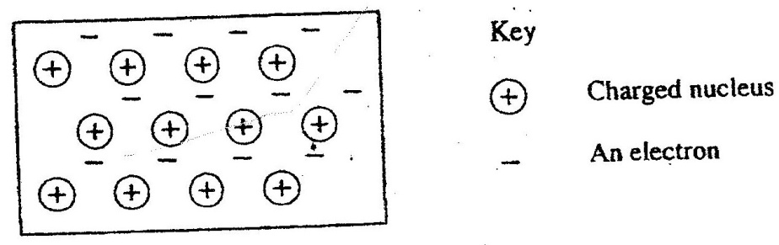
The diagram below is a section of a model of the structure of element T.

a) State the type of bonding that exists in T. (1 mark)

..............................................................................................................................................
b) In which group of the period table does element T belong? Give a reason. (2 marks)

...................................................................................................................................
...................................................................................................................................
- 2007 Q 5a-c P2
(a) The diagram below represents part of the structure of a sodium chloride crystal. The position of one of the sodium ions in the crystal is shown as ⊕

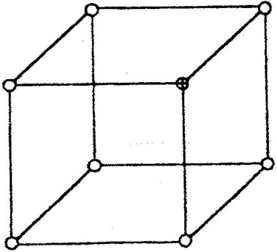

(i) On the diagram, mark the position of the other three sodium ions (2 marks)

(ii) The melting and boiling points of sodium chloride are 801⁰C and 1413⁰C
respectively. Explain why sodium chloride does not conduct electricity at 25⁰C,
but does so at temperatures between 801⁰ C and 1413⁰C (2 marks)

..............................................................................................................................................................................................................................................................................................
................................................................................................................................................................................................................................................................................................
(b) Give a reason why ammonia gas is highly soluble in water (2 marks)

..............................................................................................................................................
................................................................................................................................................
(c) The structure of an ammonia ion is shown below:
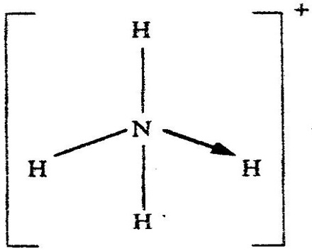

Name the type of bond represented in the diagram by N → H (1 mark)

................................................................................................................................................
- 2008 Q 2b P2
b) The table below gives information about elements A₁A₂A_{3,} and A₄

Element | Atomic  Number | Atomic  Radius (nm) | Ionic radius (nm)
A₁  A₂  A₃  A₄ | 3  5  13  17 | 0.134  0.090  0.143  0.099 | 0.074  0.012  0.050  0.181

(i) In which period of the periodic table is element A₂? Give a reason (2 marks)
..............................................................................................................................................................................................................................................................................................
................................................................................................................................................
(ii) Explain why the atomic radius of:
I A₁ is greater than that of A₂;
........................................................................................................................................................................................................................................................................
II A₄ is smaller than its ionic radius (2 marks)
........................................................................................................................................................................................................................................................................
(iii) Select the element which is in the same group as A₃ (1 mark)

............................................................................................................................................
(iv) Using dots (.) and crosses(x) to represent outermost electrons. Draw a
diagram to show the bonding in the compound formed when A₁ reacts with A₄ (1 mark)

34. 2009 Q 6a, c P2
(a) Study the table below and complete it.
(W⁻ and X⁴⁺ are not the actual symbols of the icons)

Ion | Number of Protons | Number of neutrons | Mass Number | Electron Arrangement
W⁻ |  | 20 |  | 2.8.8
X⁴⁺ | 14 |  | 28

(c) The atomic numbers of Na and Mg are 11 and 12 respectively. Which of the element
has higher ionization energy? Explain (2 marks)
................................................................................................................................................................................................................................................................................................................................................................................................................................................
- 2009 Q 5
In terms of structure and bonding, explain why the melting point of oxygen is much lower than that of sodium. (3 marks)

................................................................................................................................................................................................................................................................................................................................................................................................................................................
36. 2009 Q 8
Using dots (.) and crosses (X) ,show bonding in:
(a) The compound formed when nitrogen reacts with fluorine.
(Atomic numbers F= 9, N=7)
............................................................................................................................................................................................................................................................................................................................................................................................................
(b) Sodium oxide (Atomic numbers Na = 11,O= 8)

............................................................................................................................................................................................................................................................................................................................................................................................................
- 2010 Q 14
Using electrons in the outermost energy level, draw the dot (.) and cross (x) diagram for the molecules H₂O and C₂H₄. (H = 1, C = 6, O = 8)
(2 marks)
- H₂O

- C₂H₄

- The formula of a complex ion is Zn(NH₃)₄²⁺. Name the type of bond that is likely to exist between zinc and ammonia in the complex ion.
...............................................................................................................................

- 2010 Q 27
The atomic numbers of phosphorus, sulphur and potassium are 15, 16 and 19 respectively. The formulae of their ions are P³⁻, S²⁻ and K⁺. These ions have the same number of electrons.
Write the electron arrangement for the ions. (1 mark)

....................................................................................................................................
- Arrange the ions in the order of increasing ionic radius starting with the smallest. Give a reason for the order. (2 marks)

............................................................................................................................................................................................................................................................................................................................................................................................................
- 2010 Q 3 P2
Use the information in the table below to answer the questions that follow. The letters do not represent the actual symbols of the elements.
Element | Atomic number | Melting point (⁰C)
R  S  T  U  V  W | 11  12  15  17  18  19 | 97.8  650.0  44.0  -102  -189  64.0
          - Give the reasons why the melting point of:
- S is higher than that of R (1 mark)
............................................................................................................................................................................................................................................................................................................................................................................................................
- V is lower than that of U (2 marks)
............................................................................................................................................................................................................................................................................................................................................................................................................
          - How does the reactivity of W with chlorine compare with that of R with chlorine? Explain, (2 marks)
................................................................................................................................................................................................................................................................................................................................................................................................................................................................................................................................................................................................
          - Write an equation for the reaction between T and excess oxygen (1 mark)
........................................................................................................................................................................................................................................................................
          - When 1.15g of R was reacted with water, 600cm³ of gas was produced.
Determine the relative atomic mass of R. (Molar gas volume = 24000cm³) (3 marks)

................................................................................................................................................................................................................................................................................................................................................................................................................................................
          - Give one use of element V (1 mark)
...............................................................................................................................................................................................................................................................................................

- 2011 Q 5b(iii-vii) P2
- The table below gives the number of electrons, protons and neutrons in particles
A, B, C, D, E, F and G.

Particle | Protons | Electrons | Neutrons
A | 6 | 6 | 6
B | 10 | 10 | 12
C | 12 | 10 | 12
D | 6 | 6 | 8
E | 13 | 10 | 14
F | 17 | 17 | 18
G | 8 | 10 | 8

- Write the formula of the compound formed when E combines with G. (1 mark)
....................................................................................................................................
- Name the type of bond formed in (iii) above (1 mark)
....................................................................................................................................

- How does the radii of C and E compare? Give a reason. (2 marks)
................................................................................................................................................................................................................................................................................................................................................................................................................................................................................................................................................
- Draw a dot (.) and cross (x) diagram for the compound formed between A and
F. (1 mark)

vii) Why would particle B not react with particle D? ( 1 mark)

........................................................................................................................................................................................................................................................................
- 2011 Q 28
The diagram below shows the bonding between aluminum chloride and ammonia.

H Cl

H N Al Al

H Cl

- Name the types of bonds that exist in the molecule. (1 mark)
........................................................................................................................................................................................................................................................................
- How many electrons are used for bonding in the molecule? (1 mark)
....................................................................................................................................................................................................................................................................................

- 2012 Q7 P1
Ammonium ion has the following structure:

Label on the structure
(a) Covalent bond; (1 mark)
(b) Coordinate (dative) bond, (1 mark)

