**Name…………………………………………… ADM No…………………Class………………….**

**END YEAR EXAMINATIONS 2019**

**CHEMISTRY PAPER 1** **233/1**

**TIME 2 HOURS**

**MARKING SCHEME**

**INSTRUCTIONS TO CANDIDATES**

* Write your name and Admission Number in the spaces provided above.
* Answer **ALL** questions in the spaces provided.
* Mathematical tables and electronic calculators may be used.
* All workings **must** be clearly shown where necessary.

1. Explain why burning magnesium continues to burn in a gas jar full of sulphur (IV) oxide while a burning splint would be extinguished. (3 marks)

***Heat from magnesium splits✓1 sulphur(iv) oxide into sulphur and oxygen, the oxygen ✓1 supports burning. Heat from burning splint is not hot ✓1 enough to split sulphuric oxide***

1. Draw structural formulae and name two positional isomers with molecular formula C4H8. (2 marks)

**H H H H H H H H**

**C ═ C─ C─ C H H C ─ C ═ C ─ C H**

**H H H H H**

**But-1-ene (*✓½*) but-2-ene*✓½***

1. Dry Hydrogen chloride gas was made to dissolve in water using the set of apparatus shown below



(a) What is the use of the inverted funnel? (1 mark)

***To prevent sucking back of water✓1***

(b) State and explain the observations made on the litmus paper (2 mark)

***Litmus paper changes red✓1 hydrogen chloride ionizes into H+(aq)✓1***

(c) State and explain the observation made on the litmus paper if methylbenzene is used instead of water in the above set up. (2 mark)

***Litmus paper remains $1$ red; HCl does not ionise1***

1. Using sodium hydroxide solution, describe a chemical test that can be used to distinguish between copper (II) ions and iron (II) ions (2 marks)

***When NaOH(aq) is added to Cu2+(aq) a blue✓1 precipitate is obtained while a green✓1precipitate is formed when NaOH is added to Fe 2+(aq)***

1. The flow chart below shows laboratory preparation of chlorine gas. Study it and answer the questions that follow:

**Mn O2 + W**

**Heat**

**Water**

**Y**

**Cl2(g)**

**Dry chlorine gas**

(a) Name substances (2 marks)

W**- *hydrochloric acid✓1*** Y- ***Concentrated sulphuric(VI) acid✓1***

(b) What is the function of water in the above set up? (1 mark)***=13***

***Absorb HCl fumes✓1***

1. An unknown mass of anhydrous potassium carbonate was dissolved in water and the solution made up to 200cm3. 25cm3 of this solution neutralized 18.0cm3 of 0.22M nitric (v) acid. Calculate the unknown mass of potassium carbonate (**K**=39, **C**=12, **O**=1) (3 marks)

***Mols of HNO3 = 0.00396 ✓½moles***

***K2CO3+ 2HNO3(aq) 2KNO3(aq) +H20(l) + CO2(g)✓½***

***Moles of K2CO3in 25cm3soln = = 0.00198 moles✓½***

***Moles of K2CO3in 200cm3soln = = 0.01584✓½***

***K2CO3= 138g✓½***

***Mass ofK2CO3= 138 x 0.01584 = 2.186 g✓½***

1. Below is a sample of the periodic table

|  |  |  |  |  |  |  |  |  |
| --- | --- | --- | --- | --- | --- | --- | --- | --- |
|  |  | | | | | | |  |
|  |  |  |  |  |  |  |  |  |
| I |  |  |  |  | Q | M |  |
|  | J |  |  |  |  |  | N |  |
| K | L | P |  |  |  |  |  |

a) Give the family name to which elements **M** and **N** belong (1 mark)

***Halogens✓1***

(b) Compare the reactivity of elements **I** and **K**. Give a reason (2 mark)

***K is more reactive than ✓1 I; valence electron is Kis lost more✓1 easily than in I***

(c) Write the formular of the compound formed when **P r**eacts with **Q**  (1 mark)

***P2Q3✓1***

1. Study the experimental set up of apparatus shown below.



(i) State two observations made in the set up as the experiment progressed (2 marks)

***copper (II) oxide changes from black to red***✓1

***White precipitate in the boiling tube***✓1

(ii) Using an equation, explain the change that occurred in the boiling tube (1 mark)

***Ca(OH)2(aq) + CO2(g) CaCO3(s)✓1***

(iii) Why was the gas burned in the flame? (1 mark)

***It is burned to avoid air pollution✓1***

1. Painting, oiling, galvanizing and tin plating are methods of rust prevention.

(a) Explain the similarity of these methods in the way they prevent rusting (1 mark)

***Prevent contact of iron with water✓1***

(b) Explain why galvanized iron objects are better protected even when scratched (1mark)

***Zinc corrodes✓½ its more✓½ reactive than iron***

1. The chemical equations below are the main reactions in large scale manufacture of sodium carbonate.

NH3(g) + CO2(g) + H2O(l) NH4HCO3(aq)

NH4HCO3(aq)  + NaCl(aq) Nahco3(s) + NH4Cl(aq)

(a) Explain how the two products NaHCO3 and NH4Cl are separated (1 mark)

***By filtration✓1***

(b)How sodium carbonate is finally obtained from NaHCO3? (1 mark)

***Heating NaHCO3/ accept correct equation. ✓1***

(c) Explain how ammonia is recovered in this process. (1 mark)

***Ammonium chloride is heated with calcium hydroxide✓1***

1. 80 cm3 of oxygen gas diffused through a porous hole in 50 seconds. How long will it take 120cm3 of Nitrogen (IV) oxide to diffuse through the same hole under the same conditions? (N =14, O=16) (3 marks)

***TO2 = MO2✓½***

***T NO2NO2***

***80cm3 O2 50 sec. O2 = 32***

***120cm3 O2 75 sec.✓ NO2= 44 ✓½***

***75 = 32 ✓½***

***TNO2 44***

***TNO2 = 87.94 sec.✓½***

1. Filtration is carried out in the apparatus shown



Name : (2 marks)***=31***

X ***Residue ✓1***  Y ***Filtrate ✓1***

1. Two carbonates **P** and **Q** are weighed before and after heating. The results are given in the table below.

|  |  |  |
| --- | --- | --- |
| Carbonate | Mass in grams | |
|  | Before heating | After heating |
| P | 15.0 | 15.0 |
| Q | 15.0 | 10.0 |

Which one is likely to be sodium carbonate? Explain. (2 marks)

***P✓1; not decomposed ✓1 by heat***

1. Describe how you would separate a solid mixture of lead(II) chloride and copper(II) oxide

(3 marks)

***Add✓½water; warm✓½PbCl2 dissolves,½✓ filter.✓½ allow to cool.✓½ filter✓½***

***recrystalised PbCl2***

1. The general formula for a homologous series of organic compounds in CnH2n+2

(a) Give the name and structural formula of the fourth member of the series (2 marks)

(i) Name ………………………  ***butane✓1***

(ii) Structural formula …………….***C4H10✓1***

(b) Write an equation for the combustion reaction of the above molecule (1mark)

***2C4H10(g) +13O2 (g) 8 CO2(g)+ 10H2O(l) ✓1***

1. The scheme below shows some reactions sequence starting with solid **N**. Study it and answer the questions that follow:

**Excess NH3(aq)**

**Few drops of** **NH3(aq)**

**Solution P**

**White precipitate**

**Colourless solution Q**

**Gas R which explodes**

**With a pop sound**

**Solid N**

**Dil**

**HCl(aq**)

(a) Identify solid N…………………………………………………………………………… (1 mark)

**zinc*✓1***

b) Write the equation for the formation of the colourless solution Q (1 mark)

***2+***

***Zn(OH)2(s) + 4NH3(aq)  Zn(NH3)4 +2OH-(aq) ✓1***

c) give the identity of gas R (1 mark)

***Hydrogen gas✓1***

1. In an experiment, a gas jar containing moist sulphur (IV) oxide was inverted over another gas jar containing hydrogen sulphide gas.

(a) State and explain the observation that was made (2 marks)

***Yellow solid deposited✓1; sulphur(IV) oxide is reduced✓½ to sulphur and H2S***

***oxidised✓½ to sulphur***

(b) State the precautions that should be taken when carrying out this experiment (1 mark)

***Should be done in the fume chamber/ open air***✓***1***

1.  The graph below shows the behavior of a fixed mass of a gas at constant temperature

(a) What is the relationship between the volume and pressure of the gas? (1 mark)

***Volume decreases with increase in ✓1 pressure/volume is inversely proportional to Pressure.***

(b) 3 litres of oxygen gas at one atmosphere pressure were compressed to two atmospheres at constant temperature. Calculate the new volume occupied by the oxygen gas. (2 marks)

***P1V1 =P2V2 ✓½ ; V2 = P1V1***

***P2***

***V2 = 1 x 3✓***

***2***

***= 1.5 litres✓½***

1. The table below shows the relative atomic masses and percentages abundance of the isotopes **M1** and **M2**of element **M**

|  |  |  |
| --- | --- | --- |
|  | Relative abundance | % abundance |
| **M1** | **60.57** | **59.71** |
| **M2** | **62.83** | **40.29** |

Calculate the relative atomic mass of element **M** (2 marks)

***R .A.M =✓***

***= 61.48***✓

1. The table below shows the pH values of solutions **A,B,C** and **D**

|  |  |  |  |  |
| --- | --- | --- | --- | --- |
| solution | A | B | C | D |
| pH | 2 | 7 | 11 | 14 |

(a) Which solution is likely to be that of calcium hydroxide (1 mark)

***C✓1***

(b) Select the solution in which a sample of aluminum oxide is likely to dissolve. Give a reason for your answer

(1 mark)

***A✓½, it is ½✓strongly acidic***

***Or***

***/D; it is strongly alkaline***

1. Name one property of neon that makes it possible to be used in electric lamps. (1mark)

***It is inert✓1***

1. Distinguish between ionic bond and covalent bond (2 marks)

***In covalent bond there is sharing ✓1 of valence electrons***

***In ionic bond there is complete transfer✓1 of valence electrons from one atom to another***

1. Explain why the boiling point of hexane is higher than that of ethane. (relative molecular mass of ethane is **30** while that of hexane is **86**) (2 marks)

***Hexane has strong van der waals forces ✓1 due to its large molecular size; ethane has weak ✓1van der waals forces due to its smaller molecules.***

1. When a student was stung by a nettle plant, a teacher applied an aqueous solution of ammonia to the affected area of the skin and the student was relieved of pain. Explain (2 marks***)=58***

***Sting from nettle plant contains acidic✓1 substance which causes itching. Ammonia solution neutralizes✓1 the acid.***

1. Using dots(.) and crosses (x) show the bonding (3mks)
2. 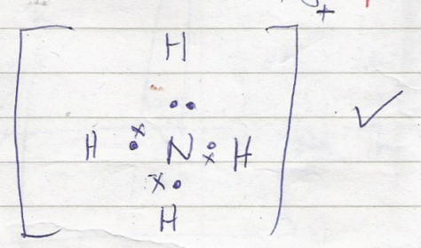NH4+
3. Carbon (iv) oxide.

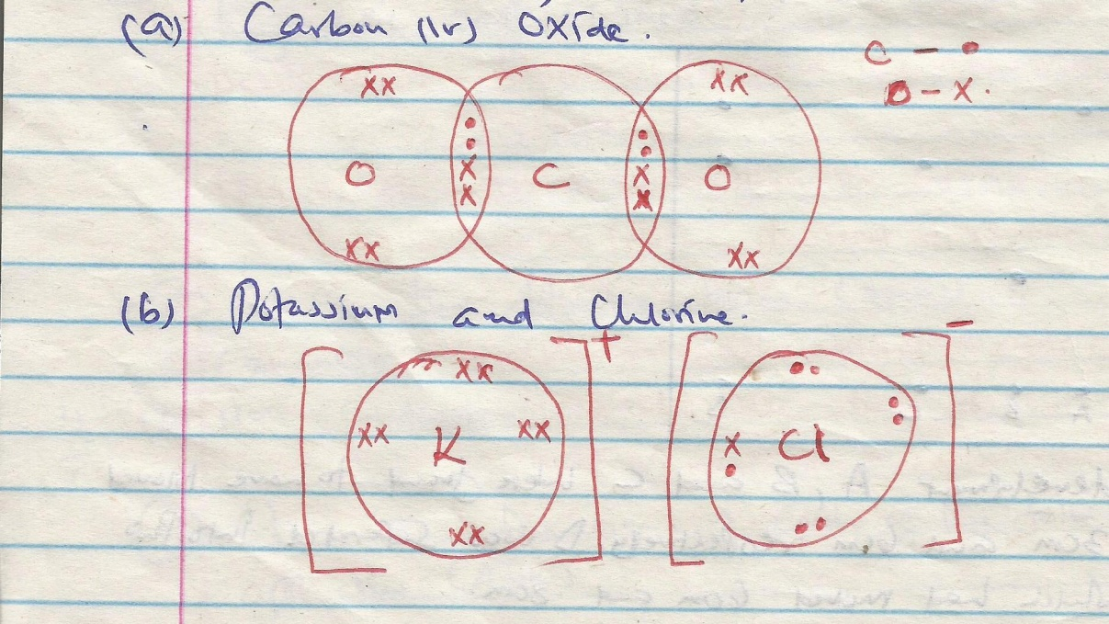

1. Potassium chloride
2. On complete combustion of a hydrocarbon gas X, 1.32g of carbon (IV) oxide and 0.54g of water. Calculate the empirical formula of X (C = 12.0, H = 1, O = 16.0) (3 marks)

***1 mole of CO2 weighs 44g***

***44g of CO2 contains 12g of c***

***∴ 1.32 of CO2 will contain***

***= 0.36g of C***

***1 mole of H2O weighs 18g***

***18g of H2O weigh 18g***

***∴ 0.54g of H2O will contain 2 $×$ 0.54 = 0.06 of H***

***18***

***Element C H***

***Mass 0.36 0.06***

***Moles 0.36 0.06***

***12 1***

1. ***: 2***

***Empirical form = CH2***

1. Study the diagram below and answer the questions that follow. (3 marks)

Gas jar

Dilute

Hydrochloric acid

Clamp

Liquid **Z**

Zinc granules

(a) Write an equation for the reaction between zinc granules and dilute hydrochloric acid. **(1 mark)**

***Zn(s) + 2HCl(aq) ZnCl2(aq) + H2(g)***

(b) What property of hydrogen is demonstrated by the method of collection shown on the diagram? **( 1 mark)**

***Lighter than air.***

1. Hydrogen gas passed through liquid **Z**. What is the name of liquid **Z** and what is the purpose of liquid **Z**? **(2 mark)**

***Conc. sulphuric acid***

***To dry the gas/Remove water present***

1. Name **one** industrial use of hydrogen. **(1 mark)**

***Used in industrial preparation of NH3(g) in the haber process***

***Used in weather balloon.***

***Used in industrial preparation of HCl(any 1x 1)***

1. Three liquids were mixed together accidentally and this included lubricating oil, kerosene and water. The table below gives information about the properties of the liquids.

|  |  |  |  |
| --- | --- | --- | --- |
| Constituent | Boiling point in 0C | Solubility in water | Solubility kerosene |
| Lubricating oil | 350 – 400 | Insoluble | Soluble |
| Kerosene oil | 175 – 250 | Insoluble |  |
| Water | 100 |  | Insoluble |

Suggest a method you would use to separate the three liquids. **(2 marks)=71**

***Use of a separating funnel to remove water***

***Fractional distillation to separate lubricating oil and kerosene.***

1. a) Define the term allotropy (1mk)

**The existence of an element in more than one form at same physical**

b) Name the two allotropes of sulphur (2 mks)

**- Monoclinic sulphur**

**- Rhombic sulphur.**

1. A concentrated solution of Sulphuric (VI) acid contains 70% H2S04 and has a density of 1.8g cm3. Determine the molarity of Sulphuric (VI) acid solution. (H= I, S=32, 0=16) (3 mrks)***=77***

**1.8g 1cm3 Acid is 70%; 50**

$\frac{70}{100 }$ $×$**1800 = 1260g**

**Moles = $\frac{1260}{98}$ 12.86moles = 12.86 M**

$?$**? ` 1000cm3**

**=1800g**