**END YEAR EXAMINATIONS 2019 FORM THREECHEMISTRYPAPER 2TIME: 2HOURS**

**MARKING SCHEME**

**INSTRUCTIONS TO CANDIDATES**

* *Answer* ***all*** *questions in the spaces provided*
* *Mathematical tables and electronic calculators* ***may*** *be used*
* *All workings* ***must*** *be clearly shown where necessary*

1. The table below shows the information concerning elements S, T, U, V, and W. the letter are not the actual symbols of the elements. **Study** it and answer the questions that follow.

|  |  |  |
| --- | --- | --- |
| Element | Period | Formula of oxide |
| S | 2 | S2O |
| T | 3 | T2O3 |
| U | 3 | UO2 or UO3 |
| V | 3 | Does not form oxide |
| W | 4 | W2O |

1. Write down:-
   1. The electronic arrangement of the element W. (1mk)

***2.8.8.11***

* 1. The formula of the ion formed by element T (1mk)

***T3+ 1***

1. Two of the oxides, S2O and UO3 are apparently dissolved in distilled water. **Compare** the PH value of the resulting solutions. (2mks)

***The solution of S2O would have a PH value greater1 than 7 while the solution of UO3 would have a PH value less than 71***

1. **Compare** with an explanation the following.
   1. The reactivity of S with that of W. (2mks)

***W is more reactive than S.1***

***W has a larger atomic radius // greater shielding effect, its outermost electron is loosely held hence can be easily lost1***

* 1. The electrical conductivity of T with that of magnesium. (2mks)

***T is better conductor than magnesium1 because it has more delocalize electrons.1***

* 1. The melting point of U with that of X which is just below U in the group. (2mks)

***X has a higher melting point than U1 because it (X) has a greater mass, hence stronger***

***intermolecular forces of attraction // Stronger Van der Waal forces // stronger molecular bonds.1***

1. **Write** the electronic configuration of V. (1mk)

***2.8.81***

1. **Select** **two** elements which are non – metals. (1mk)

***U ½ and V ½***

1. **Select** **two** elements which belong to the same group. (1mk)=13

***S and W 1 (No splitting of mark)***

1. The set up below is used to prepare and collect dry samples of hydrogen sulphide gas.

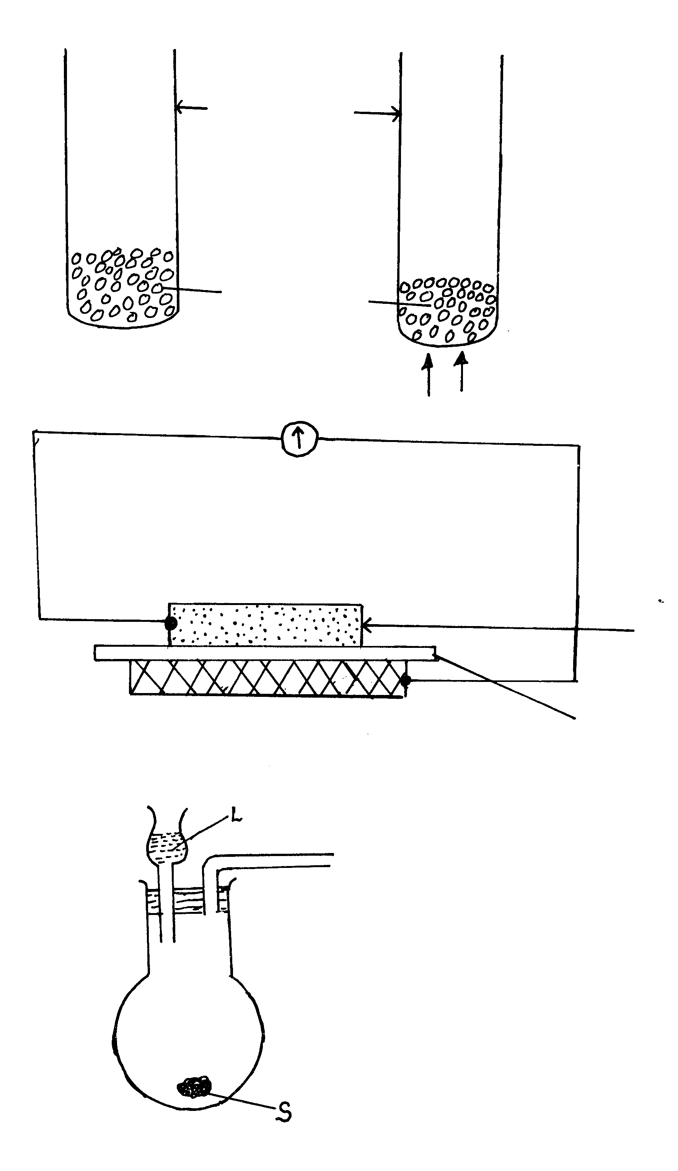

a) Name suitable substances for use as (2mks)

(i) L ***Dilute hydrochloric acid1***

(ii) S ***Iron (II) Sulphide1***

b) Complete the diagram to show how dry hydrogen sulphide gas is obtained and collected.

(3 mks)

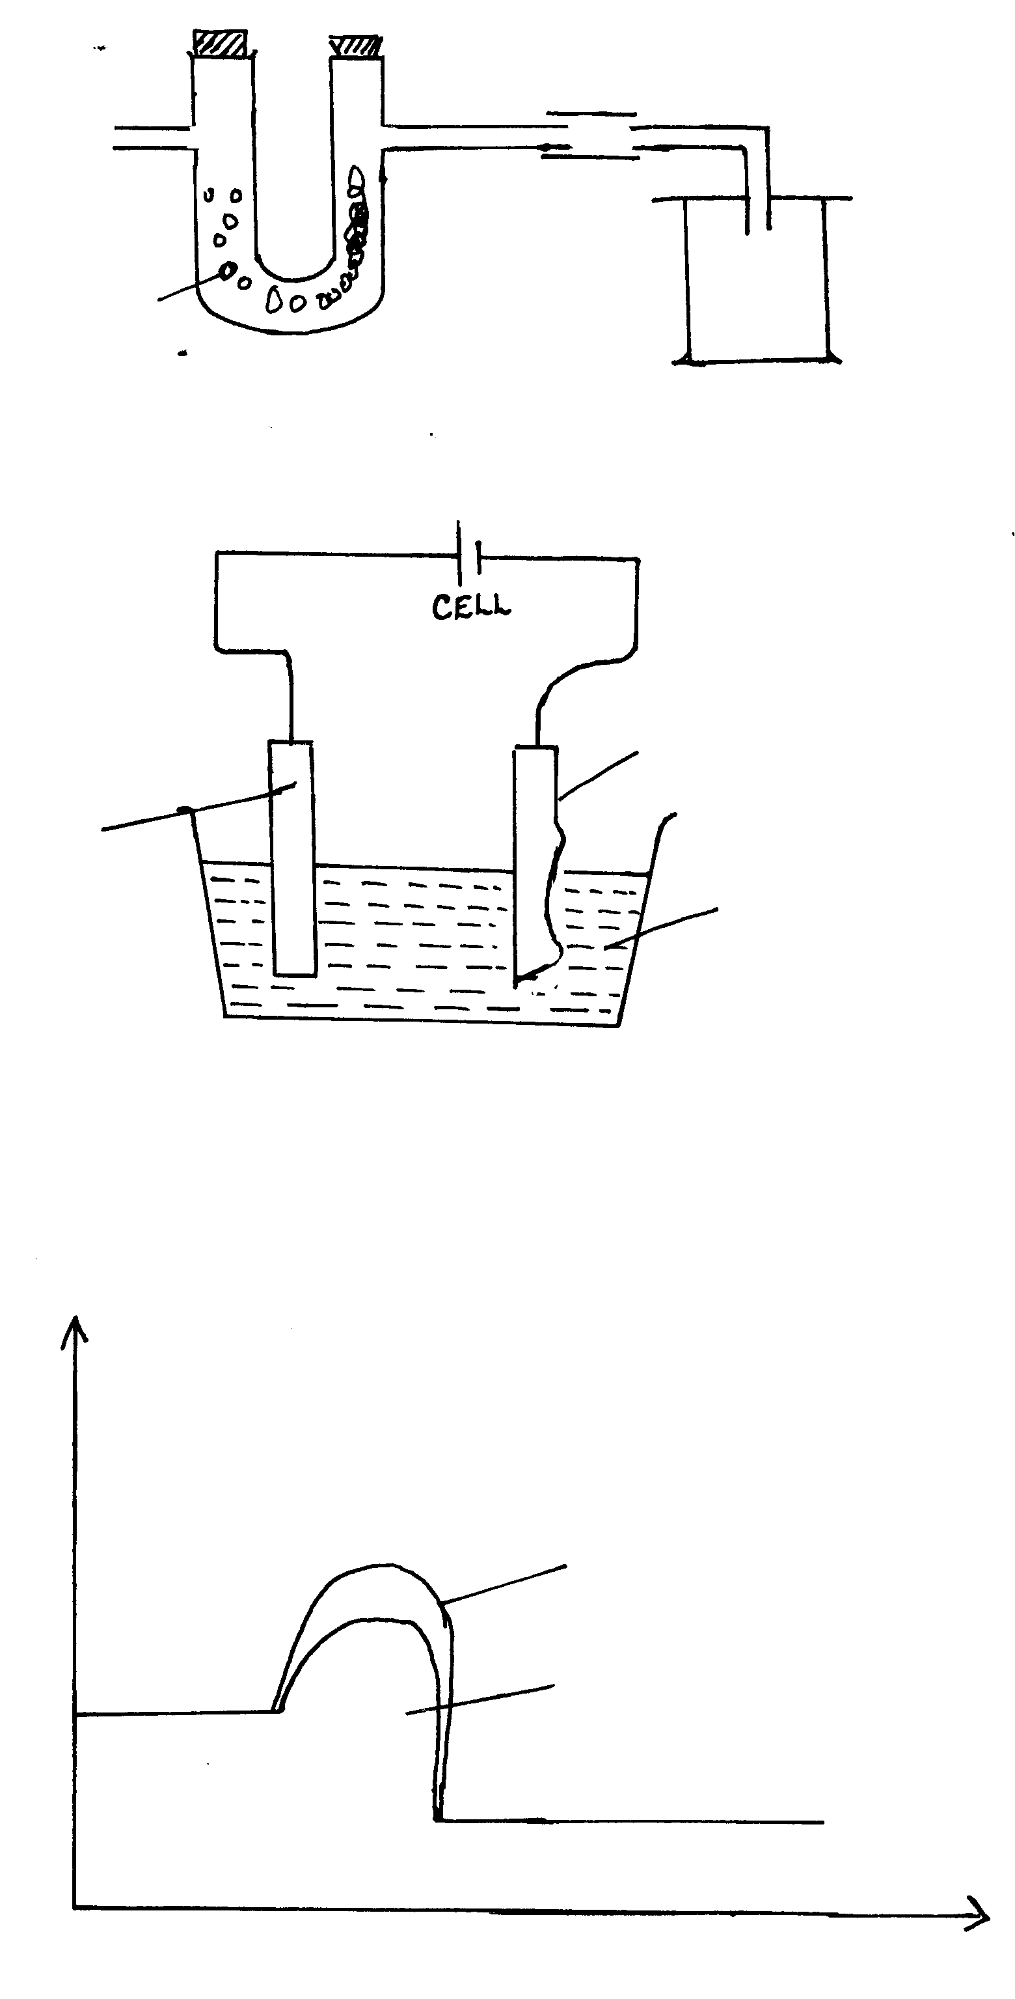***workability1***

***Anhydrous CaCl21***

***1***

c) Write a balanced equation for the reaction between L and S named in (a) above. (1mk)

***Fes(s) + 2Hcl(aq) FeCl2(aq) + H2S(g)***

d) (i) State the effect of hydrogen sulphide gas on litmus. (1mk)

***H2S turns wet blue litmus paper red 🗸 ½ but has No effect on red litmus. 🗸 ½***

(ii) State a chemical test for hydrogen sulphide gas. (1mk)

***It forms a black precipitate with lead(II) ethanoate(acetate)🗸 .***

(iii) What do you observe when hydrogen sulphide gas is passed through aqueous zinc chloride (1mk)

***A black precipitate is formed🗸***

e) (i) Name the process used to extract sulphur from the ground in Lousiana and Texas. (***½***mk)

***Frasch process 🗸 ½***

1. State the uses of the following materials during extraction of sulphur.

I - Super heated water. (1mk)

***Super heated – To melt 🗸 the sulphur***

II - Hot compressed air. (1mk)

***To create pressure to push molten Sulphur out of the ground🗸***

f) (i) Name the process used to manufacture sulphuric acid. (***½***mk)

***Contact process🗸 ½***

(ii) Calculate the mass of Sulphuric (VI) acid required to react with excess ammonia gas to produce 125.2 tons of ammonium sulphate fertilizer. (3mks)

***2NH3(g) + H2SO4(aq) (NH4)2 SO4(aq) 🗸 ½***

***98g 132g***

***H2SO4 = 2 + 32 + 64=98🗸 ½***

***(NH4)2SO4 = 18 x 2 32 + 64= 132🗸 ½***

***Mole ratio 1 : 1🗸 ½ or 98g ≡ 132g***

***? ≡ 125.2 tons***

***Mass of H2SO4= 125.2 x 98 🗸 ½***

***132🗸***

***=92.95 tons 🗸 ½***

1. State the property of sulhuric acid that is illustrated by its reaction with sucrose. (1mk)=16=29

***Dehydrating agent🗸 1***

1. The flow chart below shows how nitric (v) acid is produced on a large scale. Study it and answer the questions that follows.

Heat

Gas A Purifier Compressor exchanger Catalytic

Air Chamber (C)

gas B and air

Hot water

Absorption Reaction Purified Air

tower Chamber

1. State the functions of:

(i) Purifier (1mk)

***Purifies – removes √ 1dust particles and other impurities that would otherwise poison the catalyst.***

(ii) Heat exchanger (1mk)

***Heats √( ½)the ammonia – air mixture reactions from the compressor***

***It cools√( ½) the hot gaseous products from the catalytic chamber***

1. Identify
   1. Gas A ***Ammonia /NH3 √( ½)*** ( ½ mk)
   2. Gas B ***Nitrogen (II) Oxide /NO √( ½)*** ( ½ mk)
   3. Catalyst C ***Platinum – rhodium √( ½)***  ( ½ mk)
2. Write equations for the reaction that take place.

(i) In catalytic chamber.***4NH3(g) + 5O2(g) 4NO(g) + 6H2O(g)*** (1mk)

(ii) In absorption tower. ***2NO2(g) + H2O(l) HNO3(aq) + HNO2(aq)*** (1mk)

d) Calculate the molarity of the commercial nitric (v) acid, given that it is 68% pure and has a density of 1.42g/cm3. (N=14, H=1,)=16) ( 2 ½ mks)

***RFM HNO3 = 1 + 14 + 48 = 63 √( ½)***

***1cm3 (1.42 x 68/100 ) √( ½) g of HNO3 = 0.9656g***

***1cm3 ( 1.42 x 68) √( ½) moles of HNO3  = 0.015326 moles***

***63 100***

***∴ 1000 cm3 1000 x 1.42 x 68√( ½)***

***1 63 100***

***= 15.3 M ( ½)***

e) (i) Complete the table below to show the observations made when concentrated nitric (v) acid is added to the substances shown and warmed. (2mk)

|  |  |
| --- | --- |
| **Substance** | **Observation** |
| Acidified Iron (II) sulphate | * ***Yellow solution is formed / solution changes √from pale green to yellow*** |
| Sulphur powder | * ***Effervescence of red / brown gas / fumes (√ 1)*** |

1. Give reasons for the observations made using:

I Acidified iron (II) sulphate. (1mk)

***Conc. HNO3 oxidises(√ 1) iron (II) sulphate which is pale to yellow Iron (III) sulphate***

***OR 6FeSO4(aq) + 3H2SO4(aq) + 2 HNO3 (l)  3Fe2(SO4)3(aq) + 2NO(g) + 4H2O(l)***

II Sulphur powder (1mk***)=12=41***

***Hot conc. HNO3  oxidises sulphur to sulphuric (VI) acid and itself is reduced to (√ 1) nitrogen(IV) oxide***

***Or S(s) + 6HNO3(aq)  H2NO4(aq)  + 6NO2(g)  + 2H2O(l)***

1. In order to find out the proportion by volume of one of the main constituents of air, the following set up was established

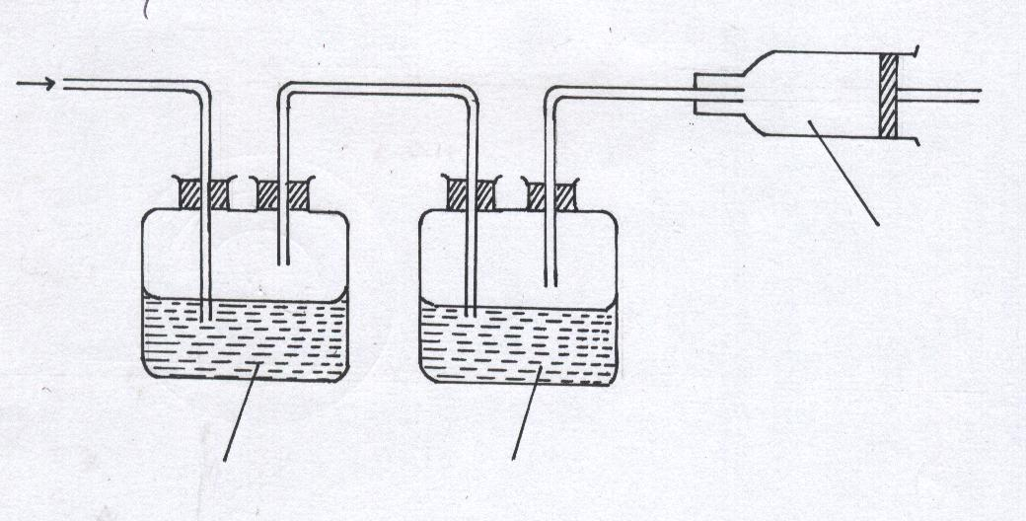

Gas T

Conc. Sulphuric acid

Aqueous sodium hydroxide

Air sample

* 1. (i) Name two constituents of gas **T** (1mk)

***Nitrogen ✓, Noble gas✓ - (Argon, Neon, Helium, Xenon, Krypton 1 mk***

(ii) Suggest a reason for passing air through:

I Aqueous sodium hydroxide (1mk)

***To absorb CO2(g) 1 mk***

II Concentrated sulphuric acid (1mk)

***To absorb moisture 1 mk***

1. The volume of the gas collected in the syringe was 60cm3.This was passed repeatedly over hot copper powder in the combustion tube until no further change of volume took place. When cooled to the original temperature, the volume was reduced to 47.4cm3

(i) What observation was made in the combustion tube? (1mk)

***Cu powder glowed red hot and formed a black powder 1 mk***

(ii) Which constituent of air was removed by copper powder? (1mk)

***Oxygen 1 mk***

(iii) Calculate the percentage of the gas in (ii) above in the sample of air (2 mks)

***✓ ✓ ½mk = 21% ✓½ mk (2 mks)***

1. The remaining gas in the syringe was repeatedly passed over hot Magnesium metal in the second combustion tube

(i) Name the main component in 47.4cm3 of the remaining gas (1mk)

***Nitrogen 1 mk***

(ii) Write an equation for the reaction in the second combustion tube (1mk)

*** 1 mk***

(iii)Name two of the gases still in the syringe at the end of the experiment.

Give a reason for your answer (2 mks)

***Carbon (IV) oxide ✓, Argon ✓ 2 mks***

1. Iron roofing sheets are coated with Zinc as a sacrificial metal

(i) What is meant by the term “sacrificial” (1mk)

***It is oxidized in place of iron since it is higher in the reactivity series, thus preserving iron sheets***

(ii) Give the name given to the process by which iron sheets are coated with Zinc (1mk)

***Galvanization 1 mk***

(iii) Write the equation of the reaction in which Iron rusts (1mk)

*** 1 mk***

1. Zinc is higher than Iron in the reactivity series yet it does not corrode as fast as Iron. Explain

(1mk)***=15=56***

***Zinc reacts with air to form an oxide layer which covers it and hinders further reaction– corrosion of Zinc***

1. In an experiment to determine the percentage of impurity in Sodium carbonate, 1.8g of impure Sodium carbonate was reacted with excess 2M Hydrochloric acid. 340cm3 of dry Carbon (IV) oxide gas was collected during the experiment at room temperature and pressure. (Na=23, 0=16, C=12; Molar gas volume at r.t.p=24dm3)
2. Why was excess 2M Hydrochloric acid used in the experiment? (1mk)

***To ensure complete reaction of the sodium carbonate***

1. Write an equation for the reaction that produced Carbon (IV) oxide (1mk)



1. Calculate
   1. The number of moles of Carbon (IV) oxide produced (2mks)

***24, 000cm3 is equivalent to 1 mole***

✓ ***= 0.0142 moles*** ✓

* 1. The number of moles of Sodium carbonate that reacted with the acid (2mks)

***Mole ratio from the equation***

***1 mole of Na2CO3 produces*** ✓***1 mole of CO2***

***0.0142 moles of CO2(g) are produced by*** ✓***= 0.0142moles***

* 1. The mass of Sodium carbonate that reacted with the acid (2mks)

***Mass of Na2CO3 that reacted***

***1 mole = 106g***

 ***moles*** ✓ ***= 1.505g***✓

* 1. The percentage of impurities in the sample of Sodium carbonate (2mks)=***10=66***

***Percentage impurity***

✓ ***= 16.39%***✓

1. a)Write down the structural formula of the following compounds

(i) 2, 2 – Dimethypropane ( 1 mk)

***CH3***

***H3C-C-CH3***

***CH3***

(ii) 2 – Chloropropene ( 1 mk)

***Cl***

***H3C-C=CH2***

iii) Tetrachloro methane (1 mk)

***Cl***

***│***

***Cl — C — Cl***

***│***

***Cl***

* 1. A,B,C are three homologous series of organic compounds

|  |  |
| --- | --- |
| Series | General formula |
| A | CnH2n-2 |
| B | CnH2n |
| C | CnH2n + 2 |

(i) What is the name given to series C (1 mk)

***Alkanes***

(ii) Write down the name and structural formula of the third member of series “B” (2mks)

Name: ***butene// but-1-ene***

Structure:

***H H H H***

**│ │ │ │**

***H-C-C-C=C***

**│ │ *│***

***H H H***

(iii) Write down an equation and name the products of reaction between HBr with second member of series “B” (2 mks)

***CH3CH(g) =CH2  + HBr(g) → CH3CHBrCH3(aq)***

c) Study the scheme given and answer the questions that follow

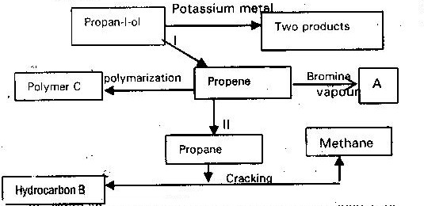

1. Write an equation for the reaction in process II ( 1mk)

***Ni***

***CH3CH=CH2(g) + H2 (g)→ CH3CH2CH3(g)***

1. Name process I and II ( 2 mks)

I ***dehydration***

II ***hydrogenation***

1. Identify the products “A” and “B” ( 2 mks)

A ***1,2-dibromo propane***

B ***ethene***

1. Name ONE catalyst used in process II (1 mk)=***14=80***

***Nickel***