**NAME:………..……………………………………………CLASS:……………ADM NO:…………..……**

**END YEAR EXAMINATIONS 2019 FORM THREE CHEMISTRY PAPER 2 233/2**

**TIME: 2HOURS**

**INSTRUCTIONS TO CANDIDATES**

* *Write your name, class and Admission Number in the spaces provided above.*
* *Answer* ***ALL*** *questions in the spaces provided*
* *Mathematical tables and electronic calculators* ***MAY*** *be used*
* *All workings* ***MUST*** *be clearly shown where necessary*

1. The table below shows the information concerning elements S, T, U, V, and W. the letter are not the actual symbols of the elements. **Study** it and answer the questions that follow.

|  |  |  |
| --- | --- | --- |
| Element | Period | Formula of oxide |
| S | 2 | S2O |
| T | 3 | T2O3 |
| U | 3 | UO2 or UO3 |
| V | 3 | Does not form oxide |
| W | 4 | W2O |

1. Write down:-
   1. The electronic arrangement of the element W……………….. (1mk)
   2. The formula of the ion formed by element T………………….. (1mk)
2. Two of the oxides, S2O and UO3 are apparently dissolved in distilled water. Compare the PH value of the resulting solutions. (2mks)
3. **Compare** with an explanation the following.
   1. The reactivity of S with that of W. (2mks)
   2. The electrical conductivity of T with that of magnesium. (2mks)
   3. The melting point of U with that of X which is just below U in the group. (2mks)
4. **Write** the electronic configuration of V. ……………………….. (1mk)
5. **Select** **two** elements which are non – metals. (1mk)
6. **Select** **two** elements which belong to the same group. (1mk)
7. The set up below is used to prepare and collect dry samples of hydrogen sulphide gas.

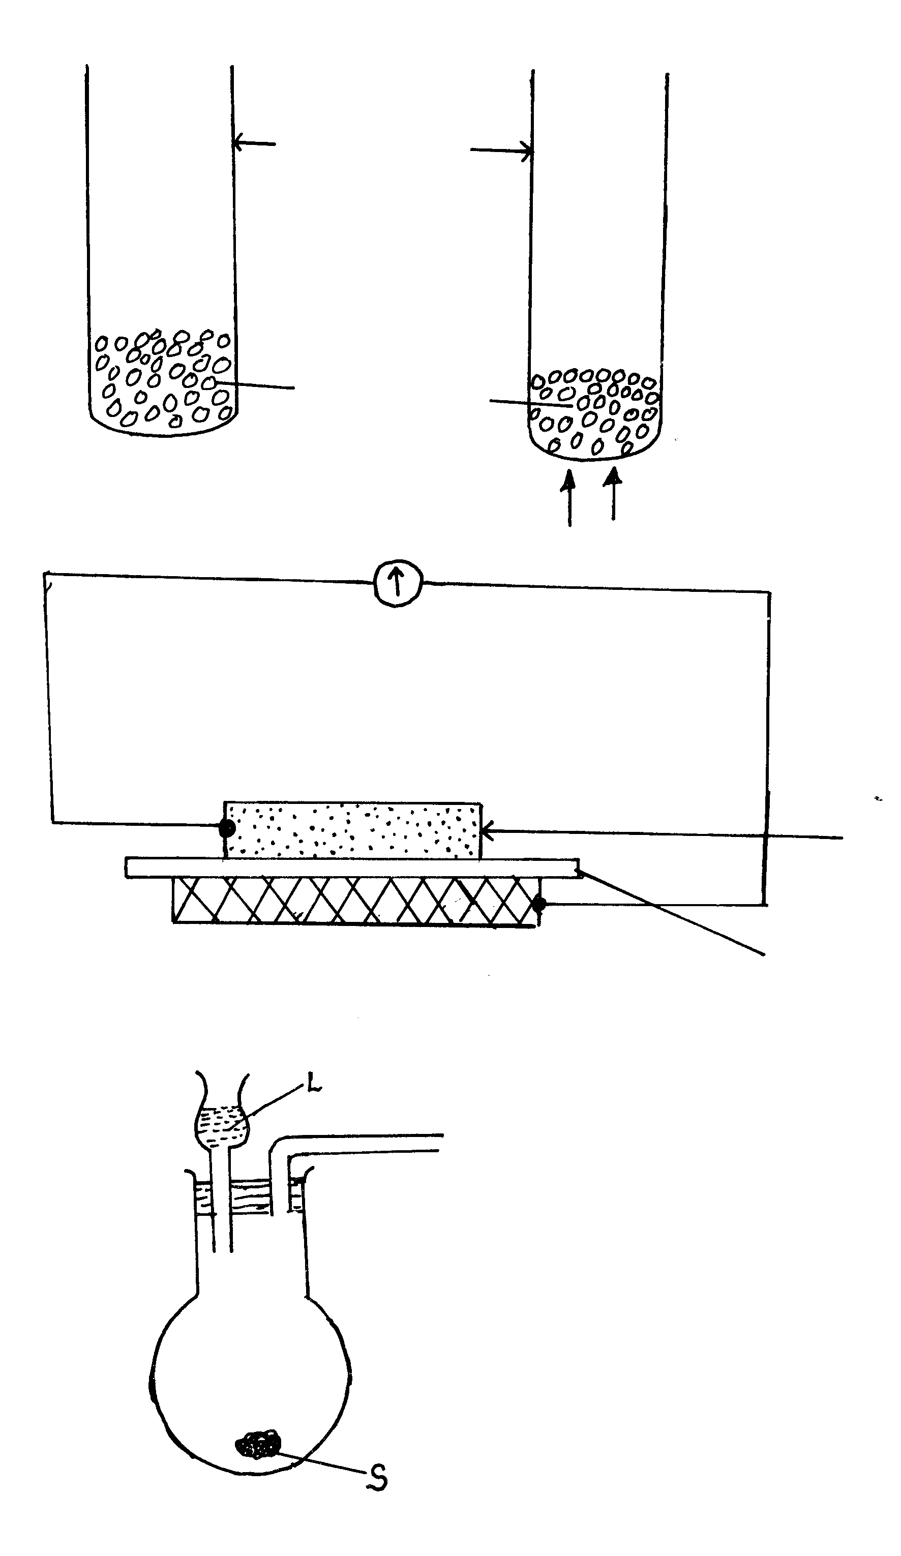

a) Name suitable substances for use as (2mks)

(i) L ………………………

(ii) S ……………………….

b) Complete the diagram to show how dry hydrogen sulphide gas is obtained and collected. (3 mks)

c) Write a balanced equation for the reaction between L and S named in (a) above. (1mk)

d) (i) State the effect of hydrogen sulphide gas on litmus. (1mk)

(ii) State a chemical test for hydrogen sulphide gas. (1mk)

(iii) What do you observe when hydrogen sulphide gas is passed through aqueous zinc chloride (1mk)

e) (i) Name the process used to extract sulphur from the ground in Louisiana and Texas. (***½***mk)

1. State the uses of the following materials during extraction of sulphur.

I - Super heated water. (1mk)

II - Hot compressed air. (1mk)

f) (i) Name the process used to manufacture Sulphuric (VI) acid. (***½***mk)

(ii) Calculate the mass of Sulphuric (VI) acid required to react with excess ammonia gas to produce 125.2 tons of ammonium sulphate fertilizer. (3mks)

1. State the property of Sulphuric (VI) acid that is illustrated by its reaction with sucrose. (1mk)
2. The flow chart below shows how nitric (v) acid is produced on a large scale. Study it and answer the questions that follows.

Heat

Gas A Purifier Compressor exchanger Catalytic

Air Chamber (C)

gas B and air

Hot water

Absorption Reaction Purified Air

tower Chamber

1. State the functions of:

(i) Purifier (1mk)

(ii) Heat exchanger (1mk)

1. Identify
   1. Gas A………………………………………… ( ½ mk)
   2. Gas B ………………………………………. ( ½ mk)
   3. Catalyst C*…………………………………………..* ( ½ mk)
2. Write equations for the reaction that take place.

(i) In catalytic chamber.(1mk)

(ii) In absorption tower. (1mk)

d) Calculate the molarity of the commercial nitric (v) acid, given that it is 68% pure and has a density of 1.42g/cm3. (N=14, H=1,)=16) ( 2 ½ mks)

e) (i) Complete the table below to show the observations made when concentrated nitric (v) acid is added to the substances shown and warmed. (2mk)

|  |  |
| --- | --- |
| **Substance** | **Observation** |
| Acidified Iron (II) sulphate |  |
| Sulphur powder |  |

1. Give reasons for the observations made using:

I Acidified iron (II) sulphate. (1mk)

II Sulphur powder (1mk)

1. In order to find out the proportion by volume of one of the main constituents of air, the following set up was established

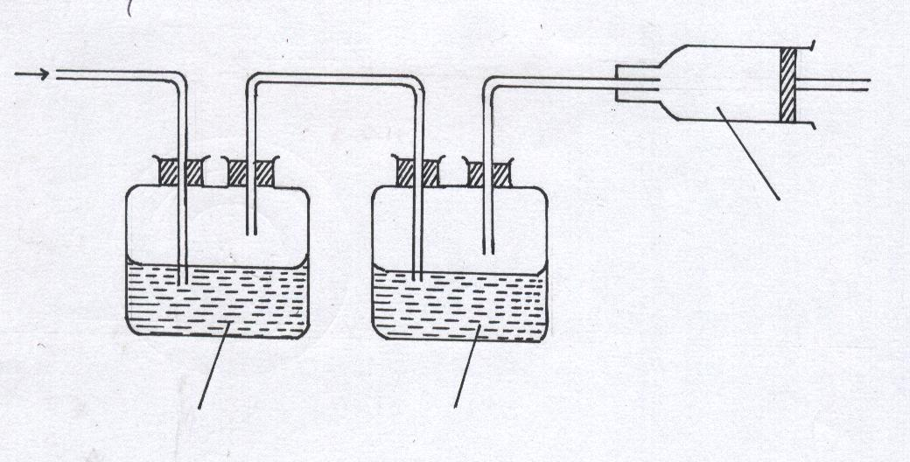

Gas T

Conc. Sulphuric acid

Aqueous sodium hydroxide

Air sample

* 1. (i) Name two constituents of gas **T** (1mk)

(ii) Suggest a reason for passing air through:

I Aqueous sodium hydroxide (1mk)

II Concentrated sulphuric acid (1mk)

b) The volume of the gas collected in the syringe was 60cm3.This was passed repeatedly over hot copper powder in the combustion tube until no further change of volume took place. When cooled to the original temperature, the volume was reduced to 47.4cm3

(i) What observation was made in the combustion tube? (1mk)

(ii) Which constituent of air was removed by copper powder? (1mk)

(iii) Calculate the percentage of the gas in (ii) above in the sample of air (2 mks)

1. The remaining gas in the syringe was repeatedly passed over hot Magnesium metal in the second combustion tube

(i) Name the main component in 47.4cm3 of the remaining gas (1mk)

(ii) Write an equation for the reaction in the second combustion tube (1mk)

(iii)Name two of the gases still in the syringe at the end of the experiment. (2 mks)

1. Iron roofing sheets are coated with Zinc as a sacrificial metal

(i) What is meant by the term “sacrificial” (1mk)

(ii) Give the name given to the process by which iron sheets are coated with Zinc (1mk)

(iii) Write the equation of the reaction in which Iron rusts (1mk)

1. Zinc is higher than Iron in the reactivity series yet it does not corrode as fast as Iron. Explain (1mk)
2. In an experiment to determine the percentage of impurity in Sodium carbonate, 1.8g of impure Sodium carbonate was reacted with excess 2M Hydrochloric acid. 340cm3 of dry Carbon (IV) oxide gas was collected during the experiment at room temperature and pressure. (Na=23, 0=16, C=12; Molar gas volume at r.t.p=24dm3)
3. Why was excess 2M Hydrochloric acid used in the experiment? (1mk)

1. Write an equation for the reaction that produced Carbon (IV) oxide (1mk)

1. Calculate
   1. The number of moles of Carbon (IV) oxide produced (2mks)
   2. The number of moles of Sodium carbonate that reacted with the acid (2mks)

* 1. The mass of Sodium carbonate that reacted with the acid (2mks)
  2. The percentage of impurities in the sample of Sodium carbonate (2mks)

1. a)Write down the structural formula of the following compounds

(i) 2, 2 – Dimethypropane ( 1 mk)

(ii) 2 – Chloropropene ( 1 mk)

iii) Tetrachloro methane (1 mk)

* 1. A,B,C are three homologous series of organic compounds

|  |  |
| --- | --- |
| Series | General formula |
| A | CnH2n-2 |
| B | CnH2n |
| C | CnH2n + 2 |

(i) What is the name given to series C (1 mk)

(ii) Write down the name and structural formula of the third member of series “B” (2mks)

Name: ***……………………………….***

Structure:

(iii) Write down an equation and name the products of reaction between HBr with second member of series “B” (2 mks)

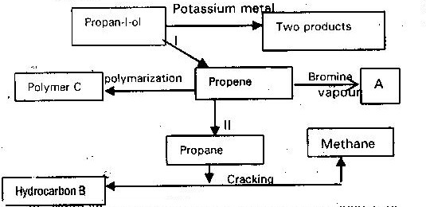c) Study the scheme given and answer the questions that follow

1. Write an equation for the reaction in process II ( 1mk)
2. Name process I and II ( 2 mks)

I………………………………. II…………………………….

1. Identify the products “A” and “B” ( 2 mks)

A…………………………………… B…………………………..

1. Name ONE catalyst used in process II (1 mk)