**FORM TWO TERM II1 2019 CHEMISTRY**

**MARKING SCHEME**

1. X – 2.8.3 (1 mk)

Y – 2.6 (1 mk)

(b) X2Y3 (1 mk)

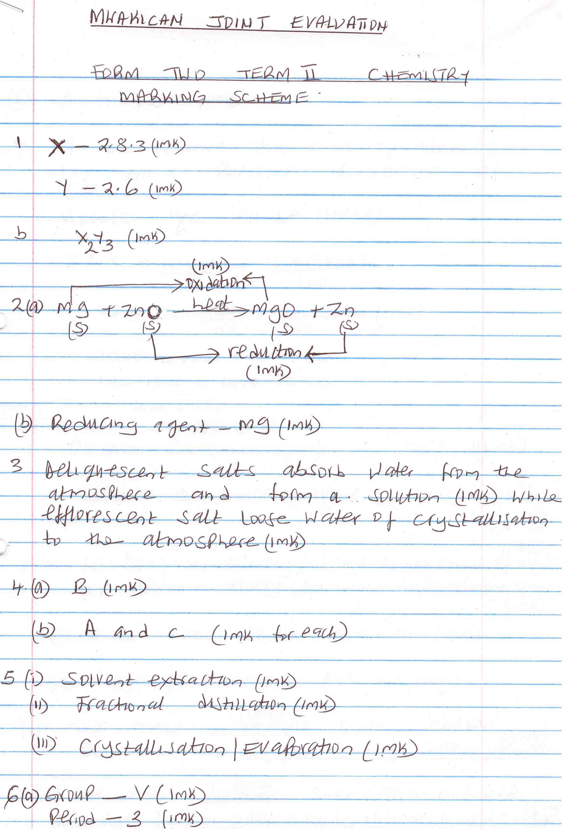2. (a)

(b) Reducing agent – Mg (1 mk)

3. Deliquescent salts absorbs water from the atmosphere and form a solution. (1 mk) while efflorescent salt loose water of crystallization to the atmosphere. (1 mk)

4. (a) B (1 mk)

(b) A and C (1 mk for each)

5. (i) Solvent extraction (1 mk)

(ii) Fractional distillation (1 mk)

(iii) Crystallisation / Evaporation (1 mk)

6. (a) Group – V (1 mk)

Period – 3 (1 mk)

(b) A non metal (1 mk)

7. Let the relative abundance of isotope $\begin{matrix}12 \\ 6\end{matrix}C$ be X. relative abundance of isotope $\begin{matrix}14 \\ 6\end{matrix}C$ will be (100 – x)

R.A.M = $\frac{12×X}{100}+\frac{14×\left(100-X\right)}{100}$

12.4 = $\frac{12X}{100}+\frac{1400}{100}$ =14x (1 mk)

1240 = 12x + 1400 – 14x

14x – 12x = 1400 – 1240

2x = 160

X = 80 (1 mk)

Relative abundance of $\begin{matrix}12 \\ 6\end{matrix}C$ is 80% (1/2 mk)

Relative abundance of $\begin{matrix}14 \\ 6\end{matrix}C$ is (100 – 80) = 20% (1/2 mk)

(accept correct ratio)

8. (i) (a) Downward delivery (upward displacement of air) (1 mk)

(b) Upward delivery (Downward displacement of air) (1 mk)

(ii) It is less dense than air. (1 mk)

(iii) Hydrogen/Ammonia (1 mk for any)

9. Y – Hydrogen bonding (1 mk)

Z – Covalent bonding (1 mk)

10.

|  |  |  |  |
| --- | --- | --- | --- |
| Element | Sulphates | Phosphates | Nitrates |
| R | RSO4 | R3(PO4)2 | R(NO3)2 |
| B | B2(SO4)3 | BPO4 | B(NO3)3 |
| Q | Q2SO4 | Q3PO4 | QNO3 |

(1/2 mk for each)

11. (a) (i) Zn(NO3)2 (1 mk)

(ii) Nitrogen(iv)oxide or NO2 (1 MK)

heat

(b) 2Zn(NO3)2(s)  2ZnO(s) + 4NO2 (g) + O2(g) (1 mk)

12. (a) Dative bond or coordinate bond (1 mk)

(b) Blue litmus paper turns to red (1 mk) while red remains red since aluminium chloride dissolves in water forming an acidic solution (1 mk)

13. (i) Mobile ions (1 mk)

(ii) Mobile ions (1 mk)

(iii) Delocalised electrons (1 mk)

14. (a) 9 + 10 = 19 (1 mk)

(b) A (1 mk)

(c) C and E (1 mk)

15. (a) (i) Dilute sulphuric (vi) acid or H2SO4(aq) (1 mk)

(ii) anhydrous copper(ii)sulphate (1 mk)

(b) CuO(s) + H2SO4(aq) CuSO4(aq) + H2O(l)

16.

* Its light (low density)
* Its not easily corroded
* It’s a good conductor of electricity

(2 mks for any two)

17. (a) M – Diamond (1/2 mk)

N – Graphite (1/2 mk)

(b) (i) N (1/2 mk) – it has delocalised electrons. (1/2 mk)

(ii) M (1/2 mk) – it is hard since it contains giant atomic structure. (1/2 mk)

18. (i) B (1 mk)

(ii) C (1 mk)

(iii) E (1 mk)

(b) N – 2.5

H – 1

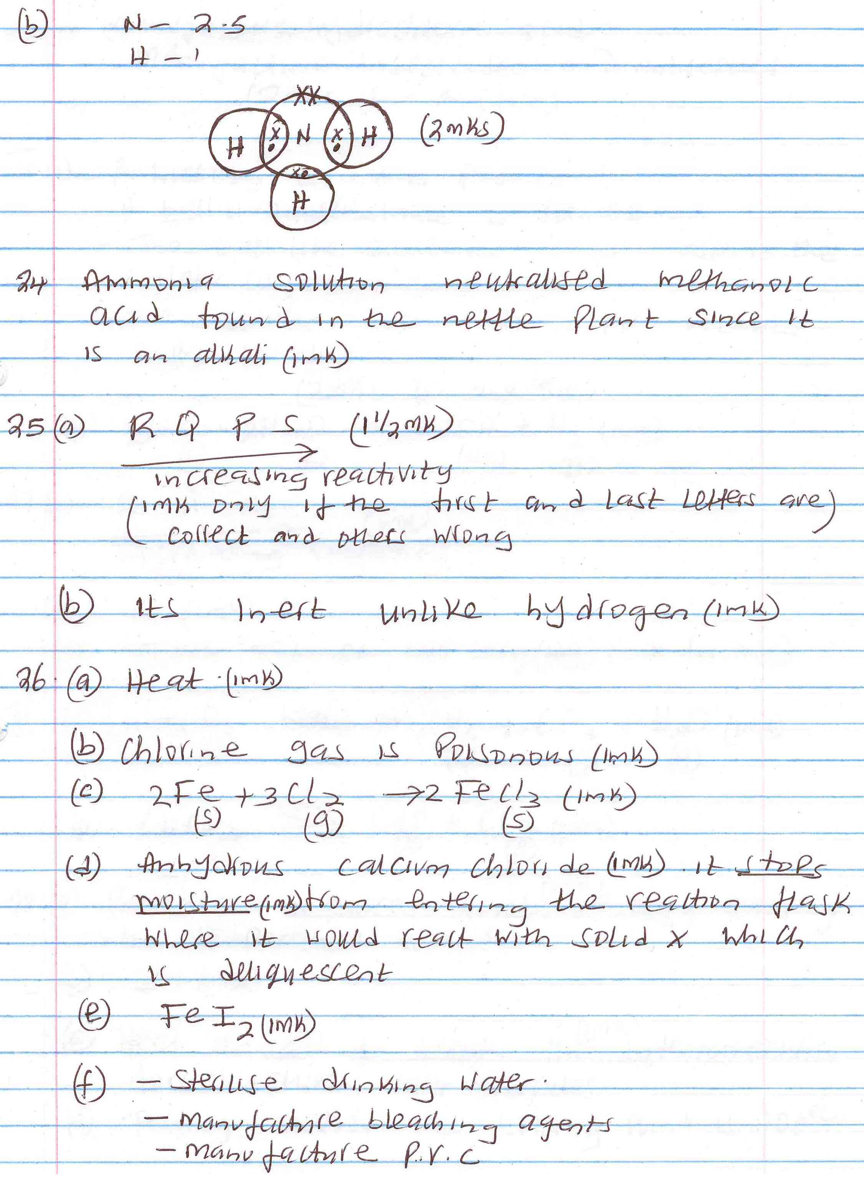 (2 mks)

(II) (i) A hissing sound is produced.

* A ball like substance is formed.
* The ball like substance darts around the water surface.
* The solution formed turns red litmus paper to blue.

(2 mks for any two)

(ii) 2Na(s) + 2H2O(l)  2NaOH(aq) + H2(g) (1 mk)

19. (a) B A C (1 mk)

Increasing reactivity

(b) C (1 mk)

c) Silver

20) i) Black solid √ 1

ii) NaOH or KOH √ 1

To absorb C02

iii) It is poisonous √ 1   
iv) 2C0 (g) + 02(g) → 2C02(g)

v) Fuel √ 1

Reducing agent’J