**NAME………………………………….…….ADM.NO:…………… CLASS: …………….**

**ANESTAR SCHOOLS**

**CHEMISTRY**

**FORM ONE**

**TERM 1 EXAM YEAR 2020**

**TIME: 1½ HRS**

## INSTRUCTIONS TO STUDENTS

1. Answer all questions in this question paper.

2. All your answers must be written in the spaces provided in this question paper.

|  |  |  |
| --- | --- | --- |
| **Question** | **Maximum score** | **Candidates score** |
| **1 - 16** | **50** |  |

1. Define the term drug abuse. 1mk
2. Name three frequently abused drugs. (3mks)
3. State two long term effects of drug abuse. (2mks)
4. Define Chemistry. (1mk)
5. Name two career opportunities open to a chemist. 2mks
6. Give three importance of studying Chemistry. (3mks)
7. Give three apparatus used for measuring accurate volume of liquid chemicals. 3mks
8. What is the name given to the following apparatus? 5mks

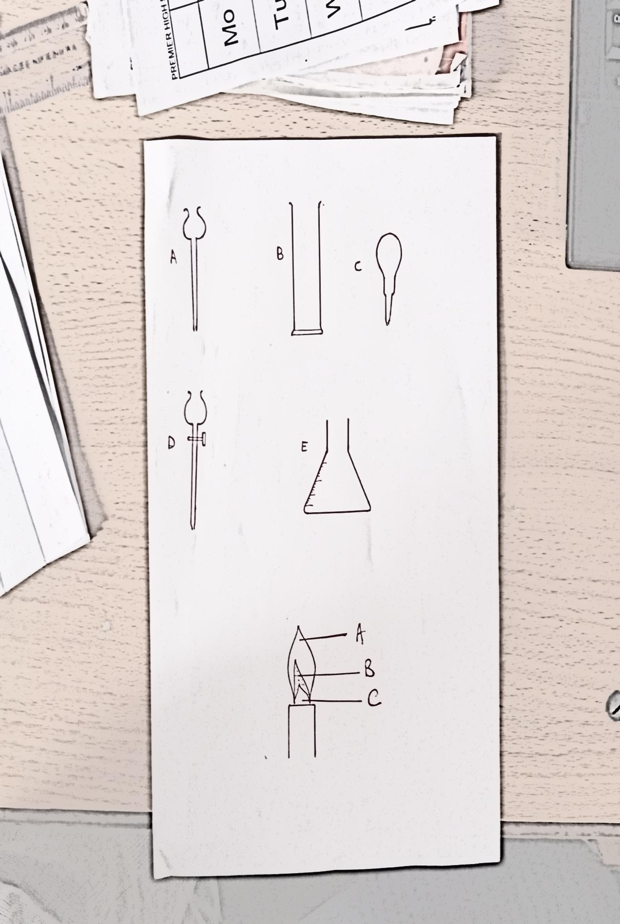

1. Give two reasons why most laboratory apparatus are made of glass. (2mks)
2. What is a flame? (1mk)
3. The diagram below shows a flame produced by a Bunsen burner .Study it and uses it to answer the questions that follow.



1. Label the parts A,B and C.3mks
2. When is the above flame produce by a Bunsen burner? 1mks
3. State two reasonsthe above flame is preferred for heating in the laboratory. 2mks
4. What is the name of the other type of flame produced by a Bunsen burner? 1mk
5. State two reasons why the Bunsen burner flame should be put off immediately after use. 2mks
6. State four laboratory rules that students are supposed to follow when in the laboratory. (4mks)
7. What is a mixture? (2mks)
8. State two physical means of separating a mixture. (2mks)
9. (i)Odege,a form one student at Anestar high school accidentally mixed sulphur and iron filings. Suggest an appropriate method of separation you would advice him to use to separate the mixture. (1mk)

(ii)Give a reason for the choice of your answer. (2mk)

1. (i). Define the term sublimation. 1mk

(ii) . State four substances that undergo sublimation 4mks

(ii). Give the reasons why dry ice is used in cold boxes instead of ordinary ice. 2mks