**NAME: ……………………………………………………. ADM NO.: …………… CLASS: …..**

**CHEMISTRY EXAM**

**FORM ONE**

**END OF TERM 2 – 2019**

**TIME:**

1. Explain why most laboratory apparatus are made of glass. (2mks)
2. (a) What is drug abuse? (1mk)

(b) Name three drugs that are commonly abused. (3mks)

(c) State two ways of preventing drug abuse. (2mks)

1. Study the diagram below and answer the question that follows.

Ice

Liquid water

Steam/ vapour

a

b

c

d

1. Name the process labeled a, b, c and d. (2mks)
2. Draw a similar diagram to show the effect of temperature on solid carbon (IV) oxide (dry ice) (2mks)
3. Identify the elements present in the following compounds.
4. Magnesium oxide. (1mk)
5. Zinc chloride. (1mk)
6. Sodium sulphate. (1mk)
7. Aluminium nitrate. (1mk)
8. State three differences between luminous and non luminous flame. (3mks)
9. The diagram below shows the effect of heat on hydrated copper (II) sulphate crystals.

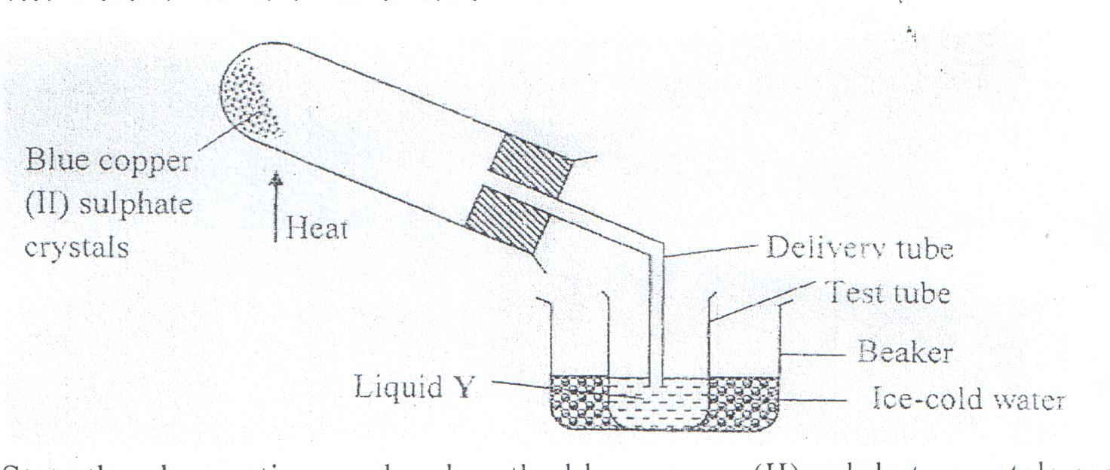

1. State the colour of hydrated copper (II) sulphate crystals. (1mk)
2. What observations are made inside the boiling tube after heating has taken place? (1mk)
3. What is the use of ice-cold water in the beaker? ( ½ mk)
4. Name liquid Y. ( ½ mk)
5. What will be observed if the residue in the boiling tube is cooled and a few drops of liquid Y added to it? )1mk)
6. What type of chemical change is exhibited by copper (II) sulphate? (1mk)
7. The graph below shows the shape of the curve obtained by a student when solid X was heated to boiling.

10

20

30

40

50

60

Temperature (oC)

**S**

**R**

**Q**

**P**

Time in minutes

1. Determine the melting point of solid X. (1mk)
2. After the experiment the student concluded that substance x was pure substance. Explain why he concluded so. (1mk)
3. If candle wax was used in the above experiment the portion QR would be horizontal. What does this tell us about candle wax? (1mk)
4. (a) What is the effect of impurities on the melting and boiling point of substances? (2mks)

(b) Explain the following:

1. During extraction of metals from their molten compounds for example calcium chloride is added to rock salt during the extraction of sodium from sodium chloride. (1mk)
2. In temperate counties there is spreading of common salt in the roads during winter. (1mk)
3. Distinguish between temporary physical and permanent chemical changes. (2mks)
4. (a) Write the names of the elements represented by symbols. (3mks)
5. K –
6. Cl –
7. Fe –
8. Mg –
9. C –
10. Be –

(b) Define:

1. Atom. (1mk)
2. Compound. (1mk)
3. Element. (1mk)
4. (a) Complete the following. (3mks)
5. Acid + metal →
6. Acid + Base →
7. Acid + Carbonate →

(b) Write word equations for the following reactions.

1. Zinc and hydrochloric acid. (1mk)
2. Potassium hydroxide and sulphuric (VI) acid. (1mk)
3. Magnesium carbonate and nitric (V) acid. (1mk)
4. Study the diagram below for the reaction between sodium carbonate and hydrochloric acid and answer the questions that follow.

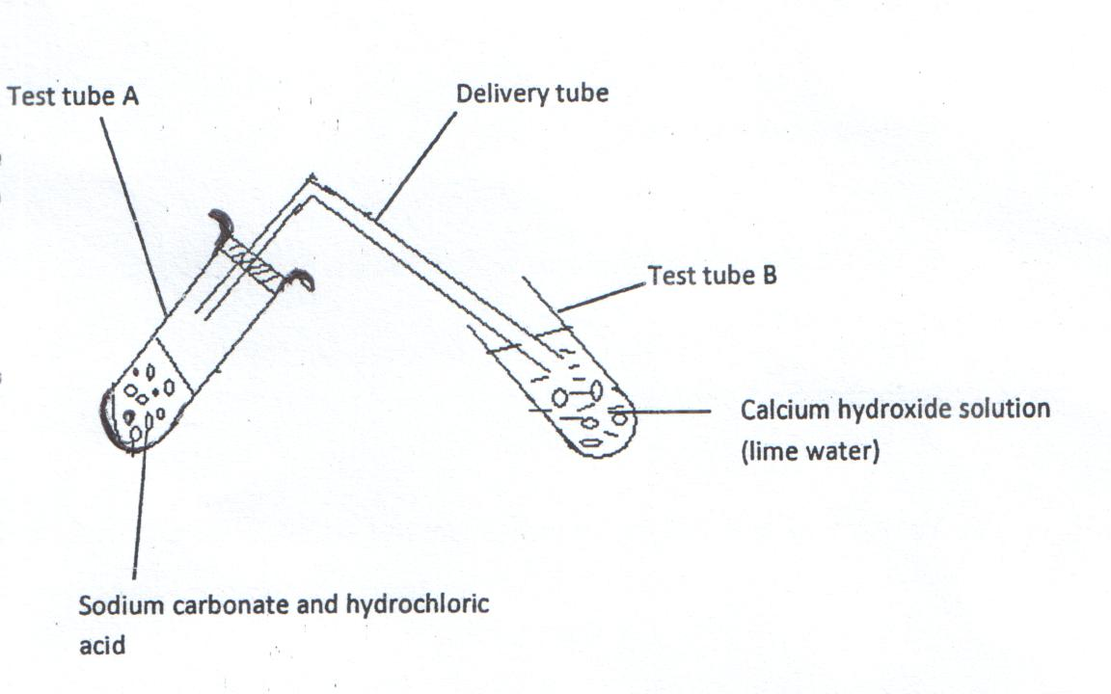

1. Explain what was observed in:
2. Test tube A. (1mk)
3. Test tube B. (1mk)
4. Write a word equation for the reaction which took place in test tube. (1mk)
5. State whether solutions with the following pH values are acidic, basic or neutral. (2mks)

pH 3 –

pH 11 –

pH 14 –

pH 7 –

1. Is air a mixture or a compound? Explain. (2mks)
2. The apparatus below were used to determine the volume of oxygen in air. About 200cm3 of air were passed repeatedly from syringe A to syringe B over heated copper turnings as shown in the diagram.

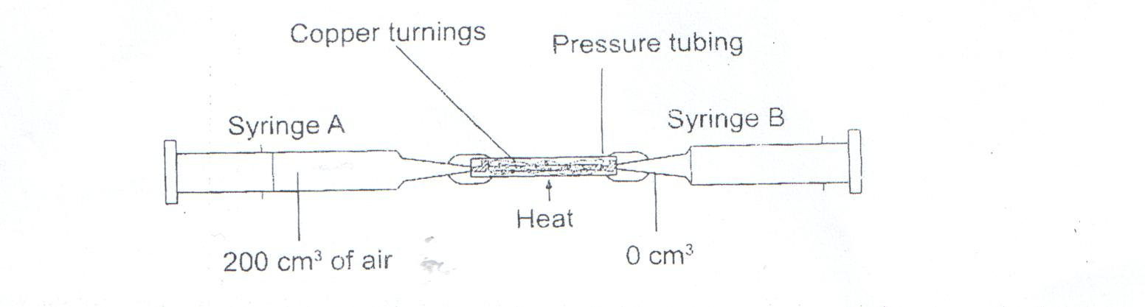

After sometime, the volume of air in the syringe A was 160cm3 and syringe B, 0cm3

1. Calculate the percentage of oxygen in the initial sample of air. (2mks)
2. The percentage of oxygen calculated above was slightly less than the percentage of oxygen in air. Explain why. (1mk)
3. The set-up below was used to prepare a sample of oxygen gas. Study it and answer the questions that follow.

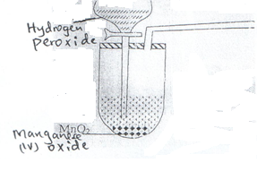

H2O2

1. Complete the diagram to show how oxygen can be collected. (2mks)
2. Write a word equation for the reaction that produces oxygen above. (1mk)
3. State two physical properties of oxygen gas. (2mks)
4. State two uses of oxygen. (2mks)
5. Candle wax is an example of a hydrocarbon.
6. What is a hydrocarbon? (1mk)
7. Name the two products formed when hydrocarbons burn in oxygen. (1mk)
8. Study the figure below and use it to answer the following questions.

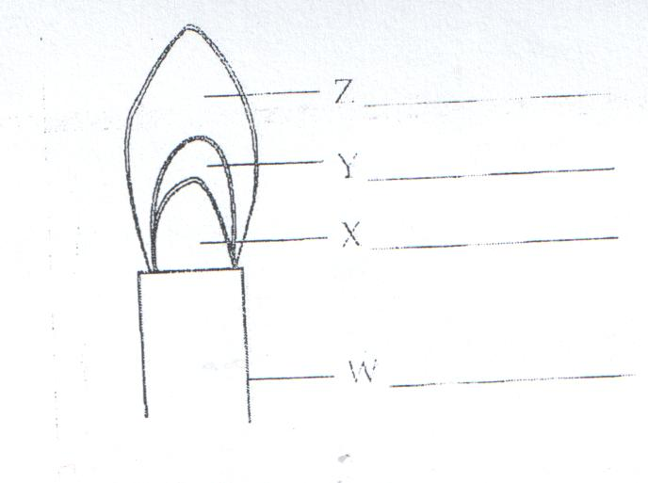

1. Name the parts labeled X and Y. (1mk)
2. Identify the flame. (1mk)
3. Which part of the flame is the hottest? (1mk)
4. The diagrams below show some physical methods of separating mixtures.

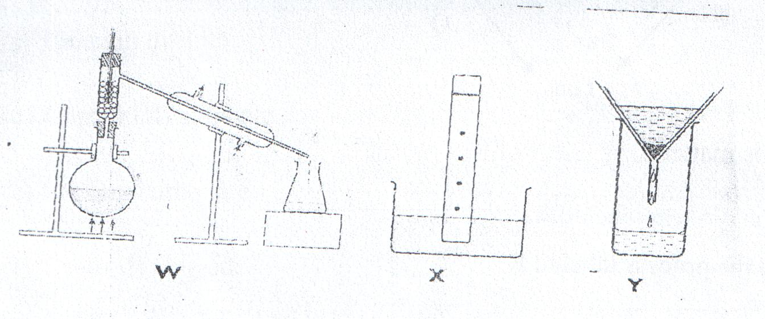

1. Name the methods of separation labeled W, X and Y.