Name…………………………………………………………. Index No………………….
Candidates Signature………………
Date ………………………………………

233/1
CHEMISTRY
Paper 1
2 Hours

END OF TERM 2 2020
Kenya certificate of secondary education (K.C.S.E)

Instructions to candidates
(a)Write your name and index number in the spaces provided above.
(b) Sign and write the date of examination in the spaces provided above
(c) Answer ALL the questions in the spaces provided in the question paper
- KNEC Mathematical tables and electronic calculators may be used for calculations
- All working MUST be clearly shown where necessary
- This paper consists of 13 printed pages
- Candidates should check the question paper to ascertain that all the pages are printed as indicated and that no questions are missing
- Candidates should answer the questions in English

For examiner’s only

question | maximum score | candidates score
1-29 | 80
Turn over.

1 . Gas X was found to decolorize moist litmus paper. A colorless solution of potassium Bromide turned red-brown when gas X was passed through it.
a) What is observed when gas x is passed through potassium iodide solution. (1mark)
……………………………………………………………………………………………………………….
b) Write an equation to accompany the observation in (a) above. (1 mark)
…………………………………………………………………………………………………………………………………………………………………………………………………

2. An organic compound J has the following percentage by mass, carbon, 64.86%, hydrogen, 13.51% and the rest oxygen. The relative molecular mass of the compound is 74. Work out the molecular formula of compound J. [C=12. H=1 O=16] (3 marks)

3. The scheme below shows the energy changes that are involved between ice, water and steam. Study it then answer the questions that follow
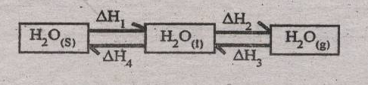

(a) What name is given to the process represented by energy change ∆H₄? (1 mark)

…………………………………………………………………………………………………………………….
(b) What is the sign of ∆H₃? Give a reason (2 marks)

…………………………………………………………………………………………………………………….

……………………………………………………………………………………………………………………
4. A fixed mass of a gas has a volume of 250cm³ at a temperature 27⁰C and 750mmHg pressure. Calculate the volume the gas would occupy at 42⁰C and 750mmHg pressure. (0⁰C = 273K) (3 marks)
…………………………………………………………………………………………………………………….

…………………………………………………………………………………………………………………….

…………………………………………………………………………………………………………………….

5. Complete the table below to show the number of the sub-atomic particles of the given nuclides. X and Y are not actual chemical symbols. {3 marks}

 | Number of
Particle | Protons | Neutrons | Electrons

6. 100cm³ of 2M nitric acid reacted with 12.5g of a carbonate of metal M. (MCO₃) according to the following equation
$$2\text{HNO}+{\text{MCO}}_{3(S)}→M({\text{NO}}_{3})_{2(\text{aq})}+{\text{CO}}_{2(g)}+H_{2}O_{(l)}$$

a) Calculate the number of moles of MCO₃ that reacted with nitric acid. (2 marks)

.........................................................................................................................................................................

.........................................................................................................................................................................

b) Calculate the relative molecular mass of MCO₃ (2 marks)

…………………………………………………………………………………………………………………….

…………………………………………………………………………………………………………………….

…………………………………………………………………………………………………………………….

7. (a) Name the substance formed when soap is used to wash in hard water (1 mark)

…………………………………………………………………………………………………………………….

…………………………………………………………………………………………………………………….

…………………………………………………………………………………………………………………….

(b) Give one advantage of drinking hard water (1 mark)

…………………………………………………………………………………………………………………….

…………………………………………………………………………………………………………………….

…………………………………………………………………………………………………………………….

8. The diagram below a heated magnesium metal lowered inside a gas jar of carbon (IV) oxide.
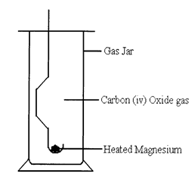
Study it and answer the questions that follow.

(i) State two observations that can be made during and after the experiment (2 marks)

…………………………………………………………………………………………………………………….

…………………………………………………………………………………………………………………….

…………………………………………………………………………………………………………………….

(ii) Write a balanced chemical equation for that reaction. (1 mark)

…………………………………………………………………………………………………………………….

…………………………………………………………………………………………………………………….

…………………………………………………………………………………………………………………….

9. The _{P}H values of some solutions labeled E to I are given in the table below. Use the information to answer the questions that follow.

_{P}H | 14.0 | 1.0 | 8.0 | 6.5 | 7.0
Solution | E | F | G | H | I
(a) Identify the solution with the highest concentration of hydroxide ions (1 mark)

…………………………………………………………………………………………………………………….

…………………………………………………………………………………………………………………….

…………………………………………………………………………………………………………………….

(b).Which solution can be used as a remedy for acid indigestion in the stomach? (1 mark)

…………………………………………………………………………………………………………………….

…………………………………………………………………………………………………………………….

…………………………………………………………………………………………………………………….

(c) Which solution would react most vigorously with magnesium metal? (1 mark)

…………………………………………………………………………………………………………………….

…………………………………………………………………………………………………………………….

…………………………………………………………………………………………………………………….

10. 120cm³ of nitrogen gas diffuses through a membrane in forty seconds. How long will it take 240cm³ of carbon (IV) oxide to diffuse through the same membrane (C=12,N=14,O=16) (3 marks)
…………………………………………………………………………………………………………………….

…………………………………………………………………………………………………………………….

…………………………………………………………………………………………………………………….

11. The table below shows the relative atomic masses and the percentage abundance of the isotopes L₁ and L₂ of element L.
Isotope | Relative atomic mass | % abundance
L₁ | 62.93 | 69.09
L₂ | 64.93 | 30.91
Calculate the relative atomic mass of element L (3 marks)
…………………………………………………………………………………………………………………….

…………………………………………………………………………………………………………………….

…………………………………………………………………………………………………………………….

12. Use the information in the table about group 1 elements to answer the questions that follow

Element | Atomic radius(nm)
Lithium | 0.123
Sodium | 0.157
Potassium | 0.203
.
When the group 1 elements react with water, hydrogen gas is given off. The diagram shows the reaction of the above three elements with water
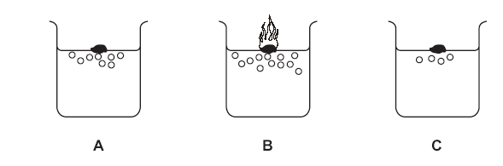
- What is the general name of the group one elements (1 mark)

…………………………………………………………………………………………………………………….

…………………………………………………………………………………………………………………….

…………………………………………………………………………………………………………………….

- Which one of these elements A, B or C is Lithium? (1 mark)

…………………………………………………………………………………………………………………….

…………………………………………………………………………………………………………………….

…………………………………………………………………………………………………………………….

(c) Apart from fizzing describe two things that you would see when sodium reacts with water. (2 marks)

…………………………………………………………………………………………………………………….

…………………………………………………………………………………………………………………….

…………………………………………………………………………………………………………………….

13. Study the chart below and answer the questions that follow.
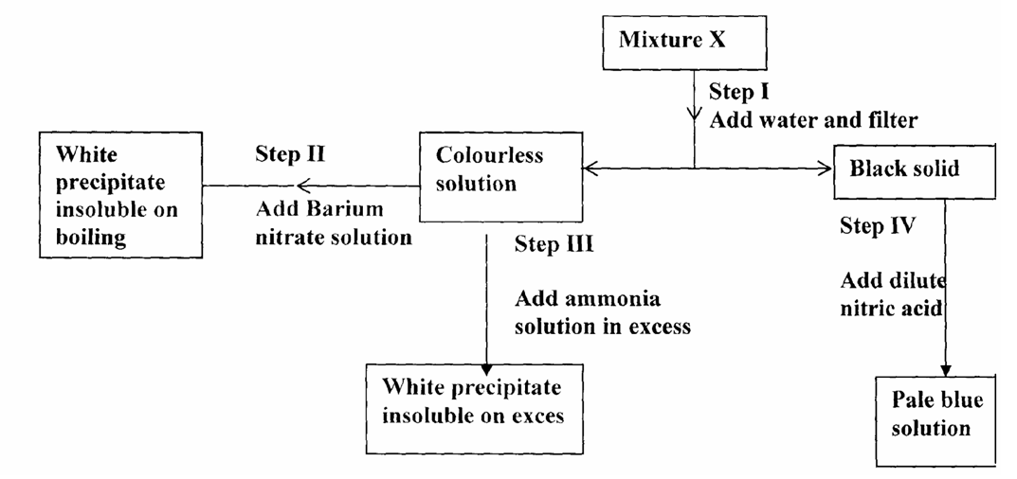
(a) Name:
(i) Cations present in mixture X. (1 mark)

…………………………………………………………………………………………………………………….

…………………………………………………………………………………………………………………….

…………………………………………………………………………………………………………………….

(ii) Anions present in the solution. (1mark)

…………………………………………………………………………………………………………………….

…………………………………………………………………………………………………………………….

…………………………………………………………………………………………………………………….

(b) Write an equation to show how the white precipitate in step III dissolves. (1 mark)

…………………………………………………………………………………………………………………….

…………………………………………………………………………………………………………………….

…………………………………………………………………………………………………………………….

(c) Name the process outlined in step IV above. (1 mark)

…………………………………………………………………………………………………………………….

…………………………………………………………………………………………………………………….

…………………………………………………………………………………………………………………….

14. Use the information in the table below to answer the questions that follow
Element | Sodium | Magnesium | Phosphorus | Chlorine
Electric conductivity | Good | Good | Poor | Poor
M.P (ºC) | 98 | 660 | 44/115 | -173
(a) Explain why both Sodium and Magnesium conducts electricity while phosphorus and chlorine do not. (1 mark)

…………………………………………………………………………………………………………………….

…………………………………………………………………………………………………………………….

(b) Suggest a reason why phosphorus has been assigned two melting point values (1 mark)
…………………………………………………………………………………………………………………….
c) Explain why atomic radii of elements in period 3 decreases generally from left to right in the periodic table (1 mark)
…………………………………………………………………………………………………………………….

…………………………………………………………………………………………………………………….
15. In an experiment, soap solution was added to three samples of water. The results below shows the volume of soap solution required to lather with 500cm³ of each water sample before and after boiling.
Volume of soap used before water boiled | Sample 1 | Sample 2 | Sample 3
Volume of soap used before water boiled | 26.0 | 14.0 | 4.0
Volume of soap after water boiled | 26.0 | 4.0 | 4.0

(i).Which water samples are likely to be soft (1 mark)
………………………………………………………………………………………………………………

…………………………………………………………………………………………………………………….

(ii) Explain the change in volume of soap solution used in sample 2 (1 mark)

…………………………………………………………………………………………………………………….

16. Describe how the following reagents can be used to prepare lead sulphate. Solid potassium sulphate, solid lead carbonate, dilute nitric acid and distilled water. (3 marks)
…………………………………………………………………………………………………………………….

…………………………………………………………………………………………………………………….
17. Using dots (.) and crosses(x) to represent -electrons show the bonding between oxygen and carbon to form carbon (ii) oxide. (1 mark)

…………………………………………………………………………………………………………………….
18. 10g of ethanol (C₂H₅OH) were completely burnt in air. The heat evolved caused the temperature of 400cm³ of water to change from 20⁰C to 85⁰C. Calculate the molar enthalpy of combustion of ethanol.
(H = 1, C = 12, O = 16. Specific heat capacity of water = 4.2 Jkg⁻¹k⁻¹) (3 marks)
…………………………………………………………………………………………………………………….

…………………………………………………………………………………………………………………….

19. The structures below represent two cleansing agents where R is along hydrocarbon chain. Which of the two cleansing agents is suitable for washing in water containing Calcium ions. Give a reason
(2 marks)

20. Give the IUPAC name of the following organic compounds; (2 marks)
- CH₃CH₂CH₂CH₂CH₃

- CH₃CHCH₂CH₂CH₃

CH₃

21 .The products formed by action of heat on nitrates of element A, B and C are shown below
Nitrate | Products formed
A | Metal oxide +Nitrogen (IV) Oxide + Oxygen
B | Metal +Oxygen (IV) Oxide
C | Metal nitrate + oxygen

- Arrange the metals in order of reactivity (1 mark)
…………………………………………………………………………………………………………………….

…………………………………………………………………………………………………………………….
- Which element forms a soluble carbonate (1 mark)

…………………………………………………………………………………………………………………….

Give an example of B (1 mark)
22. Propane C₃H₈ and Carbon(IV)oxide diffuses at the same rate under the same conditions. Explain
(1 mark)

23. Although there are large reserves of iron and aluminium ores in the world, both metals are recycled.
I. State one social benefit of recycling {1 mark}

II. Why is it particularly easy to separate iron from other scrap metals? {1mark}

III. It is cheaper to recycle aluminum than it is to extract the metal from its ore. Give a reason. {1 mark}

24. The diagrams show the structures of two forms, P and Q, of a solid element.
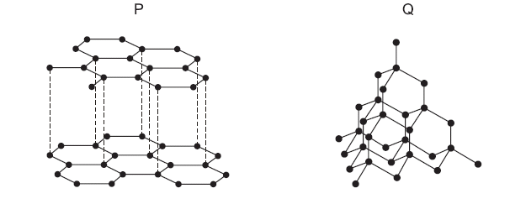
What are suitable uses of P and Q, based on their structures? (2 marks)

25. Fertilizers are added to the soil to improve crop yields. A farmer has a choice of two fertilizers, ammonium nitrate NH₄NO₃ or diammonium hydrogen phosphate (NH₄)₂HPO₄
(i) Show by calculation which of these fertilizers contains the greater percentage of nitrogen by mass
(3 marks)
(N=14, H=1, O=16,P=31)

(ii) State one major problem caused when the nitrates from fertilizers leach from the soil into streams and rivers (1 mark)

26. Study the flow chart below.
Alcohol S
Propene
Compound T
Process I

Conc. H₂SO_{4(l)}
Acidified

KmnO₄

(a).Write the structural formula of alcohol S. (1 mark)

(b) Name
(i) compound T (1 mark)

(ii) process I (1 mark)

27. Students are advised to use a non-luminous flame for heating in the laboratory.
(a) How does a Bunsen burner produce a non-luminous flame? (1 mark)

(b) Give one reason why the advice is given to students. (1 mark)

28. Study the diagram below and answer the questions
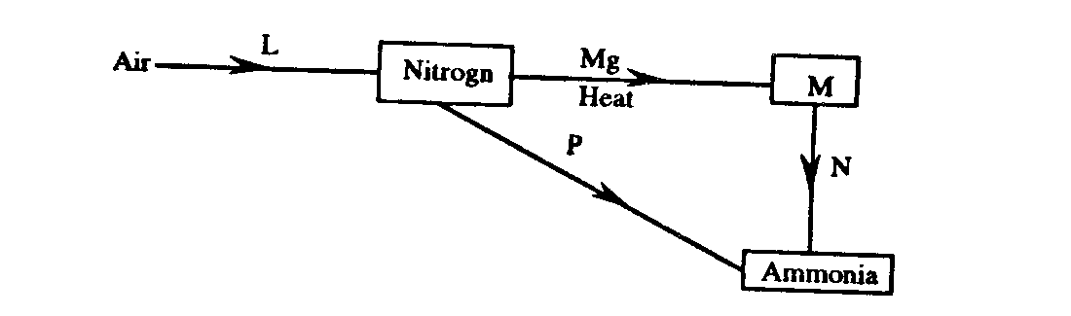
(i) What is the process involved in step L (1 mark)

(ii)Explain how process N and P can be affected (2marks)
N

29. In an experiment to determine the solubility of solid Y in water at 30⁰Cthe following results were obtained.
Mass of empty evaporating dish = 26.2g
Mass of evaporating dish + saturated solution = 42.4g
Mass of evaporating dish + dry solid = 30.4g
Use the data to calculate the solubility of Y at 30⁰_{C} grams of Y per 100g water. (3 marks)

