Name………………………………………………………………………. Adm no……………
233/2
CHEMISTRY
PAPER 2
(THEORY)
TIME: 2 HOURS

END OF TERM 2 PROJECTION 2020
Kenya certificate of secondary education (K.C.S.E)

INSTRUCTIONS:
- Write your name and admission number in spaces provided above
- Answer ALL the questions in the spaces provided
- Mathematical tables and electronic calculators may be used
- All working must be clearly shown where necessary.

FOR EXAMINERS USE ONLY
Question | Maximum Score | Candidates score
1 | 12
2 | 13
3 | 13
4 | 10
5 | 12
6 | 10
7 | 10
 | 80
TOTAL SCORE

This paper consists of 12 printed pages.
Candidates should check to ensure that all pages are printed as indicated and no questions are missing

1. (a) Use the information below to answer the questions that follow.
ΔH = -635 KJ molˉ¹
ΔH = -394 KJ molˉ¹
ΔH = -1207 KJ molˉ¹
Calculate the enthalpy change for the reaction.
(3 marks)

(b) State one factor that should be considered when choosing a fuel for cooking. (1 mark)

(c) The following data was obtained during an experiment to determine the molar heat of combustion of
ethanol.
Volume of water used = 500cm³
Initial temperature of water = 25°C
Final temperature of water = 44.5°C
Mass of ethanol + lamp before burning = 121.5g
Mass of ethanol + lamp after burning = 120.0g
Calculate the
(i) Heat evolved during the experiment (density of water = 1g/cm³, specific heat capacity of water = 4.2Jgˉ¹ˉK¹). (1 mark)

(ii) Molar heat of combustion of ethanol (C = 12, O = 16, H = 1). (2 marks)

(d) Write the thermo equation for the complete combustion of ethanol. (1 mark)

(e) At 298K and one atmosphere pressure, graphite changes into diamond according to the equation.
ΔH = +2.9 KJ/mol
In the space provided, sketch a simple energy level diagram for the above change. (2 marks)

(f). Study the information in the table below then answer the questions that follows.
Bond | Bond energy (kJmolˉ¹
H – H  Cl – Cl  H – Cl | 435  243  431

Calculate the enthalpy change for the reaction.
(2 marks)

2. (a) At 25°C 50g of substance X were added to 100g of water to make a saturated solution.
What is meant a saturated solution? (1 mark)

(b) The table below gives the solubilities of substance X at different temperatures.
Temperature °C | 14 | 24 | 33 | 40 | 46 | 52
Solubility g/100g H₂O | 24 | 36 | 50 | 62 | 72 | 90

(i). Plot a graph of the solubility of substance X (vertical axis) against temperature. (3 marks)

(ii) Using the graph.
- Determine the solubility of substance X at 20°C. (1 mark)
- Determine the mass of substance X that remained undissolved given that 90g of substance X were added to 100cm³ of water and warmed to 35°C. (2 marks)

- Calculate the molarity of the solution at 30°C. (Relative formula mass of X = 122.5). (3 marks)

(c) The figure below shows an ion exchanger used to soften hard water

Hard water containing MgCl₂

Na ⁺
Na ⁺

Na ⁺
Na ⁺
Na ⁺
Ion exchanger
Na ⁺
Na ⁺
Na ⁺

Soft water out

(i) Draw the ion exchanger and show how it will appear at the end of softening process. (2 marks)

(ii) How is the ion exchanger recharged after exhaustion (1 mark)

3.(a) Below is an incomplete diagram of a set-up of the apparatus used to obtain nitrogen gas from the air.
Water →
in
Heat
Aspirator
Water
Potassium hydroxide solution
Zinc W

- Complete the diagram to show how nitrogen gas is collected. (1 mark)

- State the role of the following:

I Water entering the aspirator. (1 mark)

II Potassium hydroxide solution. (1 mark)

(iii).Write a chemical equation for the reaction that takes place in combustion tube. (1 mark)

(b).The diagram below represents the Haber’s process for the manufacture of ammonia. Study it and answer the questions that follow.
Hydrogen
Nitrogen

Purifier
Compressor 500 atmosphere
Condenser
Heat Exchange
Liquid ammonia
10%
ammonia

unreacted gases

Catalytic chamber

( i) Name any two impurities removed by the purifier. (2 marks)

(ii) Name the catalyst used in the process (1 mark)
.................................................................................................................................................................................
(iii) In the Haber’s process the conversion of nitrogen and hydrogen into ammonia is only 10%.
The remaining unreacted gases are recycled. What is the advantage of recycling. (1mark)
..................................................................................................................................................................................

iv) A part from the catalyst and pressure of 500 atmospheres, name any other condition required for this process. (1mark)

(c) Give any two uses of ammonia (1 mark)
....................................................................................................................................................................................
d) In the manufacture of nitric (V) Acid from ammonia and air, ammonia is catalytically oxidized to nitrogen (II) oxide
(i) Name the catalyst used in the reaction. (1mark)
....................................................................................................................................................................................
(ii) Write a balanced chemical equation for the reaction between ammonia and air. (1mark)

(iii) State one environmental problem likely to be faced in an area where nitric (v) acid manufacturing plant is
located. (1 mark)
....................................................................................................................................................................................

4. In an experiment, carbon (IV) Oxide gas was passed over heated charcoal and the gas produced collected as shown in the diagram below.
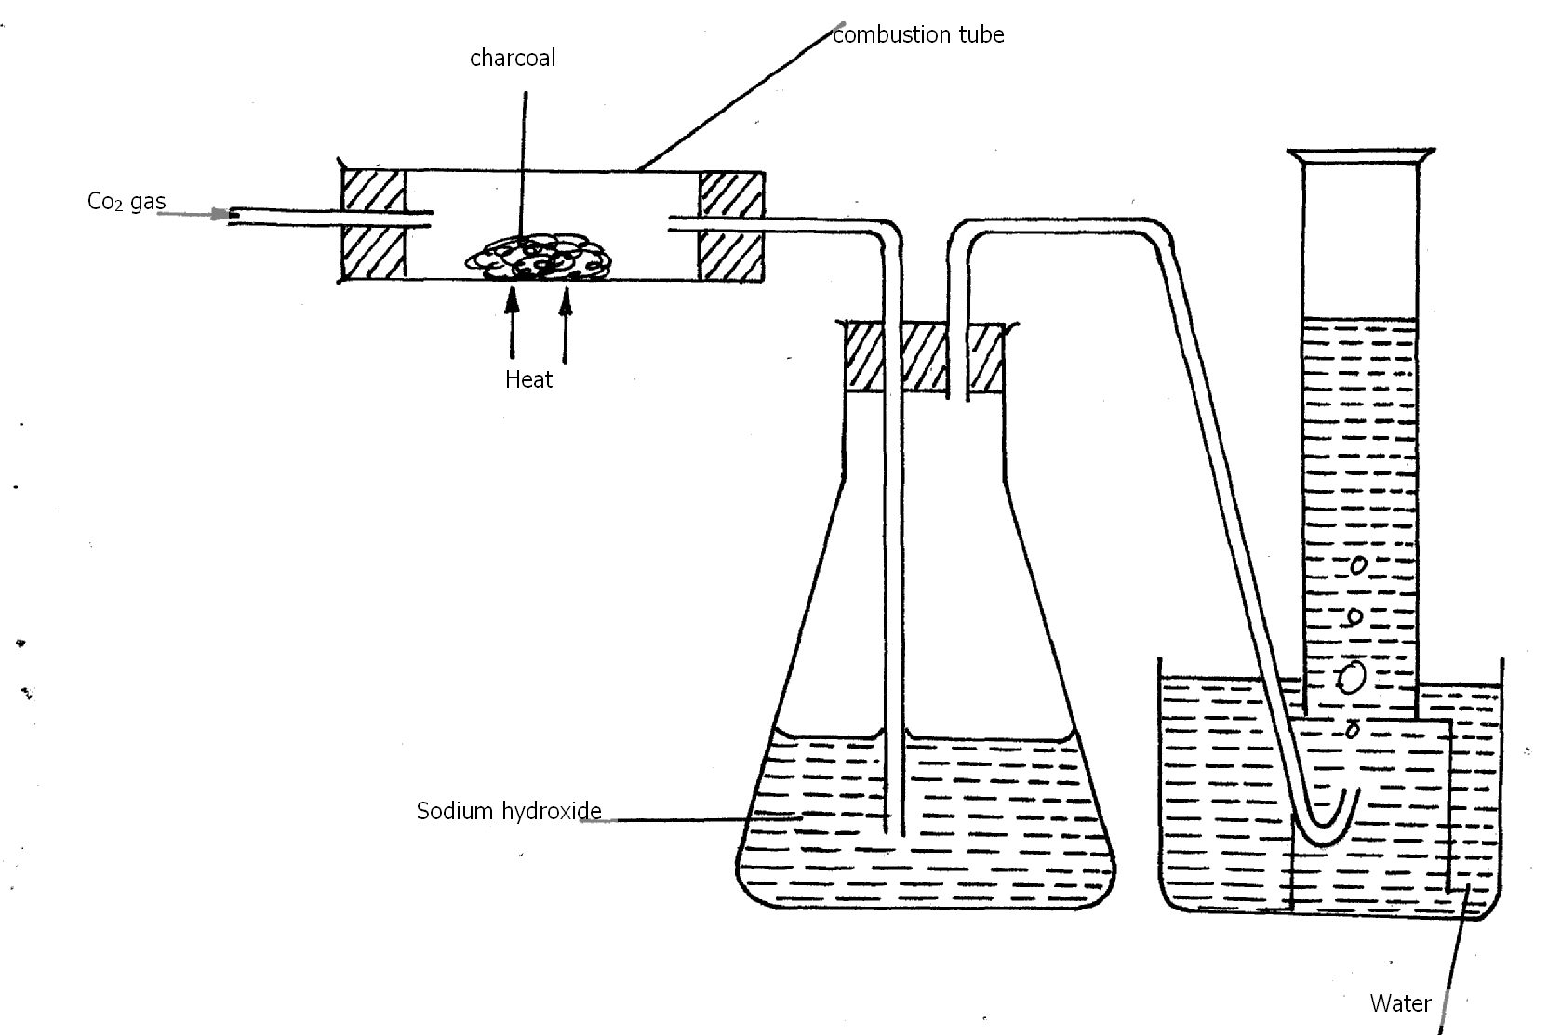
(i) Write an equation for the reaction that took place in the combustion tube . (1 mark)

(ii) Name another chemical substance that can be instead of sodium hydroxide . (1 mark)

(iii) Describe a simple chemical test to distinguish between carbon (II) Oxide and carbon (IV) Oxide (2 marks)

(iv) What is the purpose of sodium hydroxide in the above set-up (1 mark)

(v) What property of the gas makes it possible to be collected ass shown above? (1 mark)

(vi) State one use of carbon (II) oxide (1 mark)

(b) In order to prepare sodium carbonate in the laboratory, students passed carbon (IV) oxide and ammonia gas into brine as shown in the flow diagram below. Use it to answer the questions that follow:
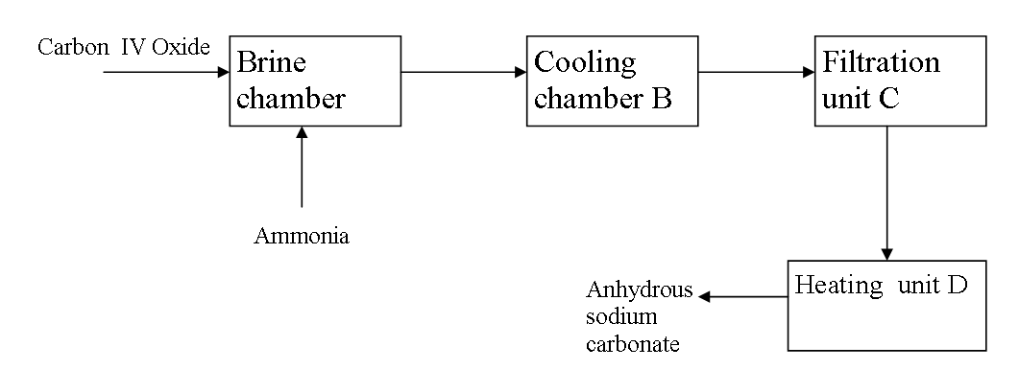
(i) Why is the mixture obtained in chamber A cooled down in chamber B? (1 mark)

(ii) Write an equation for the reaction that recurs in the heating chamber D (1 mark)

(iii) Give a reason why it is difficult to prepare potassium carbonate by the same method. (1 mark)

5. Study the flow diagram below and use it to answer the questions that follow.
Metal A + Chlorine

Water Heat
Solution C + Hydrogen gas
Compound B

Water
Colorless solution
D
Na₂CO₃
Solution
Solution
White precipitate
C
Mixed
Sodium
Few drops of solution C

Colorless solution
G
Colorless solution
F
White Precipitate
E
E
Dilute
HCl
Excess
NaOH_{(aq)}

(a) Give the name and formula of the following.
(i) White precipitate E
Name
(1 mark)

Formula
(1 mark)
(ii) Colourless solution F
Name
(1 mark)

Formula
(1 mark)
(b) What property is exhibited by white precipitate E when it reacts with Sodium hydroxide and HCl acid. (1mark)

(c) Write an ionic equation for the reaction between white precipitate E and excess sodium hydroxide solution. (1 mark)

(d) You are provided with.
i) Potassium carbonate solid
ii) Zinc hydroxide
iii) Nitric (v) acid
iv) Distilled water
State briefly how you would prepare solid zinc carbonate using the reagents given. (3 marks)
........................................................................................................................................................................
.......................................................................................................................................................................
....................................................................................................................................................................... ......................................................................................................................................................................
......................................................................................................................................................................
(e) Distinguish between a weak acid and a strong acid giving an example of each. (1 mark)

(f). Identify an acid in the forward reaction given by the equation below:

(1 mark)

6. The grid below shows part of the periodic table. Use it to answer the questions that follow. The letters do not represent actual symbols.
 |  |  |  |  |  | S | U | V
P | R |  |  |  |  | T | X | W
Q

- Which of the elements has the largest atomic radius? Explain. (2 marks)

- Identify the most reactive non-metal. Explain. (2 marks)

- Compare the atomic radius of P and R. (1 mark)

- Give the formula of one stable ion with an electron arrangement of 2.8 which is:
- Negativity charged divalent ion. (2 marks)

- Positively charged monovalent.

- Given that the mass number of W is 40. Write down the composition of its nucleus. (1 mark)

- Write the formula of the compounds formed between.
- Element R and X. (1 mark)

- Give one property of the structure formed when R and X bond. (1 mark)

7. Study the diagram below and answer the questions that follow.
Ca (OH)₂

CaC₂ + X

Step 1
1 mole HCl
Gas Y
Z
Step 2

H H
| |
C — C |
H H ₂
1 mole H₂
Step 3
C₂H₄

CH₃CH₃
200⁰C, High pressure H₂ 150⁰C
Step 5 Step 4

- Identify reagent X. (1 mark)

- Draw the structural formula of gas Y. (1 mark)

- What name is given to the process that takes place in step 5? (1 mark)

(b) An organic compound T reacts with chlorine gas in the presence of u.v light to form compound U. The structural formula of compound U is shown below.
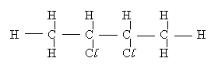
Name the organic compound T and draw its structural formula. (2marks)

(c).The structure below represents two cleansing agents, L₁ and L₂.
L₁ → R – CH₂ – CH₃
|
OSO₃Na⁺
L₂ → R – COONa⁺
(i) Identify each of the two cleansing agents, L₁ and L₂.
L₁
(½mark)
L₂

(½mark)
(ii). State a disadvantage of each of the above cleansing agents.
L₁
(½mark)
L₂
(½mark)
(d) In an experiment an organic compound was reacted with absolute ethanol in the presence of concentrated sulphuric (VI) acid to form a compound whose formula is CH₃ CH₂ CH₂ COOCH₂ CH_{3.} Name
I. The type of reaction that took place. (1 mark)

II. The name of the organic compound to which the compound belonged. (1 mark)

(e) Write the structural formula and give the systematic name of the acid used in the above experiment. (1 mark)

