**NAME:………………………………………………………………….CLASS:…………..ADM NO:..…**

**ANESTAR SCHOOLS**

**TERM EXAM**

**CHEMISTRY (MARKING SCHEME)**

**1ST TERM 2020**

**FORM 4**

**80MKS**

1. In the figure below

F

G

H

1. Name the parts labeled F,G and H. (1 ½ mks)

F  ***Pale blue zone/ region***

G ***Almost colourless zone***

H ***Chimney/barrel***

1. Describe an experiment that would confirm that the region labeled G is unsuitable for heating. (1 ½ mks)

* ***Slip a piece of white manila paper into region G and remove quickly before it catches fire and observe it.***
* ***Its found to have been burned at the sides leaving the centre unburned. This shows that the region comprises of unburnt gases hence unsuitable.***

1. Give the names of the following processes used to: (1mk)
2. Obtain a solvent from a saturated solution

***Simple distillation***

1. Separate zinc carbonate from water.

***Filtration***

1. When dilute nitric (V) acid was added to a sample of solid M, a colourless gas that formed a white precipitate with lime water was produced. When another sample of solid M was heated stronghly in a dry test tube, there was no observable change.
2. Write the formula of the ions present in M. (1mk)

***K+/ Na+ CO32-***

1. Write a chemical equation for the reaction which took place between M and nitric (v) acid. (1mk)

***K2CO3 (s) + 2HNO3(aq) 2KNO3 (aq) + CO2(g) + H2O(l)***

***Or***

***Na2CO3(s) + 2HNO3(aq) NaNO3(aq)+ CO2(g) + H2O(I)***

1. Describe how a solid sample of lead (II) chloride can be prepared using the following reagents; dilute nitric (V) acid, dilute hydrochloric acid and lead carbonate. (2mks)

* ***Add dilute nitric (V) acid to the lead (II) carbonate to obtain lead (II) nitrate solution.***
* ***Allow the reaction to go to completion.***
* ***Add excess dilute hydrochloric acid to the mixture to precipitate insoluble lead (II) chloride***
* ***Filter to obtain lead (II) chloride as the residue.***

b. Give a disadvantage of evaporating a solution to dryness during crystallization. (1mk)

***- Crystals formed do not have water of crystallization and are very small.***

1. In an experiment to study properties of carbon, a small amount of charcoal is placed in a boiling tube. 5.0cm3 of concentrated nitric (V) acid is added. The mixture is then heated.
2. What observations are made? Explain. (2mks)

* ***A brown gas comes off the boiling tube. Charcoal (carbon) reduces hot concentrated nitric (V) acid to brown nitrogen (IV) oxide and water.***

1. A substance containing only carbon and hydrogen has 80% by mass of carbon. It is also given that 1 dm3 of the compound has a mass of 1.35g. determine the molecular formula of the compound. (C=12, H=1, MGV at stp =22.4dm3)

(3mks)

***Element C H***

***% by mass 80 20***

***RAM 12 1***

***Moles 80 20***

***12 1***

***6.6667 20***

***Mole ratio 6.6667 20***

* 1. ***6.6667***

***1 : 3***

***E.F is CH3 (1mk)***

***1 dm3,CH3 = 1.35g***

***22.4dm3 = ?***

***= 22.4 x 1.35***

***1***

***= 30.24g (1mk)***

***(CH3)n = molecular formula mass***

***15n =30***

***15 15***

***n = 2***

***M.F is (CH3)2***

***=C2H6***

1. State Graham’s law of diffusion. (1mk)

***The rate of diffusion of a given mass of gas is inversely proportional to the square root of its density, temperature and pressure being constant.***

1. 100cm3 of carbon (IV) oxide diffuses through a porous plate in 30 seconds. How long will it take 150cm3 of nitrogen (IV) oxide to diffuse across the same plate under similar conditions? (3mks)

***100cm3 of CO2 diffuse in = 30sec***

***150cm3 of CO2 diffuse in = ?***

***(150 x 30)***

***100***

***= 45sec***

***Hence***

***tCO2 =√MCO2***

***t NO2 MNO2***

***45 = 0.9780***

***tNO2 1***

***+NO2 =4.5***

***0.9780***

***= 46.01 seconds***

1. What is an electrolyte? (1mk)

***Is a substance that conducts electricity/ electric current in molten or aqueous form.***

b. Below is a set up used to investigate the effect of electric current on molten sodium chloride.

carbon cathode

carbon anode

Molten sodium chloride

A gas was formed at the anode. Write an ionic equation to show the formation of the gas. (1mk)

***2Cl-(aq) Cl2(g) + 2e-***

1. What was observed in the solution around the anode? (1mk)

***Turns to red***

1. State how the following substances conduct electricity.
2. Molten magnesium chloride. ( ½ mk)

***Use of mobile/free ions***

1. Copper metal ( ½ mk)

***Use of delocalized electrons***

1. What causes water hardness? (1mk)

***Presence of dissolved Ca2+ and Mg2+ ions.***

b. State two methods of removing permanent water hardness in water. (2mks)

***- Distillation***

***- Addition of sodium carbonate***

***- Ion exchange method***

***- Addition of calcium hydroxide***

***- Addition of ammonia solution***

c. State one advantage of drinking hard water. (1mk)

***- Hard water contains Ca2+ for strong bones and teeth.***

1. A form two student in an attempt to prevent rusting put copper and zinc in contact with iron as shown below.

iron iron

Copper

X Y

1. State what would happen in set up x and y after one week. (2mks)

* ***In set up x iron turned brown while in set up y, iron remained unchanged.***

1. Explain your answer in diagram. (1mk)

* ***Iron is more reactive than copper hence combines with the moist atmospheric air while zinc is more reactive than iron hence will combine with oxygen.***

1. What name is given to the above method? (1mk)

* ***Sacrificial protction***

1. The flow chart below represents an industrial process for the manufacture of bleaching powder.

Z

Chlorine gas Bleaching powder

1. Name substance Z (1mk)

* ***Concentrated calcium hydroxide***

1. Write a formula of bleaching powder. (1mk)

* ***Ca(OCL)2***

1. Explain why a lot of soap is used during washing with water containing bleaching powder? (1mk)

* ***The presence of calcium (Ca2+)ions in bleaching powder, wastes soap.***

1. Explain:
2. Why dilute nitric (V) acid is not used in hydrogen gas preparation? (1mk)

***Nitric (V) acid is a powerful oxidizing agent and would therefore oxidize any hydrogen gas produced into water.***

1. Why copper metal granules are not used to prepare hydrogen gas. (1mk)

***Copper is below hydrogen in the reactivity series hence connect displace hydrogen from dilute acids.***

1. Explain why the boiling point of ethanol is higher than that of hexane. (R.M.M of ethanol is 46 while that of hexane is 86) (2mks)

***In addition to van der waals force, strong hydrogen bonds exist in ethanol which require more energy to break.***

1. The set up below was used to prepare a sample of ethane gas. Study it and answer the question that follows.

Ethane

mixture of B with sodaline

water

heat

1. Name B (1mk)

***Sodium propanote***

1. Write an equation for the reaction which took place. (1mk)

***CH3CH2COONa(s) + NaOH(s) C2H6(g)+ Na2CO3(s)***

1. State one use of ethane. (1mk)

***Used as a fuel***

1. In an experiment to determine the solubility of solid Y in water at 30OC, the following results were obtained.

Mass of empty evaporating dish = 26.2g

Mass of evaporating dish + saturated solution = 42.4g

Mass of evaporating dish + dry solid y = 30.4g

1. Use the data to calculate the solubility of Y in grams of y per 100g of water at 30OC. (2mks)

***Mass of solvent = 42.4 – 30.4 = 12g***

***Mass of salt = 30.4 – 26.2 = 4.2g***

***Solubility of y = 4.2g/12g of H2O at 30OC***

***Solubility of y in 100g = ?***

***4.2g = 12g***

***?=100g***

***= 100x 4.2***

***12***

***= 35g/100g of water at 30OC***

1. The structure given below represents a segment of a polymer. Use it to answer the questions that follow.

F F F F F F

C C C C C C

F F F F F F

1. Identify the polymer. (1mk)

***Polytetrafluoroethene***

1. Name and draw the structure of the monomer. (1mk)
2. Name (1mk)

***Tetrafluoroethene***

1. Structure (1mk)

***F F F F***

***C = C OR C = C***

***F F F F***

1. Give the systematic names of the following compounds.
2. CH3CH2COOH ( ½ mk)

***Propanoic acid***

1. CH3CH2CH2CHCH2 ( ½ mk)

***Pent-I- ene***

1. CH3CH2CH2CH2OK ( ½ mk)

***Potassium butoxide***

1. CH3CH2CCH ( ½ mk)

***But-I - yne***

1. Ammonia gas is oxidized in air to nitrogen (II) oxide when in contact with heated platinum. The apparatus set up for this reaction is shown in the diagram below.

Air in

Hot platinum

Conical flask

Conc. Ammonia solution

1. Write a balanced equation for the reaction taking place in the conical flask. (1mk)

***4NH3(g) + 5O2 (g) 4NO(g) + 6H2O(i)***

1. The spiral end of the platinum wire is first heated and quickly hanged inside the conical flask. The wire remains red hot throughout the reaction even without further heating. Explain. (1mk)

***The reaction is exothermic***

1. Explain why burning magnesium continues to burn in a gas jar full of sulphur (IV) oxide while a burning splint would be extinguished. (2mks)

***Burning magnesium produces enough energy to decompose sulphur (IV) Oxide into sulphur and oxygen. Oxygen supports combustion therefore magnesium would continue to burn. A burning splint on the other hand does not have sufficient energy to decompose sulphur (IV) oxide. It will therefore be extinguished.***

1. Given the element 31

P

15

Write:

1. The group (1mk)

***V***

1. The period (1mk)

***3***

1. The electron arrangement (1mk)

***2.8.5***

1. Using dots (.) and crosses (x) to represent outermost electrons, draw diagrams to show bonding in:
2. Magnesium chloride, MgCl2 (1 ½ mks)

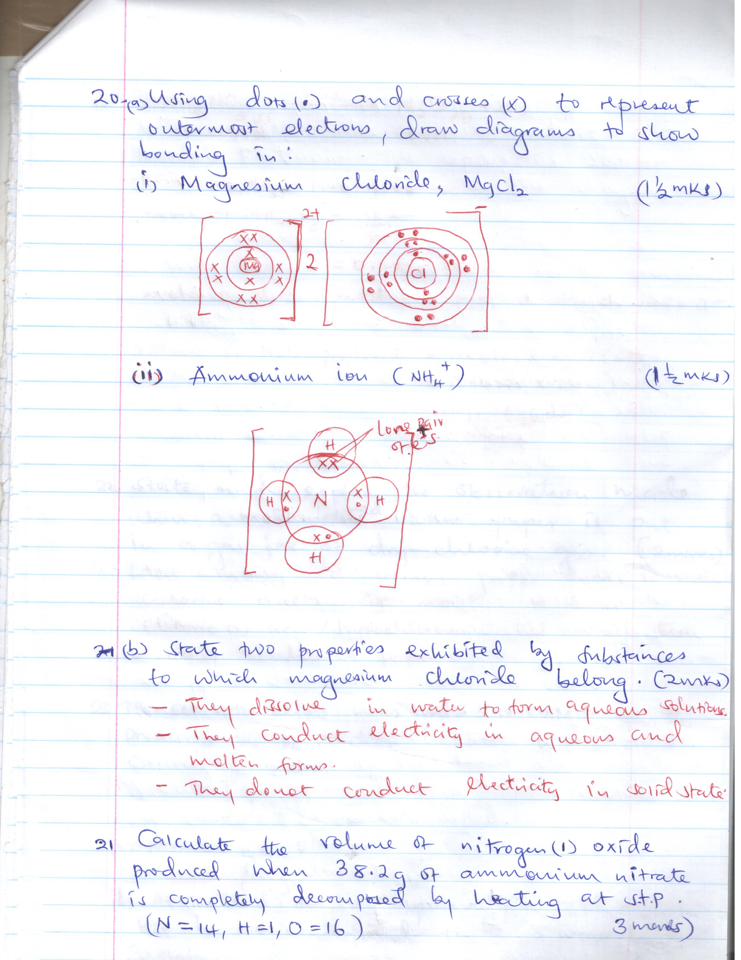

1. Ammonium ion (NH4+) (1 ½ mks)

b. State two properties exhibited by substances to which magnesium chloride belong. (2mks)

***- They dissolve in water to form aqueous solution***

***- They conduct electricity in aqueous and molten form.***

***- They do not conduct electricity in solid state***

1. Calculate the volume of nitrogen (I) oxide produced when 38.2g of ammonium nitrate is completely decomposed by heating at s.t.p. (N = 14, H= 1, O=16) (3mks)

***NH4NO3(s) N2O(g + 2H2O(l)***

***1mol/vol 1 vol***

***RFM of NH4NO3 = 14 + 4 + 14 +48 =80***

***Moles of NH4NO3= 38.2***

***80***

***= 0.4775 moles***

***Moles of N2O formed = 0.4775 since mole ratio is***

***1:1***

***Volume of N2O produced = moles x MGV (stp)***

***= (0.4775 x 22.4)***

***= 10.696 dm3***

1. State and explain the observation made when a moist red litmus paper is put in a gas jar of dry chloride gas. (2mks)

***The moist red litmus paper turns to white chlorine reacts wit moisture to form chloric (i) acid / hypochloropus acid which then bleachers the litmus paper.***

1. The set up below was used to collect gas k, produced by the reaction between water and calcium metal.

Gas K

Water

Calcium metal

Name gas k (1mk)

**Hydrogen gas**

1. At the end of the experiment, the solution in the beaker was found to be a weak base. Explain. (2mks)

* ***Calcium reacts with water to form calcium hydroxide which dissociates partially in water to produce hydroxide ions.***

1. The table below shows the relative atomic masses and percentage abudance of the isotopes L1 and L2 of element L.

|  |  |  |
| --- | --- | --- |
|  | **Relative atomic mass** | **% abundance** |
| L 1 | 62.93 | 69.09 |
| L 2 | 64.93 | 30.91 |

Calculate the relative atomic mass of element L. (2mks)

***R.A.M = Isotopic mass x relative abundance***

***100***

***= (62.93 x 69.09 ) + ( 64.93 x 30.91 )***

***100***

***= 4348 + 20.07***

***= 63.54***

1. The table below gives information about the ions T+ and Z2-.

|  |  |  |
| --- | --- | --- |
| **Ion** | **T+** | **Z2-** |
| Electron arrangement | 2.8 | 2.8.8 |
| Number of neutrons | 12 | 16 |

1. How many protons are there in the nucleus of:
2. Element T? ( ½ mk)

***11 protons***

1. Element Z? ( ½ mk)

***16 protons***

1. State two similarities of neutrons and protons. (2mks)

* ***Both are found in the nucleus of an atom.***
* ***Both have mass***

1. A sample of water is suspected to contain sulphite ions. Describe an experiment that can be carried out to determine the presence of sulphite ions. (2 ½ mks)

* ***To a small portion of the water in a test tube add a few drops of BaCl2 or Ba (NO3)2. A white precipitate will be formed.***
* ***Add a few drops of hydrochloric acid or dilute nitric (V) acid solution and shake. The white precipitate dissolves to indicate presence of sulphite ions.***

1. State two laboratory rules that should be followed to avoid contamination and wastage of chemicals. (2mks)

* ***Label all containers carrying chemicals.***
* ***Always use a clean spatula to scoop chemicals from containers.***
* ***Turn off water and gas taps when not in use.***

1. Hydrogen peroxide decomposes slowly to form oxygen gas and water. Name a substance used to speed up its decomposition in laboratory. ( ½ mk)

***- Manganese (IV) oxide***

b. Write an equation for the decomposition reaction involving the substance identified in (a) above. (1mk)

***2H2O2(g) MnO2 2H2O(i) + O2(g)***

c. State one industrial use of oxygen gas. (1mk)

***- used in welding in oxyacetylene flame.***