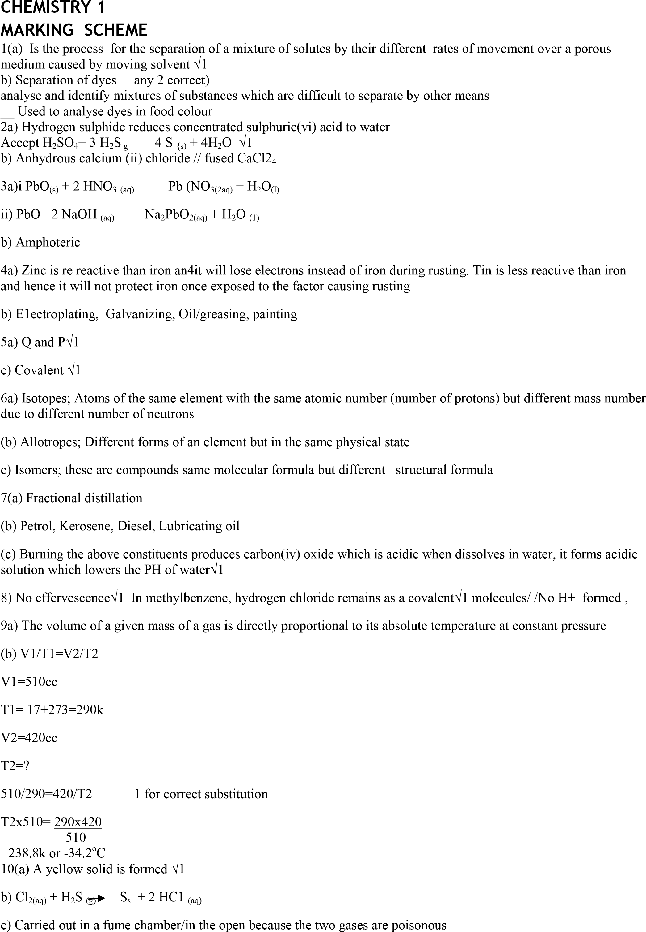

|  |  |
| --- | --- |
| 1. .Use a magnet to remove iron filings   Heat the remaining mixture NH4C1 sublimes and is collected as a sublimate.  Common salt remains as a residue√1   1. Add distilled water to ZnC12 solid and shake until all solid dissolves   Add K2CO3// Na2CO3 solution for form white ppt of ZnCO3(g)  Filter and wash the residue with a lot of water   1. White ppt forms and dissolves forming a clear solution the white ppt is due to formation of CaCO3 which is insoluble and dissolves into a clear/ colourless solution due to the soluble Ca(HCO3) formed√1   CO2(g) + Ca (OH)2(aq) CaO3 + H2O (l)  CaCO(3)(s) + H2O(I) + CO2(g) Ca(HCO3)2(aq)  White ppt Colourless soln)  14i) At 100oC l00g water 48Y 190g water  ii) In 150g of saturated solution at 100oC mass of Y = 50g  At 60oC mass of Y in solution = 4Og  Mass that crystallizes = 50—40 = l0g  Attemp to subtract  15i) –Equation shifts to the right for more CaCO3 to decompose to replace the CO2 absorbed by the NaOH √1 ii) Equation-shift to the right as the forward reaction is endothermic hence favoured by high temp  16 Hard water deposits the insoluble Mg2 and Ca2 carbonate on the pipes preventing lead from dissolving into the water. Lead dissolves in the soft water leading to lead poisoning  17i) (32 x 8)= 256√1 ii) Plastic sulphur  iii) the rings are broken to form long chains which entangle with one another making liquid viscous  18 Mass of carbon 11 x12  44  Mass of hydrogen 4.5 x 2= 0.5 √1 18  C H | |
| 3/12= | =0.5/1 |
| 0.25 | 0.5 |
| 0.25/0.25=1 0.5/0.5=2    (CH2)n=84  12n+2n=84 √ ½ | |

