**FORM 2 CHEMISTRY**

**END TERM 1 2019**

**MARKING SCHEME**

1. (a) Smallest particle of an element that can take part in a chemical change. √1

(b) Atomic number is the number of protons in the nucleus of an atom. While mass number is the sum of the protons and neutrons in an atom of an element. √1

***Both must be correct to score***

1. Protons √1

Neutrons √1

Electrons √1

1. 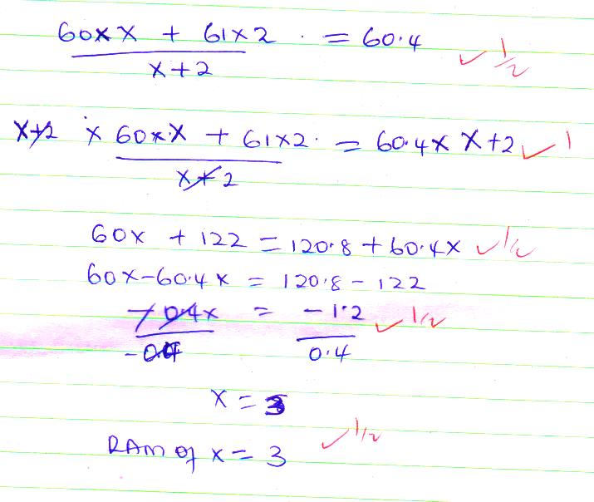,
2. (i) $\frac{24}{3}$ =8hrs √1

The student is to take 1 tablet after every 8hrs. √1

(ii) 7:00 hrs

8:00

15:00 hrs √1

8:00

23:00 hrs √1

1. (a) Sublimation√1

(b) fractional/ distillation √1

(c) simple distillation/ crystallization/ evaporation √1

1. (i) NaCl √1

(ii) Fe2O3 √1

(iii) Alluminium (III) Hydroxide √1

1. (i) Do not run in the laboratory √1

Never taste /eat anything in the laboratory to avoid poisoning √1

Label all the chemicals you are using to avoid confusion. √1

(ii) For easy making of observation because they are transparent √1

Enables one to determine the level of liquids held there in √1

Easy to clean √1

1. (a) put anhydrouse copper (ii) sulphate /cobalt (ii) chloride in a dry test tube√ $1/2$

* Add two drops of the liquid √ $1/2$
* anhydrouse copper (ii) sulphate changes from white to blue or blue cobalt (ii) chloride turns pink. √ $1/2$
* This proves the colourless liquid is water. √ $1/2$

(b) put the liquid in a boiling tube √

- heat the liquid to boiling and determine the boiling point √

- if the boiling point is sharp, the liquid is pure otherwise its impure. √ $1/2$

1. (a)(i) Y √1

(ii) X √1

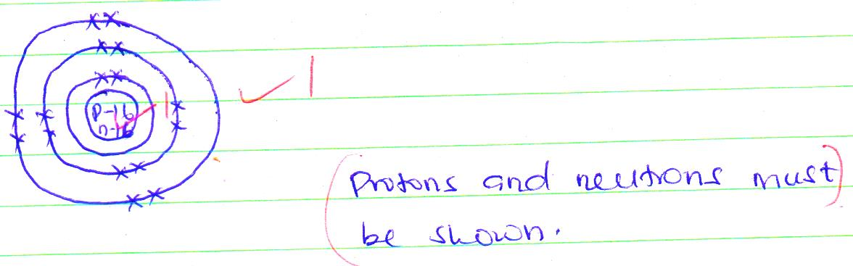(b)

1. (i) Q √1

(ii) R-√1 An oxide of sodium is basic hence turns red litmus paper blue √1

(iii) P-√1 An oxide of sulphur is acidic hence turns litmus paper red. √1

1. (a) prescription drugs are drugs that can only be obtained and used on a doctors advise. √1while over the counter drugs are drugs which are bought from a chemist or retail shops without a doctors prescription. √1

(b) bhang √ $1/2$

Khat √ $1/2$

Alcohol

(c) Hallucination √1

Depression √1

Memory loss

1. (a) (i) R √ $1/2$ S √ $1/2$ T√ $1/2$ U√ $1/2$

(ii) L√ $1/2$ R√ $1/2$

(iii) S√ $1/2$ M√ $1/2$

(IV) K√ $1/2$ W√ $1/2$

(v) P√ $1/2$ U√ $1/2$

(b) Alkali metal- because their oxides dissolve to form alkaline solution.

(c)(i) Atomic radius of P is smaller√1 than the atomic radius of U because down the group there is addition of energy levels. √1

(ii) Atomic radius is larger than √1 ionic radius because it reacts by loosing electrons hence the ion formed has one energy less than its atomic radius. √1

(iii) Atomic radius of U is smaller √1 than its ionic radius because U reacts by gaining more repulsion in the energy level resulting to enlargement of energy level outwards. √1

1. (a) G- solvent front √1

H- baseline √1

(b) Ethanol/ propanone √1

(c) A√1 C√1 D√1

(d) B√1

(e) solubility of the substance on the chromatogram. √1

- stickness/ adsorption of the substance onto the chromatogram √1

(f) used in pharmaceutical industry to test purity of drugs. √1

- used in food industry to identify contaminants in food and drinks. √1

***Any two appropriate***

1. (a) (i) Gas X – Oxygen √1

(ii) Gas Y- Argon √1

(iii) -196ᴼC √1

(b) (i) Process A – Electrostatic precipitation. √1

(ii) Reagent B- Concentrated sodium hydroxide or concentrated potassium hydroxide√1

(iii) Substance C- Copper (II) Oxide √1

(iv) Process D Fractional distillation √1

(c) To cool the air to a liquid. √1

(d) 2Cu(s) + O2(g) 2CuO(s) √1

1. (i) (a) forms an ion by losing electrons hence effective pull increases √1

(b) forms ion by gaining electrons hence incoming electrons are repelled. √1

(ii) increases √1

Metallic bond strength increases from A to C. √1

(iii) Has a giant atomic structure which has very strong covalent bond. √1

(iv) Has higher number of protons hence very high nuclear charge. √1