**FORM 2 CHEMISTRY**

**MARKING SCHEME**

1)(a) Atomic number is the number of protons in the nucleus of an atom.

b) Mass number is the sum of the protons and neutrons in the nucleus of an atom of an element.

2. 6- atomic number

12- Atomic mass / mass number.

3) Corrosion occurs only on metals while rusting occurs on irons only

4. When the air expands its temperature fall and it is passed back to cool fresh gases leaving the compressor. It is then itself returned to the compressor as the cycle is repeated several times the temperature falling each time until eventually liquefaction occurs.

5) water

a) 2H2+02= 2H2O

b) NaOH(aq) +HCI (aq)= NaCl(aq)+H2O(l)

6. (i) Phosphate

(ii)Sulphate

iii) Hydroxide.

1 mk

7. a )(i) Rows-periods

(ii) Columns-groups

b) 2.7

c)

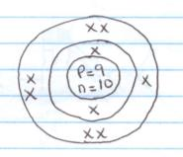

d) 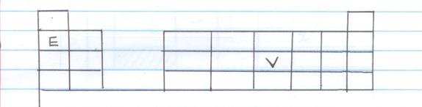

d) E 2.1 F 2.8.1

E------- group 1, period 2

V------ group (v) period 3.

8. Isotopes.

b) 12C (100-1.1) = 98 -9

RAM = 12 x 98.9 + 14 x 1.1

100 100

= 11.86+0.154

=12.022

9(a) Fractional distillation

b) (i) X- Fractionating column

(ii) Y- Liebig Condenser

c) Liquid A,

It has a lower boiling point

d) To increase the surface area for the condenser.

10. Is hotter than luminous flame

Does not dirtify the apparatus with soot

11( a ) Chromatography

b ) On the diagram

c) (i) A- is a pure substance

(ii) B- is insoluble in the solvent used.

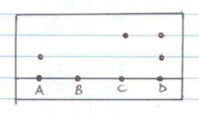d) Diagram

12 (a) M- ---------- 2.8 1mk

P3+ ---------2.8

(b) M (1mk) reacts by gaining(1mk) an electron to attain stability.

(c) M- Period 2 1 mk

P- Period 3 1 mk

Q-Period 4 1 mk

(d) group 7 (1mk) - It has seven (1mk) valence electrons

(e) M-

Q+

(f) MQ (1mk) or KF (reject QM)

(g) N n=24-12=12 1 mk

O n= 26-13 = 13 1 mk

13 (a) Curve II

It has sharp melting and boiling points

(b) The heat supplied (latent heat of fusion) helps to overcome the forces of attraction between the solid particles.

14) Pipette 1 mk

Volumetric flask 1 mk

15(a) Solvent extraction ½ mk each

(b) Sublimation

(c) Simple distillation (reject distillation or fractional distillation)

(d) Using a magnet.

16 (a) Atomic radii increase down the group due to increase in energy level. 1mk

(b) C reacts more vigorously than B

C has larger atomic radius than B thus looses electrons readily

C (g) +2HCL (aq) __________ C CL2 (aq) + H2 (g)

(d) Mg ½ & Ca their uses. (each use ½ mk)

17. a. Valency 2

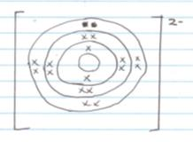 b)

c) H2L

18 (a) Used in respiratory aid for patients with breathing difficulties. 1mk

b) Oxygen is used as ex ethyne flame for welding. 1 mk

C) Liquid oxygen is used to burn the fuel in space rockets.

19. ½ mk each

|  |  |  |
| --- | --- | --- |
| **Name of Indicator** | **Acidic** | **Basic** |
| Phenolphthalein | colourless | Pink |
| methyl orange | pink | yellow |

20. (a) pink 1 mk

b) to condense the vapour forming liquid P 1 mk

c) Using anhydrous copper (II) (1mk) sulphate turns from white to blue 1mk

or

Using anhydrous ( ½ mk) cobalt (II) chloride turns from blue to pink ½ mk

Or

Determining its (½ mk) boiling point. Its 1000c ½ mk

21 (a) PbCO3  1 mk

b) Mg(NO3)2 1 mk