**NAME: ..........................................................................ADM NO:....................**

**CHEMISTRY FORM 2**

**Kenya Certificate of Secondary School**

**TERM: 2 HOURS.**

**INSTRUCTIONS: ANSWER ALL THE QUESTIONS IN THE SPACES PROVIDED**

**FOR EXAMINERS USE ONLY**

|  |  |  |
| --- | --- | --- |
| **QUESTIONS** | **MAXIMUM SCORE** | **CANDIDATE’S SCORE** |
| 1-21 | 80 |  |

1. Define the terms below
2. Atomic number (1mk)
3. Mass number (1mk)
4. An atom can be represented as $\begin{matrix}12 \\ 6\end{matrix}$ W. What do the numbers 12 and 6 represent? (2mk)
5. Differentiate between corrosion and rusting (2mk)
6. Describe how liquid air can be obtained (3mk)
7. Complete and balance the following equations
8. H2(g) + 02(g )-----------------
9. NaOH (aq)+ HCL(aq) ------------------------
10. Name the radicals below
11. PO $\begin{matrix}3- \\ 4\end{matrix}$ (1mk)
12. SO $\begin{matrix}2- \\ 4\end{matrix}$ (1mk)
13. OH- (1mk)
14. The grid below is part of the periodic table , the letters are not actual symbol

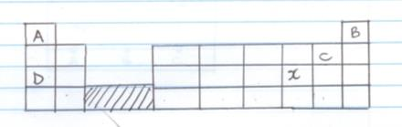

Study it and answer the questions below

1. What do the rows and columns represent?

Rows (1mk)

Columns (1mk)

1. Write the electronic arrangement of element C (1mk)
2. Draw the atomic structure of C (2mk)
3. On the grid show the position of the element with the following electronic arrangement

E=2.1 F=2.8.5 (2mk)

1. (a) Carbon atom can be represented as $\begin{matrix}12 \\ 6\end{matrix}C$ and $\begin{matrix}14 \\ 6\end{matrix}$ C State the name given to such atoms (1mk)

b) Calculate the relative atomic mass of carbon , if atom $\begin{matrix}14 \\ 6\end{matrix}$ C has relative abundance of 1.1% (3mk)

1. The set up below was used to separate liquid A (boiling point of 78oC) and liquid B (boiling point 100oC) mixture

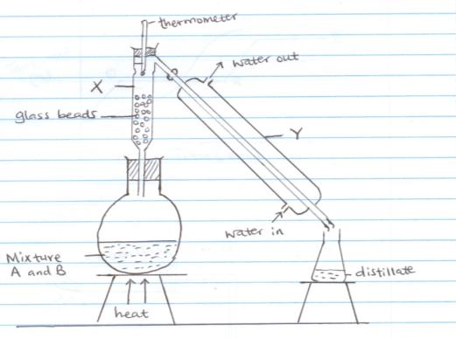

1. Name the process shown above (1mk)
2. Name the apparatus labelled
3. X (1mk)
4. Y (1mk)
5. Which liquid was collected first as the distillate? Give a reason for your answer. (2mk)
6. State the role of glass beads. (1mk)
7. State two reasons why non luminous flame is used in the laboratory instead of the luminous flame. (2mk)
8. The diagram below shows chromatograms for substances A, B and C

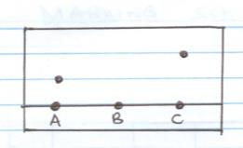

1. Name the technique used to separate the substances above. (1mk)
2. Show the solvent front on the diagram above. (1mk)
3. What does the chromatogram indicate about
4. Substance A (1mk)
5. Substance B (1mk)
6. Substance D contains substances A and C. Show the chromatogram of D on the diagram (2mk)
7. Study the following table below and answer the questions that follows ( The letters do not represent the actual symbols of the element)

|  |  |  |
| --- | --- | --- |
| Atom | Atomic Number | Mass Number |
| M | 9 | 19 |
| N | 12 | 24 |
| O | 13 | 26 |
| P | 13 | 27 |
| Q | 19 | 39 |
|  |  |  |
|  |  |  |

1. What is the electronic configuration of Ion of M and P (2mk)

M

P

1. Identify the non metallic element. Give a reason (2mk)
2. To which period do the following elements belong?
3. M
4. P
5. Q
6. Giving a reason state the group to which element M belong. (2mk)
7. Write the formulae of the most stable ions of M and Q (2mk)
8. Write the formula of the compound formed between element M and Q (1mk)
9. Give the number of neutrons in the following atoms (2mk)

N

O

1. The curves below represents variations of temperature with time when samples of solids were heated separately

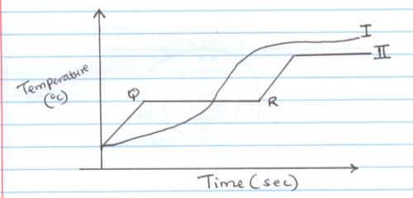

1. Which curve shows the variation of temperature for a pure solid? Explain (2mk)
2. Explain why the temperature does not rise between QR. (1mk)
3. Name two apparatus used to measure fixed accurate volume of liquids in the laboratory (2mk)
4. Name the most suitable method used to obtain the following substances from their mixture (2mk)
5. Oil from nuts
6. Ammonium Chloride from sodium chloride
7. Salt from salty water
8. Iron filings from sand
9. Element B and C belong to the second group of the periodic table. Element B is above C in the group
10. How does their atomic radii compare? Explain? (2mk)
11. How does reactivity of these elements with dilute acids compare. Explain(2mk)
12. Write an equation for the reaction between element C with dilute hydrochloric acid (1mk)
13. Name two elements which belong to group II and state their uses.(2mk)
14. The atom of element L has electronic configuration of 2.8.6
15. What is the valency of L (1mk)
16. Draw the structure of the ion formed by L (2mk)
17. Write the formulae of the compound formed between element L and hydrogen (1mk)
18. State two industrial uses of oxygen gas (2mk)
19. Fill in the colour of the following indicators in audit and basic solution (2mk)

|  |  |  |
| --- | --- | --- |
| Name of Indicator | Acidic | Basic |
| Phenolphthalein |  |  |
| Methylorange |  |  |

1. Study the set up below and answer the questions that follow

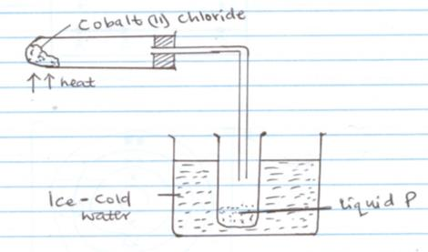

1. What is the colour of hydrated cobalt (II) Chloride (1mk)
2. What is the use of ice cold water (1mk)
3. How can liquid P be confirmed to be water (1mk)
4. Write the chemical formulae of the following compounds
5. Lead(II) carbonate (1mk)
6. Magnesium nitrate (1mk)