**NAME …………………………………………………………ADM………….CLASS………………..**

**ANESTAR SCHOOLS**

**233**

**CHEMISTRY**

**FORM 3**

**TERM 1 EXAM 2020**

**TIME: 1¼ HOURS**

***Answer all questions on the space provided.***

1. Table below gives information on four elements represented by letters A, B, C and D.

Study it and answer the questions that follows. The letters do not represent the

actual symbols of the element.

|  |  |  |  |
| --- | --- | --- | --- |
| **Element** | **Electronic Configuration** | **Atomic radius (nm)** | **Ionic radius (nm)** |
| A  B  C  D  E | 2:8:2  2:8:7  2:8:8:1  2:8:8  2:8:8:2 | 0.136  0.099  0.203  0.09  0.174 | 0.065  0.181  0.133  0.099 |

1. Which two elements have similar chemical properties? Explain. (2mks)
2. What is the most likely formula of the oxide of B. (1mk)
3. Which of the element is the most reactive. (2mks)

i) Metal

ii) Non metal

1. Explain why the ionic radius of B is larger than its atomic radius. (2mk)
2. Give the chemical family to which the following elements belong (2mks)

i) A and E

ii) D

f) Select a letter which represent a monoatomic gas. (1mk)

g) Write an equation for reaction between E and B. (2mks)

2. a) State Charles law. (1mk)

b) Nitrogen gas occupies a volume of 750cm3 at 570C. at what temperature in degrees will it occupy 100cm3 (3mks)

c) State Graham’s law. (1mk)

d) If it takes 60 seconds for 200cm3 of carbon(iv) oxide to diffuse across a porous plate. How long will it take 300cm3 of Nitrogen (iv) oxide to diffuse across the same plate under similar condition? (3mks)

e) A compound weighing 42grammes was found to contain 12g of magnesium, 6g of carbon and the rest oxygen. Determine the empirical formula of the compound (C= 12, Mg= 24, O =16) (3mks)

(c=12, O = 16, H = 1)

f) An Organic compound has a relative formula mass of 90g. A 7.5g sample contains 3g of C, 0.5g of H and 4g O. Determine its molecular formula. (3mks)

3. a) When dilute sulphuric acid is added to marble chip reaction starts then stops immediately explain this observation. (2mks)

b) In Kenya, sodium carbonate is extracted from trona at lake Magadi.

i) Give the formula of trona. (1mk)

ii) Name the process of extracting sodium Carbonate from trona. (1mk)

c) Flow chart below summarizes steps involved in production of sodium carbonate. Use it to answer questions that follows.

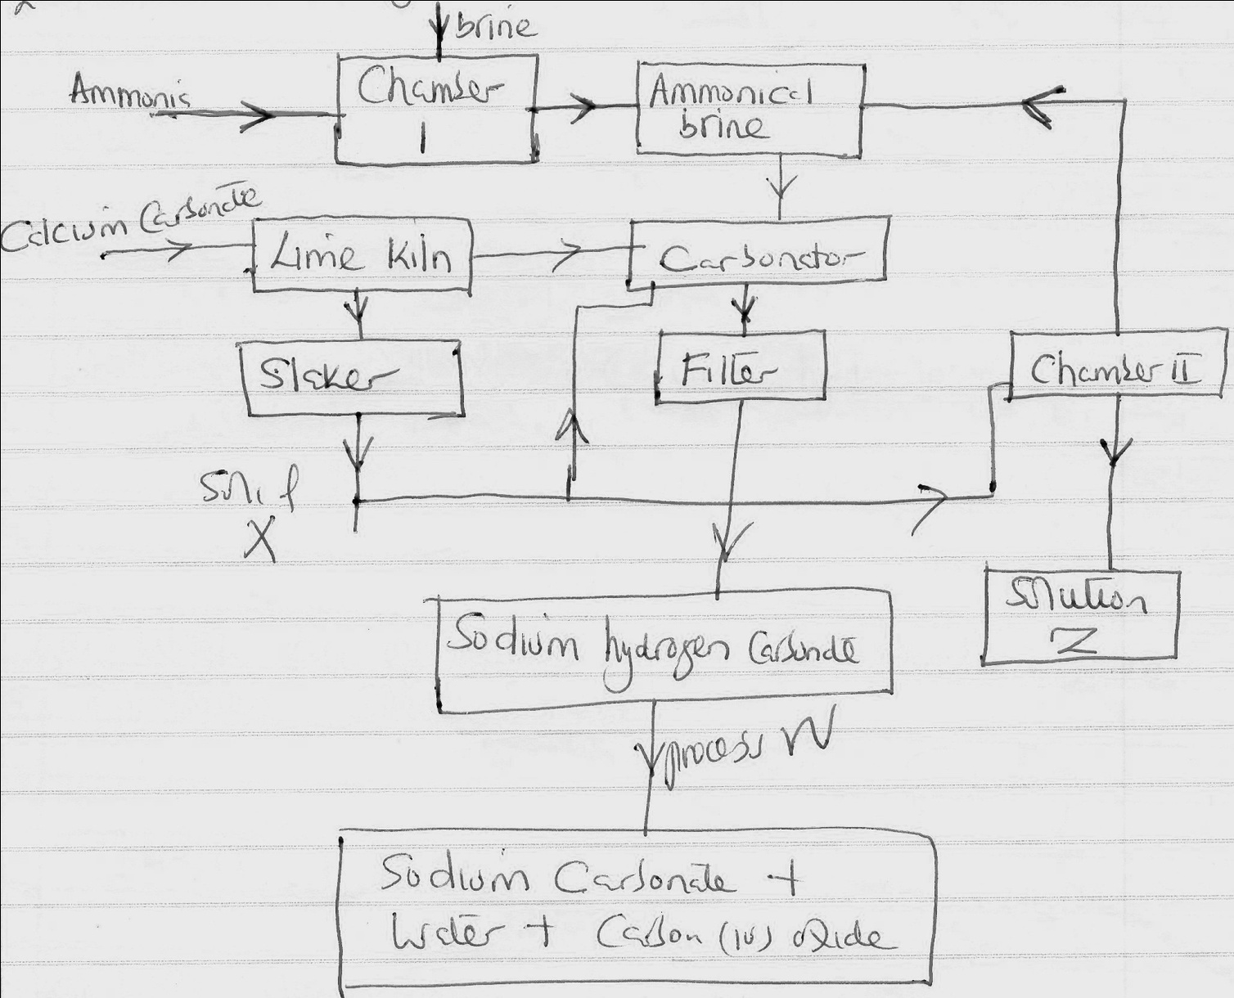

i) Name the process illustrated above. (1mk)

ii) Identify the starting raw material required in production of sodium carbonate. (2mks)

iii) Write equations of the two reactions that occurs in the carbonator. (2mks)

iv) Name two substances recycled in solvay process. (1mk)

v) Identify ; solid X (1mk)

;Process W (1mk)

vi) Write an equation for the reaction that produces solution Z. (1mk)

4. a) Write an equation for the following reactions.

i) Solution of lead (ii) lead Nitrate reacting with ammoniam sulphate. (2mk)

ii) Magnesium reacting with dilute hydrochloric acid. (2mks)

b) You are provided with zinc powder and dilute nitric acid. Describe how a solid sample of zinc nitrate can be prepared in the lab. (3mks)

c) Write a chemical equation for the action of heat on the following salts. (1mk)

i) Silver Nitrate. (1mk)

ii) Sodium hydrogen carbonate. (1mk)

iii) Lead (ii) Carbonate. (1mk)

iv) Lead (ii) Nitrate. (1mk)