**233**

**CHEMISTRY**

**2019 MID-TERM 2 EXAM**

Form 1

2019 MID-TERM 2 EXAM

**MARKING SCHEME**

**FORM 1 CHEMISTRY**

**2019 MID-TERM 2 EXAM**

**MARKING SCHEME**

1. (a) chemistry is the study of the structure, properties and composition of matter and the changes that matter undergoes. √1

(b) (i) Matter is anything that has mass and occupies space. √1

(ii) Mixture consists of two or more substances mixed together with the individual components forming the mixture retaining their physical and chemical properties. √1

1. -A solid has definite shape that is not easily changed while a liquid take the shape of the container. √1

-Solids have no ability to flow while liquids are able to flow. √1

1. (a) A drug is any substance natural or manufactured which when used alters the way the body functions. √1

(b) Addiction √1

-Dependency √1

-mental disorder

***Any two correct***

(c) (i) $\frac{24}{3}$ =8hrs√1

The student is to take 2tablets after every 8hrs. √1

(ii) 7:00hrs

8:00

15:00hrs √1

8:00

23:00hrs √1

1. –manufacture of drugs to fight diseases. √1

* Food production to fight hunger. √1
* Manufacture of detergents. √1\

|  |  |
| --- | --- |
| Luminous | Non- Luminous |
| Flame is not noisy  Yellow flame  Produces soot  Large and wavy | Flame is noisy √1  Blue flame √1  Does not produce soot √1  Small and steady √1 |

***Any 4 correct***

1. (a) -portable burner √1

-gas stove √1

- candle

***Any 2 correct***

(b) – Easy to clean √1

- for easy making of observation since the apparatus are transparent √1

- do not react with most reagents used in the laboratory √1

(c) (i) Burette √1

Syringe √1

Pippete √1

Volumetric flask √1

(ii) Weighing balance/ electrical balance √1

(iii) Thermometer √1

1. Never smell gases directly instead waft the gas towards the nose with your hand.

Incase of accident such as fire calmly walk out

Label all the chemicals you are using to avoid confussion

Always consult your teacher before trying any experiment to avoid accidents.

***Any 4 correct***

1. 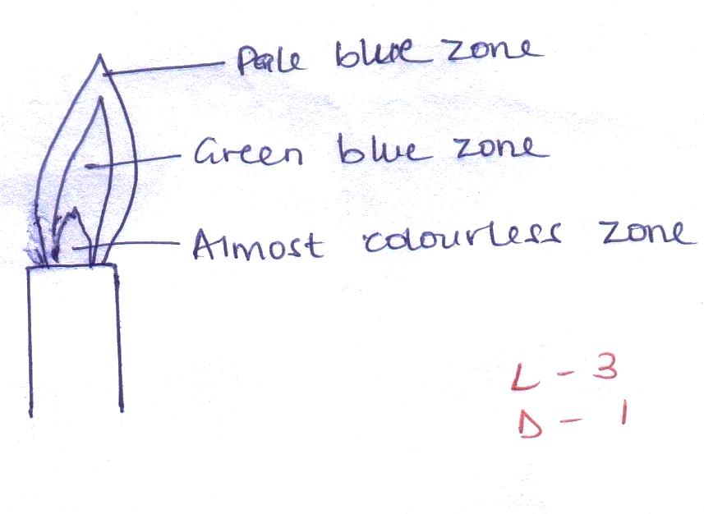
2. (a) Base √1

Chimney √1

Collar √1

(b) Base – provides support √1

Chimney- ensures that gas and air mix before they start burning at the upper end of the chimney. √1

Collar- helps to regulate the amount of air entering the chimney. √1

1. (i) Round bottomed flask √1

Used when heating liquid substances because heat is supplied uniformly so that the flask does not crack as it expands. √1

(ii) Thistle funnel

Used for delivering liquid substances

(iii) Pippete

Used to measure accurate volume

(iv) Deflagrating Spoon

Used for holding substances being burned

1. (a) a flame is a mass of burning gases √1

(b) (i) (a) almost colorless √1

(b) pale blue zone √1

(ii) W is partly burnt because the wooden splint was placed on the cooler regions of e flame √1 while Y was burnt uniformly because the flame at that region is hotter. √1

(iii) Non- Luminous flame √1

1. (a) A- conical flask √1

C- filter paper √1

D- Beaker √1

(b) Filtration √1

(c) (i) Filtrate is the liquid that passes through the filter paper √1 while residue is the solid that remains on the filter paper when filtering. √1

(ii) Filtrate- Liquid P √1

(ii) Residue- solid K √1

(d) They are immiscible substances √1

1. (a) Fractional Distillation √1

(b) (i) Thermometer √1

(ii) Fractionating Column √1

(iii) Lie- big condenser √1

(iv) Clamp and stand √1

(v) Tripod stand √1

(c) Are miscible liquids √1

Different but close boiling points √1

(d) To increase the surface area for the condensation of vapour coming from the distillation flask. √1

(e) (i) K √1

(ii)L √1

(f) If the water inlet and outlet are interchanged condensation would not occur efficiently or effectively. √1

(g) Distillate √1

(h) Ethanol and water, propanone and ethanol, propanol and water. √1

***Any 2 correct***