**Name:** …………………………………………………………… **Adm No**: ………………………………

**School:** …………………………………………………………. **Candidate’s Sign**: …………………….

**Date:** ………………………………………………………….

**CHEMISTRY**

**TIME: 2 HOURS**

**2019 MID-TERM 2 EXAM**

*Chemistry*

**FORM 1**

**Chemistry**

**INSTRUCTIONS TO THE CANDIDATES:-**

* Write your **name** and **Admission number** in the spaces provided.
* Answer ***all*** the questions in the spaces provided.
* Mathematical tables and electronic calculators may be used
* All working **MUST** be clearly shown where necessary.

**For Examiner’s Use Only:**

|  |  |  |
| --- | --- | --- |
| **Question** | **Maximum score** | **Candidate’s score** |
| 1-25 | 80 MARKS |  |

1 [a] What is Chemistry? {1mk}

……………………………………………………………………………………………………………………………………………………………………………………………………………………………………

[b] Define the following terms as used in chemistry;

{i}Matters {1mk}

…………………………………………………………………………………………………………………

…………………………………………………………………………………………………………………

{ii}Mixture {1mk}

……………………………………………………………………………………………………………………………………………………………………………………………………………………………………

2. Explain how you would distinguish a solid from a liquid {2mks}

…………………………………………………………………………………………………………………………………………………………………………………………………………………………………………………………………………………………………………………………………………………………………………………………………………………………………………………………………………

3 {a} what is a drug {1mk}

……………………………………………………………………………………………………………………………………………………………………………………………………………………………………

{b} State two long term effects of drug abuse to the user {2mks}

………………………………………………………………………………………………………………………………………………………………………………………………………………………………………………………………………………………………………………………………………………………

{c} A form one student went to the school clinic and was prescribed malarial drugs to take 2 x3

i} Explain how the student was supposed to take the drugs {2mks}

………………………………………………………………………………………………………………………………………………………………………………………………………………………………………………………………………………………………………………………………………………………

{ii} Supposing the student took the drugs at 7.00a.m in the morning. Calculate the other hours of the day when he is expected to take the other drugs {2mks}

…………………………………………………………………………………………………………………………………………………………………………………………………………………………………………………………………………………………………………………………………………………………………………………………………………………………………………………………………………

………………………………………………………………………………………………………………………………………………………………………………………………………………………………………………………………………………………………………………………………………………………

4. State three ways in which chemistry has helped improve living standards in the society {3mks}

………………………………………………………………………………………………………………………………………………………………………………………………………………………………………………………………………………………………………………………………………………………

…………………………………………………………………………………………………………………

5. State any four difference between luminous and non-luminous flame {4mks}

|  |  |
| --- | --- |
| **Luminous** | **Non-luminous** |
|  |  |
|  |  |
|  |  |
|  |  |

6. {a} Other than Bunsen burner name two other apparatus that are used in heating substances in

the laboratory {2mks]

………………………………………………………………………………………………………………………………………………………………………………………………………………………………………………………………………………………………………………………………………………………

{b} Most of the laboratory apparatus are made of glass. Give three reasons {3mks}

……………………………………………………………………………………………………………………………………………………………………………………………………………………………………………………………………………………………………………………………………………………………………………………………………………………………………………………………………………………………………………………………………………………………………………………………

{c} Name the apparatus used to measure the following;

{i} Accurate volume of liquids {three apparatus } {3mks}

……………………………………………………………………………………………………………………………………………………………………………………………………………………………………………………………………………………………………………………………………………………………………………………………………………………………………………………………………………………………………………………………………………………………………………………………

{ii} Amount of solid [one] apparatus {1mk}

……………………………………………………………………………………………………………………………………………………………………………………………………………………………………

{iii} Temperature of boiling water [one]apparatus {1mk}

………………………………………………………………………………………………………………………………………………………………………………………………………………………………………………………………………………………………………………………………………………………

7. Putting off flames not in use is one of the safety rules of laboratory to avoid injuries. List four other

safety rules applied {4mks}

…………………………………………………………………………………………………………………………………………………………………………………………………………………………………………………………………………………………………………………………………………………………………………………………………………………………………………………………………………

8. Draw and label a non-luminous flame {4mks}

9. {a} Name three major parts of bursen burner {3mks}

…………………………………………………………………………………………………………………………………………………………………………………………………………………………………………………………………………………………………………………………………………………………………………………………………………………………………………………………………………

{b} State the functions of each of the part named in {a} above {3mks}

………………………………………………………………………………………………………………………………………………………………………………………………………………………………………………………………………………………………………………………………………………………

…………………………………………………………………………………………………………………

10. The diagrams below are some common laboratory apparatus. Name each apparatus and state its use

{8mks}

|  |  |  |  |
| --- | --- | --- | --- |
|  | **APPARATUS** | **NAME** | **USE** |
|  |  |  |  |
|  |  |  |  |
|  |  |  |  |
|  |  |  |  |

11 {a} What is a flame {1mk}

……………………………………………………………………………………………………………………………………………………………………………………………………………………………………

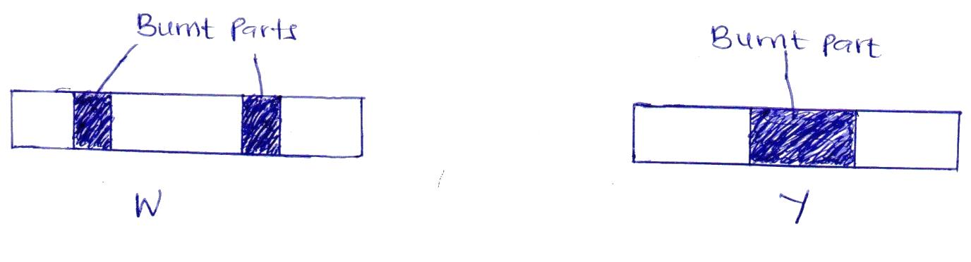{b} Wooden splint W and Y were placed in different zones of a bursen burner flame. The diagram below shows the observations that were made:

{i} State the zone of the flame that made

[a] the observation for W {2mks}

……………………………………………………………………………………………………………………………………………………………………………………………………………………………………

{b} the observation for Y

……………………………………………………………………………………………………………………………………………………………………………………………………………………………………

{ii} Explain the difference between W and Y {2mks}

………………………………………………………………………………………………………………………………………………………………………………………………………………………………………………………………………………………………………………………………………………………

{iii} Identify the most ideal flame used in the experiment above {1mk}

……………………………………………………………………………………………………………………………………………………………………………………………………………………………………

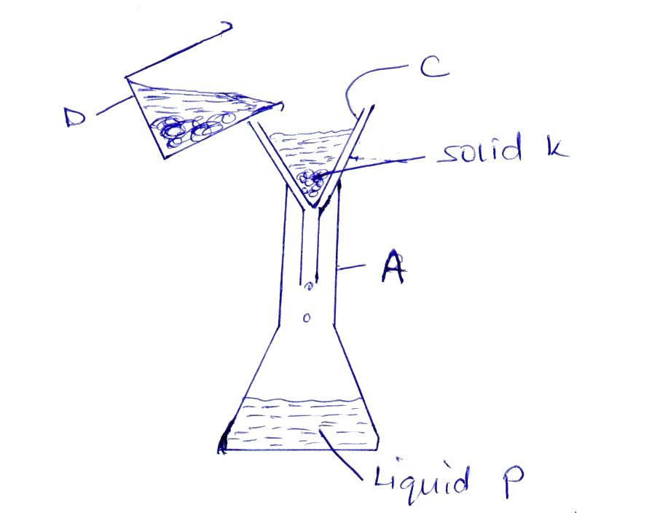12. Study the set-up shown below and answer the questions that follow;’

{a} Name:

Apparatus A {3mks}

…………………………………………………………………………………………………………………

Apparatus C

…………………………………………………………………………………………………………………

Apparatus D

…………………………………………………………………………………………………………………

{b} Name the method of separation shown above {1mk}

…………………………………………………………………………………………………………………

…………………………………………………………………………………………………………………

{c} {i} Distinguish between a filtrate and residue {2mks}

……………………………………………………………………………………………………………………………………………………………………………………………………………………………………

…………………………………………………………………………………………………………………

{ii} Identify them from the set-up above {2mks}

……………………………………………………………………………………………………………………………………………………………………………………………………………………………………

…………………………………………………………………………………………………………………

…………………………………………………………………………………………………………………

{d} Why is it possible to separate the mixture above using the method named in {b} above{1mk}

…………………………………………………………………………………………………………………

…………………………………………………………………………………………………………………

…………………………………………………………………………………………………………………

13. The set-up below was used to separate a mixture of liquid M and N with boiling points of 680C and 780 respectively by the use of method K

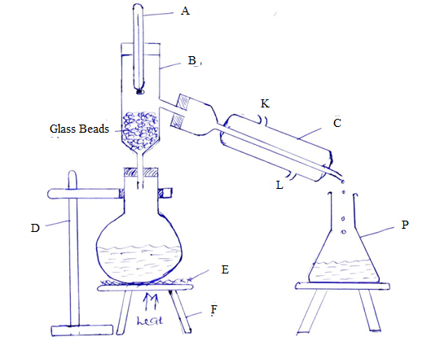

{a} Name the method K {1mk}

…………………………………………………………………………………………………………………

{b} Name the apparatus {5mks}

1. A………………………………………………….........................................................
2. B……………………………………………………………………………………….
3. C………………………………………………………………………………………..
4. D……………………………………………………………………………………….
5. F………………………………………………………………………………………..

{c} State two properties of liquid M and N that makes them possible to separate by method K shown above {2mks}

……………………………………………………………………………………………………………………………………………………………………………………………………………………………………

…………………………………………………………………………………………………………………

{d} State one function of glass beads {1mk}

……………………………………………………………………………………………………………………………………………………………………………………………………………………………………

{e} Which letter represent;

{i} Water outlet in apparatus C {1mk}

…………………………………………………………………………………………………………………

{ii} Water inlet in apparatus C {1mk}

…………………………………………………………………………………………………………………

{f} What is the effect of interchanging the water inlet and water outlet in apparatus C {1mk}

…………………………………………………………………………………………………………………

…………………………………………………………………………………………………………………

{g} What general name is given to the liquid collected in apparatus p {1mk}

…………………………………………………………………………………………………………………

…………………………………………………………………………………………………………………

{h} Give an example of two liquids that can be separated by method K {1mk}

…………………………………………………………………………………………………………………

…………………………………………………………………………………………………………………

*******