**LANGATA HIGH SCHOOL**

**FORM ONE APRIL HOLIDAY ASSIGNMENT**

1. Wooden splints **F** and **G** were placed in different zones of a Bunsen burner flame.

The diagram below gives the observations that were made

**G**

**F**

Burnt parts

Burnt part

1. Explain the difference between **F** and **G**

1. Name the type of flame that was used in the above experiment

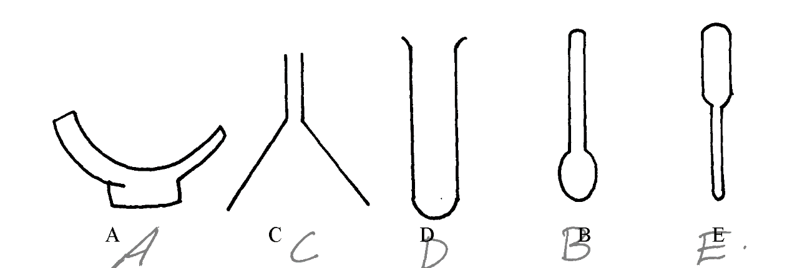2. The diagrams below represent a list of apparatus which are commonly used in a chemistry laboratory: -

**A B C D E**

1. Give the correct order of the apparatus, using the **letters only**, to show the correct arrangement that can be used to prepare and investigate the nature of PH of a sample of onion solution
2. Name **one** chemical substance and apparatus that is needed in this experiment

3. (a) When the air-hole is fully opened, the Bunsen burner produces a non-luminous flame.

Explain

1. Draw a labelled diagram of a non-luminous flame

4. (a) What is a drug?

1. Give **two** drugs that are commonly abused by the youth.

5. A mixture of hexane and water was shaken and left to separate as shown in the diagram below:

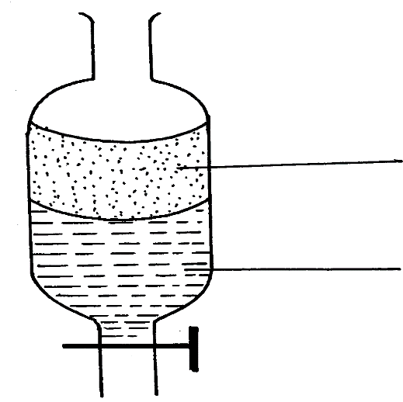

**P**

**W**

State the identity of;

(i) **P** ………………………………..…….. (ii) **W** ………………………………….….

6. The diagrams below are some common laboratory apparatus. Name each apparatus and

state its use

|  |  |  |
| --- | --- | --- |
| **Diagram** | **Name** | **Use** |
|  | (½mk ) | (½mk) |
|  | (½mk) | (½mk) |

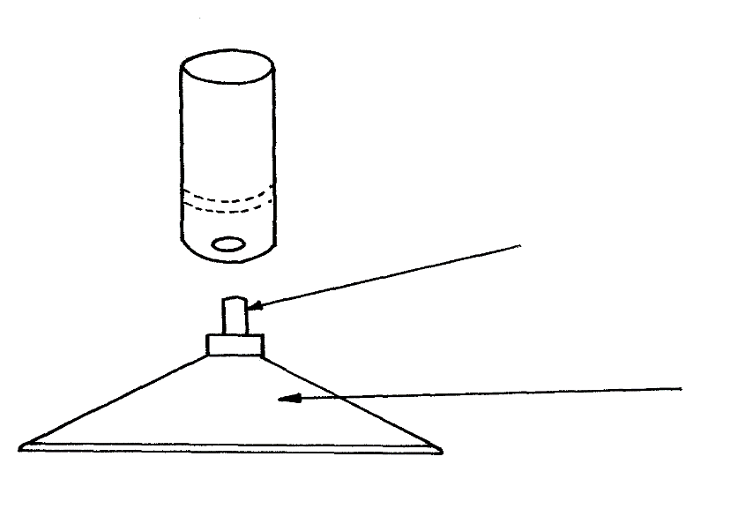7. The diagram below shows some parts of a Bunsen burner

**T**

**U**

Explain how the parts labelled **T** and **U** are suited to their functions

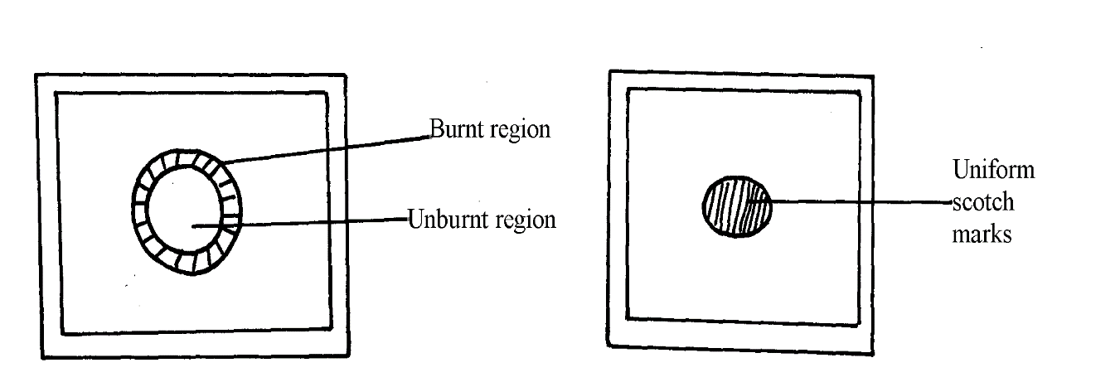8. The diagram below shows the appearance of two pieces of paper placed in different parts of a

non-luminous flame of a Bunsen burner and removed quickly before they caught fire.

1. What do the experiments show about the outer region of the flame?

(b) From the above experiment, which part of the flame is better to use for heating?Give a reason

9. The diagram below represents a paper chromatogram of pure W, X, and Y. A mixture K contains W and Y only. Indicate on the diagram the chromatogram of K. (1mk)

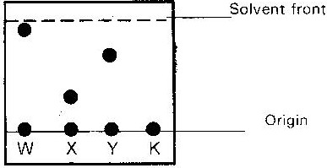

10. Study the information below and answer the question that follows. A mixture contains the solids; Alum camphor and sugar. The solubility of different liquids is shown in the table below.

|  |  |  |  |
| --- | --- | --- | --- |
| solid | | Liquid | |
|  | Water | Ethanol | Ether |
| Alum | Soluble | Insoluble | Insoluble |
| Camphor | Insoluble | Soluble | Very soluble |
| Sugar | Soluble | Soluble | Insoluble |

Explain how you would obtain a sample of solid sugar from the mixture.

11 a) What method can be used to separate a mixture of ethanol and propanol? (1mk)

b) i) Explain how a solid mixture of sulphur and sodium chloride can

be separated into solid sulphur and solid sodium chloride. (4mks)

ii) How can one determine that solid sulphur is pure? (2mks)

12.Name the methods by which the following substances could be separated.

a) Kerosene from crude oil (1mk)

b) Coloured extract from grass dissolved in ethanol. (1mk)

c) Aluminium chloride from sodium chloride. (1mk)

d) Iron fillings from sulphur powder. (1mk)

13. Some Copper (II) sulphate crystals were gently heated in a test tube until no more water was given off.

i) Draw a diagram of the apparatus that could be used to heat the crystals and collect the water given off. (3mk)

ii) State what would be observed if the residue in the test tube is cooled and few drops of water is added to it. (1mk)