**LANGATA HIGH SCHOOL**

**FORM FOUR CHEMISTRY HOLIDAY ASSIGNMENT**

1.In the industrial extraction of lead metal, the ore is first roasted in a furnace. The solid mixture obtained is then fed into another furnace together with coke limestone and scrape iron. State the functions of each of the following in this process.

(a) Coke

(b) Scrape iron

(c) Limestone

2 The flow chart below shows steps used in the extraction of zinc form one of its

Ores.

Zinc carbonate ore

Powdered zinc carbonate ore

Concentrated zinc carbonate ore

Zinc metal

Zinc oxide

Crushing

Step 1

Step 2

Step 3

Heat

Gas

Coke

Step 4

1. Name the process that is used in step 2 to concentrate the ore.

1. Write an equation for the reaction which takes place in step 3

(c) Name one use of zinc other than galvanizing

3.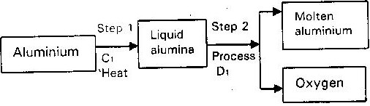During the extraction of aluminium from its ores; the ore is first purified to obtain alumina. The flow chart below shows the stages in the extraction of aluminium from alumina.

(a) Name

(i) Substance C1

(ii) Process D1

(b) Give two reasons why aluminium is used extensively in making of cooking pans

4.The flow chart below outlines some of the process involved in extraction of copper from pyrites. Study it and answer the questions that follows

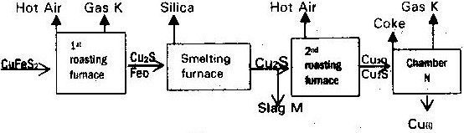

(a)

(i) Name gas “k”

(ii) Write an equation for the reaction that take place in the 1st roasting furnace

(iii) Write the formula of the cations present in the slag “M”

(iv) Identify gas “P”

(v) What name is given to the reaction that take place in chamber N. Give a reason for your answer?

(b) The copper obtained “M” is not pure. Draw a labeled diagram to show the set up you would use to refine the copper by electrolysis.

(c) Give two effects that this process could have on the environment

5. The flow chart below illustrates the industrial extraction of lead metal. Study it and answer the questions that follows

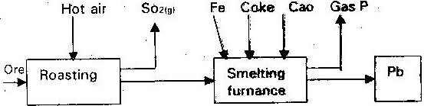

(a) (i) Name the ore that is commonly – used in this process

(ii) Explain what take place in the roasting furnace

(iii) Identify gas “p”

(iv) Write the equation for the main reaction that takes place in the smelting furnace

(v) Give two environmental hazards likely to be associated with extraction of lead

(vi) What is the purpose of adding iron in the smelting furnace?

(b) Explain why hard water flowing in lead pipes may be safer for drinking them soft water flowing in the same pipes

(c) State one use of lead other than making lead pipes

6. The raw material for extraction of aluminum is bauxite.

(a) Name the method that is used to extract aluminium from bauxite

(b) Write the chemical formula for the major components of bauxite

(c) (i) Name the major impurities sin bauxite

(ii) Explain how the impurities in bauxite are removed )

(d) Crayolite is used in the extraction of aluminium from bauxite. State its function

(e) Describe how carbon (IV) oxide is formed during the extraction of aluminium

(f) Aluminum is a reactive metal yet utensils made from aluminium do not corrode easily. Explain this observation

7. The extraction of iron from its ore takes place in the blast furnace. Below is a simplified diagram of a blast furnace. Study it and answer the questions that follow.

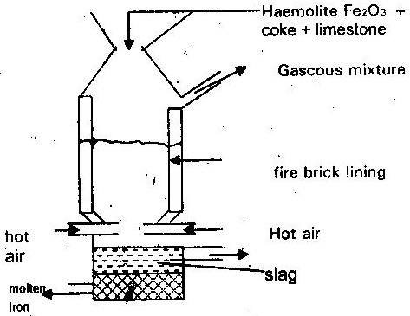

(a) (i) One of the substances in the slag

(ii) Another iron ore material used in the blast furnace

(One gas which is recycled)

(b) Describe the process which leads to the formation of iron in the blast furnace

(c) State the purpose of limestone in the blast furnace

(d) Give a reason why the melting point of iron obtained from the blast furnace is 12000 while that of pure iron is 15350C

(e) State two uses of steel

8.The curves below represents the changes in the concentrations of substances “E” and “F” with tie in the reaction

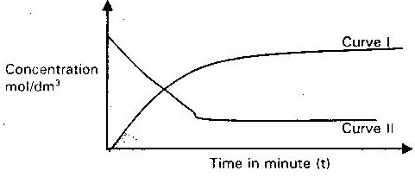

(i) Which curve represents the change in the concentration of substance F? Give a reason

(ii) Give a reason for the shapes of the curves after t minutes

9.The curves shown below were obtained when two equal volumes of hydrogen peroxide of same concentration were allowed to decompose separately in one case, manganese (IV) oxide was added to hydrogen peroxide.

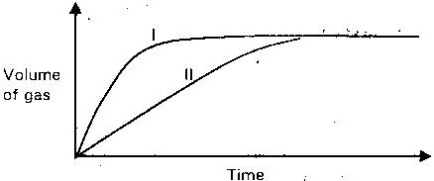

Which curve represents the decomposition of hydrogen peroxide with manganese (IV) oxide? Explain

10.State and explain how the rate of reaction between zinc granules and steam can be increased.

11.The table below gives three experiments on the reaction of excess sulphuric acid and 0.5g of zinc done under different condition. In each case the volume of gas was recorded at different time internals.

|  |  |  |
| --- | --- | --- |
| Experiment | Term of zinc | Conclusion of sulphuric acid |
| I | Powder | 0.8m |
| II | Powder | 1.0m |
| III | Granules | 0.8m |

On the same axis draw and label the three curves that could be obtained from such results

12.In an experiment to determine the heat of combustion of methanol (CH3OH) a student used a set up like the one shown in the diagram below. Study the set- up and the data below it and answer the questions that follows

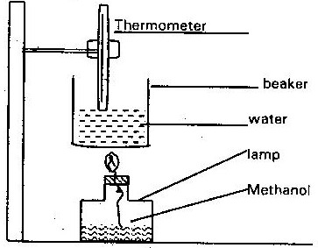

Volume of water = 500cm3

Final temperature of water = 27.00C

Initial temperature of water = 20.00C

Final mass of lamp + methanol = 22.11g

Initial mass of lamp + methanol = 22.98g

Density of water = 1.0/ cm3

Heat change = mass x temperature x 4.2j/g/C

1. Write an equation for the combustion of methanol

(b) Calculate

(i) The number of moles of methanol used in the experiment (C=12), (O= 16) (H=1)

(ii) Heat change in this experiment

(iii) The heat of combustion per mole of methanol

1. Explain why the value of molar heat of combustion for methanol obtained the theoretical value.

(d) On the axis below sketch an energy diagram for the combustion of methanol

Energy

Reaction path