**NAME** …………………………………………………………. **INDEX NO** ………………….

**SCHOOL** …………………………………………………………… **DATE** ……………………

**CANDIDATE’S SIGNATURE** …………………..

**121/1 MATHEMATICS PAPER 1 FORM 4**

**JULY 2017 TIME: $21/2 HOURS$**

**END OF TERM II EXAMINATION**

**QUESTIONS**

**Kenya Certificate of Secondary Education**

**MATHEMATICS**

**PAPER 1**

**INSTRUCTIONS TO CANDIDATES**

1. Write your name, admission number and school in the spaces provided.
2. This paper consists of two sections; Section I and Section II.
3. Answer ALL the questions in Section I and ONLY FIVE questions in Section II.
4. All answers and working must be written on the question paper in the spaces provided below each question.
5. Show all the steps in your calculations, giving your answer at each stage in the space provided below each question.
6. Marks may be given for correct working even if the answer is wrong.
7. Non programmable silent electronic calculators and KNEC mathematical tables may be used except where stated otherwise.
8. Candidates should check the question paper to ascertain that all pages are printed as indicated and that no questions are missing.

FOR EXAMINORS USE ONLY

SECTION I

|  |  |  |  |  |  |  |  |  |  |  |  |  |  |  |  |  |  |
| --- | --- | --- | --- | --- | --- | --- | --- | --- | --- | --- | --- | --- | --- | --- | --- | --- | --- |
| **Question** | **1** | **2** | **3** | **4** | **5** | **6** | **7** | **8** | **9** | **10** | **11** | **12** | **13** | **14** | **15** | **16** | **TOTAL** |
| **Marks** |  |  |  |  |  |  |  |  |  |  |  |  |  |  |  |  |  |

SECTION II

|  |  |  |  |  |  |  |  |  |  |
| --- | --- | --- | --- | --- | --- | --- | --- | --- | --- |
| **Question** | **17** | **18** | **19** | **20** | **21** | **22** | **23** | **24** | **TOTAL** |
| **Marks** |  |  |  |  |  |  |  |  |  |

**Grand Total**

**SECTION I (50 Marks)**

1. Use square roots, reciprocal and square root tables to evaluate to 4 significant figures the expression; (4 marks)
$${\left(0.06458\right)}^{\frac{1}{2}}+{\left(\frac{2}{0.4327}\right)}^{2}$$

2. Find the equation of the perpendicular bisector of line AB where A is (3, 9) and B (7, 5) giving your answer in the form $ax+by+c=0$. (3 marks)
3. It takes 40 road construction workers 8 days working 10 hours a day to complete a section of a road. How many days would 60 road construction workers working 8 hours a day take to complete the same section of the road working at the same rate? (3 marks)
4. A solid cylinder with radius 7 cm and height 5 cm is melted down and recast into a spherical ball. Calculate to 2 decimal places the radius of the ball. (3 marks)
5. The currency exchange rates of a given bank in Kenya are as follows;

|  |  |  |
| --- | --- | --- |
| Currency | Buying | Selling |
| 1 Sterling pound | 135.50 | 135.97 |
| 1 US dollar | 72.23 | 72.65 |

A tourist arrived in Kenya with 5 000 US dollars which he converted to Kenya shillings. He spent Kshs. 214 500 and converted the remaining to sterling pounds. How many pounds did he receive? (3 marks)

1. Find the value of $n$ in $4^{n+1}+2^{2n+1}=384$. (3 marks)
2. The exterior angle of a regular polygon is ${\left(x-50\right)}^{0}$ and the interior angle is ${\left(2x+20\right)}^{0}$. Find the number of sides of the polygon. (3 marks)
3. Find $x$ if $\cos\left({3x-30}^{0}\right)= \sin\left({7x+50}^{0}\right)$. (2 marks)
4. The figure below shows the motion of a particle in 20 seconds. The particle starts off at a speed of 30 m/s and accelerates at 4 m/s2 for 5 seconds. Calculate the total distance covered by the particle in 20 seconds. (4 marks)

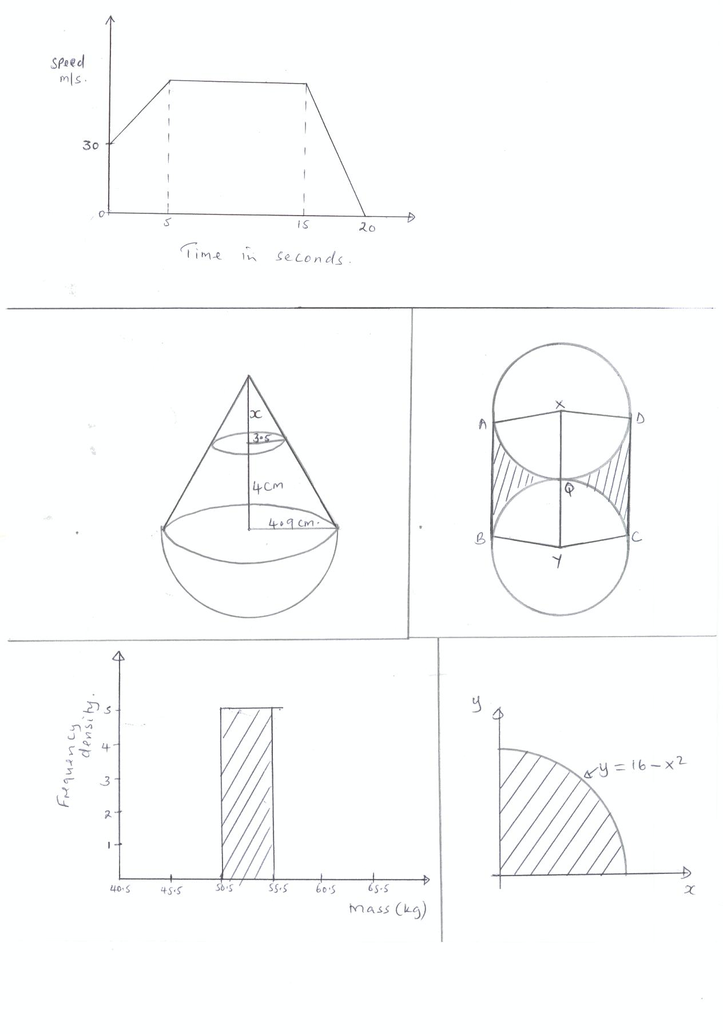

1. Construct triangle PQR such that PQ = 7 cm, QR = 5 cm and $∠RPQ= {30}^{0}$. Construct the locus L1 of all points equidistant from P and Q to meet the locus L2 of points equidistant from Q and R at M. Measure PM. (4 marks)
2. The surface areas of two cylindrical water tanks are 50 m2 and 162 m2 respectively. Given that the volume of water in the second tank is 36 450 cm3, find the volume of water in the first tank if it’s half full. (4 marks)
3. Solve the inequalities below and represent the solutions on a single number line. (3 marks)

$1-2x<5, 5-3x≥-10.$

1. From the roof of a house, a boy can see an avocado tree which is 20 m away from the house. He measures the angle of elevation of the top of the tree as 210 and the angle of depression of the bottom of the tree as 310. Find the height of the avocado tree. (3 marks)
2. Simplify (2 marks)
$$\sqrt[2]{\frac{12 x^{4}y^{-1}z^{5}}{3x^{-2}y^{-3}z^{3}}}$$

3. The position vector of **p** and **q** is $3i-2j+k$ and $2i+j-3k$ respectively. Determine the column vector PQ and hence calculate its length to 2 decimal places. (2 marks)
4. The table below shows the height of 50 bean plants, six weeks after planting.

|  |  |
| --- | --- |
| Height (h) in cm | Cumulative frequency |
| $$h≤4$$ | 4 |
| $$h≤8$$ | 15 |
| $$h≤12$$ | 31 |
| $$h≤16$$ | 44 |
| $$h≤20$$ | 50 |

Estimate the mean height of the seedlings. (4 marks)

**SECTION II (50 Marks)**

**Answer any five questions in this section in the spaces provided.**

1. A trader sold an article at Ksh. 4 800 after allowing a customer a 12% discount on the marked price of the article. In so doing he made a profit of 45%.
2. Calculate to 2 decimal places;
3. The marked price of the item. (3 marks)
4. Price at which the trader had bought the article. (2 marks)
5. If the trader had sold the same article without giving a discount, calculate the percentage profit he would have made. (3 marks)
6. To clear his stock, the trader decided to sell all the remaining articles at a loss of 12.5%, calculate the price at which he sold each article. (2 marks)
7. The diagram below represents a solid consisting of a hemispherical bottom and a conical frustum at the top.



1. Determine the value of $x$ and hence the height of the big cone. (2 marks)
2. Calculate the surface area of the solid. (4 marks)
3. Calculate the volume of the solid. (4 marks)
4. (a) Find the equation of a straight line L1 that passes through the points P $(-6, -3)$ and Q $(1, 3)$ in the form $ay+bx=c$ where a, b and c are constants. (2 marks)

(b) A second line L2 is parallel to L1 and passes through $(2, -3)$. Find the equation of L2 in the form . (2 marks)

(c) A third line L3 passes through $(2, 3)$ and is perpendicular to L1. Find the equation of L3 in the form $ay+bx=c$. (2 marks)

(d) Use matrix method to find the coordinates of R the point where L1 and L3 intersect. (4 marks)

1. A factory blends three types of juice in the ratios $A:B = 3:4$ and $B:C = 1:2$
2. Determine;
3. The ratio $A:B:C$ (1 mark)
4. The amount of type A juice in a 20 litre mixture. (2 marks)
5. The cost of producing one litre of A is Ksh. 80, one litre of B is Ksh. 84 and one litre of C is Ksh. 90.
6. Find the cost of producing one litre of the mixture. (2 marks)
7. Calculate the selling price of one litre of the mixture if the factory makes a profit of 25%. (2 marks)
8. The factory uses types of machines P and Q to blend the juices. Machine P takes 7 hours to blend 14 000 litres and Q takes 5 hours to blend 12 000 litres. Determine the time it would take the factory to blend 550 000 litres. (3 marks)
9. A motorist is to follow the route ABCD. B is 250 km from A on a bearing N750E from A. C is on a bearing of S750E from A and 275 km from B. D is 300 km on a bearing of S800E from B. using a scale 1 cm to represent 50 km;
10. Show the relative position of ABCD. (4 marks)
11. Determine;
12. The distance of A from C. (2 marks)
13. The bearing of B from C. (1 mark)
14. The distance of A from D. (2 marks)
15. The compass bearing of C from D. (1 mark)
16. Two towns P and Q are 550 km apart. A bus starts from town Q and travels towards P at $8:45$ a.m. at an average speed of 80 km/hr. A car starts from P towards Q at $10:00$ a.m. at an average speed of 100 km/hr. Calculate:
17. The distance covered by the bus before the car starts its journey. (2 marks)
18. How far from Q the vehicles met. (3 marks)
19. The time the two vehicles met. (2 marks)
20. The time the car arrived at town Q. (3 marks)
21. Triangle $ABC$ has vertices A (1, 2) B (2, 3) and C (4, 1) while triangle $A'B'C'$ has vertices $A’$ (1, -2) $B’$ (2, -3) and $C’$ (4, -1).
22. Draw triangle $ABC$ and $A'B'C'$ on the same grid. (2 marks)
23. Describe fully a single transformation that maps $ABC$ onto triangle $A'B'C'$ (2 marks)
24. On the same grid, draw triangle $A''B''C''$ the image of $ABC$ under a reflection in the line $y = -x$. (2 marks)
25. Draw triangle $A'''B'''C'''$ such that it can be mapped onto triangle ABC by a negative quarter turn about the origin. (2 marks)
26. Find the matrix of transformation that maps triangle ABC onto triangle $A'''B'''C'''$. (2 marks)
27. An investment group decided to raise Shs. 960 000 to buy a piece of land costing Kshs. 80 000 per hectare. Before they paid, four of them pulled out and those that remained were supposed to pay an additional Kshs. 40 000.
28. If the initial number of members was $x$, write down;
29. An expression of what each was to contribute originally. (1 mark)
30. An expression of what each of remaining members contributed. (1 mark)
31. Calculate the number of members who were initially in the group using the expression in (a) above. (5 marks)
32. If the land was sub divided equally, calculate what size each member got. (3 marks)