NAME: …………………………………………. INDEX NO: ……………………………….

SCHOOL: ……………….……………………… DATE : ……………………………………..

CANDIDATE’S SIGNATURE:……………………

NAIROBI COUNTY JOINT EXAMS-2018
Kenya Certificate of Secondary Education (KCSE)
MATHEMATICS
PAPER 1
TIME: 2½ HOURS

INSTRUCTIONS TO CANDIDATES
- Write your Name and Index Number in the spaces provided at the top of this page.
- Sign and write the date of examination in the spaces provided above.
- This paper contains TWO sections: section I and section II
- Answer all the questions in Section I and any FIVE questions from section II.
- All answers and working must be written on the question paper in the spaces provided below each question.
- Show all the steps in your calculations, giving your answers at each stage in the spaces provided below each question.
- Marks may be given for correct working even if the answer is wrong.
- Non-programmable silent electronic calculators and KNEC mathematical tables may be used except where stated otherwise.
FOR EXAMINER’S USE ONLY:
Section I
1 | 2 | 3 | 4 | 5 | 6 | 7 | 8 | 9 | 10 | 11 | 12 | 13 | 14 | 15 | 16 | TOTAL

Section II GRAND TOTAL
17 | 18 | 19 | 20 | 21 | 22 | 23 | 24 | TOTAL

SECTION 1: (50 MARKS)
Attempt ALL Questions in this section
- Evaluate: (3mks)
8 x ⅓ of 9 ÷ 2
(12+2x3) - ⅔ of 144 ÷ 12

- The prime numbers less than 10 are multiplied to form a number.
  - Write down the number formed. (2mks)

  - State the total value of the first digit in the number formed in 2(a) above. (1mk)

- A rhombus A B C D with its side 15cm and diagonal AC = 24cm. Find the other diagonal BD.
(2mks)

- The figure below is a regular hexagon. O is the centre and M is the mid point of AB.
B

M O
D
A
N
F E
Find angle: (i) EFD (1mk)

(ii) MNF (2mks)

- Simplify the expression: (4mks)
4x² – xy – 3y²
32x² – 18y²

- A pool of water with surface area of 0.8ha has a uniform depth of 4m. A pipe drains the pool at the rate of 400 litres per second. How many hours does it take to empty the pool? (2mks)

- Evaluate, giving your answer to 1s.f figure: (3mks)
0.0065 x 6.48

0.27

- In a class of boys and girls, the probability of selecting a girl at random is 2/5. given that there are 18 boys in the class, calculate:-
  - The number of students in the class. (1mk)

  - The probability of choosing at random two students of the same sex. (2mks)

- Solve the simultaneous inequality given below and represent the solutions on a number line. 2x + 3 > x – 4 > 3 (x – 2) (4mks)

- The travel timetable below shows the departure and arrival time for a bus plying between two towns M and R, 300 kilometres apart.
TOWN ARRIVAL DEPARTURE
M 0830h
N 1000h 1020h
P 1310h 1340h
Q 1510h 1520h
R 1600h
Calculate the average speed for the whole journey. (3mks)

- Simplify the following expression without using tables or calculator: (3mks)
4 cos 60⁰ + 16 cos²45 + 2 sin 30
Sin²45

- Given that PQ = 9 and OQ = 3 , determine:
2 -4
OP and find the magnitude of OP giving your answer in surd form. (3mks)

- A tourist arrived from USA and changed his US $1500 TO Ksh. He spent Ksh. 3000 per night in a hotel for 20 nights and a further Ksh. 9000 daily for the entire period. He left for South Africa having changed the balance to South African Rand.
Calculate the amount of South African Rands he left with, if the bank buys and sells currencies using the table below.
Currency | Buying | Selling
1 US Dollar ($)  1 Sterling Pound (£)  1 South African Rand | 78.4133  114.1616  7.8842 | 78.4744  114.3043  7.9141

- Two similar containers can hold 1000ml and 8 litres of water respectively. The larger has a surface area of 800cm². Find the surface area of the smaller container. (3mks)

- The diagram below represents a parallelogram. Calculate the area of the shaded region.
(2mks)
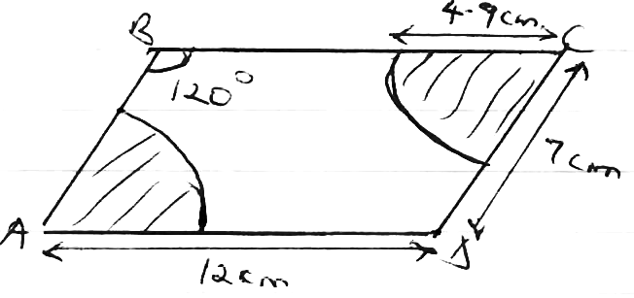

- A flag post 10m long is fixed on top of a tower. From a point on horizontal ground, the angle of elevation of the top of flag post is 40⁰ and the angle of depression from the bottom of the flag post is 33⁰. Taking 1cm represent 2m, determine by scale drawing the height of the tower. (4mks)

SECTION II (50 MARKS)
Answer any five questions in this section

- A group of choir members decided to raise 3600/= to buy a guitar. Each member was to contribute equal amount. In the preparation process five members transferred to another church, that meant the remaining contributors had to pay more to achieve the target.
  - Show that the increase in the contribution per member was:
Sh. 18,000 if n is the initial number of members.
n(n-5)

  - If the increase in the contribution per member was sh. 24, what was the original contribution before the other members left?

  - Calculate the percentage increase in the contribution before the others left.

- y

B
x + y = 8

x – y = 6
C

E x
D

A

The diagram above represent Cartesian plane.
Determine the:
- Coordinates of points A. (2mks)

- Coordinates of points C. (3mks)

- If a line passes through the point C and the origin, find the equation of the line. (3mks)

- Coordinates of point D. (1mk)

- Coordinates of point E. (1mk)

- The table below shows the marks scored by form four students in a mathematical test.
Marks | 5<marks<14 | <24 | <34 | <54 | <64 | <84 | <94
Frequency | 3 | 10 | 22 | 72 | 87 | 98 | 100

- State the modal class. (1mk)

- Calculate the mean mark. (3mks)

- Calculate the 70th mark. (3mks)

- Draw a histogram to represent this information. (3mks)

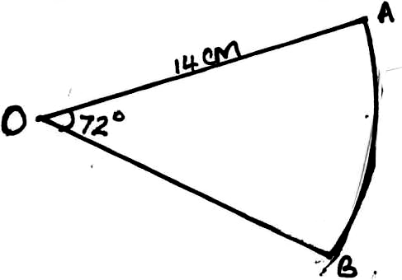
- The figure below shows a sector of a circle. If the radius OA = 14cm and the angle AOB = 72⁰.

  - Calculate the area of the sector. (2mks)

  - The sector is folded to form a cone. Calculate:-
  - The radius of the cone formed. (2mks)

  - The volume of the solid formed. (3mks)

  - A solid cone of same size in (b) above is melted down and casted into circular washers. Each washer has an external diameter of 4cm, internal diameter of 1½ cm and 0.3cm thick. Calculate number of washers made. (3mks)

- A bus left Kisumu for Nairobi at an average speed of 60km/hr. After 1½ hours another car left Kisumu for Nairobi along the same route at an average speed of 100km/h. If the distance between Kisumu and Nairobi is 500km, determine:-
  - (i) The distance of the bus from Nairobi when the car took off. (2mks)

(ii) The distance the car travelled to catch up with the bus. (4mks)

  - Immediately the car caught up with the bus, the car stopped for 25 minutes. Find the new average speed of which the car travelled in order to reach Nairobi at the same time as the bus. (to the nearest whole number). (4mks)

- A metal R is an alloy of two metals X and Y. Metal X has a mass of 70g and a density of 16g/cm³. Metal Y has a mass of 19g and a density of 4g/cm³.

  - Calculate the density of the metal R. (4mks)

- If metal R is divided into two equal parts and each half reinforced by adding metal X to get to initial volume. Find the density of the new alloy. (4mks)

- The two metals are mixed in a ratio of 4:1 respectively. What is the density of the alloy?
(2mks)

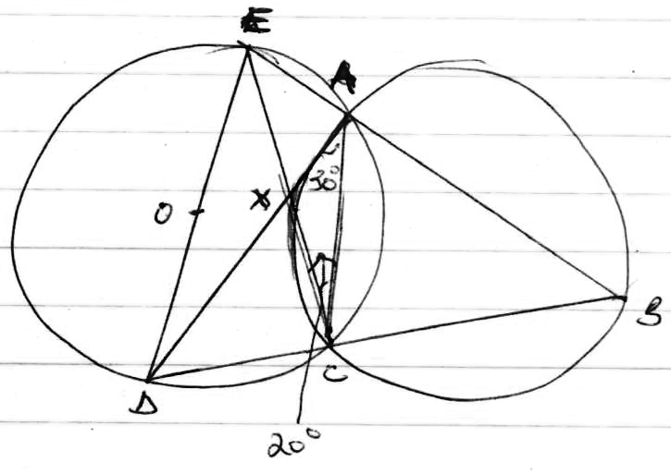
The figure above A B C X and A C D E are cyclic quadrilaterals of two circles intersecting at A and C D E O is a diameter of the circle, angle C A D = 30⁰ and ACE = 20⁰.
Find the following angles, giving reasons for each answer.
- BAC (2mks)

- ABC (2mks)

- CED (2mks)

- ADE (2mks)

- AEC (2mks)

- (a) Draw a regular pentagon PQRST of sides 7cm. On it draw a line AR such that it is a line
of symmetry to the figure. (4mks)

(b) Locate a point M on AR such that M is equidistant from P and Q, hence measure the
shortest distance of M from TS. (2mks)

(c) Shade the region within the figure such that a variable X must lie, given that X satisfies
the following conditions: (4mks)
- X is nearer to PT than to PQ.
- RX is not more than 7.5cm.
- Angle PXT is greater than 90⁰.

