NAIROBI COUNTY JOINT EXAMS-2018
121/2 MATHEMATICS PAPER 2 – MARKING SCHEME

1 | No. Std form Log  (0.0246)² (2.46 x 10⁻²)² 2.3909  x 2  4.7818  142 1.42 x 10² +2.1523  2.9341  0.002 2.0 x 10⁻³ 3.3010  1.14 1.14 x 10⁰ 0.0569  3.3579  2.9341  - 3.3579  1.5762  1.5762  3  3.3527 3.3527 x 10⁰ 0.5254 | M1  M1  M1  A1 | Correct logs addition  Correct  Correct answer
 |  | 04
2 | (3√2 + 5) (3√2 – 5) = 18 – 25 = -7  4(3√2 - 5) - 3(3√2 + 5)  -7  12√2 - 20 – 9√2 – 15  -7  3√2 – 35 = 35 – 3√2  -7 7  Or = 5 – ³/₇√2 | M1  M1  A1
 |  | 03
3 | (2 + ¹/₅x)⁸ = 1x2⁸(¹/₅x)⁰+8x2⁷(¹/₅x)¹ + 28 x 2⁶ x (¹/₅x)²+ 56x2⁵x(¹/₅x)³  = 256 + 1024x + 1792x² + 1792x³  5 25 125  (2 + ¹/₅x)⁸ (2.04)⁸  = (2 + 0.04)⁸  Hence ¹/₅x = 0.04  x = 0.04 x 5  x = 0.2  (2.04)⁸ = 256 x 1024(0.2) + 1792 (0.2)² + 1792(0.2)³  5 25 125  = 256 + 40.96 + 2.8672 + 0.114688  = 299.94188  = 299.9419 | M1  A1  M1  A1 | Expansion  Substitution
 |  | 04
4 | Log₁₀25 – Log₁₀4 + Log₁₀1600  = Log₁₀25 x 1600  4  = 4 | M1  A1
 |  | 02
5 | S² = r²t²  r²–t  S²(r² – t) = r²t²  S²r² – S²t = r²t²  S²r² – r² t²= s²t  r² (S^{2 –} t²) = s²t²  r² = s²t²  s² - t²  r = + s²t²  s² - t² | M1  M1  A1
 |  | 03
6. | (a) n^{th} term = 2n + 1  When n = 1 2(1) + 1 = 3  2 2(2) + 1 = 5  3 2(3) + 1 = 7  4 2(4) + 1 = 9  1st 4 terms are 3, 5, 7, 9  (b) Sn = ^{n}/₂ [2a + n-1)d]  = 40 [2 x 3 + (40-1)2]  2  = 20 (6 + 78)  = 1680 | A1  01  M1  A1  02
 |  | 03
7 | A² = 1 2 1 2 = 9 8  4 3 4 3 16 17  Let B be a b  c d  9 8 = 1 2 + a b  16 17 4 3 c d  a + 1 = 9 a = 8  b + 2 = 8 b = 6  c + 4 = 16 c = 12  d + 3 = 17 d = 14  therefore B = 8 6  12 14 | M1  M1  A1
 |  | 03
8 | - 6.XR = 4.8 x 5  XR = 4.8 x 5  6  = 4  - QT² = 18 x 8 = 144  QT = 12cm | M1  A1  M1  A1
 |  | 03
9 | (2 – 1)² + (5 – K)² = 10  1 + 25 – 10k + k² = 10  k² – 10k + 16 = 0  (k – 2) (k – 8) = 0  k = 2 or 8  centre (1,2) and (1,8) | M1  M1  A1
 |  | 03
10 | Work done by A in 1h = ¹/₆  = 3½ = ⁷/₂ x ¹/₆ = ⁷/₁₂  Work remaining = 1 - ⁷/₁₂ = ⁵/₁₂  Time taken by B in 1hr = ⁵/₁₂ ÷ ¹/₉  = ⁵/₁₂ x ⁹/₁₁ = ⁴⁵/₁₂  = 3¾ hrs | M1  M1  A1
 |  | 03
11 | Lower quartile = 19.5 + 20 – 18 x 10 = 20.83  15  Upper quartile = 49.5 + 60 – 58 10 = 52  8  Quartile deviation = 52 – 20.83  2  = 15.585  ≈16 | B1  B1  M1  A1 | C.A.O.
 |  | 04
12 | Cos²x = 1 – sin²x  3(1-sin²x) + sinx + 1 = 0  3 – 3 sin²x + sinx + 1 = 0  4 – 3sin²x + sin x = 0  3sin²x – sin x – 4 = 0  3sin²x – 4 sin x + 3sinx – 4 = 0  Sinx (3sinx – 4) + 1(3sinx – 4) = 0  (sinx + 1) (3sinx – 4) = 0  Sinx = -1  X = sin⁻¹-1  X = 270⁰ | M1  M1  A1
 |  | 03
13 | S = 29.4t – 4.9t²  ds = 29.4 – 9.8t  dt  At maximum height velocity = 0  0 = 29.4 – 9.8t  9.8t = 29.4  t = 3  29.4(3) – 4.9(9) = 88.2 – 44.1  = 44.1 metres | M1  M1  A1
 |  | 03
14 | A B  168 153  165  12 3  4:1  Ratio 4:1  AB = 4:1  Alt. method  168A + 153B = 165  A + B  168A + 153B = 165A + 165B  3A = 12B  A = 12 = 4  B 3 1  A:B = 4:1 | M1  A1  M1  A1
 |  | 04
15 | y x² + x  y = kx² + mx  20 = 4k + 2m 3  36 = 9k + 3m 2  60 = 12k + 6m  72 = 18k + 6m  -12 = -6k  k = 2  m = 6  y = 2x² + 6x | M1  A1  B1 | Both correct values
 |  | 03
16 | 1 + T = -1  2 2  T = -1 - -1  2 2  = -2  0  x + -2 = -3  y 0 -3  x = -3 - -2  y -3 0  x = -3 + 2 = -1  y -3 +0 -3 R (-1, -3) | M1  M1  A1
 |  | 04
 | SECTION II
17 | (a) Taxable pay = 24,200 x 115 - 700  20 100 20  = 1391.5 – 35  = K£.1356.5  (b) 342 x 2 = 684  342 x 3 = 1026  342 x 4 = 1368  330.5 x 5 = 1652.5  Total tax Ksh. 4730.5  - Personal Relief = sh. 1056  +  Insurance 15 x 2400 = sh. 360  100 Sh. 1416  Net tax = 4730.5 – 1416  = Sh. 3314.5  - 24,200 – (3314.5 + 2400)  Ksh. 18485.50 | M1  A1  M1  M1  A1  M1  A1  M1  A1 | Addition of tax
 |  | 10
18 | - XZ = XO + OZ  = -(p + 2q) + 7p – 2q  = -p – 2q + 7p – 2q  = +6p – 4q  - XM = ½ XZ  = ½ (6p – 4q)  = 3p – 2q  - OM = OX + XM  = p + 2q + 3p – 2q  = 4p  - OY = OZ + ZY  = 7p – 2q + 3kq + mp  =7p + mp + 3kq – 2q  =(7 + m)p + (3k – 2)q  =(7 + m)p + (3k – 2)q  - OY : OM = 3 : 2  OM = ²/₃OY  OY = ³/₂OM  OY = ³/₂(4P)  = 6P  OY = (7 + m)P + (3k – 2)q  7 + m = 6 (3k – 2) = 0  m = 6-7 3k = 2  m = -1 k = ²/₃ | M1  A1  A1  A1  M1  A1  M1  M1  A2 | 1mk for each correct answer of k & m
 |  | 10
19 | F  A E  M  D  10  B 5 C  Solid form  Labelled dimensions  (b) Triangular prism  (c) (i) CM = 10² + 2.5²  = 106.25  = 10.31cm  CF = 10² + 5²  = 125  = 11.18cm  Cos = 10.31  11.18  = 22.75  (ii)  = cos⁻¹ 2.5  11.18  = 77.08  (iii) 60⁰ A  B C | B1  B1  B1  M1  M1  A1  M1  M1  A1  B1
 |  | 10
20 | (a) (i) 90 x 22 x 6370 x 2  360 7  = 10010.00km  (ii) 90 x 60  = 5400nm  (b) (i) 120 x 27  = 3240nm  (ii) 60 x x cos 45⁰ = 3240  = 3240  60cos45⁰  = 54√2  = 76.37⁰  = = 76.37⁰ - 20⁰ = 56.37⁰  Position of R (45⁰N, 56.4⁰E) | M1  M1  A1  M1  A1  M1  A1  A1  B1 | Angle 90⁰  Subst.  Distance
 |  | 10
21 | - (i)  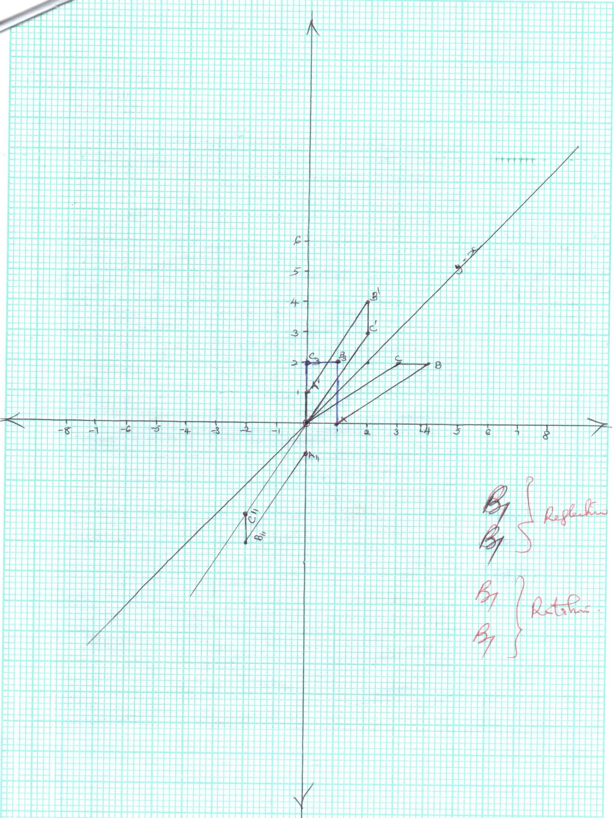
 | Correctly drawn OA,B,C  Correctly labelled  (ii) 0 1  - 0  - (i) Correctly drawn OA₂ B₂ C₂  Correctly labelled.  (ii) Reflection on the line y = -x  - (i) C₃ (0,2)  (ii) Shear factor (-1.5)  From the unit square  Matrix 1 -1.5  - 1  Inverse matrix 1 -1.5  0 1 | B1  B1  B1  B1  B1  B1  B2  A1  B1
 |  | 10
22 | - x + y > 50  x > 10  3x + y < 120  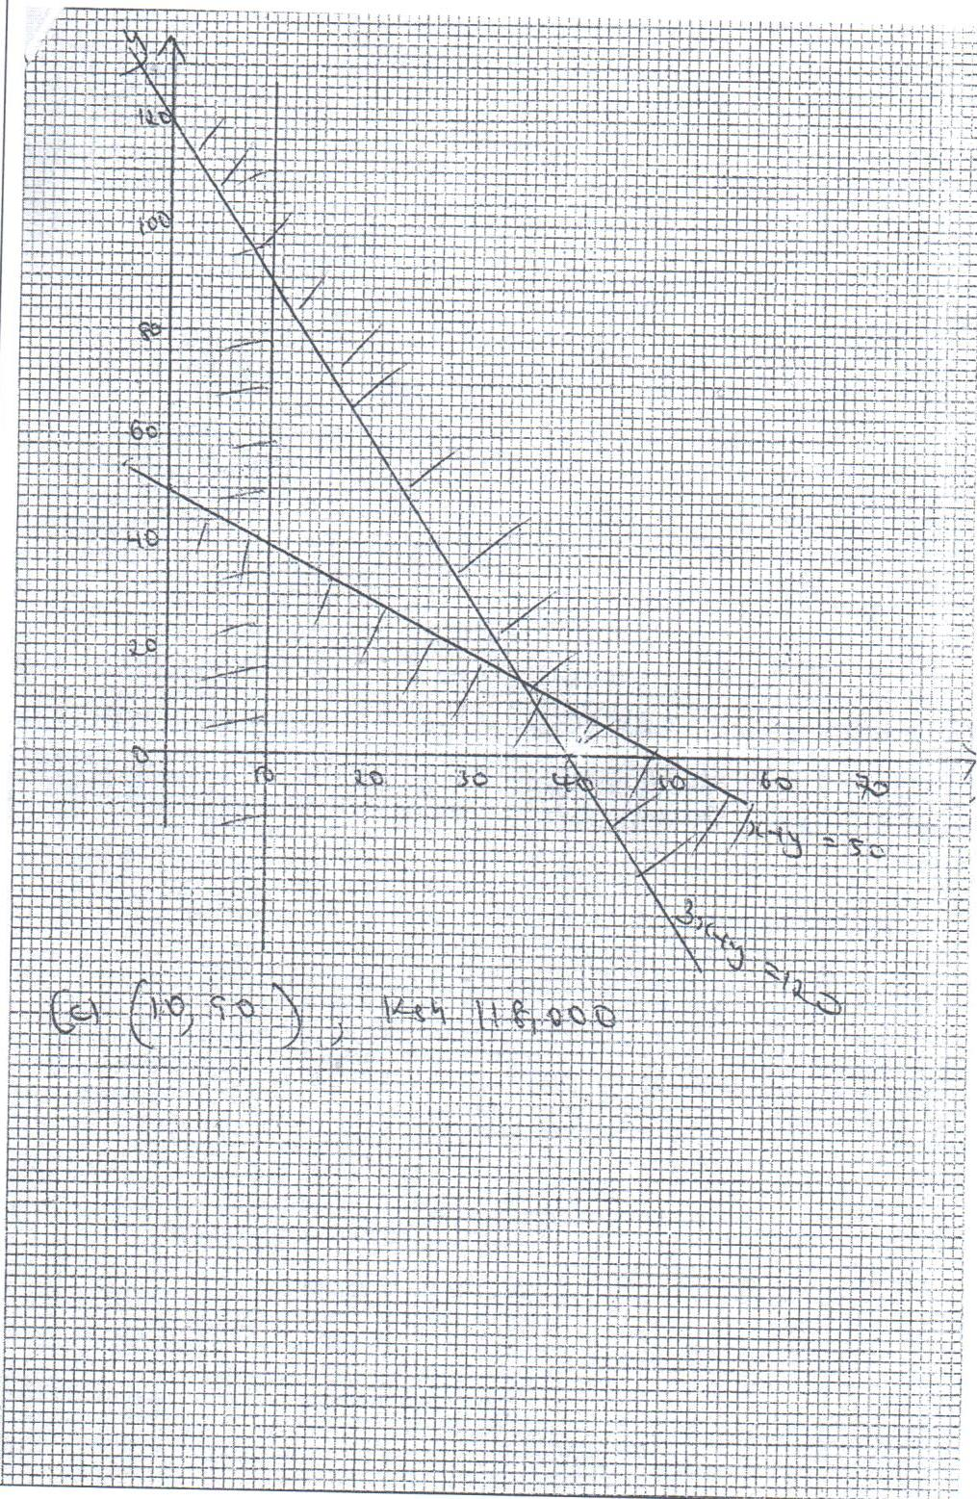 | B1  B1  B1  S1  P1  L1  B1  M1  A1  B1 | All inequalities correctly plotted.  All lines correctly drawn.  Correct region.
23 | Area = 1(3.75 + 6.75 + 11.75 + 18.75 + 27.75 + 38.75)  = 107.5sq. units.  8  - Exact Area = x² – 3x + 5dx  2  8  = x³ – 3x² + 5x  3 2  2  = 512 – 3(64) + 40 - 8 – 12 + 10  3 2 3 2  = 168 – 90 + 30  = 108 sq. units  - Percentage Error: 0.5 x 100 = 0.463%  1.08 | B2  B1  M1  M1  A1  M1  M1  A1  M1  A1 | All correct  For at least five correct.  ̃ ̃
  x | 2 | 3 | 4 | 5 | 6 | 7 | 8
  y | 3 | 5 | 9 | 15 | 23 | 33 | 45
  x | 2.5 | 3.5 | 4.5 | 5.5 | 6.5 | 7.5
  y | 3.75 | 6.75 | 11.75 | 18.75 | 27.75 | 38.75
 |  | 10
24 | A (a) (i) 28² = 17² + 34² – 2 x 17 x 34 cosA  784 = 1445 – 1156cosA  17cm 34cm 784 – 1445 = -1156cosA  CosA = -661  B 28cm C -1156  = 0.5718  A = Cos⁻¹0.5718  A = 55.12⁰  (ii) A = ½ cb sin A  = ½ x 17 x 34 sin 55.12  = 17 x 17 sin 55.12  = 237.08cm²  (iii) 28 = 2R  Sin 55.12  34.13 = 2R  R = 17.06  (b) Let the length be x  x = 3.2  sin42 sin60  x = 3.2 x sin42  sin60  x = 2.47m | M1  M1  A1  M1  A1  M1  A1  M1  B1  A1 | For correct expression of cosine net.  Simplification  Correct expression of sin rule.  Simplification.
 |  | 10

