NAME: …………………………………………. INDEX NO: ……………………………….

SCHOOL: ……..……………………………… DATE : …………………………………..

CANDIDATE’S SIGNATURE:…………………

NAIROBI COUNTY JOINT EXAMS-2018
Kenya Certificate of Secondary Education (KCSE)
MATHEMATICS
PAPER 2
TIME: 2½ HOURS

INSTRUCTIONS TO CANDIDATES
- Write your Name and Index Number in the spaces provided at the top of this page.
- Sign and write the date of examination in the spaces provided above.
- This paper contains TWO sections: section I and section II
- Answer all the questions in Section I and any FIVE questions from section II.
- All answers and working must be written on the question paper in the spaces provided below each question.
- Show al the steps in your calculations, giving your answers at each stage in the spaces below each question.
- Marks may be given for correct working even if the answer is wrong.
- Non-programmable silent electronic calculators and KNEC mathematical tables may be used except where stated otherwise.
FOR EXAMINER’S USE ONLY:
Section I
1 | 2 | 3 | 4 | 5 | 6 | 7 | 8 | 9 | 10 | 11 | 12 | 13 | 14 | 15 | 16 | TOTAL

Section II GRAND TOTAL
17 | 18 | 19 | 20 | 21 | 22 | 23 | 24 | TOTAL

SECTION 1: (50 MARKS)
Answer ALL the Questions in this section in the spaces provided.

- Use logarithm table to evaluate: (4mks)

(0.0246)² x 142
3 0.002 x 1.14

- Expand the expression: (3√2 + 5) (3√2 – 5). Hence work out the following: (3mks)
4 – 3
3√2 + 5 3√2 – 5

- Expand (2 + ¹/₅x)⁸ up to the term in x³. Use your expansion to evaluate (2.04)⁸ correct to 4 decimal places. (4mks)

- Evaluate without using mathematical tables or calculators: (2mks)
2 Log₁₀5 – ½ Log₁₀16 + 2 Log₁₀40

- Make r the subject in the formular: (3mks)
s = rt
(r² – t)

- The n^{th} term of a sequence is 2n + 1.
    - State the first four terms of the sequence. (1mk)

    - Determine the sum of the first 40 terms of the series. (2mks)

- If matrix A = 1 2 Find B given that A² = (A + B). (3mks)
4 3

- In the figure below QT is a tangent to a circle at Q. PXRT and QXS are straight lines. PX = 6cm, RT = 8cm, QX = 4.8cm and XS = 5cm.
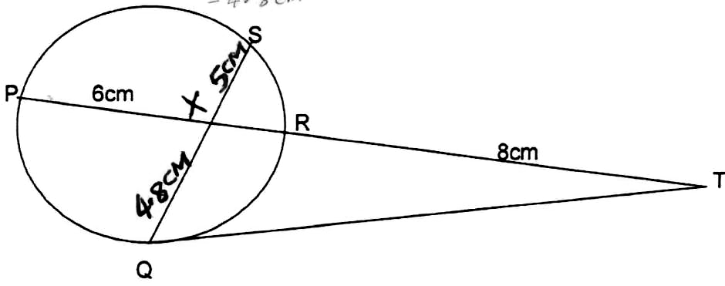
Find the length of:
- XR (2mks)

- QT (2mks)

- A circle whose equation is (x – 1)² + (y – k)² = 10 passes through point (2,5). Find the coordinates of the two possible centres of the circle. (3mks)

- A machine A can do a piece of work in 6 hours while machined B can do the same work in 9 hours. Machine A was set to do the work but after 3½ hours it broke down and machine B did the rest of the work. Find how long machine B took to do the rest of the work. (2mks)

- The marks of 80 students in a Mathematics test are shown in the table below.
Marks | 0-9 | 10-19 | 20-29 | 30-39 | 40-49 | 50-59 | 60-69 | 70-79 | 80-89 | 90-100
No. of students | 8 | 10 | 15 | 14 | 11 | 8 | 7 | 5 | 2 | 0

Find the quartile deviation of the marks. (4mks)
(Give your answer to the nearest whole number)

- Solve for x in the equation:
3cos²x + sin x + 1 = 0 For 0 < x < 360 (3mks)

- A stone is thrown vertically upwards from Point O. After t seconds the stone is S metres from O. Given that S = 29.4t – 4.9t², find the maximum height reached by the stone. (3mks)

- A blender mixes two brands of Juice A and B to obtain 70mls of the mixture worth Ksh. 165 per litre. If brand A is valued at Ksh. 168 per 1 litre bottle and brand B at Ksh. 153 per 1 litre bottle, calculate the ratio in which the bands A and B are mixed. (2mks)

- A quantity y varies partly as the square of X and partly as X. When y = 20, x = 2 and when y = 36 x = 3. Determine the equation relating y and x. (3mks)

- The image of a point Q(1,2) after a translation is Q¹(-1,2). What is the co-ordinate of the point R whose image is R¹(-3, -3) after undergoing the same translation?

SECTION II (50 MARKS)
Answer any five questions in this section

- The table below shows monthly income tax rates.
Monthly taxable pay K£ Rate of tax Kshs per K£
1 – 342 2
343 – 684 3
685 – 1026 4
1027 – 1368 5
1369 – 1710 6
Over 1710 7
A government employee earns a monthly salary of Ksh. 24,200 and is provided with a house at a nominal rent of Ksh. 700 per month.
  - Calculate the employee’s taxable pay in K£. (2mks)

  - Calculate the total tax. (4mks)

  - The employee is entitled to a personal relief of Kshs. 1056 per month; and a monthly insurance relief at the rate of 15% of the premium paid. Calculate the net tax paid by the employee if the monthly premium amounts to Kshs. 2,400 for life insurance cover.(3mks)

  - Calculate his / her net pay that month. (1mk)

- In the diagram M is the midpoint of XZ. OX = p + 2q. Oz = 7p – 2q and ZY = 3Kq + Mp where k, and m are constants.
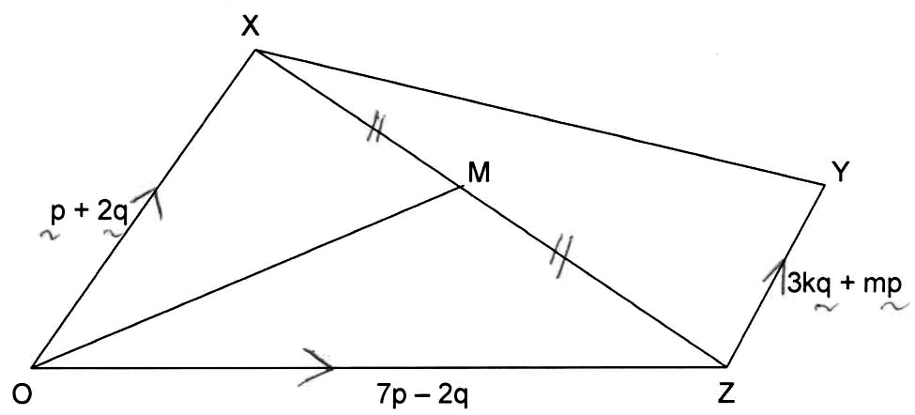
- Express the following in terms of p and q.
  - XZ (2mks)

  - XM (1mk)

  - OM (1mk)

- Express OY in terms of p, q, k and m. (2mks)

- If y lies on OM produced with OY:OM = 3:2. Find the values of k and m. (4mks)

- The figure below shows a net of solid. The dimensions AC = CB = BA = 5cm, AF = 10cm and the triangles ABC and DEF are equilateral and equal.
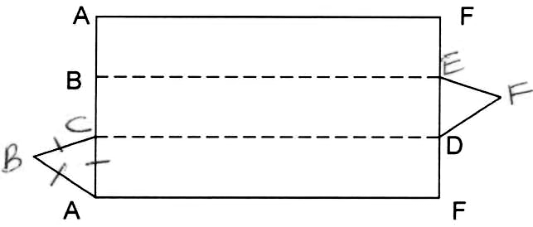
  - Taking BCDE as the base of the solid, draw a proportionately well labelled solid that can be made from the net. (2mks)

  - Name the solid formed. (1mk)

  - Using the figure, calculate:-
    - The angle between line CF and the plane BCDE. (3mks)

    - The angle between lines BD and DF. (3mks)

    - The angle between the planes BCDE and CDFA. (1mk)

- The position of two towns P and Q are given to the nearest degree as P(45⁰N, 20⁰W) and Q(45⁰N, 160⁰E).
Find:
  - Shortest distance between the two towns in:-
    - Kilometres (take radius of the earth as 6370km) (3mks)

    - Nautical miles. (Take π = ²²/₇) and the earth’s radius = 6370km. (2mks)

  - A ship leaves town P and sails due east for 120 hours to another town R at an average speed of 27 knots.
    - Calculate the distance between the two towns in nautical miles. (2mks)

    - Find the position of town R. (3mks)

- The parallelogram OABC has vertices (0,0), (1,0), (4,2), (3,2) respectively.
- (i) OABC is mapped onto O₁A₁B₁C₁ by a reflection on the line y = x. Draw and label the image O₁A₁B₁C₁. (2mks)

(ii) State the matrix which represent this reflection. (1mk)

- O₁A₁B₁C₁ is mapped onto parallelogram O A₂B₂C₂ by a rotation through 180⁰ about O.
(i) Draw and label O A₂B₂C₂ on your diagram. (2mks)

(ii) Describe the transformation that maps O A B C onto O A₂B₂C₂ (1mk)

- OABC is mapped onto the rectangle O A₃B₃C₃ by a shear X axis invariant. If the co-ordinates of B₃ are (1,2), find:-
  - The co-ordinates of C_{3.} (2mks)

  - The matrix representing the shear. (2mks)

- A farmer has at least 50 acres of land on which he plans to plant potatoes and cabbages. Each acre of potatoes requires 6 men and each acre of cabbages requires 2 men. The farmer has 240 men available and he must plant at least 10 acres of potatoes. The profit on potatoes is Ksh. 1000 per acre and on cabbages is Ksh. 1200 per acre. If he plants x acres of potatoes and y acres of cabbages:
  - Write down three inequalities in x and y to describe this information. (3mks)

  - Represent these inequalities graphically. (4mks)

  - Use your graph to determine the number of acres for each crop which will give maximum profit and hence find the maximum profit. (3mks)

- (a) Complete the table below for the function:
y = x² – 3x + 5 (2mks)
x 2 3 4 5 6 7 8
y

(b) Use the mid-ordinate rule with six ordinates to estimate the area enclosed by the curve of the functions y = x² – 3x + 5, x – axis and the lines x = 2 and x = 8. (3mks)

(c) Find the exact area of the region described in (b) above. (3mks)

(d) If the mid-ordinates rule is used to estimate the area under the curve between x = 2 and x = 8, what will be the percentage error in the estimation? (2mks)

- In a triangle ABC, AB = 17cm, BC = 28cm and AC = 34cm.
Find:-
  - (i) BAC (3mks)

(ii) Using the angle BAC in (a) (i) above, find the area of triangle ABC. (2mks)

(iii) The radius of its circumcircle that can be drawn on the triangle. (2mks)

  - A stone is hung from a horizontal beam by two strings. The longer string makes an angle of 42⁰ with the horizontal and is 3.2m long. If the shorter string makes an angle of 60⁰ with the horizontal, calculate its length. (3mks)

42⁰ 60⁰

3.2m

Stone

