121 /2
MATHEMATICS
PAPER 2
MARCH/APRIL2020
1. | 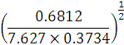 | B1  M1  M1  A1 | Find  reciprocal and reading of log 5  All logs   All operations +, - and ÷  Accept std form
  NO | LOG
  0.6812 |  |  | -
  7.627 | 0.8824  +
  0.3734
   |  |  |  | 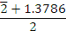
 |  | 4 Mks
2. | 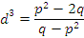  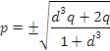 | M1  M1  A1
 |  | 3 Mks
3. |  | M1  A1  M1  A1
 |  | 4 Mks
4. | 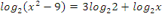  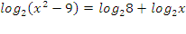  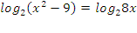  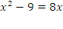  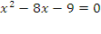  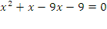  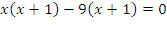  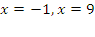 | M1  M1  A1 | For ✓ dropping logs  For ✓ x = $±$5  $⇒$CAO
 |  | 3 Mks
5. | 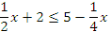  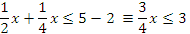  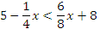  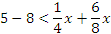 | B1  B1  B1
 |  | 3 Mks
6. | 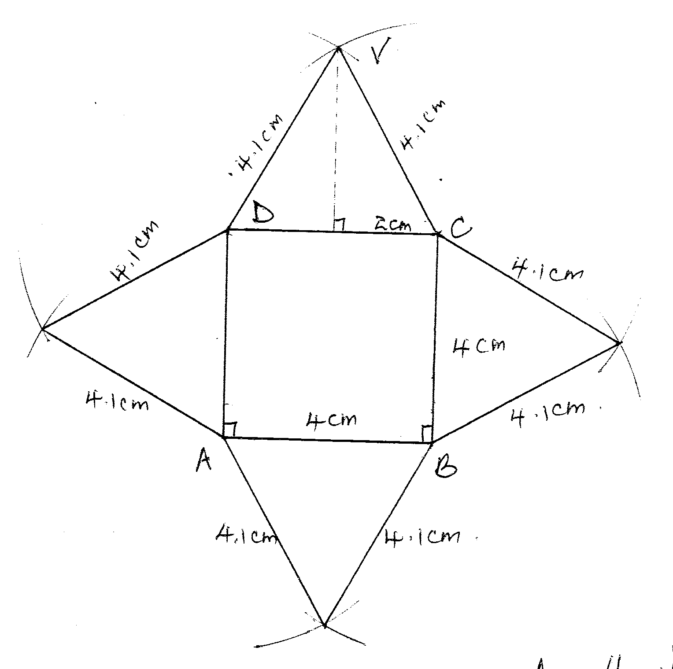  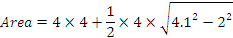 | B1  B1  B1 | ✓Net  ✓labling
 |  | 3 Mks
7. | - 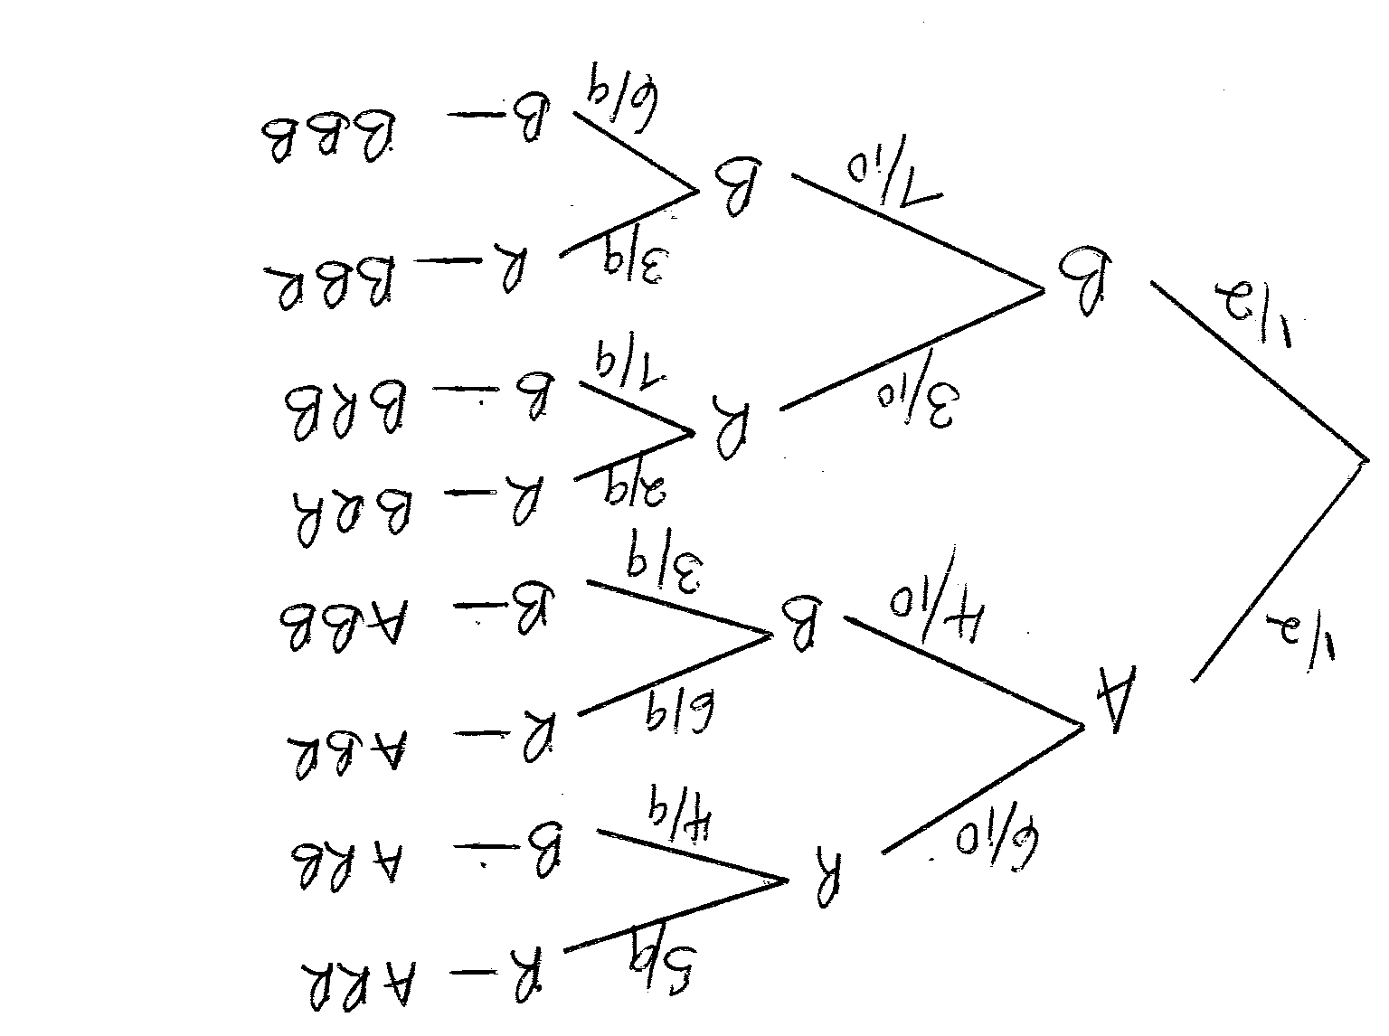  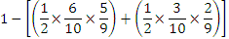  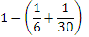  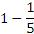 | B1  M1  A1 | Tree diagram
 |  | 3 Mks
8. | 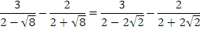  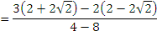  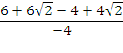  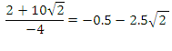  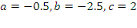 | M1  M1  A1
 |  | 3 Mks
9. | a) Co – ordinate of  A  b) | B1  B1  B1 | Or equivalent
 |  | 3 Mks
10. | 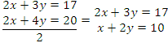 | B1  B1  M1  A1
 |  | 4 Mks
11. | 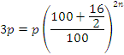  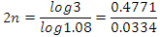 | M1  M1  M1  A1
 |  | 3 Mks
12. | 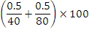  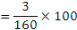  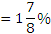 | M1  A1 | 1.875%
 |  | 2 Mks
13. | 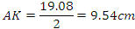 | M1  A1  B1
 |  | 3 Mks
14. | 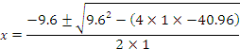  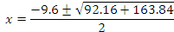  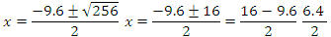 | M1  A1  B1 | Or equivalent
 |  | 3 Mks
15. | 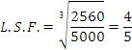  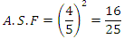  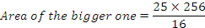 | B1  M1  A1
 |  | 3 Mks
16. | 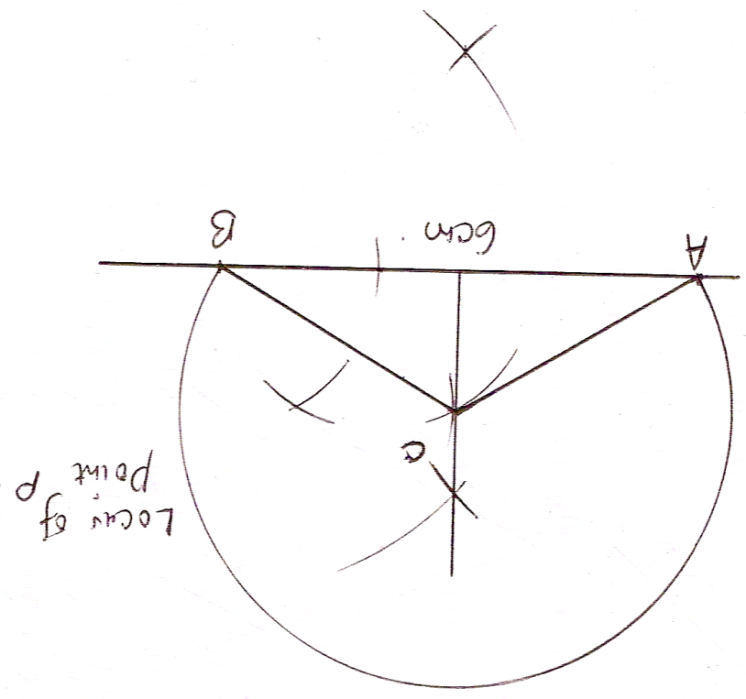 | B1  B1  B1 | ✓ly constructed  Triangle ABC  Locus of P
 |  | 3 Mks
17. | a) 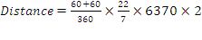  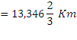  - 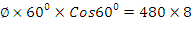  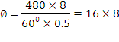  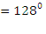  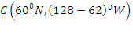  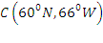  c) Time difference = $\frac{\text{128}×4}{\text{60}}$  = 8hrs 32mins  local time at C = 1730hrs – 8hrs 32 Min  Local time C = 8.58 a.m  d) Total distance moved = 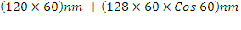  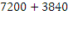  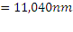 | M1  A1  M1  M1  A1  B1  M1  A1  M1  A1
 |  | 10 Mks
18. | 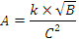  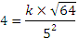  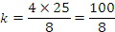  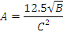  - 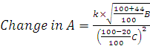  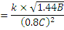  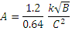  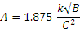  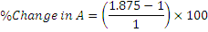 | M1  M1  A1  B1  M1  A1  M1  A1  M1  A1 | Value of the constant
 |  | 10 Mks
19. | - Portion filled in one minute  $\frac{1}{6}+\frac{1}{\text{24}}+\frac{1}{\text{36}}−\frac{1}{\text{72}}=\frac{\text{12}+3+2−1}{\text{72}}$  = $\frac{2}{9}$  - (i) Portion filled in 1½ min  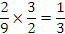  (ii) work done in 1minutes 12 seconds.  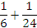  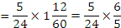  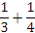  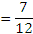  (c) Portion left unfilled after 2 minutes 42 seconds.  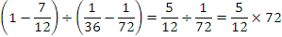 | M1  A1  B1  M1  M1  M1  A1  M1  M1  A1
 |  | 10 Mks
20. | 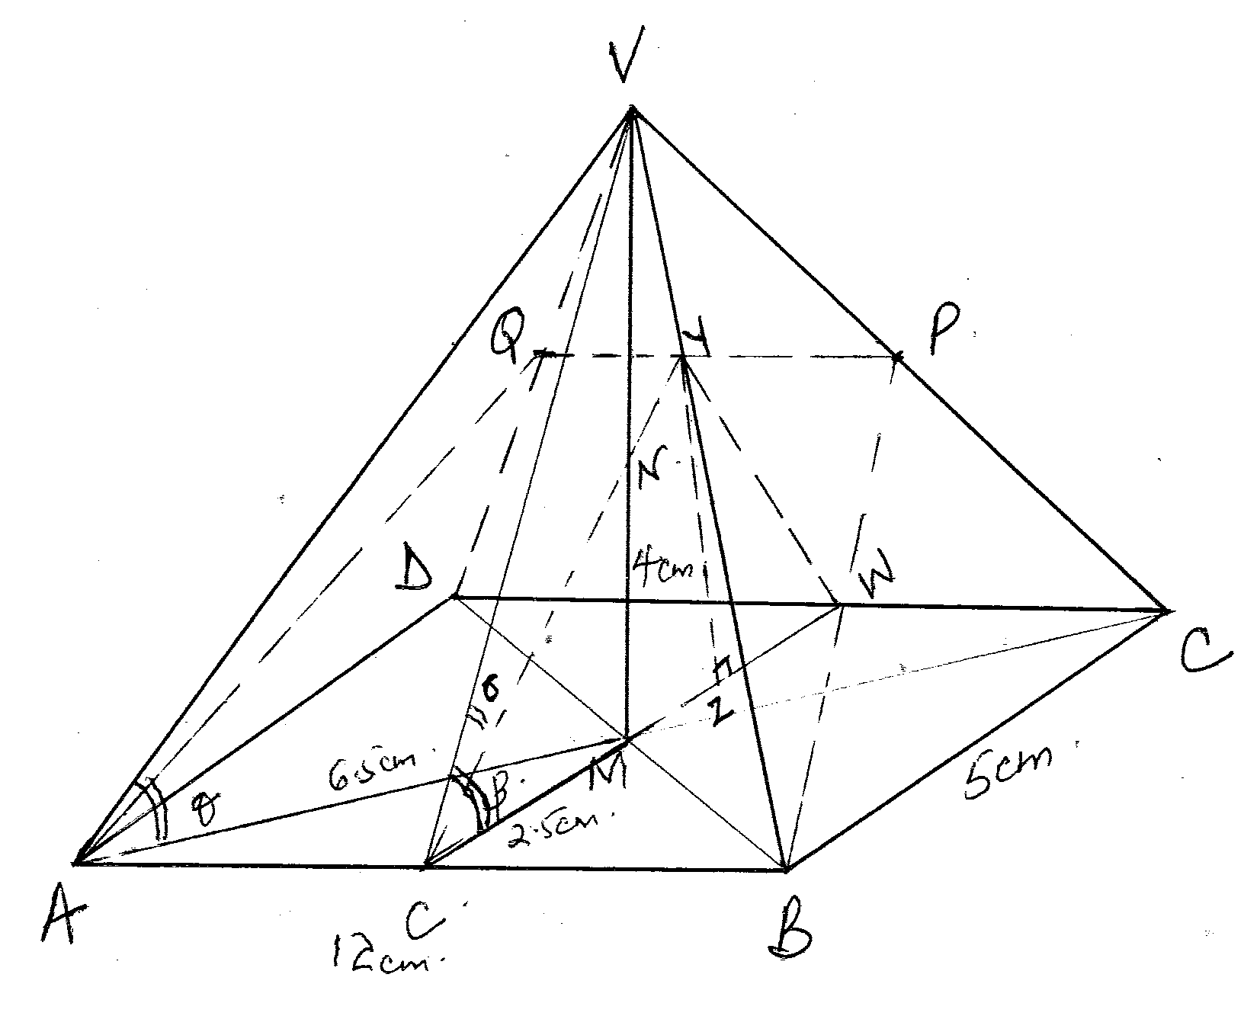  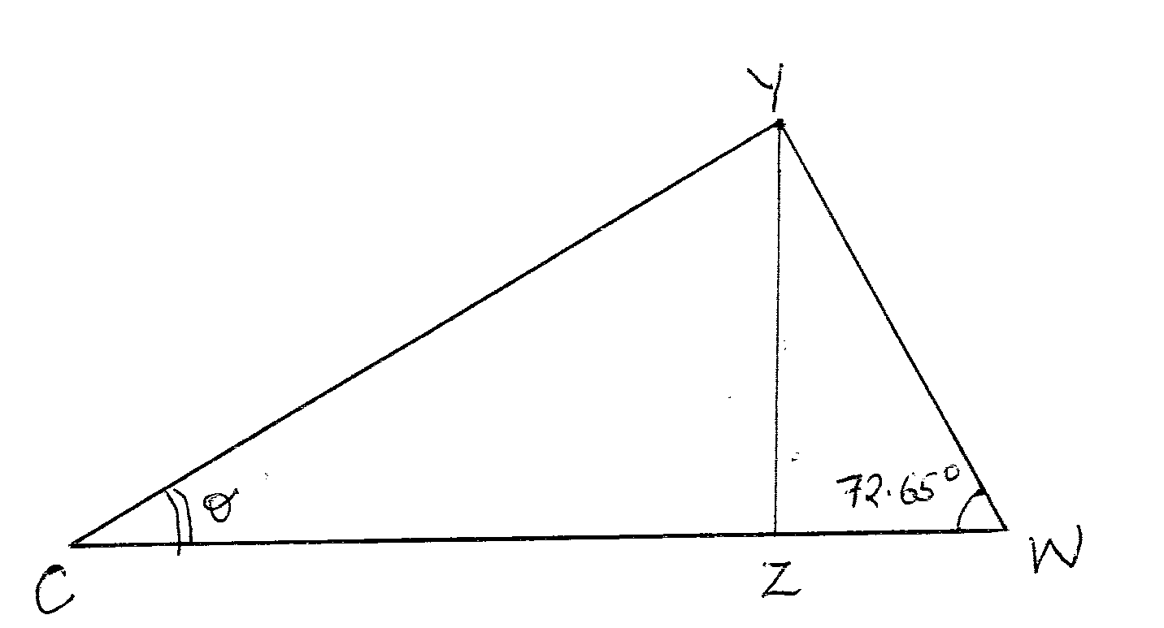  YZ  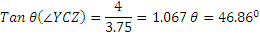 | M1  A1  M1  A1  M1  A1  B1  M1  M1  A1 | For CV or WY
 |  | 10 Mks
21. | 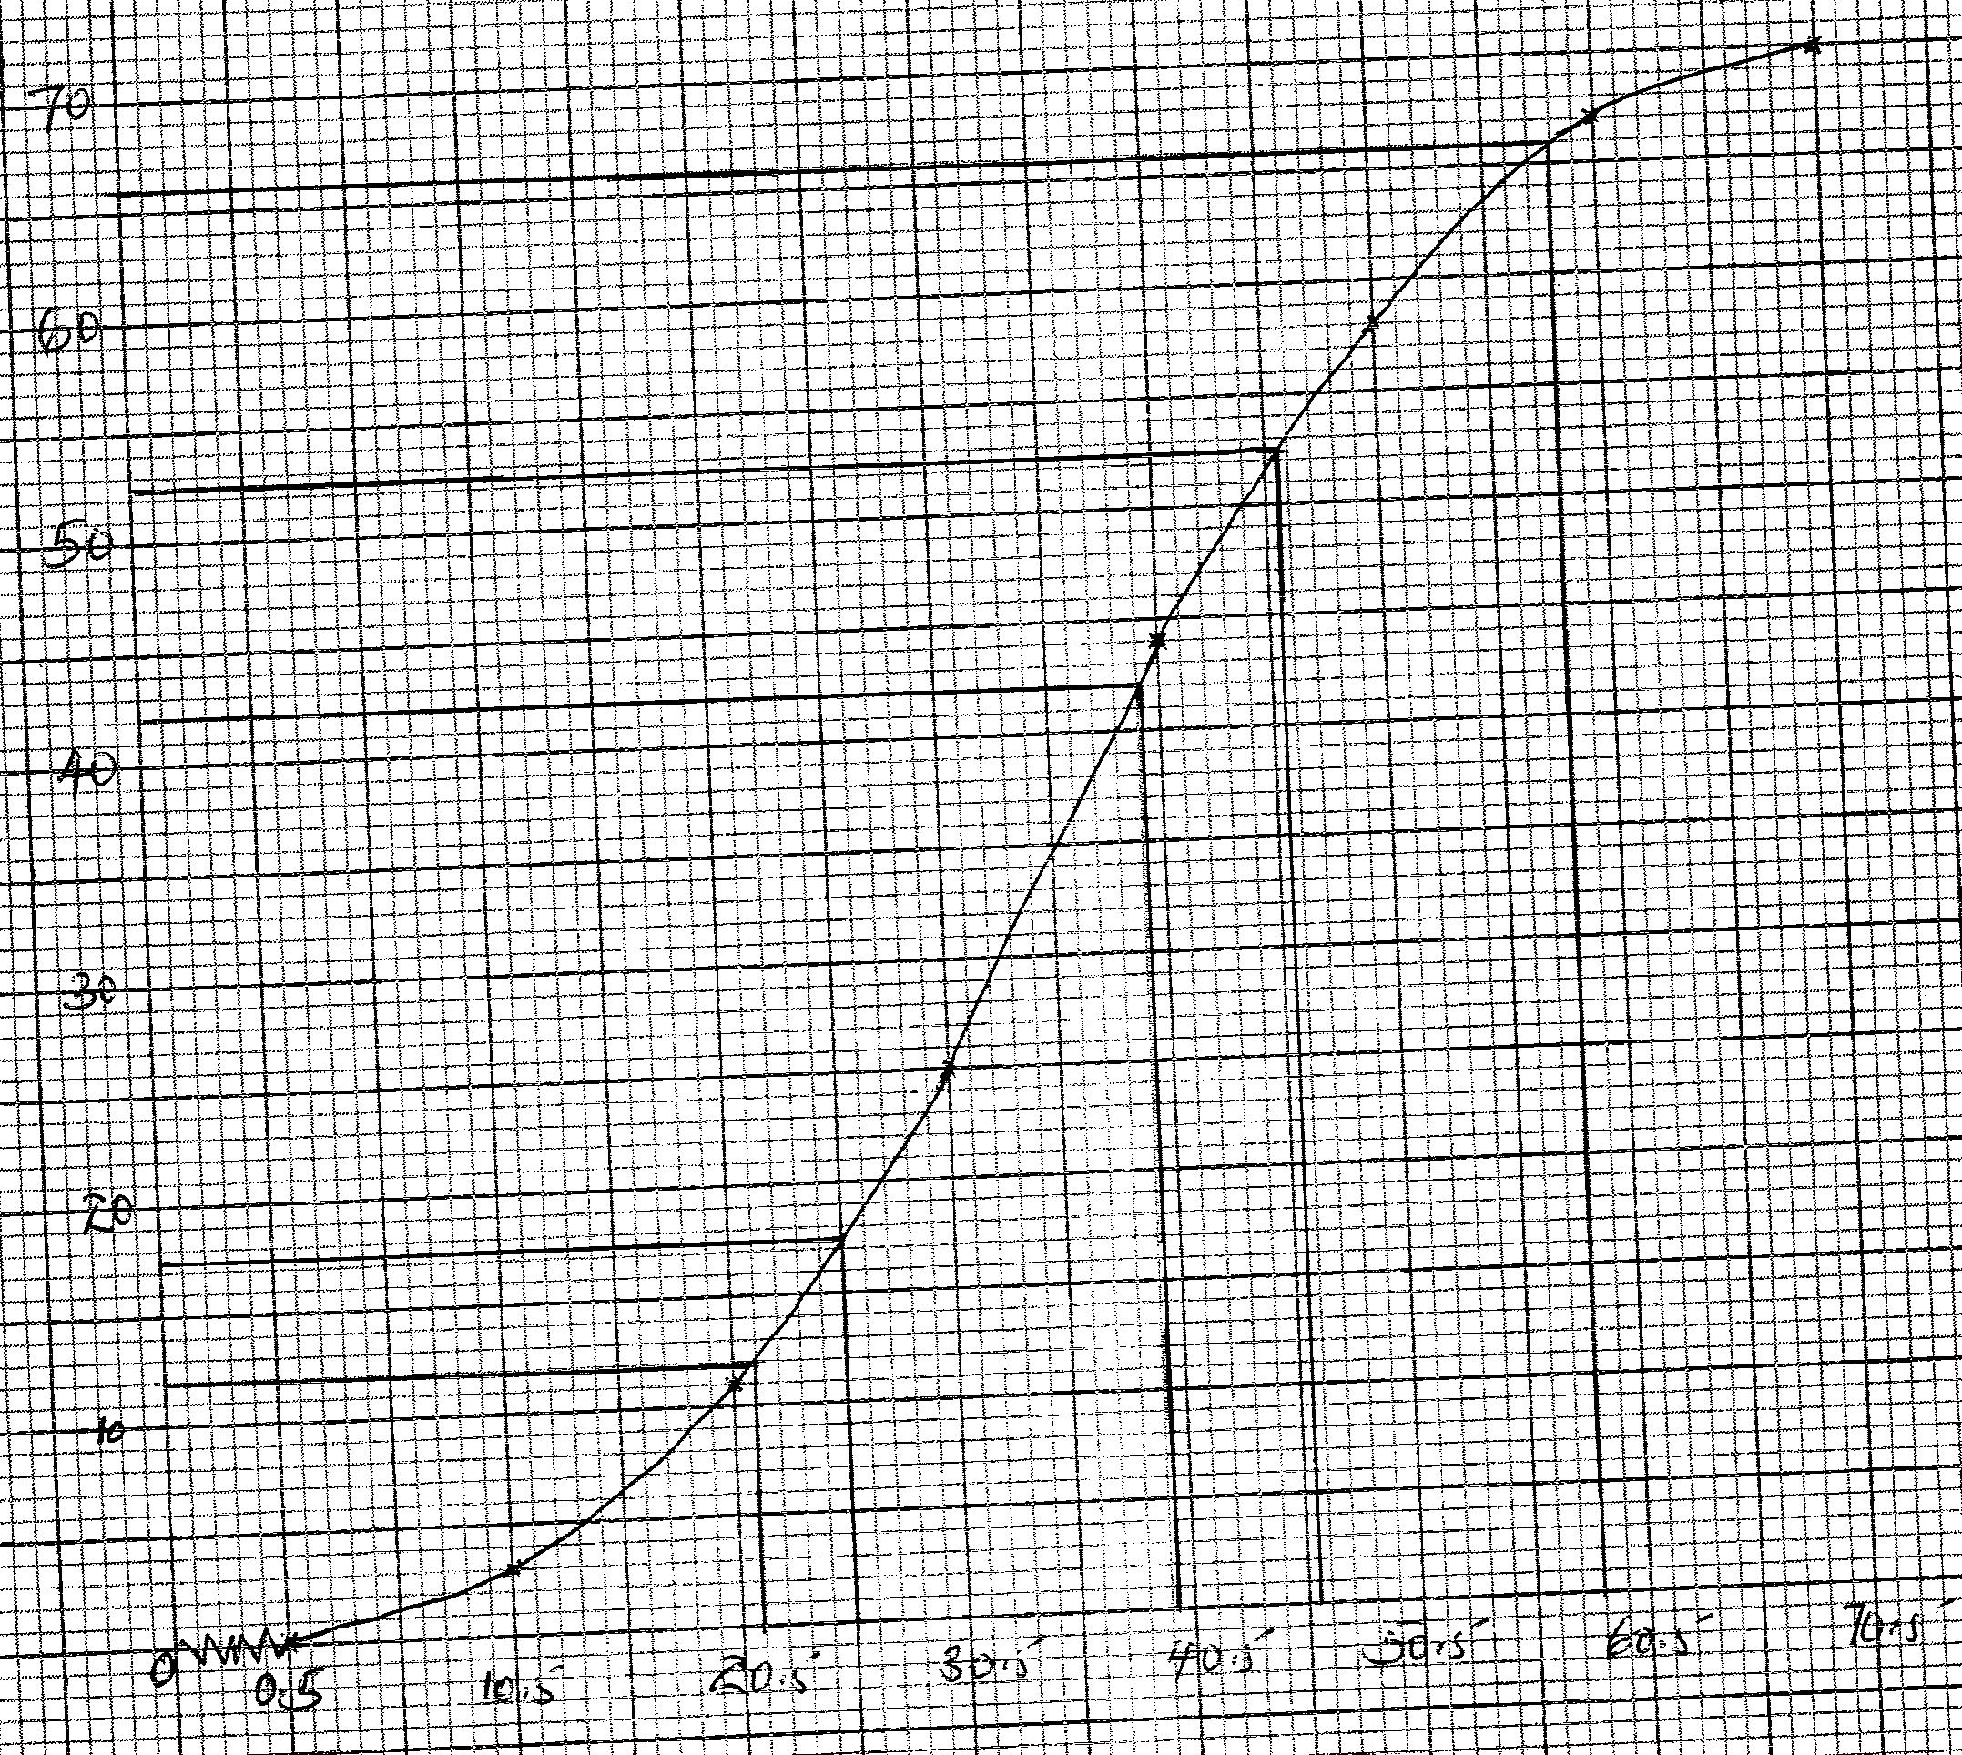  - The 60th percentile 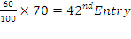  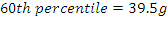  ii) The quartile deviation  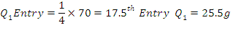  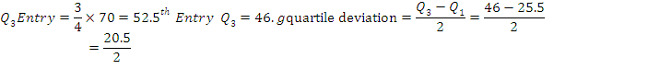  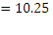  iii) The percentage of passion fruits to the nearest two decimal places whose masses lie in the range 21.5g to 58.5g.  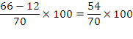  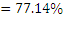 | B1  S1  P1  C1  B1  B1  M1  A1  M1  A1 | For the CF  For Q₁ or Q₃
  Mass |  | 1-10 | 11-20 | 21-30 | 31-40 | 41-50 | 51-60 | 61-70
  f |  | 3 | 8 | 14 | 19 | 14 | 9 | 3
  UCB | 0.5 | 10.5 | 20.5 | 30.5 | 40.5 | 50.5 | 60.5 | 70.5
  c.f. | 0 | 3 | 11 | 25 | 44 | 58 | 67 | 70
 |  | 10 Mks
22. | a)  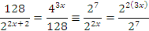  b)  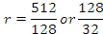  c)  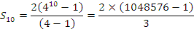  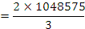  d) | M1  A1  M1  A1  M1  M1  A1  B1  M1  A1
 |  | 10 Mks
23. | a) 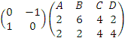=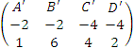  $A'B'C'D'$ on the grid  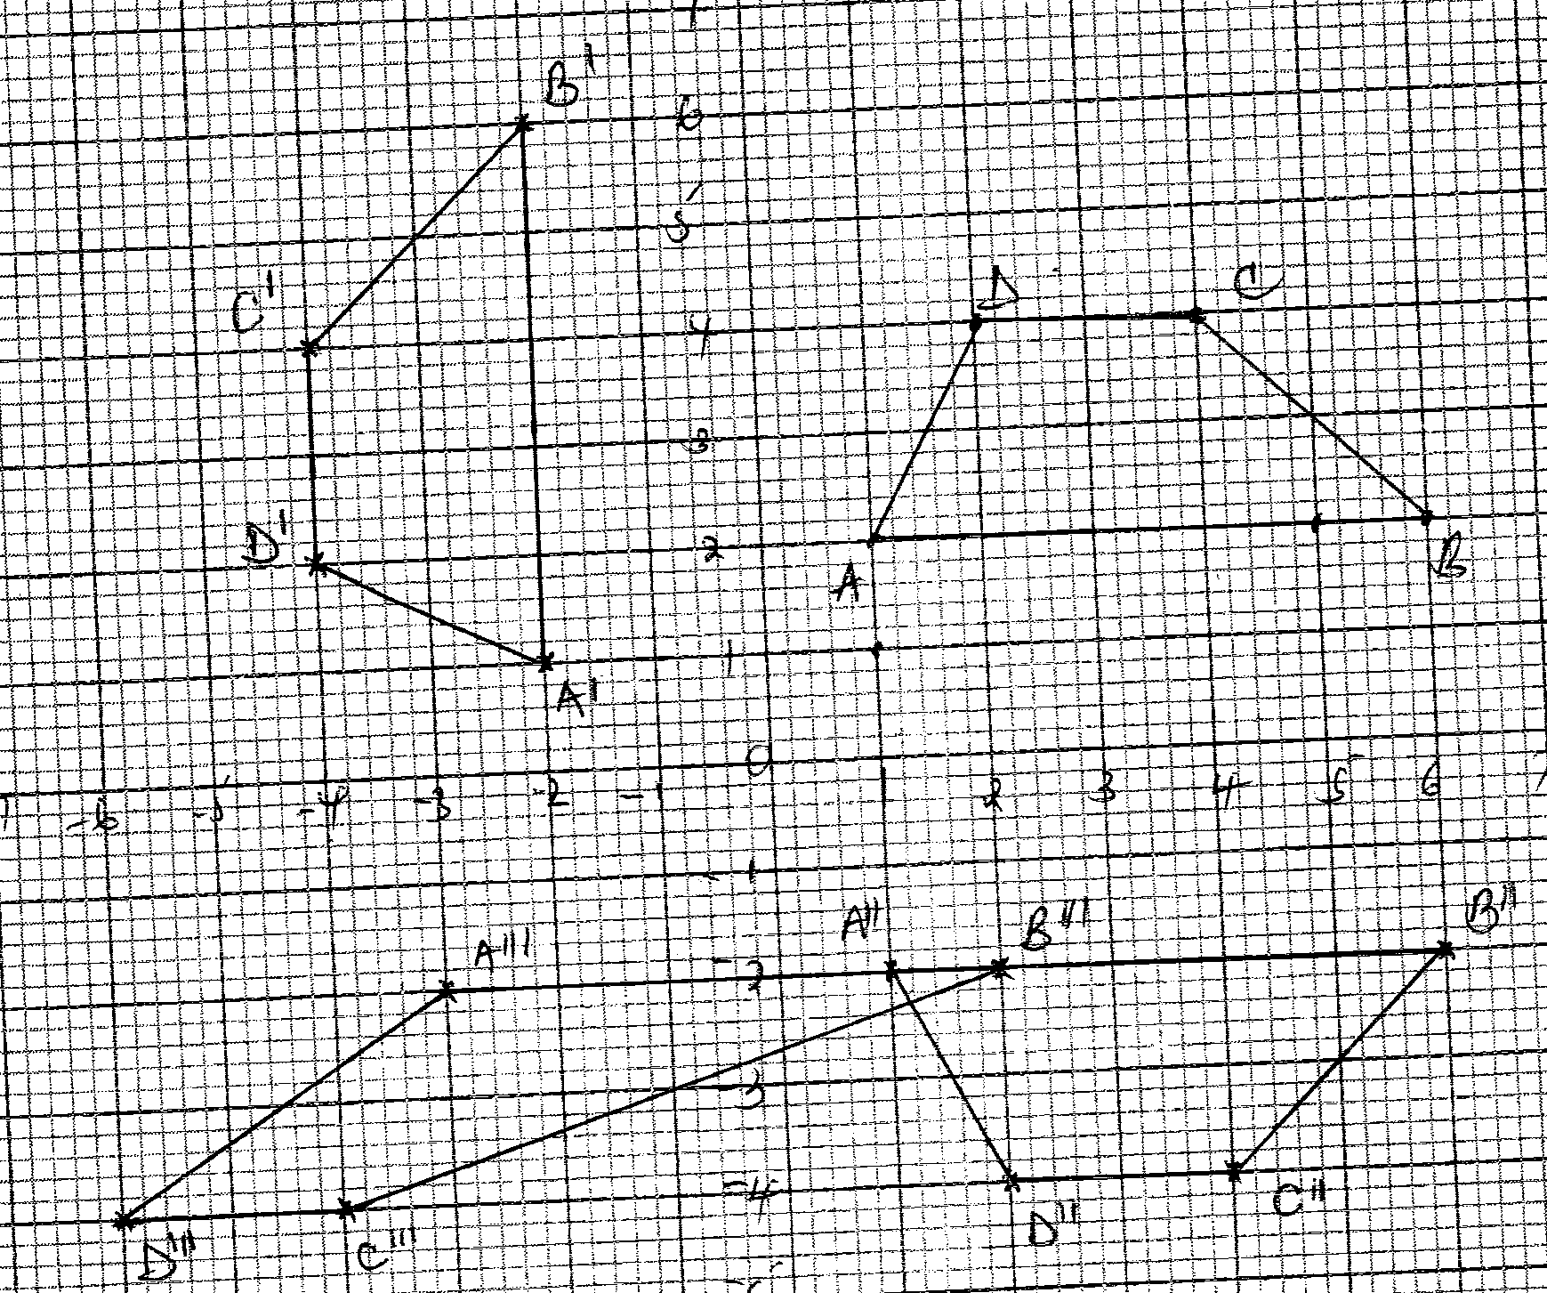  (b) 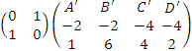  =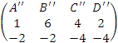  $A\text{''}B\text{''}C\text{''}D\text{''}$ on the grid  (c)(i)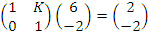  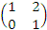  Shear matrix  (ii)  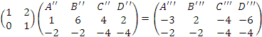  $A\text{'''}B\text{'''}C\text{'''}D\text{'''}$ on the grid | B1  B1  B1  M1  A1  B1  M1  A1  B1  B1 | Object ✓ly plotted and drawn  Image 1 ✓ly plotted and drawn
 |  | 10 Mks
24. | a) To complete the table below by filling the blank  spaces  b) 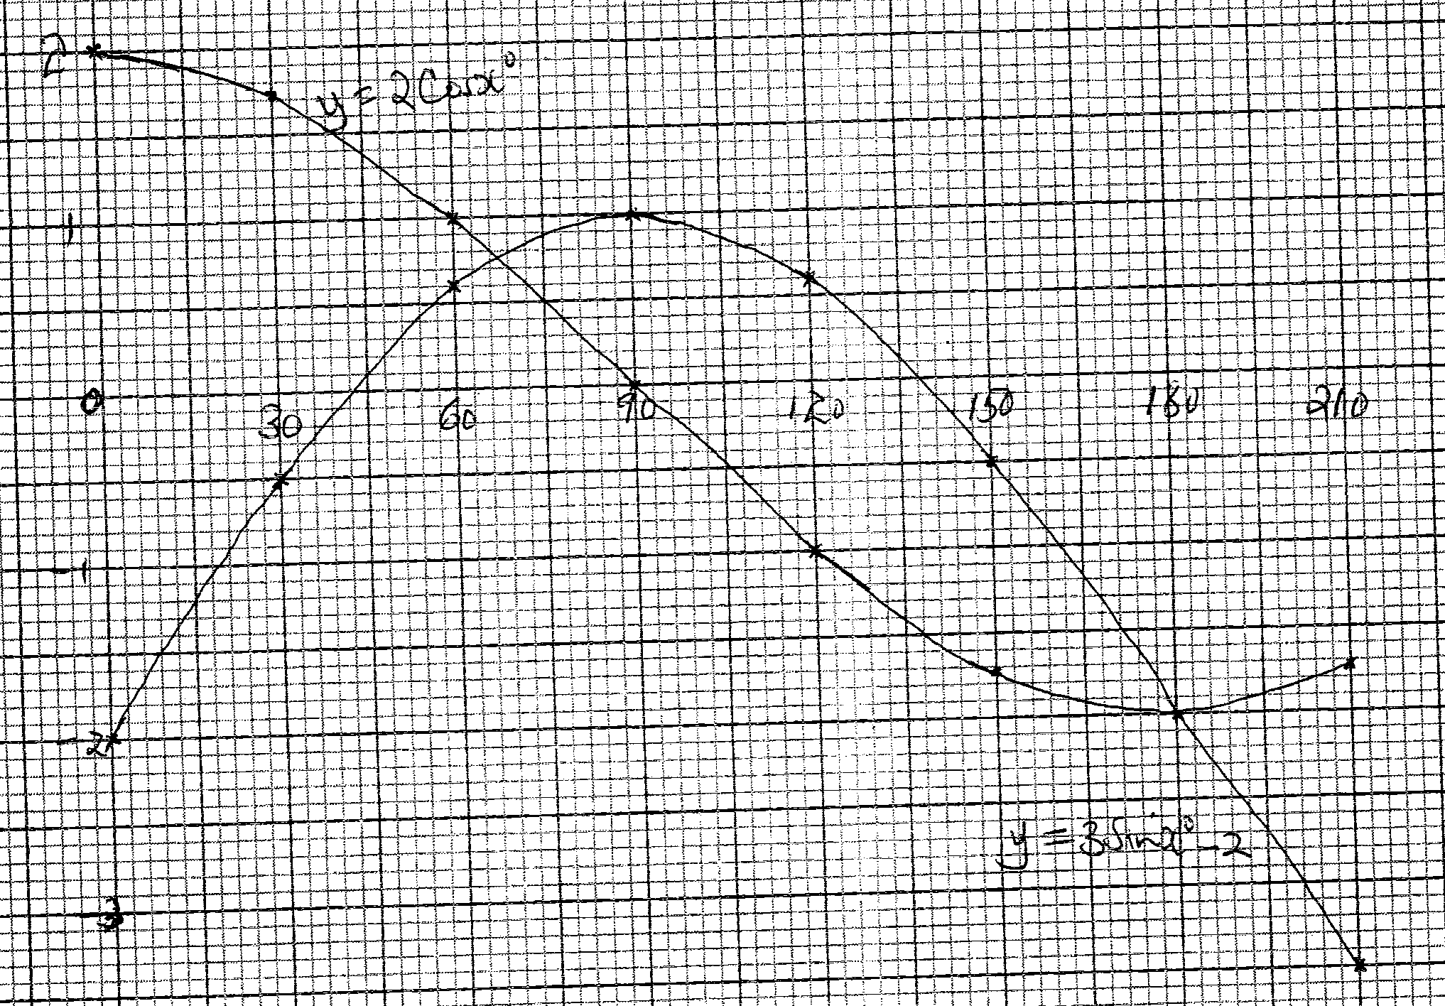  c)  d) State the amplitude of a)  b) | B2  S1  P1  C1  P1  C1  B1  B1  B1 | B₁ for 6✓  For  For  For
   | 0 | 30 | 60 | 90 | 120 | 150 | 180 | 210
   | -2 | -0.5 | 0.60 | 1 | 0.60 | -0.5 | -2 | -3.5
   | 2 | 1.73 | 1 | 0 | -1 | -1.73 | -2 | -1.73
 |  | 10 Mks

