NAME……………………………………………………............ INDEX NO……......……………………..

121/2 CANDIDATE’S SIGNATURE…………………
MATHEMATICS ALT A
PAPER 2 DATE…………………………………………….
March/April,
TIME: 2½ hours

INSTRUCTIONS TO CANDIDATES:
- Write your name, admission and class in the spaces provided at the top of this page.
- Sign and Write the date of examination in the spaces provided above.
- This paper consists of TWO Sections; Section I and Section II.
- Answer ALL the questions in Section I and only five questions from Section II.
- Show all the steps in your calculation, giving your answer at each stage in the spaces provided
below each question.
- Marks may be given for correct working even if the answer is wrong.
- Non-programmable silent electronic calculators and KNEC Mathematical tables may be used except
where stated otherwise.
- This paper consist of 14 printed pages.
- Candidates should check the question paper to ascertain that all the pages are printed as indicated and that no questions are missing
- Candidates should answer the questions in English.

FOR EXAMINER’S USE ONLY:

SECTION I

1 | 2 | 3 | 4 | 5 | 6 | 7 | 8 | 9 | 10 | 11 | 12 | 13 | 14 | 15 | 16 | TOTAL

SECTION II GRAND TOTAL

17 | 18 | 19 | 20 | 21 | 22 | 23 | 24 | TOTAL

SECTION 1 (50 marks)
Answer all the questions in this section in the spaces provided.
- Use logarithms table to evaluate. (4mks) 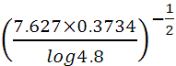

- Make P the subject of the formula given. (3 Marks)
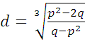

- Expand and Simplify ( 1 – 5x)⁵ up to the term in x³ (2mks)

Hence use your expansion to estimate ( 0.95)⁵ correct to 4 decimal places (2mks)

- Find, without using mathematical tables the values of x which satisfy the equation (4marks)

- Solve the following inequality and list down the integral values. (3 marks)

- The diagram below represents a right pyramid on a square base of sides 4cm. The slant edge of the pyramid is 4.1cm.

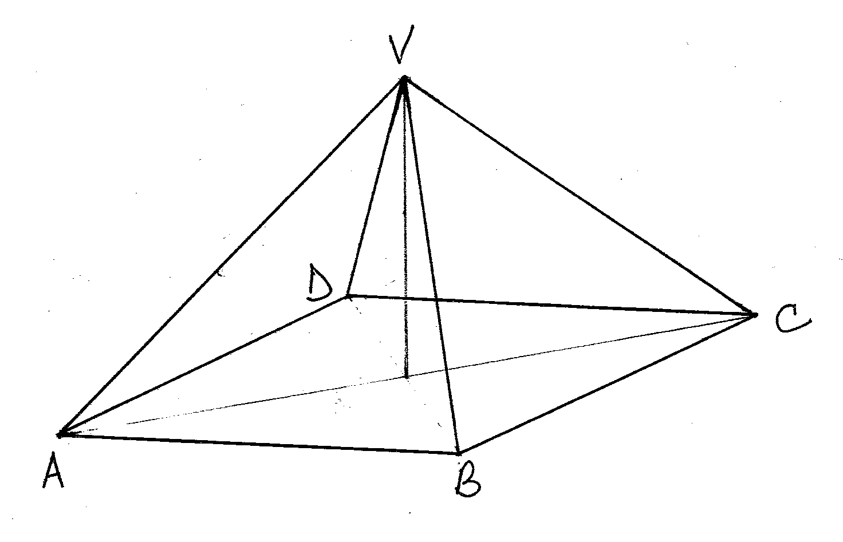
(a) Draw the net of the pyramid (2mks)

(b) Using the net, calculate the surface area of the pyramid (1mks)

- Two similar bags A and B each contain a mixture of red and blue balls. Bag A contains 6 red balls and 4 blue balls while bag B contains 3 red balls while and 7 blue balls.
A bag is selected at random and two balls are picked at random from it
a) Draw a probability tree diagram to illustrate this information. (1 Mark)

b) Find the probability that at least a blue ball picked is blue. (2 Marks)

- Given that $\frac{3}{2−\sqrt{8}}−\frac{2}{2+\sqrt{8}}=a+b\sqrt{c}$. Find the values of a, b and c. (3 marks)

- The points with coordinates (13,3) and (-3,.-9) are the ends of a diameter of a circle
Centre A
Determine:
(a) The coordinates of A (1mk)

(b) The equation of the circle, expressing it in form x² + y² + ax + by + c = 0 Where a, b, and c are constants (2mks)

- Determine the inverse of the matrix A = $\left[\begin{matrix}2 & 3 \\ 1 & 2\end{matrix}\right]$.
Hence find the co-ordinates to the point at which two lines 2x+3y = 17 and 2x+4y=20 intersect.
(3 marks)

- A man invest a certain sum of money at 16% compound interest semi-annually. Find the number of years, to the nearest year it takes to triple the money. (4 marks)

- A rectangular room was measured and its measurement was found to be 40m by 80m to the nearest metre. Calculate the percentage error in working out its area. (2 marks)

- A triangle ABC is such that AB=10cm, BC=12cm,K divides AC in the ratio 1:1 and angle ABC=120⁰. Calculate the length of AK. (3 marks)

- AC is a tangent to the circle given below (not drawn to scale) at B. ED is a chord to the same circle extended to meet tangent AC at C. Given that BC = 6.4cm and ED = 9.6cm, then find EC. (3 Marks)
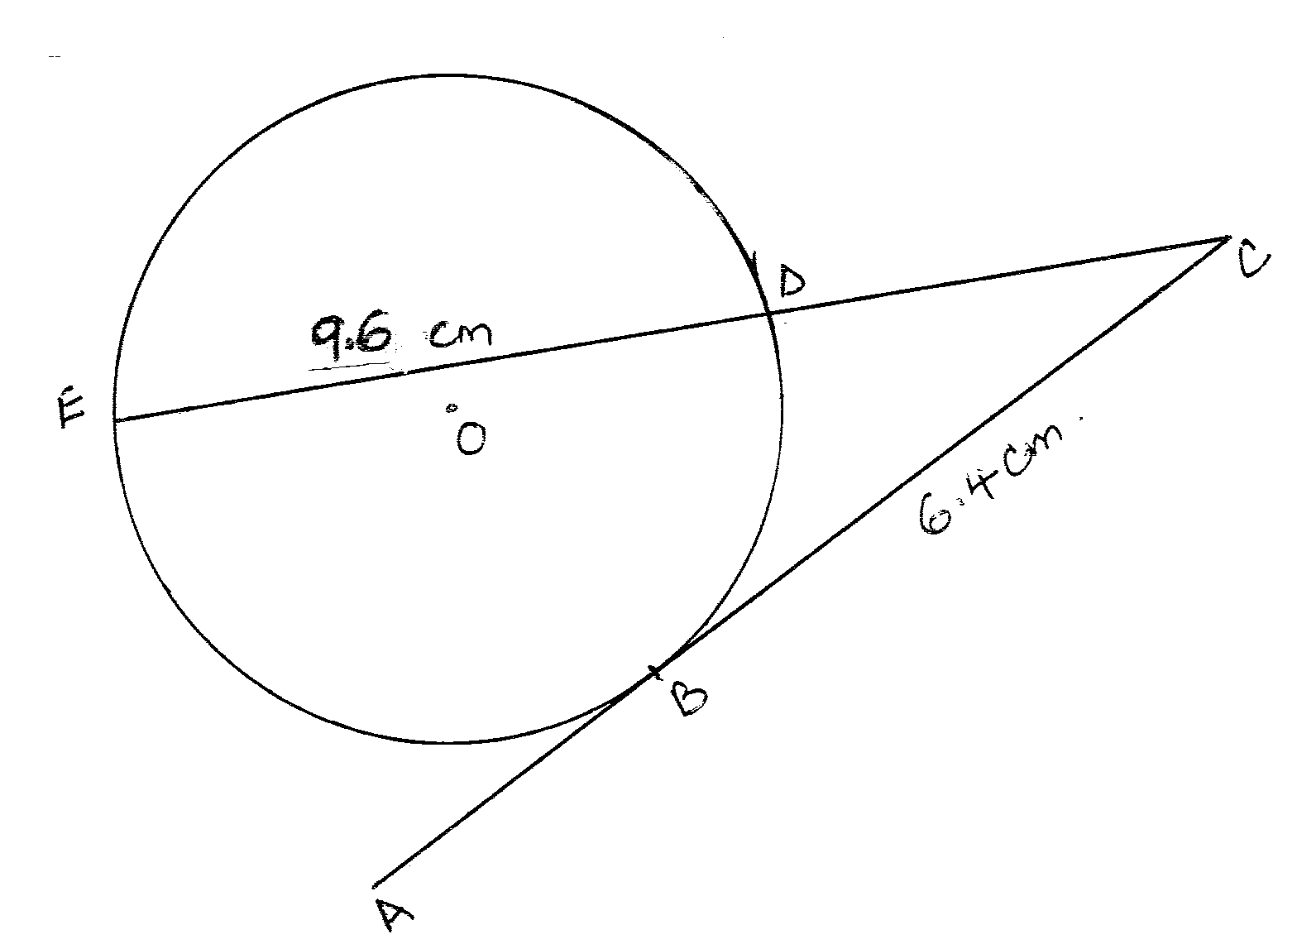

- The masses of two similar bars of soap are 2560g and 5000g. If the surface area of the smaller bar is 256 cm². Calculate the surface are of the larger bar. (3 marks

- Use ruler and a pair of compasses only in this question
a) Construct triangle ABC such that AB = 6cm, AC=BC and angle ACB = 120⁰ 2mks
b) On one side only construct the locus of P such that = 60⁰ 1mks

SECTION 11 (50 marks)
Answer only five questions from this section in the spaces provided.
- An aircraft leaves town A ( 60°S, 62°E) and moves directly northwards to B(60°N, 62°E). It then moved at an average speed of 480 knots for 8 hours westwards to town C. Determine;
a) The distance AB in kilometers. Take 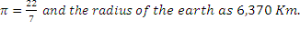 in. (3 marks)

b) The position of town C. (3 marks)

c) The local time at C if local time at A is 5.30p.m (2 marks)

d) The total distance moved from A to C in nautical miles (2 mks)

- Three quantities A B and C are such that A varies directly as the square root of B and inversely as the square of C.
- Given that A=4 when B=64 and C=5, find
  - The law connecting A B and C ( 4mks)

  - A when B=16 and C=10. ( 2mks)

b) If B is increased by 44% and C decreases by 20%, find the percentage change in A.
(4 Marks)

- Three taps A, B and C can take 6 minutes, 24 minutes and 36 minutes respectively to
fill a water tank. Tap D alone can take 72 minutes to empty the whole tank. Starting with an empty tank all the taps A, B, C and D are opened together for 1 ½ minutes. Tap C and D are then closed while A and B are left to continue for the next 1 minute and 12 seconds. After the 1 minute and 12 seconds taps A and B are closed while C and D are re-opened to continue for the rest of the time until the water tank is full. Determine:

(a) The portion of the tank filled during the first one minute if all the taps are opened. (2 mks)

(b) Portion filled after 2 minutes and 42seconds. (5 marks)

(c) Time taken to fill the water tank completely. (3 marks)

- The diagram below shows a right pyramid VABCD. The base of pyramid is a rectangle ABCD, with AB = 12CM and BC= 5CM. The height of the pyramid is 8 cm.
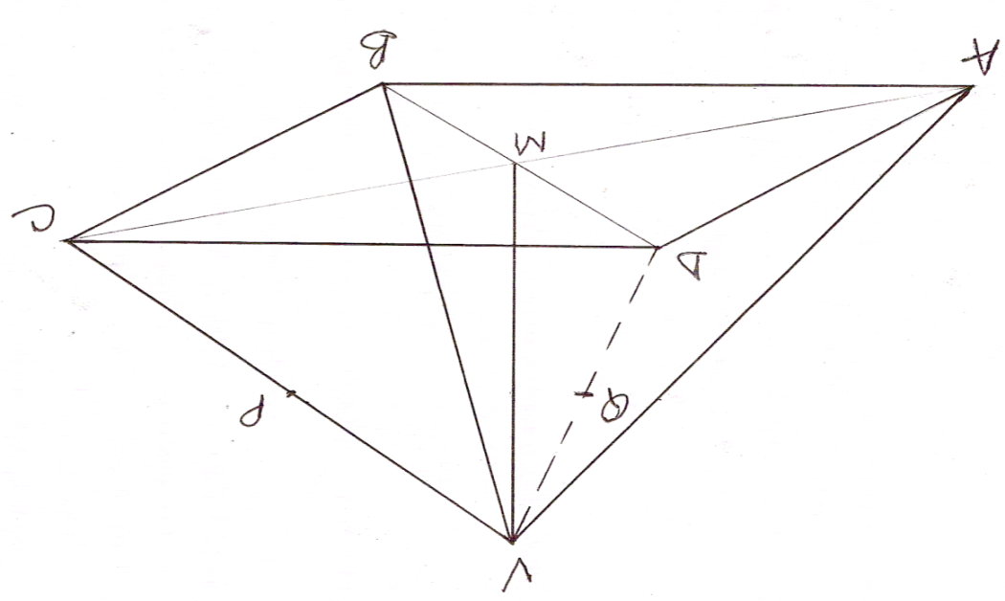

a) Calculate the
i) Length AC. ( 2 mks)

ii) The angle VA makes with the plane ABCD. (2 mks)

iii) Angle between the face VAB and the base. ( 2mks)

b) P is the midpoint of VC and Q is the midpoint of VD. Find the angle between the plane VAB and the plane ABPQ. ( 4 mks)

- The data below shows the masses in grams of 70 passion fruits.
Mass | 1-10 | 11-20 | 21-30 | 31-40 | 41-50 | 51-60 | 61-70
f | 3 | 8 | 14 | 19 | 14 | 9 | 3
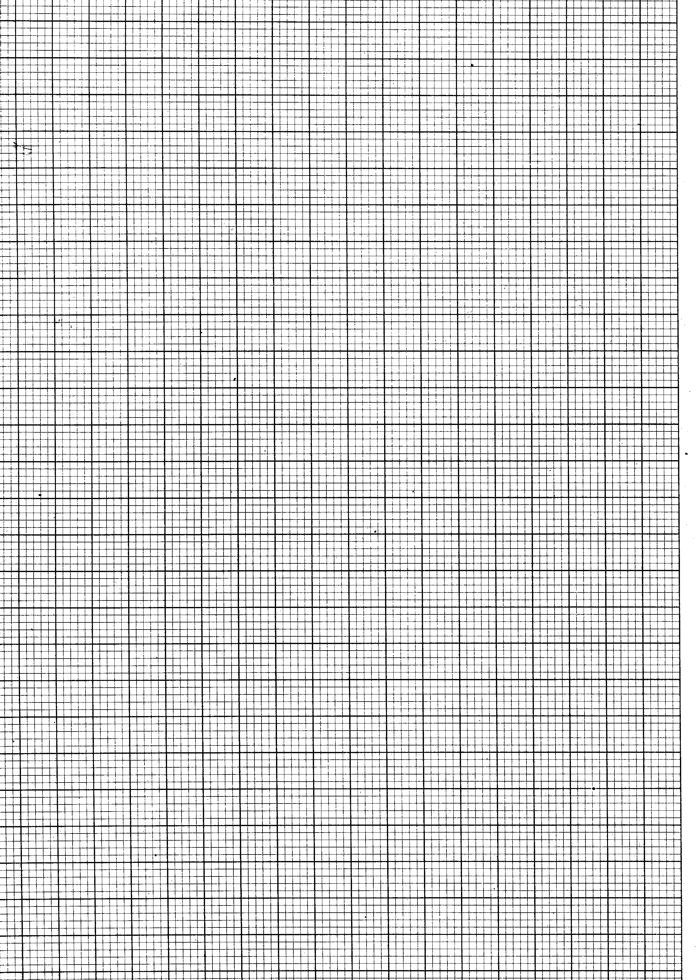
a) On the grid provided above, draw a cumulative frequency curve for the data. (4 marks)
Use the graph in (a) above to determine
i) The 60th percentile (1 mark)
ii) The quartile deviation (3 marks)

iii) The percentage of passion fruits to the nearest two decimal places whose masses lie in the range 21.5g to 58.5g. (2 marks)
- The third, fourth and fifth terms of a G.P are 2 ^{2x+2}, 128 and 4^{3x} respectively.
- Calculate the value of x (2mks)

- Find the common ratio of the series. (2mks)

- Calculate the sum of the first 10 terms of the series. (3mks)

- Given that the 2nd and 3rd terms of the G.P in (a) above form the first and the second terms of an A.P Calculate the sum of the first 30 terms of the A.P. (3mks)

- A quadrilateral ABCD is such that the vertices area A (1, 2),B (6,2),C (4,4) and D (2,4).

- $A'B'C'D'$is the image of $\text{ABCD}$under the transformation 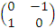. On the grid provided below. draw the quadrilateral ABCD and its image$A'B'C'D'$. (3 marks)
- $A\text{''}B\text{''}C\text{''}D\text{''}$is the image of $A'B'C'D'$under the transformation 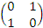 . On the same grid draw the image$A\text{''}B\text{''}C\text{''}D\text{''}$. (3 marks)

- Point $A\text{''}(6,−2)$is mapped onto $A\text{'''}(2,−2)$by a shear y axis invariant.
- Determine the shear matrix (2 marks)

- On the same grid show image $A\text{'''}B\text{'''}C\text{'''}D\text{'''}\text{.}$ (2 marks)
- a) Complete the table below by filling in the blank spaces. (2mks)

 | 0 | 30 | 60 | 90 | 120 | 150 | 180 | 210
 | -2 | -0.5 | 0.60
 | 2 | 1.73 | 1 |  |  | -1.73

b) On the same axes draw the graphs of and for 0° x 210°.
(5 Marks)

c) Use the graph to solve the equation ( 1mks)

d) State the amplitude of ( 2mks)
a)
b)

