Name: ………………………………………………………….. Class: ……..…..............................................

Date: …………………………………………………………… Adm No: ……………………………………..

MATHEMATICS

TIME: 2 HOURS 30 MINUTES

**FORM 1 MATHEMATICS 2019**

END OF TERM 2 EXAM

**INSTRUCTIONS TO CANDIDATES:**

* Write your name, admission number, Class, Signature and write date of examination in the spaces provided
* The paper contains two sections. Section I and Section II.
* Answer **ALL the questions** in section I
* Answer **ALL the questions** in section II.
* Answers and working must be written on the question paper in the spaces provided below each question.
* Show all steps in your calculations below each question.
* Marks may be given for correct working even if the answer is wrong.
* KNEC mathematical table may be used, except where stated otherwise.

**FOR EXAMINERS USE ONLY**

**SECTION I**

|  |  |  |  |  |  |  |  |  |  |  |  |  |  |  |  |  |  |
| --- | --- | --- | --- | --- | --- | --- | --- | --- | --- | --- | --- | --- | --- | --- | --- | --- | --- |
| Question | 1 | 2 | 3 | 4 | 5 | 6 | 7 | 8 | 9 | 10 | 11 | 12 | 13 | 14 | 15 | 16 | TOTAL |
| Marks |  |  |  |  |  |  |  |  |  |  |  |  |  |  |  |  |  |

**SECTION II**

**GRAND TOTAL**

|  |  |  |  |  |  |  |  |  |  |
| --- | --- | --- | --- | --- | --- | --- | --- | --- | --- |
| Question | 17 | 18 | 19 | 20 | 21 | 22 | 23 | 24 | TOTAL |
| Marks |  |  |  |  |  |  |  |  |  |

**SECTION I (50 MARKS)**

***Answer all the questions from this section***

1. (a) Write the following number in words. (2 marks)

10 001 001

(b) Write down in figures the number that is nine more than one hundred thousand.

(2 marks)

1. Evaluate without using mathematical tables or a calculator (3 marks)

$\frac{27.72 ×0.3876}{2.09×0.4284}$

1. Express the numbers 1470 and 7056, each as a product of its prime factors.

Hence evaluate $\frac{{ \left(1470\right)}^{2}}{\sqrt{7056}}$ leaving your answer in prime factor form (3 marks)

1. Three light signals have been set to flash at intervals of 15 seconds, 20 seconds and 24 seconds. If they all flash together at 8.13 am, when will they flash together? (3 marks)
2. Find the greatest number which when divided by 181 and 236, leave a remainder of 5 in each case. (3 marks)
3. Without using a calculator evaluate, (3 marks)
$$\frac{-8+\left(-5\right)×\left(-8\right)-(-6)}{-3+(-8)÷2×4}$$

4. Evaluate (3 marks)
$$\frac{\frac{1}{2}+\frac{1}{3}}{\frac{1}{7} of \left(\frac{2}{3}- \frac{1}{6}\right)}+ \frac{1}{2}$$

5. Express as a fraction in simplest form. (3 marks)
$$0.\dot{1}\dot{5}$$

6. Use mathematical tables to evaluate
7. $\sqrt{0.57}$ (2 marks)
8. ${\left(356.8\right)}^{2}$ (2 marks)
9. Simplify by factorization (3 marks)
$$\frac{2m-am-2y+ay}{2m+2y -am-ay}$$

10. If $x=2, y= -3 and z=5$ evaluate

$\left(x-y\right)- z$ (3 marks)

1. If $a :b=3 :4 and b :c=5 :7$ find $a :b :c$ (3 marks)
2. Calculate the volume of 1.5kg of cork if the density of cork is 0.25g/cm3. (3 marks)
3. A church service lasted 2 hours and 25 minutes. What time did it start if it ended at 12:15pm (3 marks)
4. The price of radio has been raised by 20% to sh.3600. What was the price before the increase? (3 marks)
5. A ball has a mass of 1.5kg. What is the weight of the ball near the surface of the moon where acceleration due to gravity is 1.6m/s2? (3 marks)

**SECTION II (50 MARKS)**

***Answer ALL the questions from this section***

1. A swimming pool 30m long is 1m deep at its shallow end and 4m deep at its deep end. The pool is 14m wide.
   1. Find the volume of water, in cubic metres, when the pool is full. (4marks)
   2. Calculate the volume of the swimming pool in cubic centimeters (2 marks)
   3. A circular pipe of diameter 14cm is used to empty the swimming pool. Water flows through pipe at a rate of 5m per sec. Calculate the time it would take, to the nearest minute, to empty the pool. (4marks)
2. (a) Four businessmen decided to buy a building. An agent was selling the building at

ksh.3, 800, 000. The agreement was that the buyer would first pay a deposit of 55% of

the total cost and the balance to be paid in one moth time. Find:

1. The amount of deposit paid. (2 marks)
2. The balance to be paid in one month’s time. (2 marks)

(b) The balance was paid in the ratio 1:2:3:6.

Calculate:

1. The money paid by the second highest contributor. (2 marks)
2. The difference between the money paid by the highest and lowest contributors. (4 marks)
3. Kamua uses $1/4$ of his land to plant vegetables. He uses $1/3$ of the remaining land to plant maize. He uses $1/5$ of the remainder to plant beans. The rest of the land is used for grazing. 30 hectares of land are used for grazing.
4. Determine the size of Kamau’s land used to plant maize. (5 marks)
5. In 2018 he harvested 18 bags of beans in every hectare under beans. He sold $4/5$ of the total bags harvested and kept the rest for family use. The cost of every bag of beans is Kshs. 2000. Determine:
6. The total number of bags of beans harvested that year. (3 marks)
7. The total amount of money received from the sale of beans. (2 marks)
8. The floor of a municipal hall is in the shape of a rectangle whose length is 80 metres and width is 62 metres.
9. Calculate the area of the floor of the hall. (2 marks)
10. The floor is covered with tiles leaving a region of 2 metres round the hall as shown in the figure below.

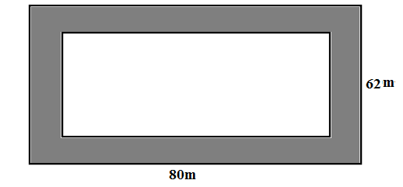

Calculate:

1. The area of the floor covered with the tiles. (2 marks)
2. The area of the floor not covered with the tiles. (2 marks)
3. The square tiles used measures 0.5m by 0.5m. The tiles are packed in cartons, each containing 16 tiles. Determine the number of cartons used. (4 marks)
4. The diagram below shows a solid block measuring 5.8m long, 40cm long and 30cm high.

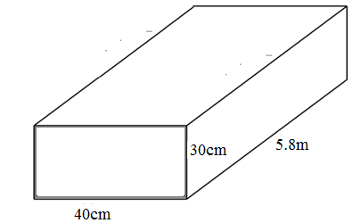

1. Calculate the volume of the block in m3 (3 marks)
2. A circular hole of radius 14cm is drilled right through the bottom block as shown below.

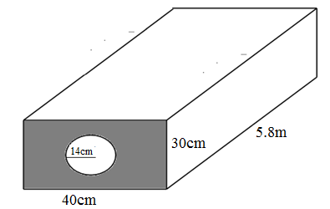

Calculate:

1. The volume of the material removed in m3 (Take π = (3 marks)
2. The volume of the remaining solid in m3 (2 marks)
3. If the density of the block is 3.5 g/cm3, find the mass of remaining solid in kilograms (2 marks)