MARKING SCHEME
FORM II MATHEMATICS
END TERM 1
2020
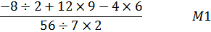

= 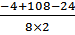

=

= 5
Distance = 56 X

= 140 KM
2

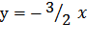 + ½ M= 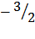
when y = 0, 3=1, 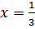

(,0)

when = 0, 2=1, 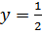
3

0.1555 + 0.2809 2 + 0.1175
= 0.1555 + 0.5618 + 0.1175
= 0.8348
= 0.835
2
X []

= 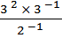 = 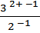

= 3¹X 2¹
= 6 3

Area = ½ X 7.5 X X 2

= 34.5 cm²
2
Let daughter’s age be y yrs
Fathers age is 3y yrs
3y+12 = 2(y+ 12)
= 2y + 24
y = 24-12
= 12
Fathers age is 12 3 = 36 yrs
3
No. | Log
37  37²  0.168  75.63  7.4268 x 10⁻¹  0.74268 | 1.5682  1.5682  2  3.1364  .2253  1.3617  1.8787–  .4830 x ¼  .8708  4
+

D =

V = 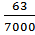 = 0.009 m³ = 0.009 X 100000
= 9000 cm³

X – section area = 12 x 15 – 12 x10
= 180 – 120
= 60 cm²

Volume = x – section area x length
Length of pipe = 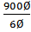
=150 cm
=1.5 m
4

y = + 5
M₁ = M₂ =
y = + c ═ c = 5- ⁻²

= 4 or

y = 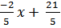 or 5y + 2 = 21
4
………………… (i)
………………… (ii)

………………….(i) x 2
+ ………………..(ii) x 3

= = 2
From equation (i)
2 x 2 + 3y =1

3y = 1 – 4

y =
= -1
4
M. P x = 3150

M. P = 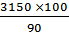

= 3500/=
2
3.
10 37.1717…
100 3717.1717…
10 -10 3717.1717-37.1717
990 = 3680
= 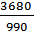
=
= 3
3

Days Huts People
30 5 7
27 9 ?

No. of day decrease, workers increase in the ratio
30:27
No. of huts increase, workers increase in the ratio
9:5

People required = 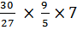

= 14
3
6
= 30
Angle of triangle ata the centere of polygon
=

Number of sides =

= 12
3
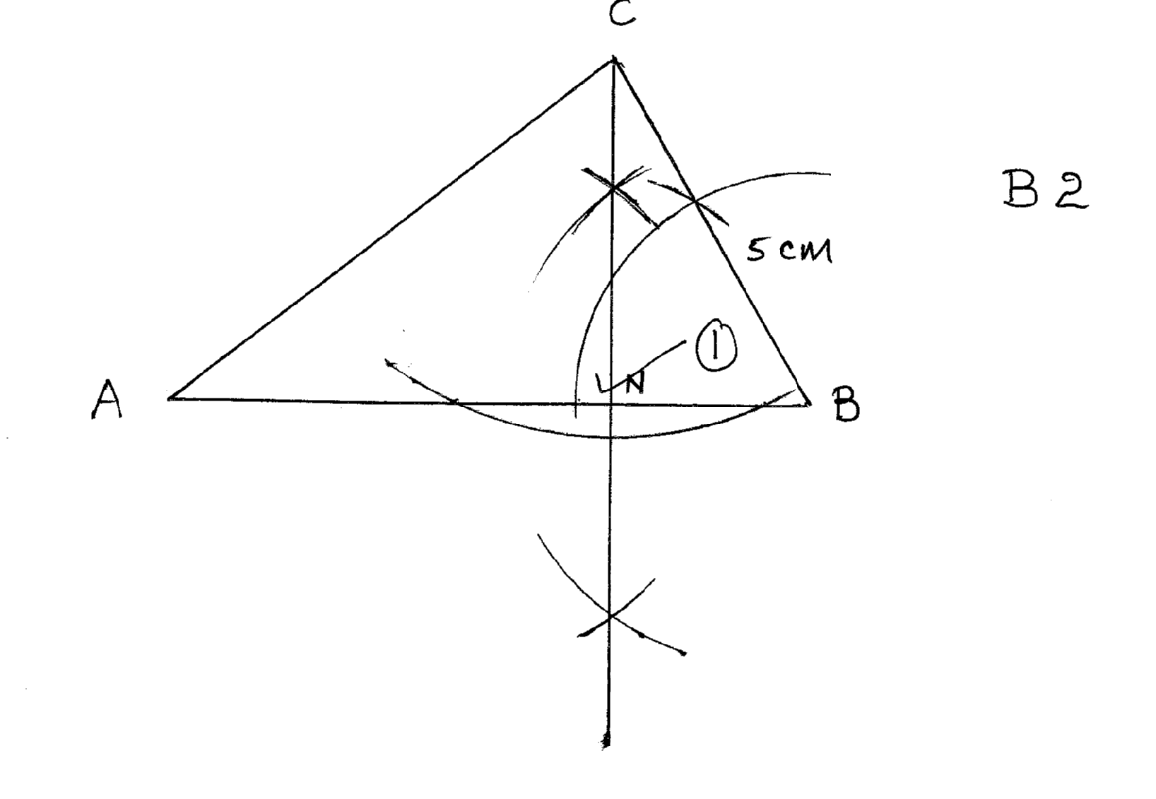
CN = 4.3 CM B1

AB = 8 CM.

Area of = ½
= 20 cm² A1
5
  - 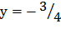 + 4
 | -2 | 0 | 2
y | 7 | 4 | 1
 | -2 | 0 | 2
y | -7 | -3 | 1

All 4 – 3
3 – 2
2 – 1
3
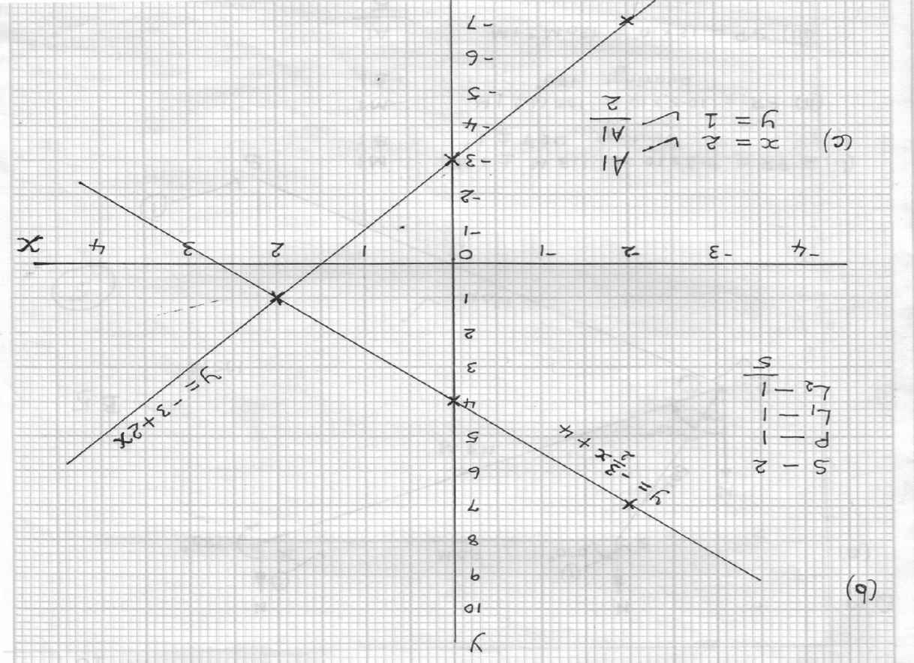

Area of ceiling (10x7) = 70 m² B2
Area of walls (7 x 4)2 = 56 m² B2
Area of walls (10 x 4)2 = 80 m² B2

Total surface area = 70 +56 + 80 = 206 m² B2
Cost of painting = 206 x 200 M1
= 41,200 A1
10
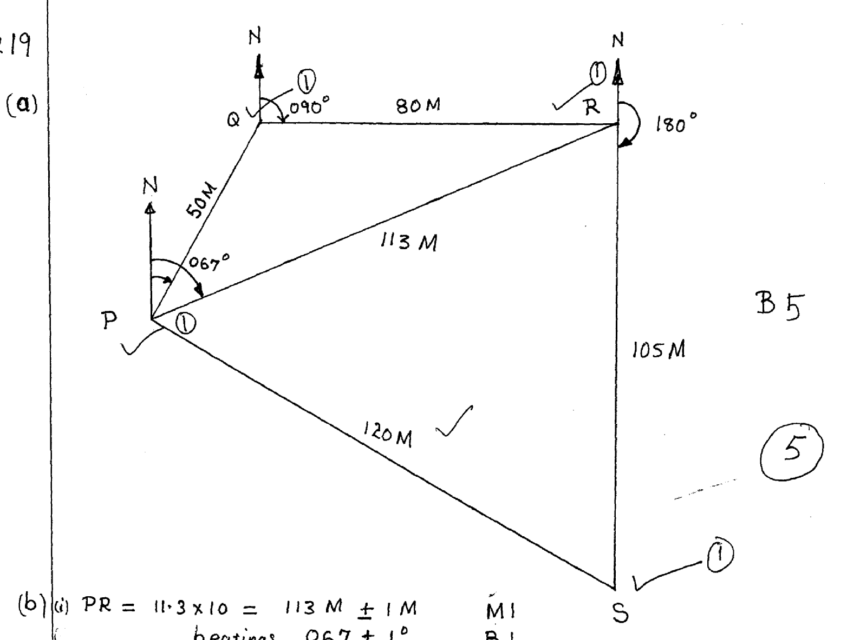

- (i) PR =11.3 x 10 = 113 M M1
(ii) PR = 11.3 X10 = 113M B1
Bearings 067 1
(iii) SR = 10.5 x10 = 105 M M1
Bearings 180 A1
5
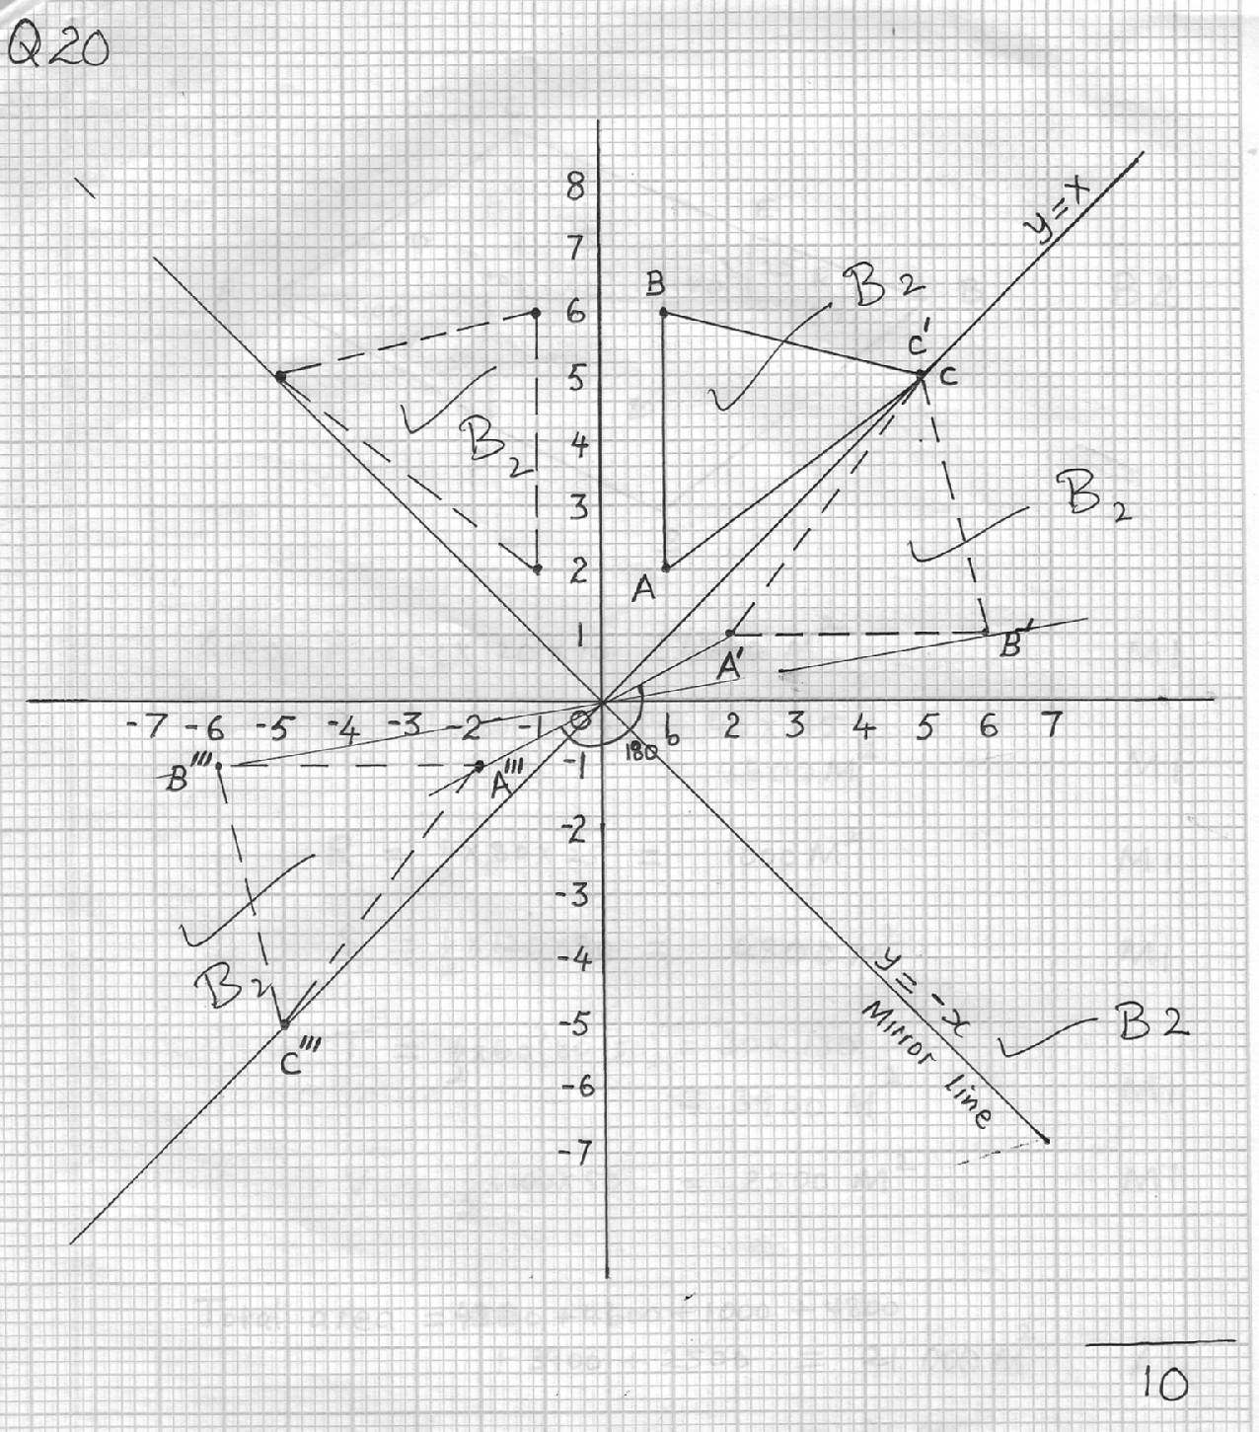
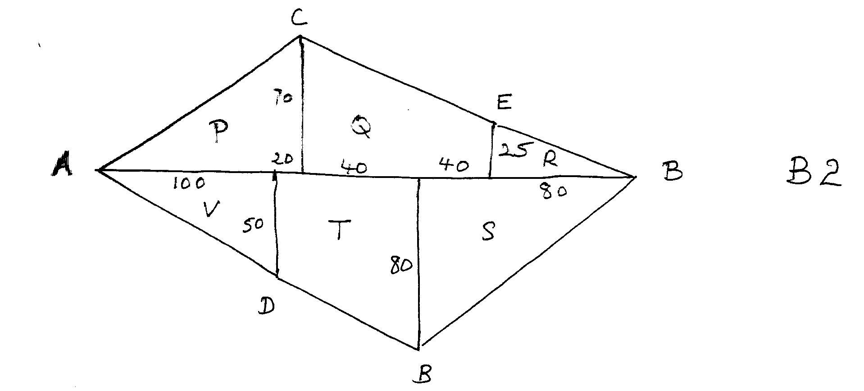

Area P = ½ x 120 x 70 = 4200 m² M1
Q = ½ x 80 (75+40)=40x115
4600 m² M1
R = ½ x 80 x 25 = 1000 m² M1
S = ½ x 120 x80 = 4800 m² M1
T = ½ x 60 (80 +50)= 30 x130
3900 m² M1
V = ½ x 100 x 50 = 2500 m² M1

Total Area = 4200+4600+1000+4800+3900+2500 = 21 000 m² A1

= 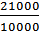

= 2.1 ha A1
10

