Form 2

MATHEMATICS

MARKING SCHEME

SECTION I (50 MARKS)
NO | WORKING | MARKS | REMARKS
 | No Log Working  41.07 1.6135 +  0.03142 2.4972  0.1107  0.0156 2.1931 + 0.3824  5.8941 0.7704 1.1472  2.9635 3  1.1472  2.422 0.3824 | M1  M1  M1  A1 | All logs  Addn & Subtr  Attempt to divided by 3  C.A.O
 |  | 4
 | $$\frac{36- 8 ×-4 - 15 - 3}{3 ×-3 + -8 \{ 6- \left(-2\right)\}}$$  Numerator: 36 –8 $×$–4 + 5 = 36 + 32 + 5 = 73  Denominator : 3 $×$–3 + –8(8) = –9 – 64 = – 73  ∴ $Quotient= \frac{73}{-73}= -1$ | M1  M1  A1 | Simplification of the num.  Simplification of the den.
 |  | 3
 | 130 x 1600 = 2080  100  80% = 2080  1% = 2080  80  100% = 2080 x 100  80  = sh.2600 | M1  M1  A1
 |  | 3
M1

M1
A1
 |  | 3
 | sum of interior angles of n-sided polygon  = (n - 2) 180  (n - 2) 180 = 1260  180_{n} - 360 = 1260  180n = 1620  n = 1620 = 9  180  exterior angle = 360= 360 = 40º  n 9 | M1  M1  A1
 |  | 3
 | 247 - 7 = 240  367 - 7 = 360  607 - 7 = 600  2 x 2 x 2 x 3 x 5 = 2³ x 3 x 5 = 120 | M1  M1  A1 | Subtracting 7 from each number  Correct table
 |  | 4
 | let cost of trousers = x  let cost of shirt = y  3 (3x + 2y = 2400)  2(2x + 3y = 1975)  9x + 6y = 7200  4x + 6y = 2950  5x = 4250  x = 4250  5  = 850 (cost of trouser)  3x + 2y = 2400  3(850) + 2y = 2400  2250 + 2y = 2400  2y = 2400 - 2250  2y = 150  y = 75 (cost of shirt)  cost of 1 trouser + 4 shirts  850 + (4 x 75) = 850 + 300 = sh.1150 | M1  M1  A1
 |  | 3
M1

M1

A1
 |  | 3
 | Let $a=4.2\dot{5}$  10a = 42.55555...  100a = 425.5555...  100a – 10a = 425.55555... – 42.55555...  90a = 383  $$a= \frac{383}{90}$$  $$a=4\frac{23}{90}$$  Therefore x = 23 | M1  M1  A1
 |  | 3
 | Mass = density x volume  = 2.5 x 314.2  = 785.5g  = $\frac{785.5}{1000}=0.7855kg$  $$weight=mg$$  $$weight=0.7855kg ×10=7.855N$$ | M1  M1  A1
 |  | 3
 | $=\left(\frac{2^{4}}{3^{4}}\right)$^{-3/4} x $2^{9}$  =$\frac{2^{-3}}{3^{-3}}$ x $2^{9}$  = $\frac{2^{6}}{3^{-3}}$  = $2^{6}$ x $3^{3}$ | M1  M1  A1
 |  | 3
 | $=\frac{1}{17.62}$=$\frac{1}{1.7662 ×{10}^{1}}=\frac{0.5675}{10}=$ 0.05676  $${=5.318}^{2}=28.281$$  $=0.05676+$28.281  $$=28.33776$$  $=28.34$ (4 significant figures) | M1  M1  A1
 |  | 3
 | $$sin{30}^{0}=\frac{h}{12}$$  $$h =12sin{30}^{0}$$  $$=6cm$$  A = bh  $$=20×6$$  $$=120{cm}^{2}$$ | M1  M1  A1
 |  | 3
 | 2 30 15 84  2 15 15 42  3 15 15 21  5 5 5 7  7 1 1 7  1 1 1  7x5x3x2x2 = 420 seconds = $\frac{420}{60}=7 minutes$  11.00 pm + 7 mins  11:07 p.m | M1  M1  A1
 |  | 3
 | Ø = $180-\left(80+70\right)= {30}^{0}$  $$Area= \frac{1}{2}ab\sin{Ø}$$  $$Area= \frac{1}{2}×13×15×\sin{{30}^{0}}$$  $$Area= 48.75{cm}^{2}$$ | M1  M1  A1
 |  | 3
 | $$\frac{0.0084 ×1.23 ×3.5 × {10}^{7}}{2.87×0.056 ×{10}^{7}}$$  $$\frac{84 ×123 ×35}{287×56 ×100}$$  $$\frac{9}{40}$$ | M1  M1  A1
 |  | 3

SECTION II (50 marks)
a) L₁ : y - 2 = -1
x + 1 2
2y - 4 = -x - 1
2y - 4 = -x - 1
y = -¹/₂x + ³/₂

b) L₂ : m = 6 - -3 9
4 - 2 2
y - 6 = 9
x - 4 2
2y - 12 = 9x - 36
2y = 9x - 24
y = ⁹/₂x – 12

c) -¹/₂x + ³/₂ = ⁹/₂x - 12
-5x = -13½
x = ²⁷/₂ x ¹/₅
= ²⁷/₁₀, y = ³/₂₀
point of intersection (²⁷/₁₀, ³/₂₀)

d) y - 6 = -1
x - 4 2
2y - 12 = -x + 4
2y = -x + 16
y = -½x + 8

e) gradient of L₂⁹/₂
new gradient -²/₉
y - -2 = -2
x - -2 9
9y + 18 = -2x - 4
9y = -2x - 22
y = -²/₉x - ²²/₉

 |  | 10
 | - Managers annual salary =$4500×12$  $=$ Sh. 54 000  - Retained profit = $\frac{20}{100}×365 000$  $$=Shs. 73 000$$  - Ratio of contribution = 2:3  Net profit = $365 000-\left(54 000+73 000\right)$  $=Sh. 238 000$  $$Net profit =Sh. 238 000$$  - Meshack share = $\frac{2}{5}×238 000$  $$=Sh. 95 200$$  Kelvin share = $\frac{3}{5}×238 000$  $$=Sh. 142 800$$ | M1  A1  M1  A1  M1  A1  M1  A1  M1  A1
 |  | 10
 | a) Area of hemispherical part  = ¹/₂ x 4r²  = 2 x ²²/₇ x 35 x 35  = 7700cm³  b) Slant height for original cone  l = 35  l - 60 1  L = 100  surface area RL = rl  = ²²/₇ x 35 x 100 - ²²/₇ x 14 x 40  = 11000 - 1760  = 9240cm²  c) Total surface area  7700 + 9240 + ²²/₇ x 14²  = 7700 + 9240 + 616  = 17556cm² | M1M1  A1  M1  M1  M1  A1  M1  M1  A1
 |  | 10

- A¹(-3, 1) B¹(-5, 5) C¹(-3, 4) D¹(-1,4)

- A¹¹ (-3, -4) B¹¹(-5, -5) C¹¹(-3, -4) D¹¹ (-1, -4)

 |  | 10
 | 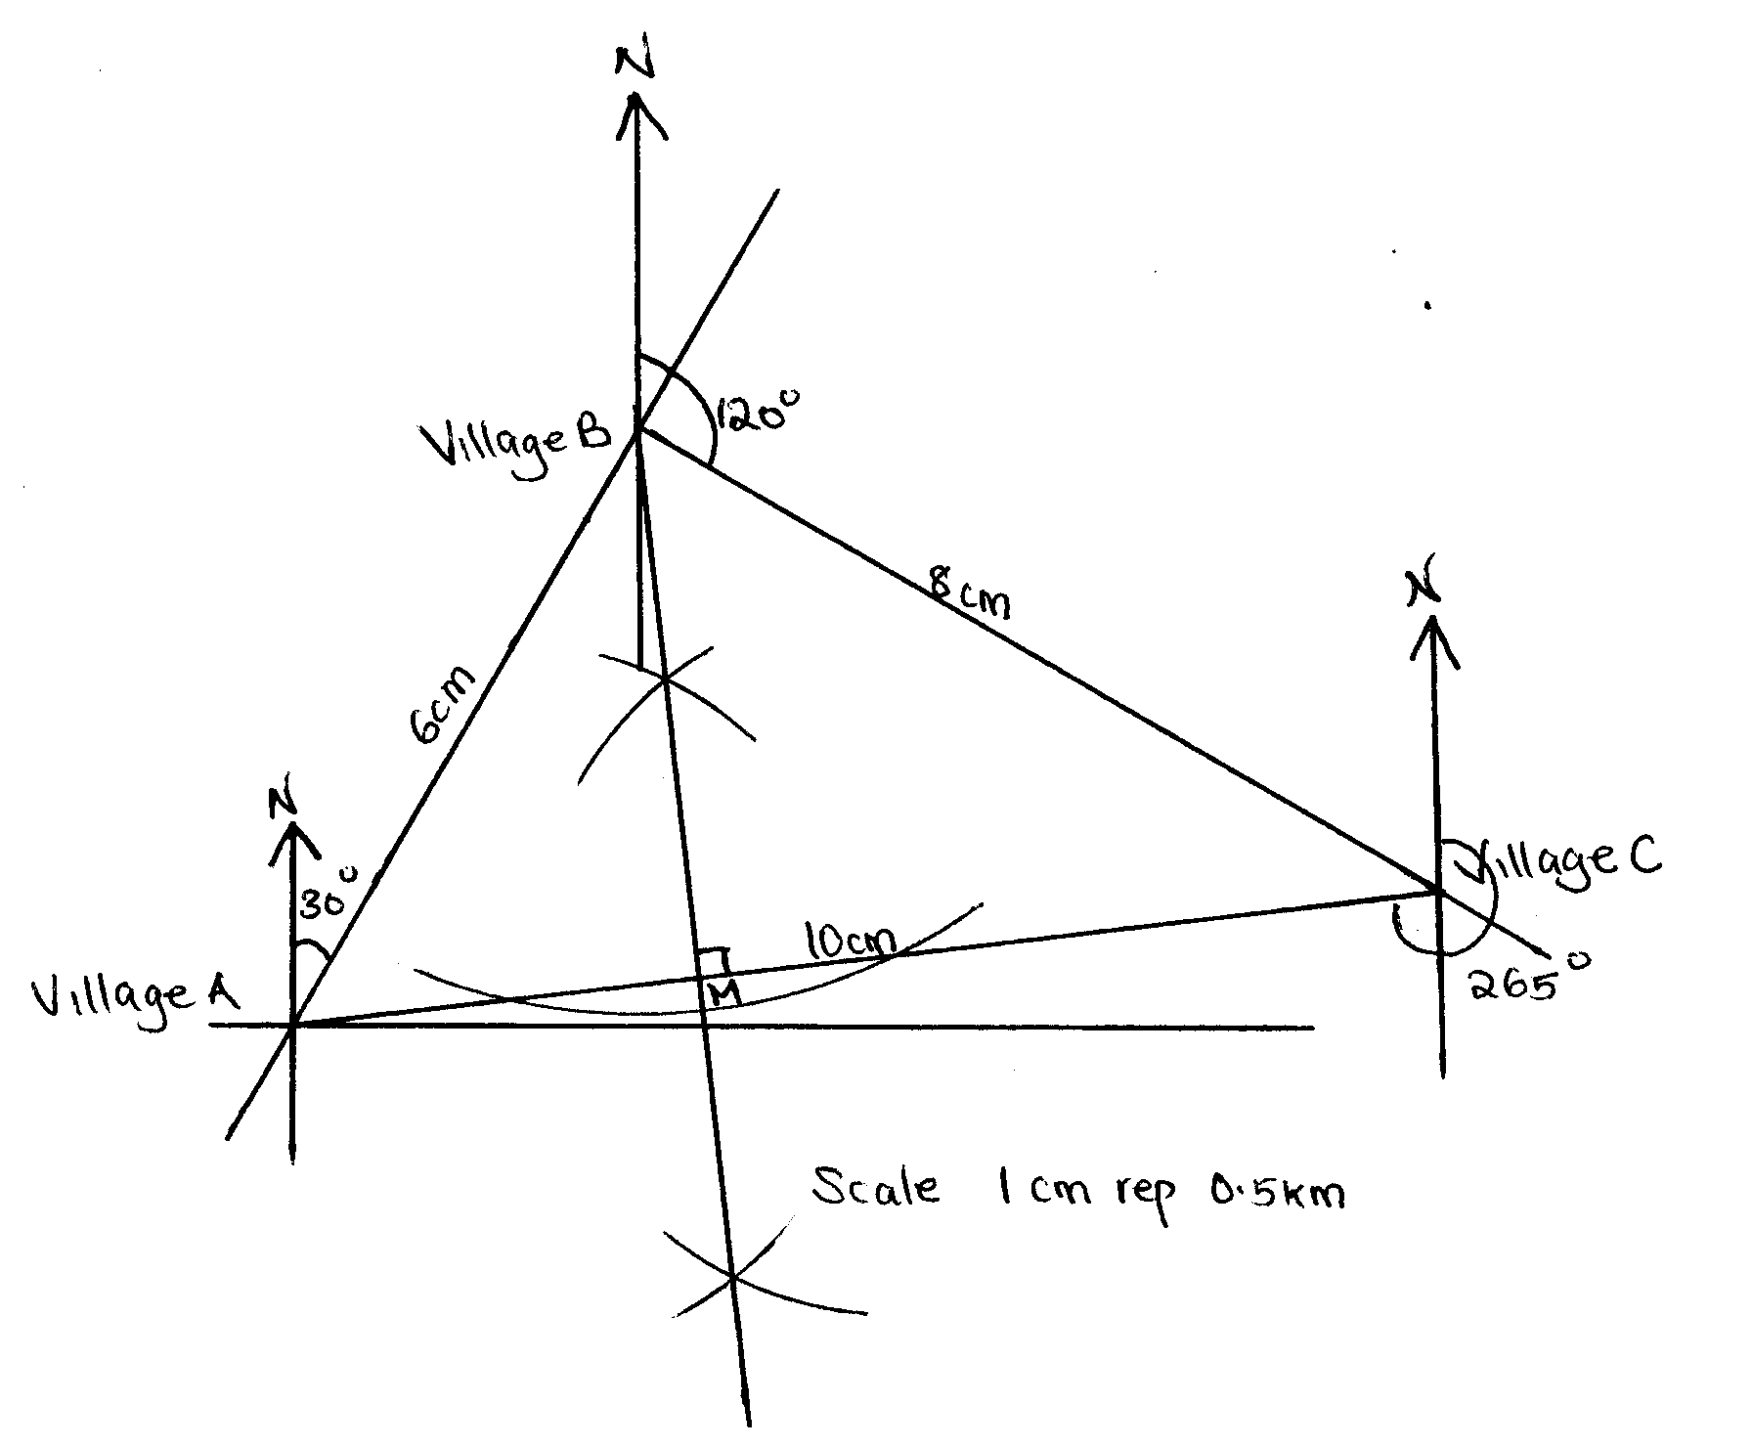 | B1  B1  B1  B1  B1  M1  A1  B1  B1  M1  A1 | Position of B & C  measurements  relative positions of A, B & C
 |  | 10
 | 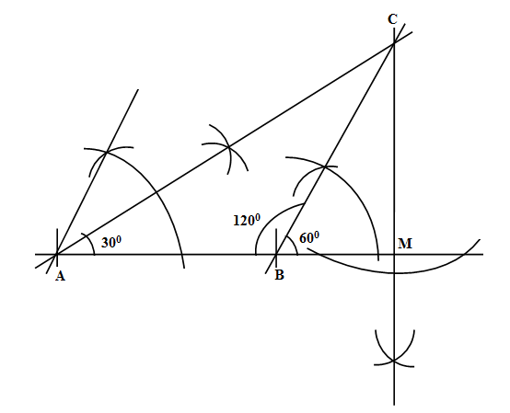  - Line BC = $7.0±0.1cm$  - Line BC = $12.0±0.1cm$  Dropping perpendicular  M labeled  - CM = 6.1 $±0.1cm$  - $Area= \frac{1}{2}×7×6.1$  $=21.35 ±0.35$ | B1  B1  B1  B1  B1  B1  B1  B1  M1  A1 | Line AB drawn  Angle ABC and ABC drawn  Triangle ABC  Dropping perpendicular  M labeled
 |  | 10
 | - Air ticket = $\frac{1}{4}$  Remainder = $\frac{4}{4}- \frac{1}{4}= \frac{3}{4}$  Meals = $\frac{1}{4} of \frac{3}{4}= \frac{1}{4} × \frac{3}{4}= \frac{3}{16}$  Air ticket + meals = $\frac{1}{4}+\frac{3}{16}= \frac{7}{16}$  Remainder = $\frac{16}{16}- \frac{7}{16}= \frac{9}{16}$  Accomodation = $\frac{1}{9} of \frac{9}{16}= \frac{1}{9} × \frac{9}{16}= \frac{1}{16}$  Air ticket + meals + Accomodation  = $\frac{1}{4}+\frac{3}{16}+\frac{1}{16}= \frac{8}{16}=\frac{1}{2}$  Remaining = $\frac{1}{2}$  Gift = $\frac{1}{3} of \frac{1}{2}= \frac{1}{3} × \frac{1}{2}= \frac{1}{6}$  Air ticket + meals + Accomodation+Gift  = $\frac{1}{4}+\frac{3}{16}+\frac{1}{16}+\frac{1}{6}= \frac{2}{3}$  Remainder = $\frac{1}{3},$Therefore $\frac{1}{3}=12 600$  Total April salary = $\frac{3}{1} ×12 600=shs.37800$  - Meals  $$=\frac{3}{16} ×37800$$  $$=shs. 7087.5$$  - Accommodation  $$=\frac{1}{16} ×37800$$  $$=shs. 2362.5$$  - Gift  $$=\frac{1}{6} ×37800$$  $$=shs. 6300$$ | M1  M1  M1  A1  M1  A1  M1  A1  M1  A1
 |  | 10
 | 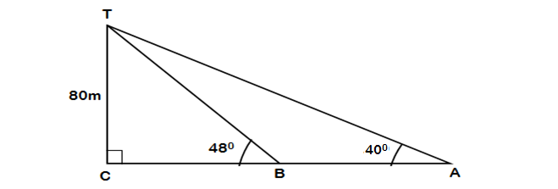  - $\operatorname{Tan}{{40}^{0}= \frac{80m}{CA}}$  $$\operatorname{CA}{= \frac{80m}{Tan{ 40}^{0}}}$$  $$\operatorname{CA}{= 95.34m (}4 s.f.)$$  - $\operatorname{Tan}{{48}^{0}= \frac{80m}{CB}}$  $$\operatorname{CB}{= \frac{80m}{Tan{ 48}^{0}}}$$  $$\operatorname{CB}{= 72.03m (}4 s.f.)$$  $$BA=CA-CB$$  $$BA=95.34m-72.03m$$  $$=23.31m$$  - $angle BTA=angle CTA-angle CTB$  $$={50}^{0}-{42}^{0}$$  $$=8^{0}$$ | M1  M1  A1  M1  M1  A1  M1  A1  M1  A1
 |  | 10

