Name: ………………………………………………………….. Class: ……..…..............................................

Date: …………………………………………………………… Adm No: ……………………………………..

MATHEMATICS

TIME: 2 HOURS 30 MINUTES

**FORM 2 MATHEMATICS 2019**

END OF TERM 2 EXAM

**INSTRUCTIONS TO CANDIDATES:**

* Write your name, admission number, Class, Signature and write date of examination in the spaces provided
* The paper contains two sections. Section I and Section II.
* Answer ALL the questions in section I
* Answer any five questions in section II.
* Answers and working must be written on the question paper in the spaces provided below each question.
* Show all steps in your calculations below each question.
* Marks may be given for correct working even if the answer is wrong.
* KNEC mathematical table may be used, except where stated otherwise.

**FOR EXAMINERS USE ONLY**

**SECTION I**

|  |  |  |  |  |  |  |  |  |  |  |  |  |  |  |  |  |  |
| --- | --- | --- | --- | --- | --- | --- | --- | --- | --- | --- | --- | --- | --- | --- | --- | --- | --- |
| Question | 1 | 2 | 3 | 4 | 5 | 6 | 7 | 8 | 9 | 10 | 11 | 12 | 13 | 14 | 15 | 16 | TOTAL |
| Marks |  |  |  |  |  |  |  |  |  |  |  |  |  |  |  |  |  |

**SECTION II**

**GRAND TOTAL**

|  |  |  |  |  |  |  |  |  |  |
| --- | --- | --- | --- | --- | --- | --- | --- | --- | --- |
| Question | 17 | 18 | 19 | 20 | 21 | 22 | 23 | 24 | TOTAL |
| Marks |  |  |  |  |  |  |  |  |  |

**SECTION I (50 MARKS)**

***Answer all the questions from this section***

1. Use logarithm tables only to evaluate to 4 decimal places (4 marks)

$$\sqrt[3]{\frac{41.07 ×0.03142}{0.0156 ×5.8941}}$$

1. Without using a calculator, evaluate (3 marks)

$$\frac{36- 8 ×-4 - 15 - 3}{3 ×-3 + -8 \{ 6- \left(-2\right)\}}$$

1. A tailor bought a pair of trousers at sh.1600. He marked the price such that after allowing his discount of 20% he would still make a profit of 30% on the cost price. Determine the price at which the pair of trousers was marked. (3 marks)
2. In the figure below, AC is an arc of a circle centre B. Given that AB = BC = 14cm,CD =8cm and angle ABD = 750

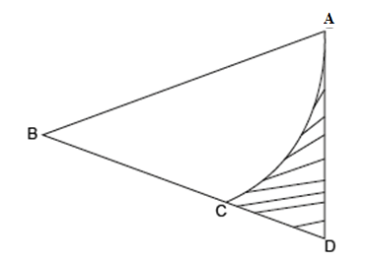

Calculate the area of the shaded region (3 marks)

1. A regular polygon has the sum of all its interior angles as 1260o. Find the size of each exterior angle of the polygon. (3 marks)
2. Find the greatest number which when divided by 247, 367 and 607 leaves a remainder of 7 in each case. (3 marks)
3. The cost of 3 pairs of trousers and 3 shirts is sh.2400. The cost of two pairs of trousers and 3 shirts is 1975. Find the cost of one pair of trousers and 4 shirts. (3 marks)
4. Two similar solid have surface area of 48cm2 and 108cm2 respectively. Find the volume of the smaller solid if the bigger one has a volume of 162cm3. (3 marks)
5. Given that $4.2\dot{5}=4\frac{x}{y}$, where x and y are whole numbers determine the value of $x$ (3 marks)
6. A solid sphere whose volume is 314.2cm3 is made up of a material whose density is 2.5g/cm3. Calculate the weight of the sphere given that the acceleration due to gravity is 10m/s2 (3 marks)
7. Without using mathematical tables or a calculator evaluate, leaving your answer in power form. (3marks)
$${\left(\frac{16}{81}\right)}^{{-3}/4}×{512}^{2/3}$$

8. Use reciprocal and squares tables to evaluate, to 4 significant figures. (3marks)
$$\frac{1}{17.62}+ {5.318}^{2}$$

9. The figure below shows a parallelogram ABCD.

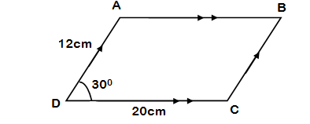

Given that AB=DC= 20cm and AD=BC=12cm AND angle ADC=300, find the area of parallelogram ABCD. (3mks)

1. Three alarms ring at intervals of 30 seconds, 15 seconds and 84 seconds. The alarms ring together at 11.00 p.m. Find the time the alarms will next ring together. (3 marks)
2. In the triangle PQR below PR = 13cm, PQ = 15cm, angle PQR=800 and angle PRQ =800

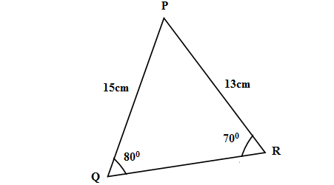

Calculate the area of the triangle PQR (3 marks)

1. Evaluate without using mathematical tables or a calculator,

$\frac{0.0084 ×1.23×3.5}{2.87×0.056}$

Express your answer as a single fraction. (3marks)

**SECTION II (50 MARKS)**

***Answer five questions only from this section***

1. A straight line L1 which passes through A($-$ 1, 2) has a gradient of $-\frac{1}{2}$. Another straight line L2 passes through the points B (2, $-$ 3) and C(4, 6). Determine :
2. The equation of L1 in the form y = mx + c (2 marks)
3. The equation of L2 in the form y = mx + c (2 marks)
4. The coordinates of the point of intersection of lines L1 and L3 (2 marks)
5. The equation of a line through C and parallel to L1 in the form $y=mx+c$ (2 marks)
6. The equation of the line passing through D($-$ 2, $-$ 2) and perpendicular to L2 in the form $y=mx+c$ (2 marks)

1. Meshack and Kelvin contributed shs. 60,000 and sh. 90,000 respectively in order to start business. They employed a manager and agreed to pay him sh. 4,500 per month from the profit made each year. They also agreed that 20% of the profit made each year would be put back into the business while the rest would be shared between them in the ratio of their initial contribution. During the first year they made a profit of sh. 365,000. Calculate:-
2. The manager’s annual salary for that year (2 marks)
3. The money put back into business that year. (2marks)
4. The business net profit for that year. (2marks)
5. How much each partner received that year. (4marks)
6. The figure below represents a model of a solid structure in the shape of a frustum of a cone with hemispherical top. The diameter of the hemispherical part is 70cm and is equal to the diameter of the top of the frustum. The frustum has a base diameter of 28cm and a slant height of 60cm.

Calculate, taking  = $\frac{22}{7}$

**a)**  The area of the hemispherical surface. (3 marks)

**b)** The surface area of the curved surface (4 marks)

**c)** The total surface area of the model. (3 marks)

1. A(1,3) B(5,5) C (4,3) and D(4,1)are the vertices of quadrilateral ABCD.
2. On the grid draw quadrilateral ABCD (2marks)
3. Quadrilateral A′B′C′D′ is the image of ABCD under a positive quarter turn about the origin. On the same grid draw A′B′C′D′ and state its co−ordinates. (3marks)
4. A′B′C′D′ is mapped onto quadrilateral A′′B′′C′′D′′ by a reflection on the x−axis. On the same grid draw A′′B′′C′′D′′and state its co−ordinates. (3marks)
5. Under a reflection on line PQ quadrilateral A′′B′′C′′D′′ is mapped back onto ABCD. On your graph draw the minor line PQ and give its equation. (2marks)
6. Three villages A, B and C are such that B is 3km on a bearing of 0300 from A; C is 4km on a bearing of 1200 from B.
   1. Using a scale of 1cm to represent 0.5km, **draw** a scale diagram to show the relative positions of the village A, B and C. (5marks)
   2. **Find** the distance and bearing of village A from C. (3mks)
   3. A straight main road runs from village A to C. **Find** the length of the shortest path from village B to the main road. (2marks)
7. Triangle ABC is such that AB = 7cm, angle ABC = 1200 and angle BAC = 300.
8. Using a ruler and a pair of compass only, construct triangle ABC. (3 marks)
9. Measure the length of:
10. Line BC (1 mark)
11. Line BC (1 mark)
12. Drop a perpendicular from C to meet line AB extended at M. (2 marks)
13. Measure the length of line CM (1 mark)
14. Calculate the area of triangle ABC (2 marks)
15. Musyoka spent $\frac{1}{4}$ of his net April salary on air ticket to travel from Machakos to Kitui. He spent $\frac{1}{4}$ of the remainder on meals while on the journey. He spent $\frac{1}{9}$ of the remainder on accommodation. He spent $\frac{1}{3}$ of what was remaining to buy a gift for his wife. If he was left with sh.12 600, calculate
16. His total April salary. (4 marks)
17. Money spent on meals. (2 marks)
18. Money spent on accommodation. (2 marks)
19. Money spent on the gift for the wife. (2 marks)
20. The figure below shows the positions of a boat A which is observed sailing directly towards the pier C at the base of a vertical cliff CT. The angle of elevation of the top of the cliff from A is 400. After 10 seconds the boat is at point B and the angle of elevation of T is now 480.

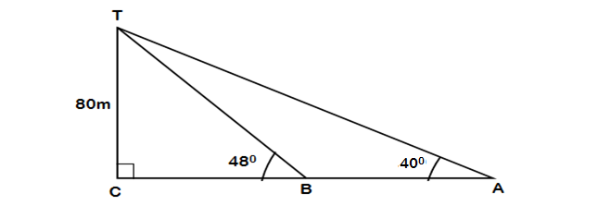

If the high of the cliff is 80m, calculate:

1. The distance CA (3 marks)
2. The distance BA (5 marks)
3. Calculate the size of angle BTA (2 marks)