**NAME…………………………………………………………ADM NO…………………….CLASS……………….**

**MATH PAPER 1, FORM 3 TERM III, 2016 TIME: 2 ½ HOURS**

*SECTION I-(answer* ***all*** *the 16 question in this section-50MARKS)*

1. Use tables of square roots and reciprocals tables to evaluate to 3 decimal places the

problem below.

 (3marks)

1. The heights of two similar pails are 12cm and 8cm. The larger pail can hold 2 litres.

What is the capacity of the smaller pail? (3 marks)

3.Find the equation of the perpendicular bisector of the line AB where A is (3, 9) and B is

(7, 5) giving your answer in the form ax + by + c = 0. (3 marks)

4. Mr. Ochuodho who deals in electronics sells a radio to a customer at Kshs. 1,440 after giving him a discount of 10% but finds that he still makes a 20% profit. Find the profit Mr. Ochuodho would make if he does not give a discount. (3mks)

5. Simplify the expression

 (3marks)

6. Solve for x in  (4marks)

7. The length and width of a rectangle are stated as 18.5cm and 12.4cm respectively. Both measurements are given to the nearest 0.1cm.

1. Determine the lower and upper limit of each measurement. (1 mark)
2. Calculate the percentage error in the area of the rectangle. (3 marks)

8. In a regular polygon, each interior angle is *xo* and each exterior angle is 

1. Find angle *Xo* (1mk)
2. Find the number of sides of the polygon (2mks)

9.Find the integral values of *x* which satisfy the following inequalities;

*2x + 3 > 5x – 3 > -8* (3mks)

10.Two boys and a girl shared some money. The younger boy got  of it; the elder boy got  of the remainder and the girl got the rest. Find the percentage share of the younger boy to the girl’s share. (3mks)

11. Simplify the expression below leaving your answer in rationalized surd form of a + b

(3mks)

12. Mutua bought 8 pairs of trousers and six shirts at Sh. 4160.if Had he bought twice as many shirts and half as many trousers, he would have saved Sh. 160. Find the cost of each item (3 marks)

13.A solid block in the shape of a cylinder has a height of 14cm and weighs 22kg. If it is made of material of density 5g/cm3, find the radius of the cylinder. Take π= (3mks)

14. The number 5.81 contains an integral part and a recurring decimal. Convert the number into an improper fraction and hence a mixed fraction. (3 Marks)

15.Using a pair of compasses and a ruler only construct a triangle ABC such that AB= 4cm,

BC = 6cm and angle ABC = 135°. (3mks)

16. The curved surface area of a cylindrical container is 1980cm2. If the radius of the container is 21cm, calculate to one decimal place the capacity of the container in litres (3 mks)

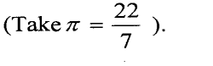

**SECTION II ANSWER ANY FIVE QUESTIONS**

17(a) Train A leaves a station 45 minutes before train B. Both trains travel in the same

direction and their speeds are 36km/h and 48km/h respectively.

1. How long will it take train B to catch up with train A? (3 marks)
2. How far from the start were the two trains when they met. (2 marks)

b) A car accelerated from rest to a velocity of 10m/s in 10 seconds. It travelled at this velocity for 20 seconds and then came to a stop in 5 seconds. Find;

1. The initial acceleration. (2 marks)
2. The distance travelled. (2 marks)
3. The average velocity. (1 mark)

18. Two circles with centres O and Q and radii 8cm intersect at points A and B as shown below. 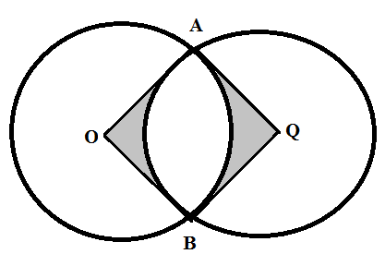

Given that the distance between O and Q is 12cm and that the line AB meets OQ at X, find:

(a) the length of the chord AB. (3marks)

(b) the reflex angle AOB. (3marks)

(c) the area of the shaded region.  (4marks

19.A triangle whose vertices are A(1,4) B(2,1) and C(5,2) is given the following transformations.

1. A reflection along the line y = x to $A^{1}B^{1}C^{1}$
2. $A^{1}B^{1}C^{1}$ is given a rotation of a positive quarter turn about the origin $A^{11}B^{11}C^{11}$
3. $A^{11}B^{11}C^{11}$ is given an enlargement of linear scale factor -2 about (1,2) to $A^{111}B^{111}C^{111}$
4. Using the grid provided, plot the triangle ABC and its image $A^{1}B^{1}C^{1}$ (3mks)
5. Locate the image $A^{11}B^{11}C^{11}$ from the grid hence state its co-ordinates. (3mks)
6. Find the co-ordinates of $A^{111}B^{111}C^{111}$ hence plot it on the grid (4mks)

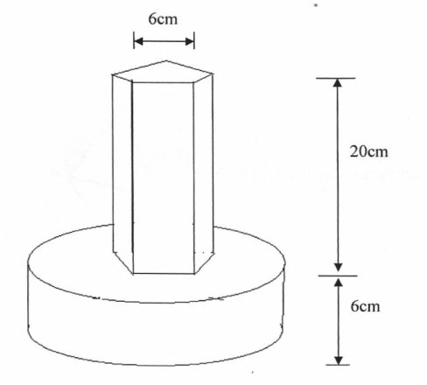 20.The figure below shows a prism whose cross section is a regular pentagon of side 6cm and whose length is 20cm joined to a cylinder of radius 14cm and height 6cm to form a the model of a solid

(a) Calculate the cross section area of the pentagon (3mks)

(b) Calculate the total volume of the solid (4mks)

(c) The model represents a pillar of total height 5.2m, calculate the volume of the actual solid in m3 (3mks)

1. An expedition has 5 sections AB, BC, CD, DE and EA. B is 200m on a bearing of 0500 from A. C is 500m from B. The bearing of B from C is 3000. D is 400m on a bearing 2300 from C. E is 250m on a bearing 0250 from D.

(a) Sketch the route (1 Mark)

(b) Use the scale of 1cm to 50m to draw the accurate diagram representing the route. (5 Marks)

**SKETCH** **TO SCALE**

(c) Use your diagram to determine

(i) Distance in metres of A from E (2 Marks)

(ii) Bearing of E from A (2MKS)

1. In the figure below PQ = 2500m, U T= 1000m and TS =2350m. PQR is a straight line. Parallel to UT and angle UPQ =22.5o.

**S**

22.50

**2350m**

**U 1000m T V**

**P 2500m C R**

**Q**

Calculate to the nearest meter

(a) (i) U Q (2marks)

(ii) T V (2marks)

(iii) V S (2marks)

(iv) P U (2marks)

(b) Find the perimeter of the figure. (2marks)

1. A circular lawn is surrounded by a path of uniform width of 7m. The area of the path is 21%

that of the lawn.

(a) Calculate the radius of the lawn. (4 mks)

(b) Given further that the path surrounding the lawn is fenced on both sides by barbed wire on posts at intervals of 10 metres and 11 metres on the inner and outer sides respectively.

Calculate the total number of posts required for the fence. (4 mks)

(c) Calculate the total cost of the posts if one post costs sh 105. (2 mks)

1. A surveyor recorded the measurements of a field book using XY=400m as the base line as shown below.

|  |
| --- |
| Y  320  210  170  50  X |

To E 200

150 To D

To F 250 150 To C

225 To B

100 To A

1. Use a scale of 1cm to represent 50m to draw the map of the field. (5mks)
2. Find the area of the field in hectares (5mks) ***(more working space at back page)***