**NAME………………………………………………………ADM NO…………………..CLASS………….**

**END OF TERM 3 2019 MATHEMATICS PAPER 2**

**TIME: 2½ HOURS**

**SECTION I (50 MARKS)**

***Answer ALL questions in the spaces provided.***

1. Evaluate using mathematical tables only. (3 marks

6.373log4.948

$$\sqrt{0.004636}$$

1. Determine the inverse of the matrix $\left(\begin{matrix}4 & 3 \\ 5 & -2\end{matrix}\right)$. Hence find the coordinates of the point at which the two lines 4x – 18 = –3y and 5x – 2y = 11intersect. (4 marks)
2. Solve the equation.

5 2x+1 – 3(5x + 1) + 10 = 0 (4 marks)

1. Solve for x in the equation cos x = sin (3x – 30). Hence determine the value of tan x leaving your answer in surd form. (3 marks)
2. In the figure below, YZ is parallel to WX. Angle WZX = 50o and angle WXM = 60o. Determine the size of angle YZW. (2 marks)



1. Kaula has two types of coffee, costing Ksh.120 and Ksh.200 respectively. He mixed them in the ratio

6: 5 by weight.

1. Determine to the nearest shilling the cost of one kilogramme of the mixture. (2 marks)

b) Find the percentage profit on the cost price if the mixture was sold at Ksh. 250.

(Give your answer in 2 d.p). (2 marks)

1. Rationalise the denominator and simplify leaving your answer in the form $\sqrt{a}+b$. (3 marks)
$$\frac{\sqrt{2}+2\sqrt{5}}{\sqrt{5}- \sqrt{2}}$$

2. Use squares, square roots and reciprocals tables only to evaluate;

$\frac{3}{\sqrt{42.15}}+ \frac{4}{{\left(3.152\right)}^{2}}$ (4 marks)

1. Make h the subject of the formula in

m = $\frac{p}{\sqrt{h}+ k^{2}}$ (3 marks)

1. The diagram below shows an equilateral triangle ABC inscribed in a circle of radius 9cm. Calculate the length of the sides of the triangle (2 d.p) (2 marks)



1. Agotho has a rectangular plot that was measured to the nearest meter and found to be 80m in length and 60m in width. Determine the percentage error in its perimeter. (3 marks)

1. A circle of radius 3cm has its centre at (3, −2). Express the equation of the circle in the form

x2 + y2 + mx + ny + c = 0. Where m, n and c are constants. (3 marks)

1. Wambua invested Sh. 6400 at 15% per annum compound interest for 3 years. Muinde invested twice that amount at 12 $\frac{1}{2}$% per annum simple interest for the same period of time. Find whose investment earned more interest and by how much. (4 Marks)
2. a) Expand ${\left(1-\frac{1}{2}x\right)}^{5}$ (1 mark)

b) Use the expansion upto x3 in (a) above to evaluate (0.98)5 correct to 4 d.p (2 marks)

1. The figure below shows a quadrilateral ABCD which is cyclic. Solve for x. (2 marks)



1. Solve for x in the equation log (x – 1) = log 12 – log (x – 2) (3 Marks)

**SECTION II (50 MARKS)**

*Answer only* ***FIVE*** *questions from this section in the spaces provided.*

1. Mr. Kobe is a civil servant who earns a monthly salary of Ksh.21200. He has a house allowance of Ksh.12000 per month, other taxable allowances are commuter Ksh.1100, medical allowance Ksh.2000. He is entitled to a personal relief of Ksh.1240 per month.

Using the income rates below, solve the questions that follow.

|  |  |
| --- | --- |
| Income in Ksh. per month | Rates in Ksh per sh 20 |
| 1 – 8,400  8401 – 18,000  18001 – 30,000  30001 – 36,000  36001 – 48,000  Above 48,000 | 2  3  4  5  6  7 |

Determine;

1. i) His monthly taxable income. (2 marks)

ii) Net tax (PAYEE) (5 marks)

1. In addition to the PAYEE, the following deductions were made. Ksh.250 for NHIF, Ksh.120 service charges,he repays a loan at sh.4500 and contributes towards savings at sh.1800 every month. Calculate his net salary per month. (3 marks)
2. a) From whole numbers 1 to 10, a number is selected at random, find the probability that, the number selected is a prime or a multiple of 3. (2 marks)

b) A tetrahedron is thrown and a coin is tossed.

i) List down all the possible events in the probability space. (1 mark)

ii) Find the probability of getting at least 2 and a head. (2 marks)

c) i) A bag contains 6 white marbles and some brown ones. If the probability of picking a brown marble is 0.6, find the number of marbles in the bag. (3 marks)

ii) Two marbles are then picked, one at a time from the bag in c(i) above, with replacement.

Find the probability that the marbles picked are of different colours. (2 marks)

1. Kennedy bought three cows and twenty-five goats spending a total of Sh. 75000. If he had bought two cows and thirty three goats, he would have saved Sh. 5400. Kennedy later sold all his animals at a profit of 40% per cow and 50% per goat.

Determine;

1. the cost at which he bought each animal. (5 Marks)
2. the total amount of money Kennedy received after selling all the animals. (5 Marks)
3. The figure below shows the position of a boat Q which is observed sailing directly towards the pier P at the base of a vertical cliff PT. The angle of elevation of the top of the cliff from Q is 25.40. After 14 seconds the boat is at point R, and the angle for elevation of T is now 64.70.

T

P

Q

25.40

64.70

50 m

If the cliff is 50m high, calculate

1. The distance PQ (2 Marks)
2. The distance QR (4 Marks)
3. The speed of the boat in km/h (4 Marks)

P

S

Q

R

T

O

In the figure above, OPQ is a triangle in which OS = $\frac{3}{4}$ OP and PR: RQ = 2:1

~

~

~

~

Line OR and SQ meet at T.

1. Given that OP = p and OQ = q, express the following vectors in terms of p and q.

~

~

~

~

~

~

(i) PQ (1 Mark)

~

(ii) OR (2 Marks)

~

(iii) SQ (1 Mark)

~

1. You are further given that ST = mSQ and OT = nOR. Determine the values of m and n. (6 marks)
2. Two variables A and B are connected by the equation. A = kBn  Where k and n are constants.

The table below gives values of A and B.

A. 1.5 1.95 2.51 3.20 4.50

B. 1.59 2.51 3.98 6.31 11.5

(a) Find a linear equation connecting A and B (2 Marks)

1. On the graph paper provided draw a suitable straight line graph to represent the relation in (a) above (5 Marks)

1. Use your graph to estimate the values of k and n in to one decimal place. (3 Marks)

1. (a)

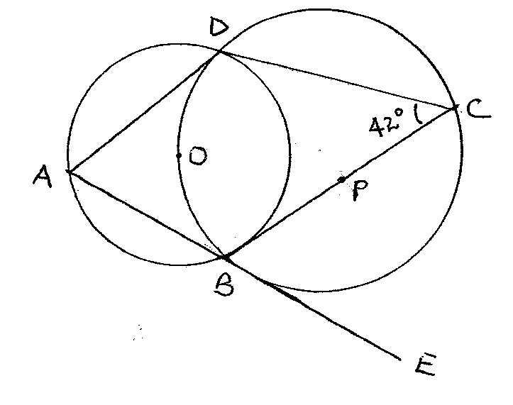

Giving reasons, determine the size of:

1. Angle CBD (2 marks)
2. Angle ODB (2 marks)
3. Angle BAD (2 marks)
4. Angle ABC (2 marks)
5. Angle ODA (2 marks)
6. (a) Draw the graph of the function below on the grid provided

y = 2x2 – 7x – 2 for the values of -1≤X≤6 (5 marks)

(b) From your graph determine the roots of the function. 2x2 – 7x – 2 = 0. (1 marks)

(c) By drawing a suitable graph of function y = 2x – 7 on the same axis, solve the simultaneous equations y = 2x2 – 7x – 2 and y = 2x – 7. (4 marks)