**NAME** …………………………………………………………. **INDEX NO** ………………….

**SCHOOL** …………………………………………………………… **DATE** ……………………

**CANDIDATE’S SIGNATURE** …………………..

**121/1 MATHEMATICS PAPER 2 FORM 4**

**JULY 2017 TIME: $21/2 HOURS$**

**END OF TERM II EXAMINATION**

**QUESTIONS**

**Kenya Certificate of Secondary Education**

**MATHEMATICS**

**PAPER 2**

**INSTRUCTIONS TO CANDIDATES**

1. Write your name, admission number and school in the spaces provided.
2. This paper consists of two sections; Section I and Section II.
3. Answer ALL the questions in Section I and ONLY FIVE questions in Section II.
4. All answers and working must be written on the question paper in the spaces provided below each question.
5. Show all the steps in your calculations, giving your answer at each stage in the space provided below each question.
6. Marks may be given for correct working even if the answer is wrong.
7. Non programmable silent electronic calculators and KNEC mathematical tables may be used except where stated otherwise.
8. Candidates should check the question paper to ascertain that all pages are printed as indicated and that no questions are missing.

FOR EXAMINORS USE ONLY

SECTION I

|  |  |  |  |  |  |  |  |  |  |  |  |  |  |  |  |  |  |
| --- | --- | --- | --- | --- | --- | --- | --- | --- | --- | --- | --- | --- | --- | --- | --- | --- | --- |
| **Question** | **1** | **2** | **3** | **4** | **5** | **6** | **7** | **8** | **9** | **10** | **11** | **12** | **13** | **14** | **15** | **16** | **TOTAL** |
| **Marks** |  |  |  |  |  |  |  |  |  |  |  |  |  |  |  |  |  |

SECTION II

|  |  |  |  |  |  |  |  |  |  |
| --- | --- | --- | --- | --- | --- | --- | --- | --- | --- |
| **Question** | **17** | **18** | **19** | **20** | **21** | **22** | **23** | **24** | **TOTAL** |
| **Marks** |  |  |  |  |  |  |  |  |  |

**Grand Total**

**SECTION I (50 Marks)**

**Answer all questions in this section in the spaces provided.**

1. Use logarithms to evaluate; (4 marks)
$${\left(\frac{6.79×0.3911}{\log{5}}\right)}^{\frac{3}{4}}$$

2. The equation of a line is $-\frac{3}{5}x+3y=6$. Find the
3. Gradient of the line. (1 mark)
4. Equation of a line passing through point $(-1, 2)$ and perpendicular to the given line. (3 marks)
5. A shirt whose marked price is sh. 800 is sold to a customer after allowing him a discount of 13%. If the trader makes a profit of 20%, find how much the trader paid for the shirt. (3 marks)
6. Simplify $\frac{\sqrt{11}}{\sqrt{11}-\sqrt{7}}$ (2 marks)
7. The length and width of a rectangular signboard are $\left(3x+12\right) cm$ and $\left(x-4\right)cm$ respectively. If the diagonal of the signboard is 200 cm, determine its area. (4 marks)
8. Find the value of $x$ given that; (3 marks)

$\log\left(x-1\right)+2=\log\left(3x+2\right)+\log{25}$

1. Use the expansion of ${\left(x-y\right)}^{5}$ to evaluate ${\left(9.8\right)}^{5}$ correct to 4 d.p. (3 marks)
2. Evaluate $\int_{2}^{4}{\left(x^{2}+2x-15\right) dx}$ (3 marks)
3. Make y the subject of formula: (3 marks)
$$P=\frac{xy}{x-y}$$

4. In the figure below, ABCD is a cyclic quadrilateral. Point O is the centre of the circle. $∠ ABO=30°$ and $∠ ADO=40°$.

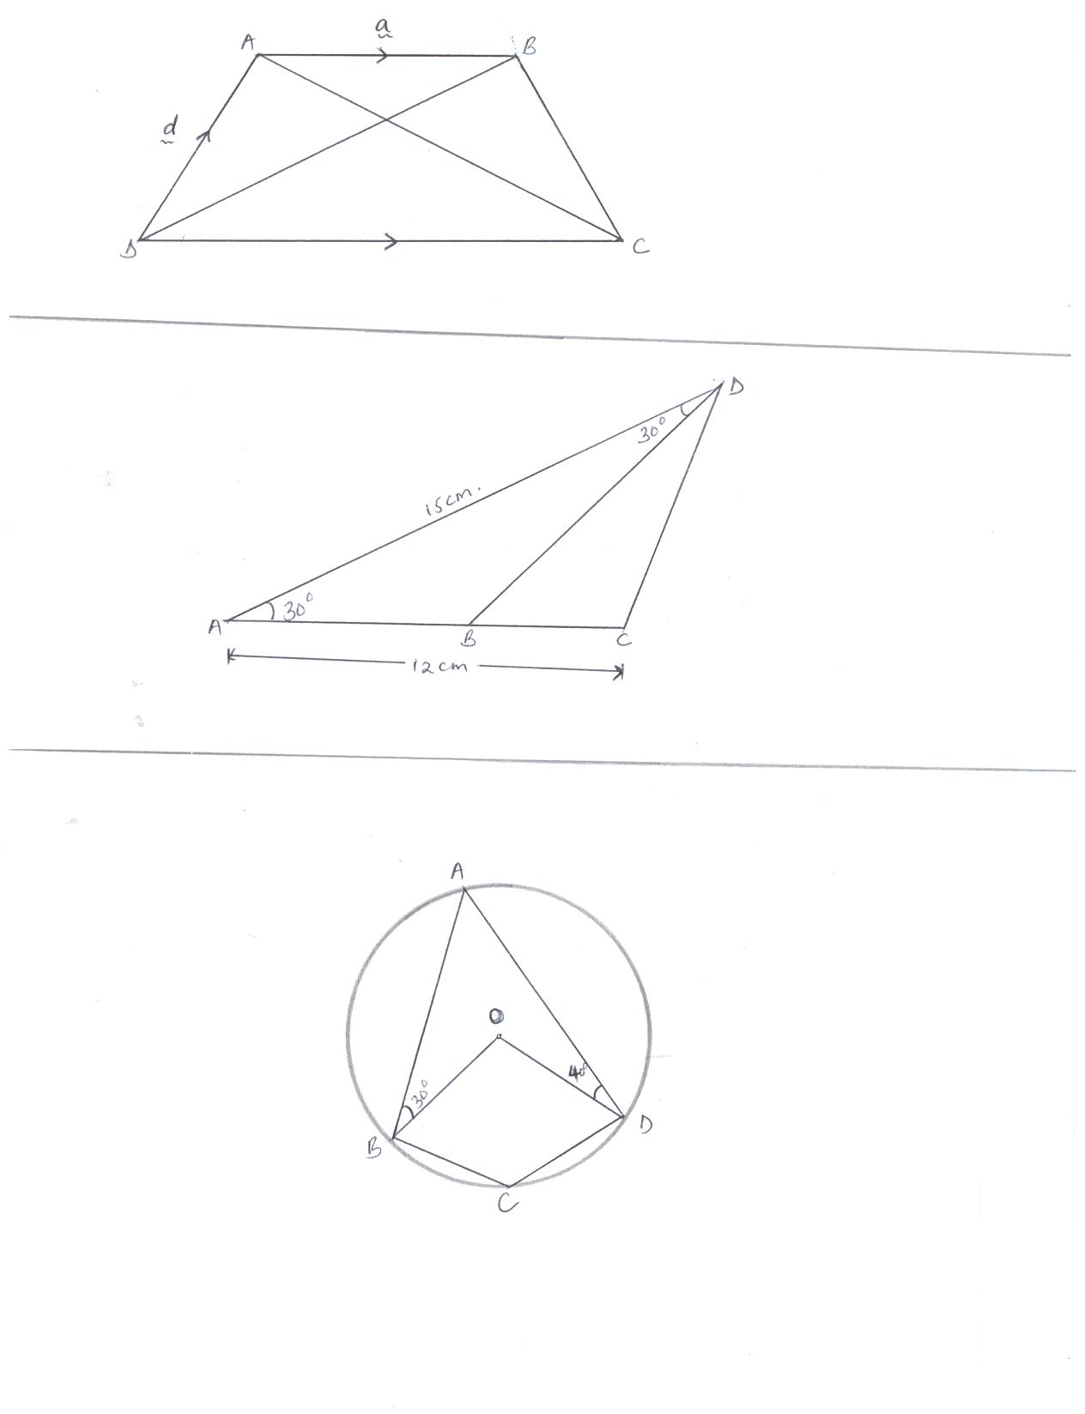

Calculate the size of angle BCD. (2 marks)

1. Find the number of terms of the series $2 + 6 + 10 + 14 + 18 …$ that will give a sum of 800. (2 marks)
2. A bag contains 10 balls of which 3 are red, 5 are white and 2 are green. Another bag contains 12 balls of which 4 are red, 3 are white and 5 are green. A bag is chosen at random and then a ball chosen at random from the bag. Find the probability that the bell chosen is red. (3 marks)
3. The point $(5, 2)$ undergoes the transformation $\left[\begin{matrix}3 & 2 \\ -1 & 0\end{matrix}\right]$ followed by a translation $\left({-6 \atop 11}\right)$. Determine the coordinates of the image. (3 marks)
4. The latitude and the longitude of two stations A and B are $\left(47°N, 25°E\right)$ and $\left(47°N, 70°E\right).$ Calculate the distance in nautical miles between A and B along latitude 470 N. (3 marks)
5. Using a ruler and a pair of compass only;
6. Construct a parallelogram PQRS in which PQ = 6 cm, and QR = 4 cm and $∠ SPQ=75°$ (3 marks)
7. Determine the perpendicular distance between PQ and SR. (1 mark)
8. The mass of a mixture A of beans and maize is 72 kg. The ratio of beans to maize is 3:5 respectively.
9. Find the mass of maize in the mixture. (1 mark)
10. A second mixture B of beans and maize of mass 98 kg is mixed with A. The final ratio of beans to maize is 8:9 respectively. Find the ratio of beans to maize in B. (3 marks)

**SECTION II (50 Marks)**

**Answer any five questions in the spaces provided in this section**

1. Given the simultaneous equations
$$5x+y=19$$

$$-x+3y=9$$

2. Write the simultaneous equations in matrix form. Hence solve the simultaneous equations. (6 marks)
3. Find the distance of the point of the intersection of a line $5x+y=19$ and $-x+3y=9$ from the point $(11, - 2)$ (4 marks)
4. A particle was moving along a straight line. The acceleration of the particle after t seconds was given by $a=\left(9-3t\right){ms}^{-2}$. The initial velocity of the particle was 7 m/s. Find:
5. The velocity (V) of the particle at any given time (t). (4 marks)
6. The maximum velocity of the particle. (3 marks)
7. The distance covered by the particle by the time it attained maximum velocity. (3 marks)
8. The figure below represents a right pyramid with vertex V and a rectangular base PQRS. $VP=VQ=VR=VS=18 cm$ PQ = 16 cm and QR = 12 cm. M and O are the mid points of QR and PR respectively.

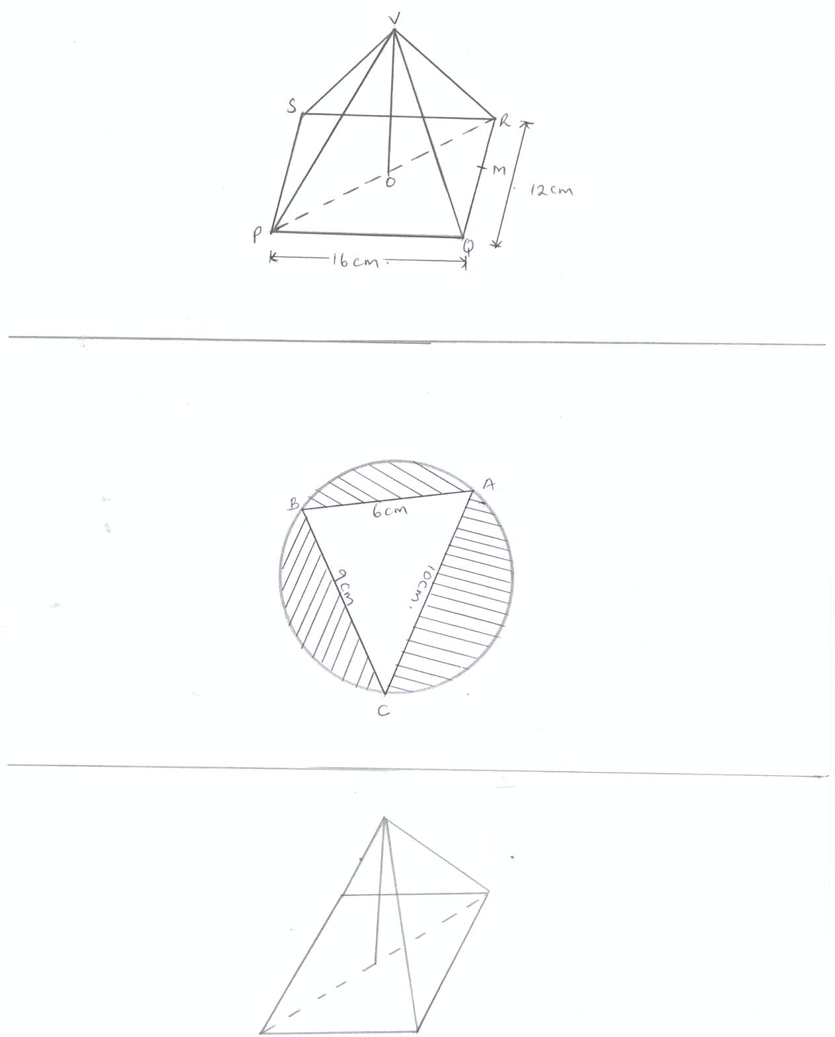

Find;

1. The length of the projection of line VP on the plane PQRS. (3 marks)
2. The size of the angle between line VP and the plane PQRS. (3 marks)
3. The size of the angle between the planes VQR and PQRS. (4 marks)
4. Two towns A and B lie on the same latitude in the northern hemisphere. When it is 8:00 a.m. at A, the time at B is 11:00 a.m.
5. Given that the longitude of A is $15°$ E, find the longitude of B. (3 marks)
6. A plane leaves A for B and takes $3\frac{1}{2}$ hours to arrive at B travelling along a parallel of latitude at 850 km/h. Find,
7. The radius of the circle of latitude of towns A and B. (4 marks)
8. The latitude of the two towns. (3 marks)
9. The gradient function of a curve is given by the expression $2x+1$. If the curve passes through the point $(-4, 6)$,
10. Find;
11. The equation of the curve. (3 marks)
12. The values of x at which the curve cuts the x- axis. (3 marks)
13. Determine the area enclosed by the curve and the x- axis. (4 marks)
14. The transformation A given by the matrix $\left(\begin{matrix}a & b \\ c & d\end{matrix}\right)$ maps $\left(\begin{matrix}17 \\ 0\end{matrix}\right)$ to $\left(\begin{matrix}15 \\ 8\end{matrix}\right)$ and $\left(\begin{matrix}0 \\ 17\end{matrix}\right)$ to $\left(\begin{matrix}-8 \\ 15\end{matrix}\right)$
15. Determine the matrix A giving a, b, c and d as fractions. (4 marks)
16. Given that A represent a rotation through the origin, determine the angle of rotation. (3 marks)
17. S is a rotation through 1800 about the point (2, 3). Determine the image of (1, 0) under followed by A. (3 marks)
18. The figure below shows a triangle ABC inscribed in a circle (not drawn to scale.) AB = 6 cm, BC = 9 cm and AC = 10 cm.



Calculate;

1. The radius of the circle. (6 marks)
2. The area of the shaded parts. (4 marks)
3. In an experiment involving two variables t and r, the following results were obtained.

|  |  |  |  |  |  |  |
| --- | --- | --- | --- | --- | --- | --- |
| t | 1.0 | 1.5 | 2.0 | 2.5 | 3.0 | 3.5 |
| r | 1.50 | 1.45 | 1.30 | 1.25 | 1.05 | 1.00 |

1. On the grid provided, draw the line of best fit for the data. (4 marks)
2. The variables r and t are connected by the equation $r=at+k$ where **a** and **k** are constants. Determine;
3. The values of **a** and **k.**  (3 marks)
4. The equation of the line of best fit. (1 mark)
5. The value of t when $r = 0$. (2 marks)