|  |  |  |
| --- | --- | --- |
| Day | Morning | Afternoon |
| Monday |  |  |
| Tuesday |  | Image result for drawing of RAIN FROM A CLOUD |
| Wednesday | Image result for drawing of RAIN FROM A CLOUD | Image result for drawing of the sun |
| Thursday | Image result for drawing of a cloudy day | Image result for drawing of RAIN FROM A CLOUD |
| Friday | Image result for drawing of the sun | Image result for drawing of a cloudy day |

**ST. AUGUSTINE MUKUMU BOYS’ PRIMARY**

**ENVIRONMENTAL ACTIVITIES**

**GRADE 2 END TERM EXAM TERM 1 2019**

Use the weather chart above to answer questions 1-5

1. Which day was not good for washing clothes? (Monday, Wednesday)
2. Wednesday afternoon was ______ (Sunny, rainy)
3. Which day did the pupils wear sweaters throughout? (Wednesday, Thursday)
4. Thursday was ____________ in the afternoon. (cloudy, rainy)
5. Which day was best for washing clothes? (Monday, Thursday)

Name four containers used to store water at home.

1. _________________________
2. _________________________
3. _________________________
4. _________________________

Write four ways of transporting water at home?

1. __________________________
2. __________________________
3. __________________________
4. __________________________

Name the main parts of a plant

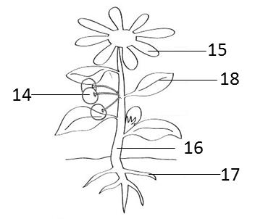

1. __________________________
2. __________________________
3. __________________________
4. __________________________
5. __________________________
6. Name the best soil for growing plants.______________ (loam, sandy).
7. The best soil for making long ribbons is _________________(clay, sand).

**Group the following animals into domestic and wild.**

Cat, donkey, snake, giraffe, hen, lion

|  |  |
| --- | --- |
| Domestic | Wild |
| 21. |  |
| 22. |  |
| 23. |  |

Name two things that produce light that could harm our eyes.

24. _____________________

25._______________________